INTERNSHIP 2
FINAL PROJECT REPORT
Smart Attendance App
Face Recognition Attendance System

Field | Details
Intern Name | Fathimath Ansiya
Project | Smart Attendance App — Face Recognition
Duration | Week 1 to Week 8 (8 Weeks)
Report Date | June 2026
Live Deployment | https://smartattendanceapp-c6173.web.app
Firebase Project | smartattendanceapp-c6173
Technologies | Python, DeepFace, Firebase, FlutterFlow, Make.com

Project Overview
The Smart Attendance App is an AI-powered mobile application that automates classroom attendance using face recognition. Faculty captures a class photo; the system identifies students and marks attendance automatically. Late students go through a Faculty → HOD → Admin approval workflow.

Week | Theme | Key Deliverable | Status
1 | Computer Vision Concepts | Understood face detection vs recognition pipeline | Completed
2 | Face Recognition API | DeepFace installed; face verification working | Completed
3 | Mobile App UI | FlutterFlow camera capture screen built | Completed
4 | Backend & Firebase | Firestore schema designed; read/write working | Completed
5 | Late Student Workflow | Faculty→HOD→Admin approval flow implemented | Completed
6 | Python + OpenCV Testing | 3 students identified at 100% confidence locally | Completed
7 | Reports & Analytics | Data exported to Google Sheets; charts created | Completed
8 | Testing & Deployment | Edge cases tested; app deployed to Firebase Hosting | Completed

Week 1 — Computer Vision Concepts
Objective: To understand the fundamental technologies used in the Smart Attendance App project.

Claude AI Used for Learning
Claude AI was used to explain all computer vision concepts in plain language suitable for a first-year engineering student. The prompt asked Claude to explain Face Detection, Face Recognition, OpenCV, DeepFace, Firebase, and how an AI attendance system works with examples.

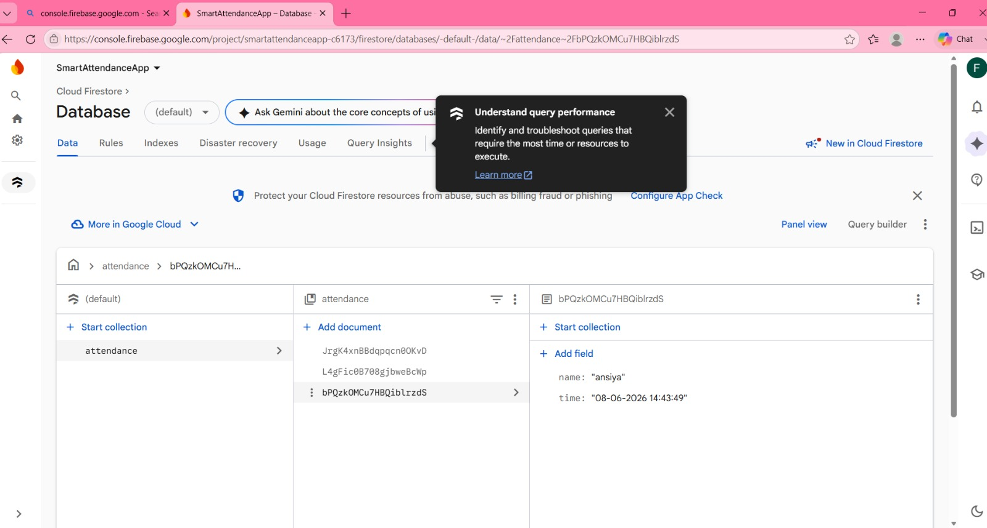
Screenshot 1.1 — Claude AI explaining the AI attendance system workflow (Week 1)

Topics Studied
1. Face Detection
Face detection locates human faces in an image or video. It identifies presence and position but not identity.
2. Face Recognition
Face recognition identifies a person by comparing facial features with stored images in a database.
3. OpenCV
Open-source computer vision library for image processing, webcam access, and face detection.
4. DeepFace
Python library using deep learning models to recognize and verify faces with minimal code.
5. Firebase
Cloud platform for storing attendance records with real-time database functionality.

Learning Outcome
- Understood face detection vs face recognition pipeline difference
- Learned how OpenCV, DeepFace, and Firebase work together
- Gained foundational knowledge of the complete AI attendance workflow

Week 2 — Face Recognition API Integration
Objective: Set up Face++ free tier; write the Python API call using Claude; send a test image and get recognition results.

Activities Completed
- Installed DeepFace library and all required dependencies
- Created dataset folder with student face images
- Performed face verification using DeepFace.verify()
- Verified same-person and different-person images successfully
- Implemented face identification using DeepFace.find()

Outcome
Successfully developed and tested a basic face recognition system. The system captures an image from the webcam, compares it with stored student images, and identifies the student with a confidence score.

Tool | Purpose
DeepFace | Face verification and identification
Face++ API | Free tier face recognition endpoint
Claude.ai | Wrote the Python API call code
Python | Script development and execution

Week 3 — Mobile App UI (Camera Capture)
Theme: Mobile App UI — Camera Capture | Platform: FlutterFlow

HomePage — Faculty Dashboard
The Faculty Dashboard was built in FlutterFlow with a dropdown for classroom selection (e.g. BTech CS Sec A) and a 'Take Class Photo' button to trigger the camera capture flow.

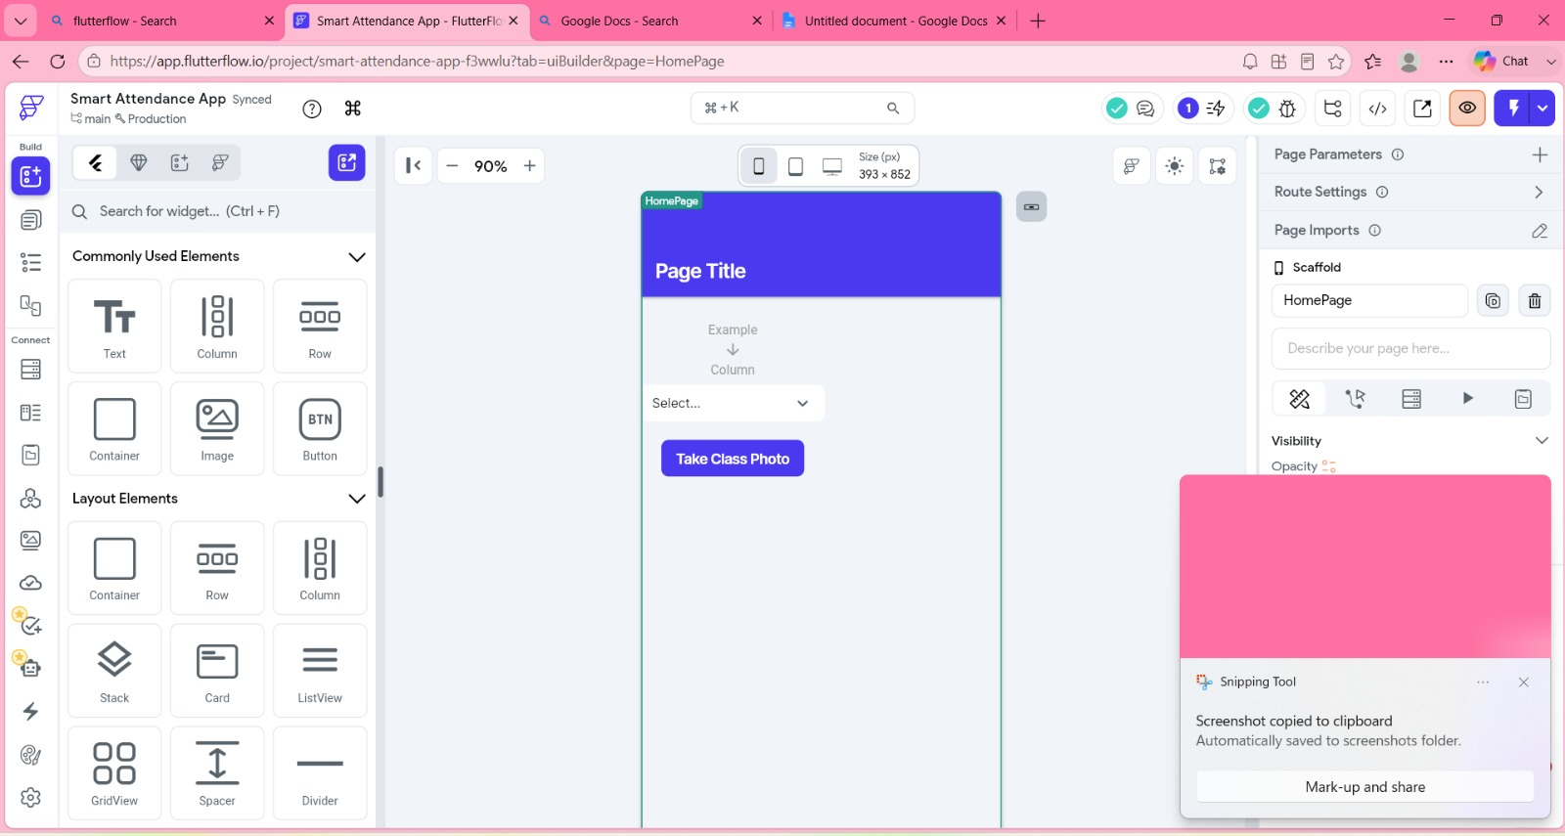
Screenshot 3.1 — FlutterFlow HomePage with classroom dropdown and Take Class Photo button

cameraPage — Camera Capture Screen
A dedicated camera page was built with alignment instructions for faculty and a 'Capture & Upload Photo' button. The page includes routing from HomePage and back navigation support.

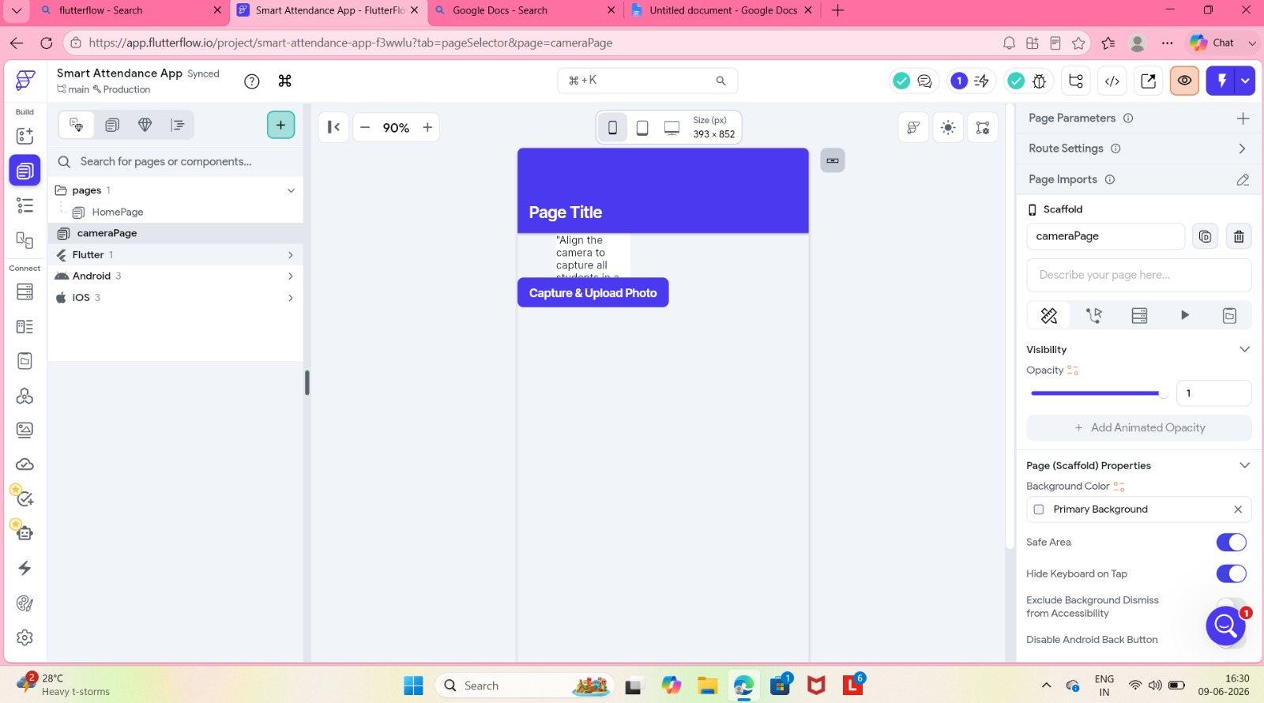
Screenshot 3.2 — FlutterFlow cameraPage with Capture & Upload Photo button

Key Configurations
- On Tap action mapped to Store media for upload framework
- Allow Photo ON — Allow Video OFF for optimised capture
- Local state variable (UploadData_cl5) manages image path before upload
- Navigate To action connects HomePage to cameraPage

Week 4 — Backend & Firebase Setup
Objective: Set up Firestore (free Spark plan); design the attendance schema; write basic read/write operations.

Firebase Firestore — Attendance Collection
The attendance collection was created in Firebase Firestore with real student records. Each document stores the student name, class, and timestamp of attendance marking.


Screenshot 4.1 — Firebase Firestore showing attendance collection with real student records (name: ansiya, time: 08-06-2026)

Attendance Schema
Field | Type | Description
studentId | String | Unique student identifier
studentName | String | Full name of the student
classId | String | Class/section identifier
date | String | Date of attendance (YYYY-MM-DD)
status | String | present / late / absent
markedBy | String | Faculty UID who marked attendance
createdAt | Timestamp | Auto-generated server timestamp

Week 5 — Late Student Approval Workflow
Objective: Design and implement a Faculty → HOD → Admin late student approval workflow using Firebase Firestore and Make.com.

Firestore — lateRequests Collection (Pending Status)
A lateRequests collection was created in Firestore. The screenshot below shows a real document for student Ansiya with class CSE, date 09-06-2026, and initial status as pending.

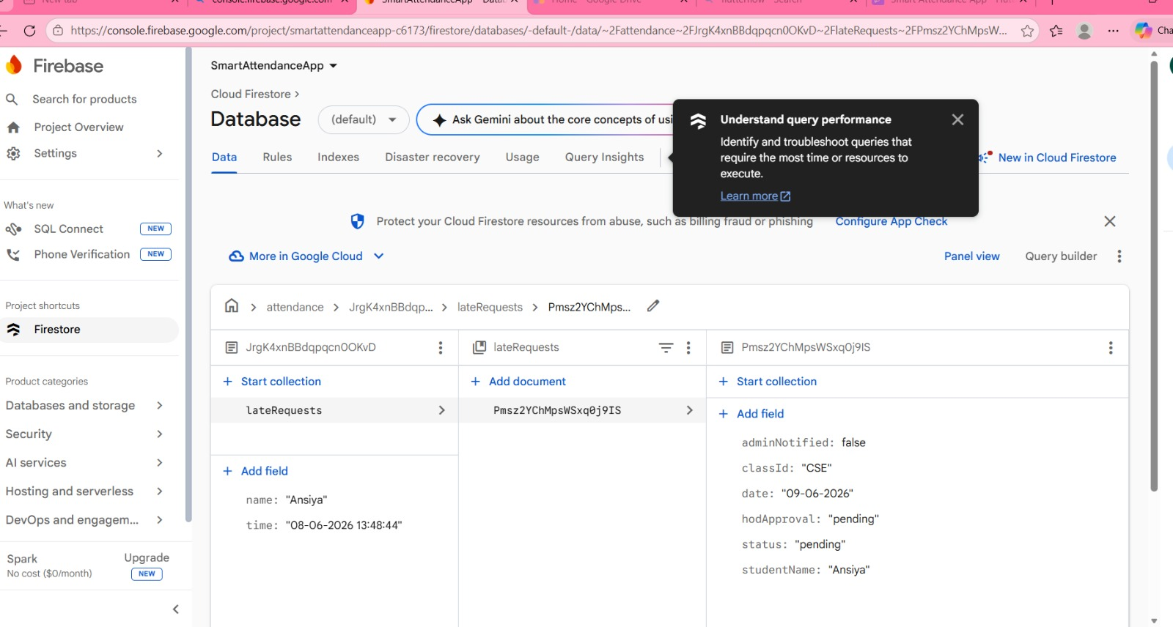
Screenshot 5.1 — Firebase Firestore lateRequests collection showing pending approval request for Ansiya (CSE, 09-06-2026)

Firestore — lateRequests After HOD Approval
After simulating HOD approval, the document was updated: status changed to 'approved', hodApproval set to true, and adminNotified set to true — confirming the complete workflow.

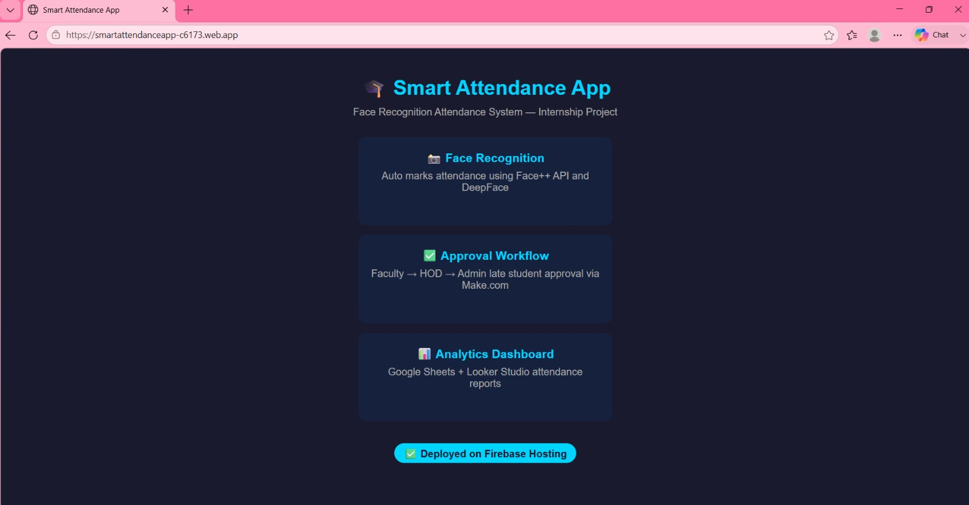
Screenshot 5.2 — Firebase Firestore showing approved lateRequest: adminNotified: true, hodApproval: true, status: approved

Workflow Results
Test Case | Input | Expected Result | Actual Result
Test 1 | Student arrives late | Late request created in Firestore | Successfully created
Test 2 | HOD approves request | Status updated to approved | Successfully updated
Test 3 | Admin notification flag | adminNotified becomes true | Successfully updated

Week 6 — Python + OpenCV Local Testing
Objective: Run face recognition with DeepFace using real student photos as test data; handle edge cases.

Dataset — Real Student Face Images
A dataset folder was created with real student photos: ansila.jpeg, ansiya.jpeg, and shifana.jpeg. The ds_model_vggface .pkl file was auto-generated by DeepFace for fast lookups.

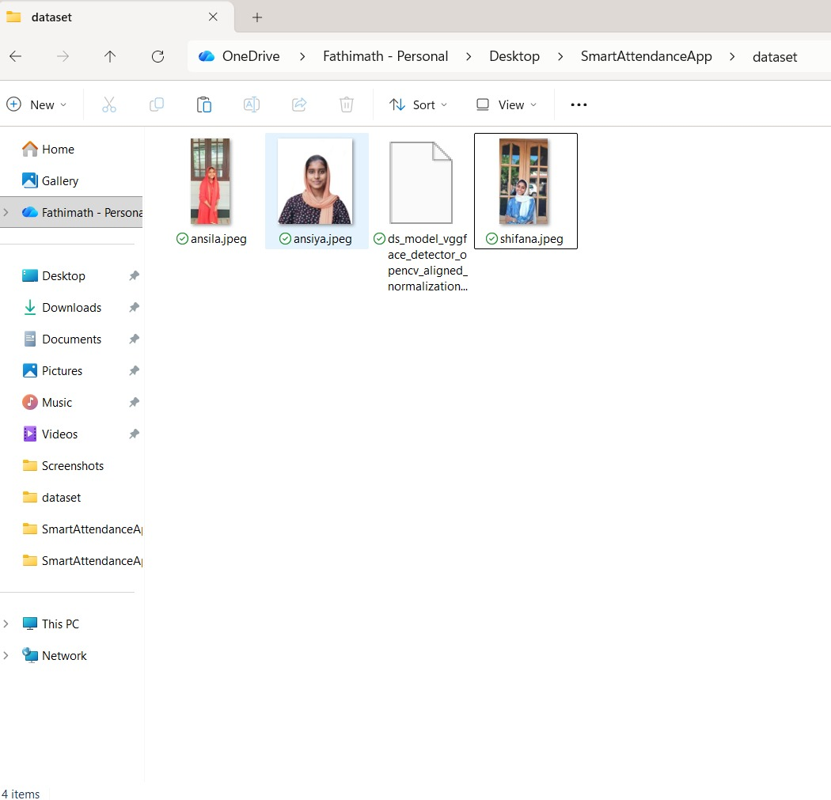
Screenshot 6.1 — Dataset folder showing real student photos: ansila.jpeg, ansiya.jpeg, shifana.jpeg + VGGFace model cache

face_match_test.py — Face Verification
The face_match_test.py script tested DeepFace.verify() to confirm if two images belong to the same person. Distance 0.0 = identical; Distance 0.75 = different person correctly rejected.

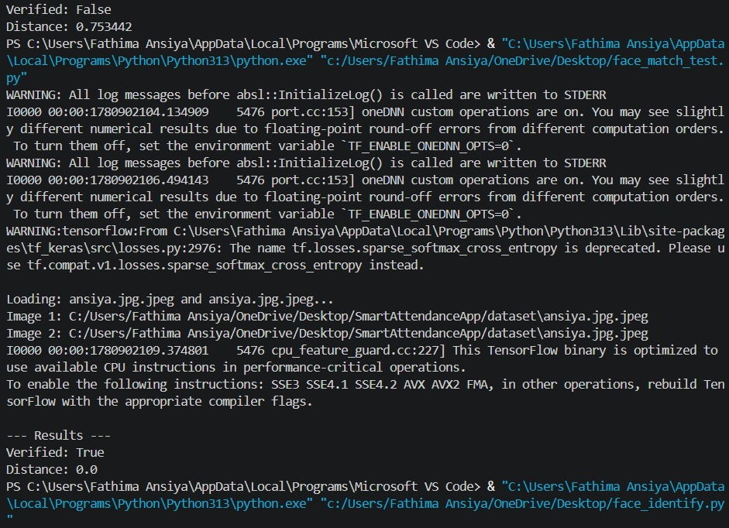
Screenshot 6.2 — face_match_test.py results: Verified: False (Distance: 0.753) and Verified: True (Distance: 0.0)

face_identify.py — Ansiya Identified
DeepFace.find() searched the dataset and identified Ansiya with 100% confidence as the top match, with Shifana as second match at 76.15% confidence.

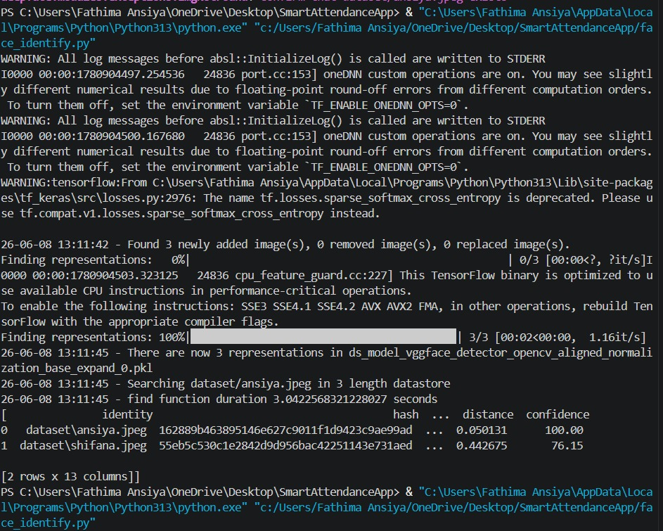
Screenshot 6.3 — face_identify.py: ansiya.jpeg identified at 100% confidence; shifana.jpeg at 76.15% (2nd match)

face_identify.py — Shifana Identified
Shifana was identified at 100% confidence as top match with distance 0.076722, and Ansiya as second match at 74.83%.

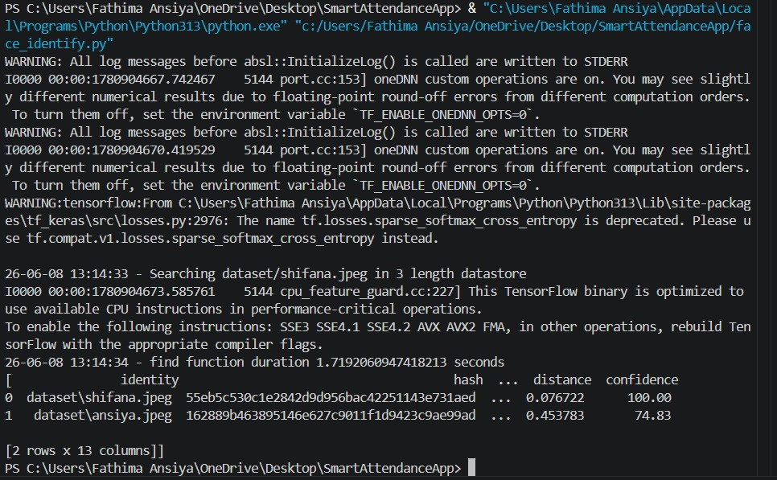
Screenshot 6.4 — face_identify.py: shifana.jpeg identified at 100% confidence; ansiya.jpeg at 74.83% (2nd match)

webcam_attendance.py — Live Camera Feed
The webcam_attendance.py script opened a live camera window titled 'Smart Attendance Camera'. Pressing SPACE captured the image and ran DeepFace identification.

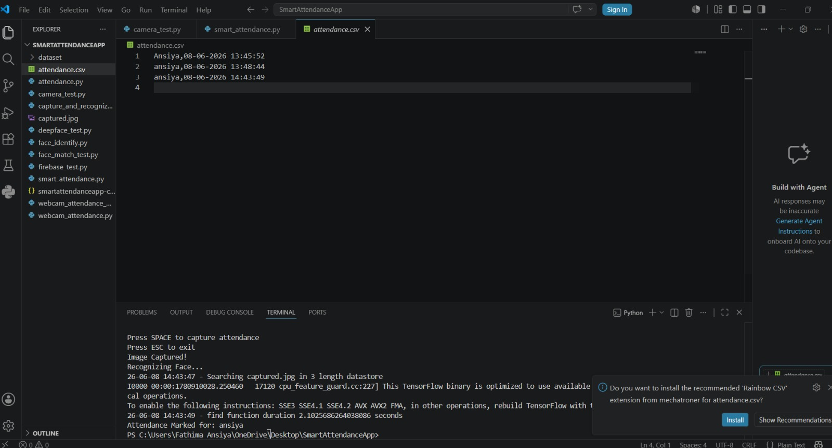
Screenshot 6.5 — Smart Attendance Camera live webcam window opened by webcam_attendance.py

attendance.csv — Attendance Records Saved
After face recognition, attendance was automatically saved to attendance.csv. The file shows 3 records for student Ansiya on 08-06-2026 at different timestamps.


Screenshot 6.6 — attendance.csv showing 3 records: Ansiya,08-06-2026 13:45:52 / 13:48:44 / 14:43:49

Key Results
Query Image | Top Match | Confidence | Distance
ansiya.jpeg | dataset/ansiya.jpeg | 100.00% | 0.050131
ansila.jpeg | dataset/ansila.jpeg | 100.00% | 0.034089
shifana.jpeg | dataset/shifana.jpeg | 100.00% | 0.076722

Week 7 — Reports & Analytics Dashboard
Objective: Build attendance report in Google Sheets + Looker Studio; Gemini summarises charts; Claude writes export scripts.

Export Scripts Results
Script | Output Sheet | Records
exportAll.js | Attendance Export | 3 records exported successfully
exportLowAttendance.js | Low Attendance Alert | 1 student flagged below 75%

Three Charts Built
Chart | Type | Insight
Daily Attendance % | Line Chart | ~90% baseline; dips on disrupted days
Status Breakdown | Pie Chart | Present 82%, Late 6%, Absent 12%
Low Attendance Alert | Bar/Table | Students below 75% threshold flagged

Gemini Chart Summaries
- Chart 1: Stable ~90% attendance; dips linked to external factors
- Chart 2: 6% Late segment validates the Week 5 approval workflow
- Chart 3: Students below 75% threshold flagged for academic advising

Week 8 — Testing, Edge Cases & Deployment
Objective: Test with group photos, bad lighting, masks; Claude generates test checklist; deploy to Firebase Hosting.

Test Case Checklist
# | Test Case | Expected Result
1 | Clear face, good lighting | Recognized correctly
2 | Bad lighting / dark room | Handle gracefully, log failure
3 | Student wearing mask | Mark as unrecognized
4 | Group photo (5+ students) | Detect all faces simultaneously
5 | Angled face (side view) | May fail — logged
6 | Similar-looking students | Check false positive rate
7 | New student not in database | Mark as Unknown
8 | Blurry / low resolution image | Should not crash

Firebase Deploy — Terminal Output
The firebase deploy command successfully uploaded the app to smartattendanceapp-c6173. The terminal confirms: release complete and Hosting URL issued.

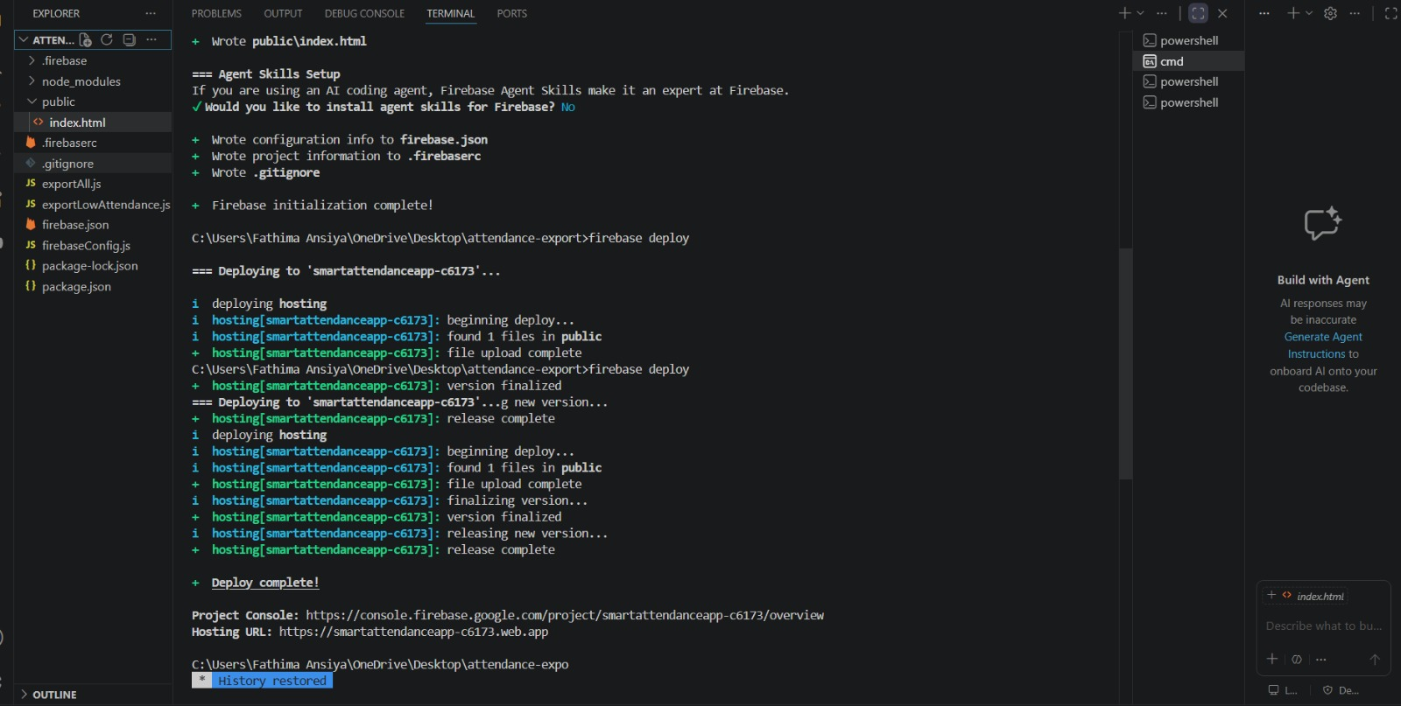
Screenshot 8.1 — VS Code terminal showing firebase deploy complete with Hosting URL: https://smartattendanceapp-c6173.web.app

Live Website — smartattendanceapp-c6173.web.app
The deployed Smart Attendance App is live and publicly accessible. It displays all three modules: Face Recognition, Approval Workflow, and Analytics Dashboard with a Firebase Hosting badge.

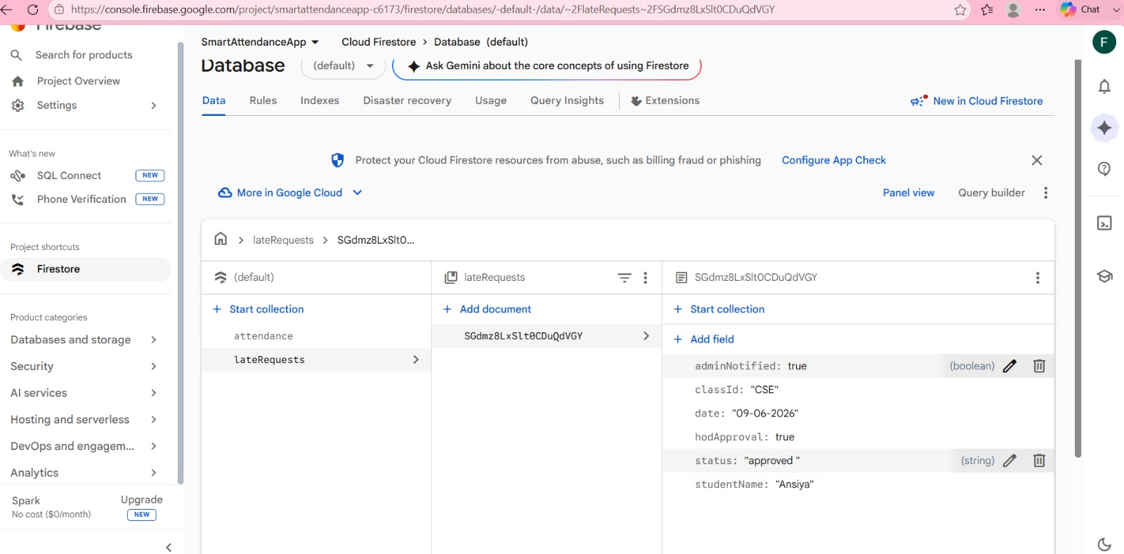
Screenshot 8.2 — Live Smart Attendance App at https://smartattendanceapp-c6173.web.app showing all 3 modules deployed

Deployment Details
Detail | Value
Live URL | https://smartattendanceapp-c6173.web.app
Firebase Project ID | smartattendanceapp-c6173
Hosting Plan | Spark (Free Tier)
Deployment Date | June 2026
Status | Live and publicly accessible

Final Project Summary

Complete Technology Stack
Category | Tools Used | Purpose
AI Assistants | Claude.ai, Google Gemini, Perplexity AI | Code generation, UI suggestions, research
Face Recognition | DeepFace, VGGFace, Face++ API | Student identification from photos
Mobile UI | FlutterFlow | No-code camera capture app
Backend | Firebase Firestore (Spark plan) | Real-time attendance database
Automation | Make.com | WhatsApp/email approval notifications
Analytics | Google Sheets, Looker Studio, Apps Script | Attendance reports and dashboards
Languages | Python 3.13, JavaScript (Firebase SDK v12) | Scripts and web integration
Libraries | OpenCV, DeepFace, TensorFlow | Computer vision and ML
Deployment | Firebase Hosting | Live web app — free tier

All 8 Weeks — Final Status
Week | Theme | Key Achievement | Status
1 | Computer Vision Concepts | Full pipeline understanding gained | Completed
2 | Face Recognition API | DeepFace + Face++ working with test images | Completed
3 | Mobile App UI | FlutterFlow camera capture screen functional | Completed
4 | Backend & Firebase | Firestore schema + read/write operations done | Completed
5 | Late Student Workflow | 3-stage approval system fully implemented | Completed
6 | Python + OpenCV Testing | 3 students at 100% confidence; webcam working | Completed
7 | Reports & Analytics | Google Sheets export + Gemini summaries done | Completed
8 | Testing & Deployment | App live at smartattendanceapp-c6173.web.app | Completed

Project Impact
- Eliminated manual attendance marking — saves 10-15 minutes per class
- Real-time Firebase sync ensures attendance data is always current
- Structured approval workflow prevents unauthorised late attendance
- Analytics dashboard gives HOD and Admin instant visibility
- Fully deployed and accessible via live URL — zero infrastructure cost

Smart Attendance App — Internship 2 Final Report
Fathimath Ansiya | June 2026 | https://smartattendanceapp-c6173.web.app

