YUVA INTERN – WEEK 1
DATA SCIENCE PROJECT PLANNING
AND STRATEGY DESIGN
A hypothetical Customer Churn Prediction project using Python
Submitted by: ______________________________
Internship Program: YUVA INTERN
Week: 1
Date: ______________________________
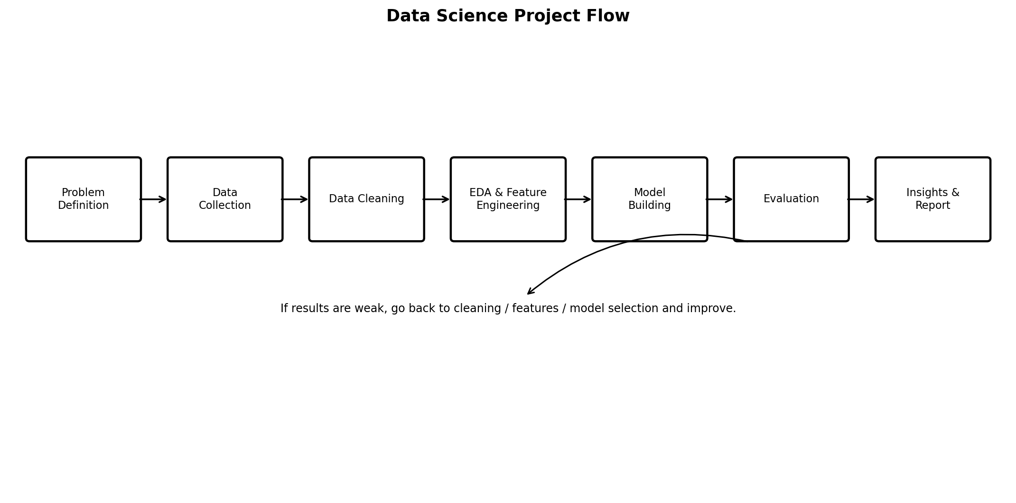

1. Introduction and Project Background
For this project, I have selected Customer Churn Prediction as the hypothetical data science problem. The idea is to use customer-related information to identify customers who may stop using a company's service in the future. This is a suitable problem for a data science project because customer records usually contain many useful variables such as subscription type, length of relationship, usage, payment history and support interactions.
The project is planned using Python because Python provides libraries for almost every stage of the data science process, from reading and cleaning data to visualization, machine learning and evaluation. Since this is the first week of the internship, the focus is on planning the complete approach rather than working with an actual dataset.

1.1 Problem Statement
A subscription-based company wants to understand why customers leave and identify existing customers who are more likely to churn. The proposed solution is to study historical customer data and build a classification model that predicts whether a customer is likely to churn.

1.2 Motivation
- Customer churn can affect revenue and long-term business growth.
- It is difficult for a company to manually check every customer's risk level when there are many customers.
- Data can help identify patterns that are not obvious from individual customer records.
- A prediction model can help the company focus retention efforts on customers who need attention.
- The project gives practical experience with the complete data science workflow.

1.3 Why Python?
Python is selected because it is easy to work with and has a large collection of data science libraries. Pandas and NumPy can be used for data handling, Matplotlib and Seaborn for visualization, and Scikit-learn for preprocessing, machine learning and evaluation.

2. Project Objectives and Scope

2.1 Objectives
- Understand and define the customer churn problem clearly.
- Identify the type of data required for the project.
- Plan a method for collecting, checking and preparing the data.
- Explore customer data and find patterns related to churn.
- Create useful features for prediction.
- Build a baseline model and compare suitable machine learning models.
- Evaluate the models using appropriate classification metrics.
- Interpret the results and convert them into useful business observations.
- Document the complete process so that the project can be implemented in later stages.

2.2 Scope of the Project
The project will cover:
- Customer account and subscription information.
- Customer usage and activity information.
- Payment-related information.
- Customer support interaction information.
- Historical churn information.
- Data cleaning and preprocessing.
- Exploratory data analysis.
- Feature engineering.
- Classification model development.
- Model evaluation and interpretation.

2.3 Out of Scope
- Developing a complete mobile or web application.
- Automatically contacting customers or running marketing campaigns.
- Real-time production deployment during this planning stage.
- Using confidential customer information without permission.
- Making guaranteed claims about which individual customer will leave.
- Revenue forecasting that is not directly related to the churn problem.

3. Methodology and Strategy
The planned methodology follows the common data science lifecycle. The stages are connected and may need to be repeated. For example, if a model performs poorly, I may need to return to feature engineering or data cleaning instead of immediately changing the model.

3.1 Stage 1 – Understanding the Problem
- Define exactly what is meant by churn.
- Decide the time period used for prediction.
- Define the target variable as Churn = 1 and Not Churn = 0.
- Identify what the business wants to achieve from the prediction.
- Decide which errors are more important for the business.

3.2 Stage 2 – Data Collection Plan
The hypothetical dataset may contain the following groups of variables:
Data Group | Examples | Purpose
Customer information | Customer ID, tenure, customer type | Understand customer profile and relationship length
Subscription | Plan, contract type, billing frequency | Study whether service plans relate to churn
Usage | Sessions, activity, usage volume | Measure customer engagement
Payments | Payment method, late payments, payment status | Study payment-related risk
Support | Number of complaints/tickets, support contacts | Study service problems and dissatisfaction
Target | Churn / No Churn | Label used for supervised learning
Before analysis, the data would be checked for missing values, duplicate records, incorrect data types, inconsistent categories, impossible values and possible data leakage.

3.3 Stage 3 – Data Cleaning and Preprocessing
- Load the data and inspect the number of rows, columns and data types.
- Check for duplicate customer records.
- Identify missing values and decide how each important variable should be treated.
- Correct inconsistent spellings or category names.
- Check numerical fields for invalid or extreme values.
- Convert categorical variables into a form suitable for machine learning.
- Scale numerical variables when required by the selected model.
- Split the data into training and testing sets before fitting the model.
- Use a reproducible preprocessing pipeline so that the same steps are applied consistently.

3.4 Stage 4 – Exploratory Data Analysis
- Calculate the overall churn percentage.
- Compare churn across different contract and subscription types.
- Study the relationship between tenure and churn.
- Compare usage levels of churned and retained customers.
- Check whether payment problems are associated with higher churn.
- Analyze support interactions and complaints.
- Use charts such as bar charts, histograms, box plots and correlation plots.
- Write down observations and possible explanations before moving to modeling.

3.5 Stage 5 – Feature Engineering
- Create useful tenure groups from customer tenure.
- Create activity or usage trend variables when historical usage is available.
- Calculate the number or frequency of support interactions.
- Create payment reliability indicators.
- Create a service-count feature if a customer uses multiple services.
- Remove features that contain information only available after the customer has already churned.

3.6 Stage 6 – Model Building
The first model will be a simple baseline. More models will then be tested so that their performance can be compared.
Model | Why it will be considered | Advantage | Limitation
Logistic Regression | Baseline for binary classification | Simple and easy to interpret | May not capture complex relationships
Decision Tree | Understand nonlinear rules | Easy to visualize and explain | Can overfit
Random Forest | Strong option for tabular data | Handles nonlinear patterns well | Less simple to explain
Gradient Boosting | Possible performance-focused model | Can give strong results on structured data | Needs careful tuning

3.7 Stage 7 – Evaluation
The following measures will be considered:
- Accuracy – percentage of predictions that are correct.
- Precision – how many customers predicted as churners actually churned.
- Recall – how many of the actual churners were identified.
- F1-score – balance between precision and recall.
- ROC-AUC – measures how well the model separates the two classes across thresholds.
- Confusion matrix – shows true positives, true negatives, false positives and false negatives.
Accuracy alone will not be treated as the deciding metric because churn datasets may be imbalanced. Recall and F1-score will receive particular attention, along with the business cost of false positives and false negatives.

3.8 Stage 8 – Interpretation and Reporting
- Compare model results in a clear table.
- Identify the variables that appear important for prediction.
- Explain findings in simple business language.
- Avoid treating a prediction as proof of a cause.
- Record limitations and assumptions.
- Prepare recommendations that the company could investigate further.

4. Project Architecture
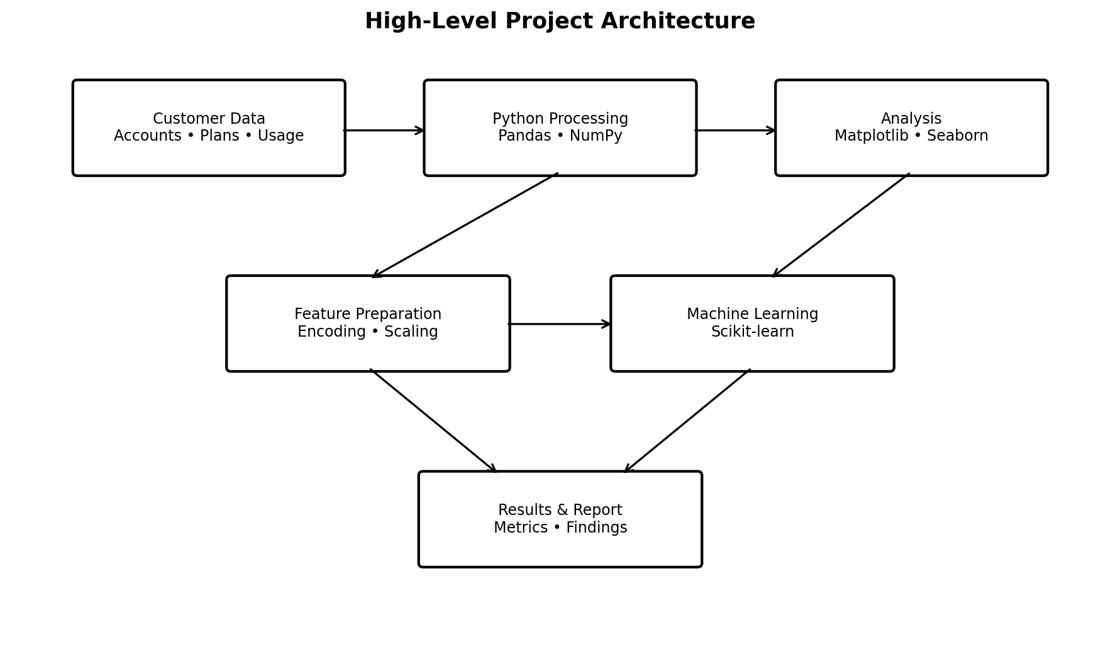
The architecture shows how the planned project moves from customer data through Python processing and analysis to machine learning and final reporting.

5. Timeline and Work Allocation
A total of 33 hours has been planned for Week 1. The time is approximate and can be adjusted slightly depending on the complexity of each stage.
Work Area | Main Activities | Hours | Expected Result
Problem definition | Background, motivation, objectives and scope | 4 | Clear problem statement
Data planning | Data sources, variables and quality checks | 5 | Data collection plan
Cleaning strategy | Missing values, duplicates, outliers and preprocessing | 5 | Cleaning strategy
EDA and features | Exploration, charts and feature ideas | 5 | EDA and feature plan
Modeling | Baseline and candidate models | 6 | Model selection plan
Evaluation | Metrics, validation and interpretation | 4 | Evaluation plan
Documentation | Diagrams, editing, final review and GitHub preparation | 4 | Final submission
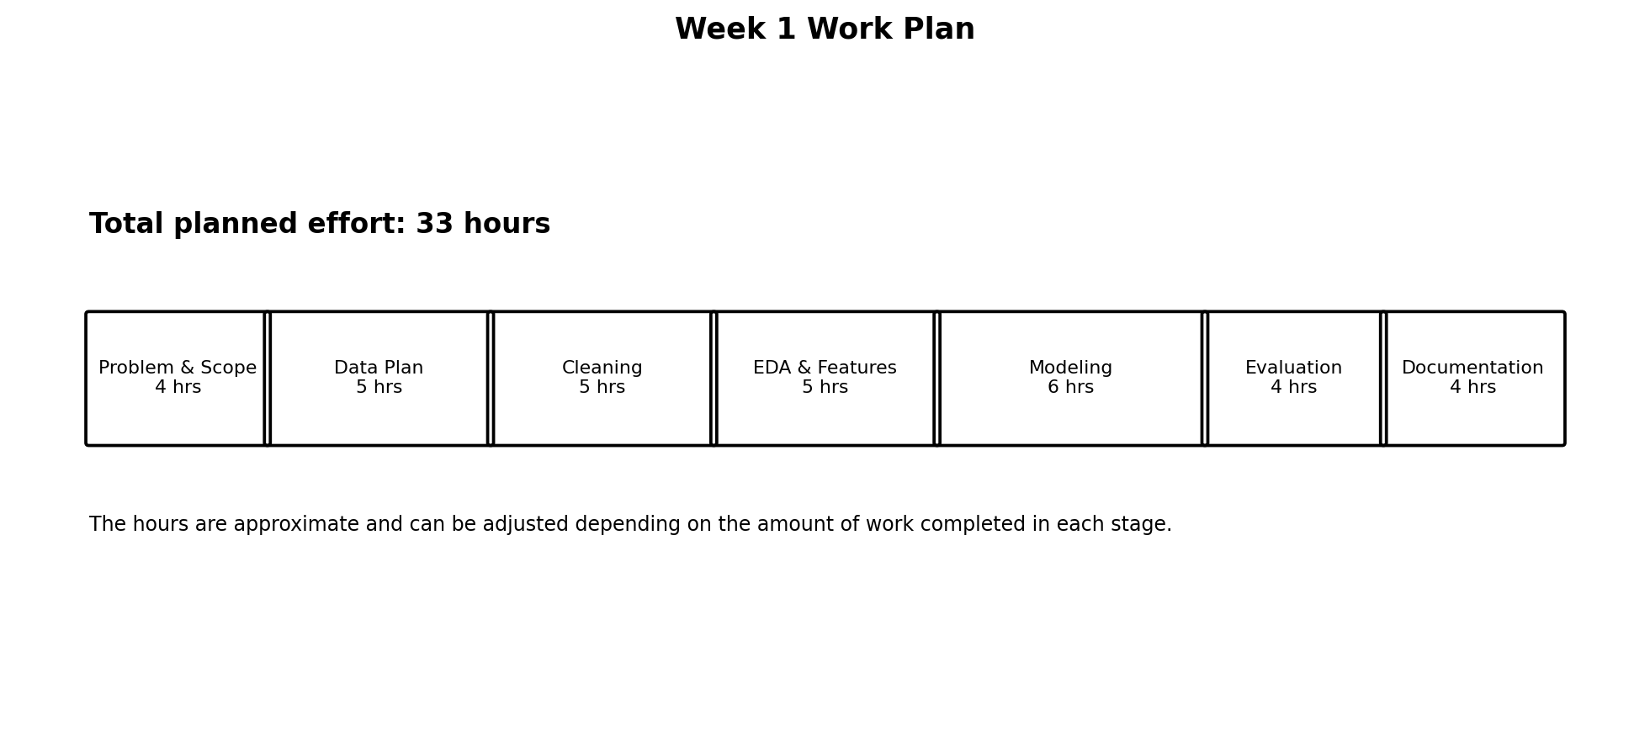

6. Python Libraries and Tools
Tool | Planned Use | Reason for Selection
Python | Main programming language | Suitable for the complete data science workflow
Pandas | Reading, cleaning and transforming tabular data | Simple and powerful data handling
NumPy | Numerical calculations | Useful for numerical operations
Matplotlib | Basic charts | Flexible plotting library
Seaborn | Statistical charts | Useful for EDA and clear visualizations
Scikit-learn | Preprocessing, models and metrics | Provides the main classical ML tools
Jupyter Notebook | Exploration and experimentation | Makes analysis easy to document step by step
VS Code | Writing and organizing Python files | Useful for project development
Git / GitHub | Version control and project submission | Keeps project work organized and shareable

7. Expected Outcomes and Benefits
- A clearly defined and measurable customer churn problem.
- A well-planned data preparation and analysis process.
- An understanding of which customer characteristics may be linked with churn.
- A baseline model and one or more candidate models for comparison.
- A clear evaluation framework instead of relying only on accuracy.
- Business-oriented insights that can support future customer retention work.
- A reusable project structure that can be developed further in later internship tasks.
- A properly documented project that demonstrates understanding of the data science lifecycle.

8. Expected Challenges and Mitigation
Possible Challenge | Effect | Planned Mitigation
Missing values | May reduce data quality | Measure missingness and use an appropriate treatment for each variable
Class imbalance | Model may focus on non-churners | Use precision, recall, F1 and stratified validation; consider class weights if needed
Data leakage | Results may look unrealistically good | Define the prediction point and remove information that would not be available at prediction time
Overfitting | Model may perform poorly on new data | Use train/test separation, cross-validation and simpler models as baselines
Poor interpretability | Business users may not understand predictions | Keep an interpretable baseline and explain important features
Privacy concerns | Customer information could be exposed | Use only necessary data and anonymize identifiers
Changing customer behavior | Model may become less accurate over time | Plan future monitoring and retraining

9. Ethical and Responsible Data Use
- Only data relevant to the project should be collected.
- Personal information should be minimized and protected.
- Customer IDs should be anonymized or replaced with non-identifying values when possible.
- The model should support decision-making, not automatically make unfair decisions about customers.
- Model performance should be checked carefully before using predictions in a real business setting.
- The limitations of the model should be reported honestly.
- No confidential internship/company dataset should be uploaded to a public GitHub repository.

10. How the Plan Meets the Evaluation Criteria
Evaluation Requirement | How this submission addresses it
Completeness and clarity | Covers background, objectives, scope, methodology, timeline, tools, outcomes and challenges.
Understanding of data science | Follows problem definition, collection, cleaning, EDA, feature engineering, modeling and evaluation.
Logical organization | Sections are arranged in the same order as a normal data science project workflow.
Detailed and justified strategy | Each major stage explains what will be done and why.
Visual clarity | Includes a lifecycle flowchart, 33-hour work plan and project architecture diagram.

11. GitHub Repository Requirement
The internship instructions state that a GitHub URL is compulsory for technical/software-related work. The repository should contain the project document and supporting diagrams. A real repository link must be added before final submission.
Field | Details
GitHub URL | PASTE YOUR ACTUAL PUBLIC GITHUB REPOSITORY URL HERE
Suggested repository name: data-science-week1-churn-planning
Suggested contents:
- README.md – short explanation of the project
- Week_1_Data_Science_Project_Plan.docx – submitted report
- diagrams/ – flowchart, timeline and architecture images
- requirements.txt – Python libraries planned for later implementation
- notebooks/ – future analysis notebooks
- src/ – future Python source files

12. Final Submission Checklist
☐ Project background and problem statement completed
☐ Motivation and justification included
☐ Objectives clearly defined
☐ In-scope and out-of-scope areas included
☐ Data collection strategy included
☐ Cleaning and preprocessing strategy included
☐ EDA and feature engineering strategy included
☐ Modeling and evaluation strategy included
☐ 33-hour timeline included
☐ Python libraries and tools identified
☐ Three planning diagrams included
☐ Expected outcomes and benefits discussed
☐ Challenges and mitigation strategies discussed
☐ Ethical and privacy considerations included
☐ GitHub URL added before submission

13. Conclusion
This Week 1 plan provides a practical starting point for a complete data science project. The selected customer churn problem is realistic and can be handled using Python and standard data science techniques. The plan begins with understanding the business problem, continues through data preparation, exploration and modeling, and ends with evaluation and reporting. The next stages of the internship can use this plan as a guide for actual Python implementation when a dataset is available.

