YUVA INTERN
WEEK 4
COMPREHENSIVE DATA SCIENCE REPORT
AND INSIGHTS PRESENTATION PLAN

PROJECT
CUSTOMER CHURN PREDICTION USING PYTHON

DETAIL | INFORMATION
Student Name | Fathimath Zulfah
Course | Bachelor of Computer Applications (BCA)
University | Mangalore University
Internship | YUVA INTERN – Data Science Internship
Internship Week | Week 4
Project Title | Customer Churn Prediction Using Python

ACADEMIC REPORT AND PORTFOLIO DOCUMENT

2. Executive Summary
IMPORTANT: All numerical values, findings, charts and model scores in this report are illustrative hypothetical examples. They are not actual experimental or business results.
Customer churn refers to the situation in which customers stop using a company's products or services. It is an important business problem because losing existing customers can reduce revenue, increase the cost of acquiring new customers and affect long-term business growth.
The project titled Customer Churn Prediction Using Python focuses on understanding how data science and machine learning can help identify customers who may be at risk of leaving a service. The proposed approach uses customer information such as tenure, contract type, monthly charges, payment method and customer service interactions.
The purpose of this Week 4 report is to organize the proposed methodology, present illustrative findings, explain possible business insights and prepare a communication plan for presenting data science results to non-technical decision-makers. The numerical values in this report are hypothetical examples created for demonstration and learning.
Machine learning can support customer retention by identifying patterns that may not be easy to notice through manual analysis. Classification models can estimate whether a customer belongs to a likely-to-leave or likely-to-stay group. Such predictions should support human decisions rather than automatically determine how customers are treated.
For this illustrative example, the analysis suggests that month-to-month contracts, shorter customer tenure and higher monthly charges may be associated with increased churn. Payment behaviour and customer service experience may also provide useful signals. These are demonstration patterns, not verified findings from a real customer dataset.
The business value of communicating these insights is that managers can understand where retention efforts may be useful, which customer groups may need additional attention and how to evaluate possible improvements. Clear charts, simple language and practical recommendations help turn technical analysis into decisions that business teams can understand.

3. Project Background and Objectives

3.1 Understanding Customer Churn
Customer churn is the loss of customers over a particular period. In a subscription-based business, churn may occur when a customer cancels a subscription, does not renew a contract or stops using a service. Churn can be voluntary, such as a customer choosing a competitor, or involuntary, such as service termination due to payment problems.

3.2 Business Problem
Businesses may have large amounts of customer information but may not have a clear way to identify customers who are likely to leave. If a business only reacts after a customer cancels, it may lose the opportunity to understand the customer's concerns and offer suitable support.

3.3 Purpose of the Project
The purpose is to demonstrate how a structured data science workflow could be used to study customer churn and support early retention planning. The project connects data preparation, exploratory analysis, machine learning concepts, visualization and business communication.

3.4 Project Objectives
- Understand the meaning and business importance of customer churn.
- Identify customer attributes that may be related to churn.
- Describe a suitable data collection and preprocessing approach.
- Explore customer patterns using tables and visualizations.
- Understand the use of classification algorithms for churn prediction.
- Compare possible machine learning models using suitable evaluation metrics.
- Translate analytical observations into understandable business insights.
- Prepare practical recommendations for customer retention.
- Communicate the proposed findings to a non-technical audience.

3.5 Scope and Benefits
The proposed scope covers customer-level information, exploratory data analysis, preprocessing, classification model concepts, evaluation, visualization and business recommendations. The report does not claim that a live company system has been accessed or that a real prediction model has been deployed.
- Helps explain why customer retention matters.
- Demonstrates how customer data can be organized and interpreted.
- Shows how machine learning can support risk identification.
- Improves the ability to communicate technical ideas using charts.
- Connects data science concepts with practical business decisions.

3.6 Intended Presentation Audience
The intended audience includes business managers, customer relationship teams, marketing teams, customer support managers and decision-makers who may not have a technical background. The presentation should focus on the business problem, important patterns, possible actions and expected value rather than lengthy mathematical explanations.

4. Methodology Overview
A methodology is a planned sequence of steps used to complete a project. For customer churn prediction, the proposed workflow begins with defining the problem and understanding the data. It continues through cleaning, preprocessing, model preparation, evaluation and interpretation.
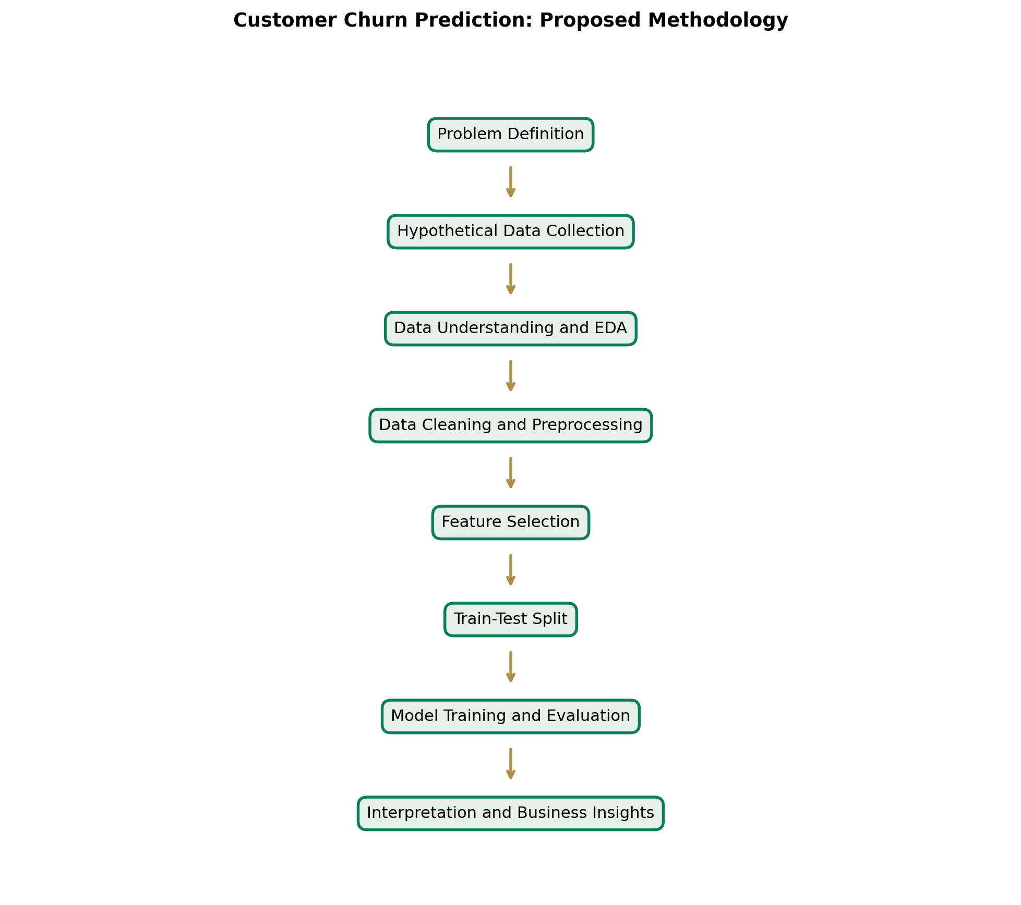
Figure 1: Proposed Customer Churn Prediction Methodology
Interpretation: The flowchart shows the order of the main stages, from problem definition to business interpretation.
Why this visualization is useful: It gives readers a quick overview of the complete workflow before the individual stages are explained.

1. Problem Definition
Define customer churn as the outcome to be studied. Identify the business question: which customer characteristics may help indicate the possibility that a customer will leave?

2. Hypothetical Data Collection
For demonstration, consider a structured customer dataset containing customer ID, tenure, contract type, monthly charges, payment method, service usage, support interactions and churn status. A real project would require authorized and properly documented data access.

3. Data Understanding and EDA
Examine the number of rows and columns, variable types, category values, summary statistics and the distribution of the target variable. EDA helps reveal patterns, unusual values and questions that need further study.

4. Data Cleaning
Check for missing values, duplicate records, inconsistent labels, incorrect data types and unusual values. Decide how to handle each issue based on its meaning and the quality of the available data.

5. Data Preprocessing
Prepare the dataset for analysis and machine learning. Numerical features may require scaling depending on the selected model. Categorical features can be converted into numerical form using methods such as one-hot encoding.

6. Feature Selection and Engineering
Choose useful variables and, where appropriate, create additional features. For example, tenure may be grouped into customer-life-stage categories. Feature decisions should be based on business understanding and training data.

7. Train-Test Split
Separate the available data into training and testing portions. The training data is used to fit the model, while the test data provides an estimate of performance on unseen records. Data leakage must be avoided.

8. Model Selection
Consider Logistic Regression, Decision Tree, Random Forest and Gradient Boosting. Different models have different strengths, levels of complexity and interpretation requirements.

9. Model Training and Evaluation
Fit the selected algorithms using training data. Evaluate them using appropriate measures such as accuracy, precision, recall, F1-score and confusion matrix. Accuracy alone may not be sufficient when churn classes are imbalanced.

10. Interpretation and Business Insights
Study the model results and important patterns. Explain what the results could mean for customer retention, identify limitations and present recommendations that can be reviewed by business stakeholders.

4.1 Algorithms Considered
Algorithm | Simple Explanation | Possible Strength
Logistic Regression | Estimates the probability of a customer belonging to a churn class. | Relatively easy to explain and useful as a baseline.
Decision Tree | Uses a sequence of decision rules to classify customers. | Can be visualized and explained through rules.
Random Forest | Combines predictions from multiple decision trees. | Can capture more complex patterns than a single tree.
Gradient Boosting | Builds models in sequence, with later models improving earlier errors. | Can provide strong predictive performance when tuned carefully.

The best algorithm should not be selected only because it has the highest accuracy. Model selection should consider recall for churn customers, precision, F1-score, interpretability, fairness, operational cost and the business impact of incorrect predictions.

5. Hypothetical Findings and Data Analysis
IMPORTANT: All numerical values, findings, charts and model scores in this report are illustrative hypothetical examples. They are not actual experimental or business results.
This section demonstrates how findings could be reported if a suitable customer dataset were available. The example uses an illustrative group of 1,000 customers: 720 customers stayed and 280 customers left. These numbers are created only to demonstrate report writing and visualization.
Customer Status | Illustrative Count | Illustrative Share
Stayed | 720 | 72%
Left | 280 | 28%
Total | 1,000 | 100%

5.1 Churn Distribution
The illustrative distribution contains 720 customers who stayed and 280 who left. This gives an example churn share of 28%. In a real project, the churn rate would be calculated from the actual target column after checking the dataset and defining the observation period.
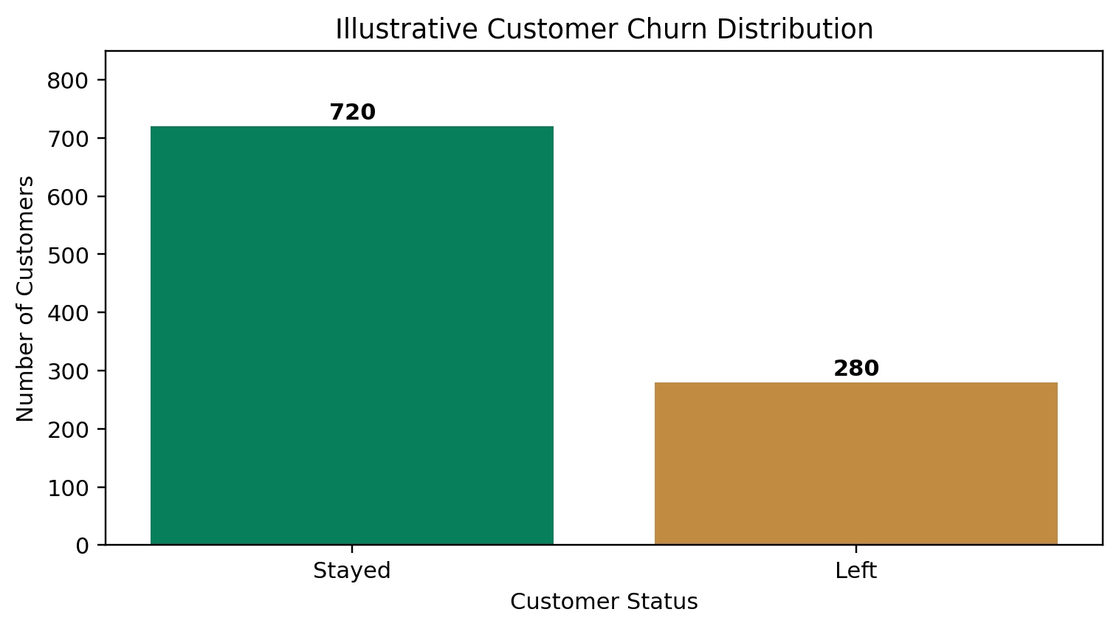
Figure 2: Illustrative Distribution of Customers Who Stayed and Left
Interpretation: In this example, the number of customers who stayed is greater than the number who left.
Why this visualization is useful: The chart quickly communicates the balance between the two outcome groups and helps identify whether the target classes may be imbalanced.

5.2 Churn by Contract Type
The illustrative churn rates are 42% for month-to-month contracts, 18% for one-year contracts and 8% for two-year contracts. This example suggests that customers with shorter contract commitments may require closer retention attention. It does not prove that contract length causes churn; other factors may influence the relationship.
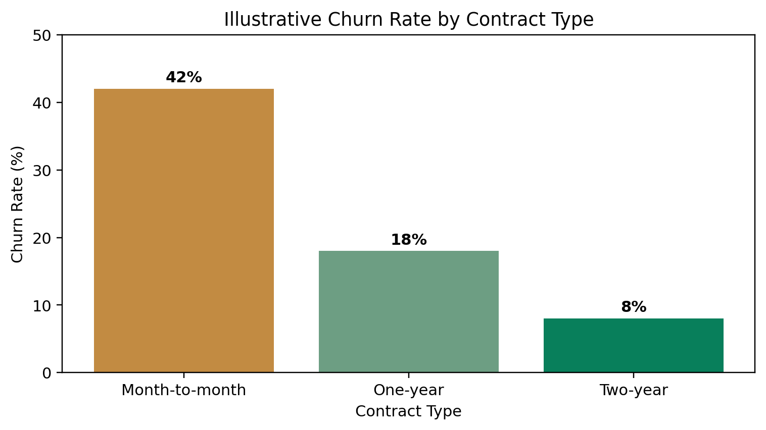
Figure 3: Illustrative Churn Rate by Contract Type
Interpretation: The example shows a higher churn rate for month-to-month customers than for customers on longer contracts.
Why this visualization is useful: Contract comparisons can help managers consider whether onboarding, pricing clarity or suitable longer-term plan options need review.

5.3 Tenure and Churn
Tenure means the length of time a customer has used a service. The illustrative pattern shows higher churn among customers in the first six months and lower churn among customers with longer tenure. This may indicate that early customer experience is important.
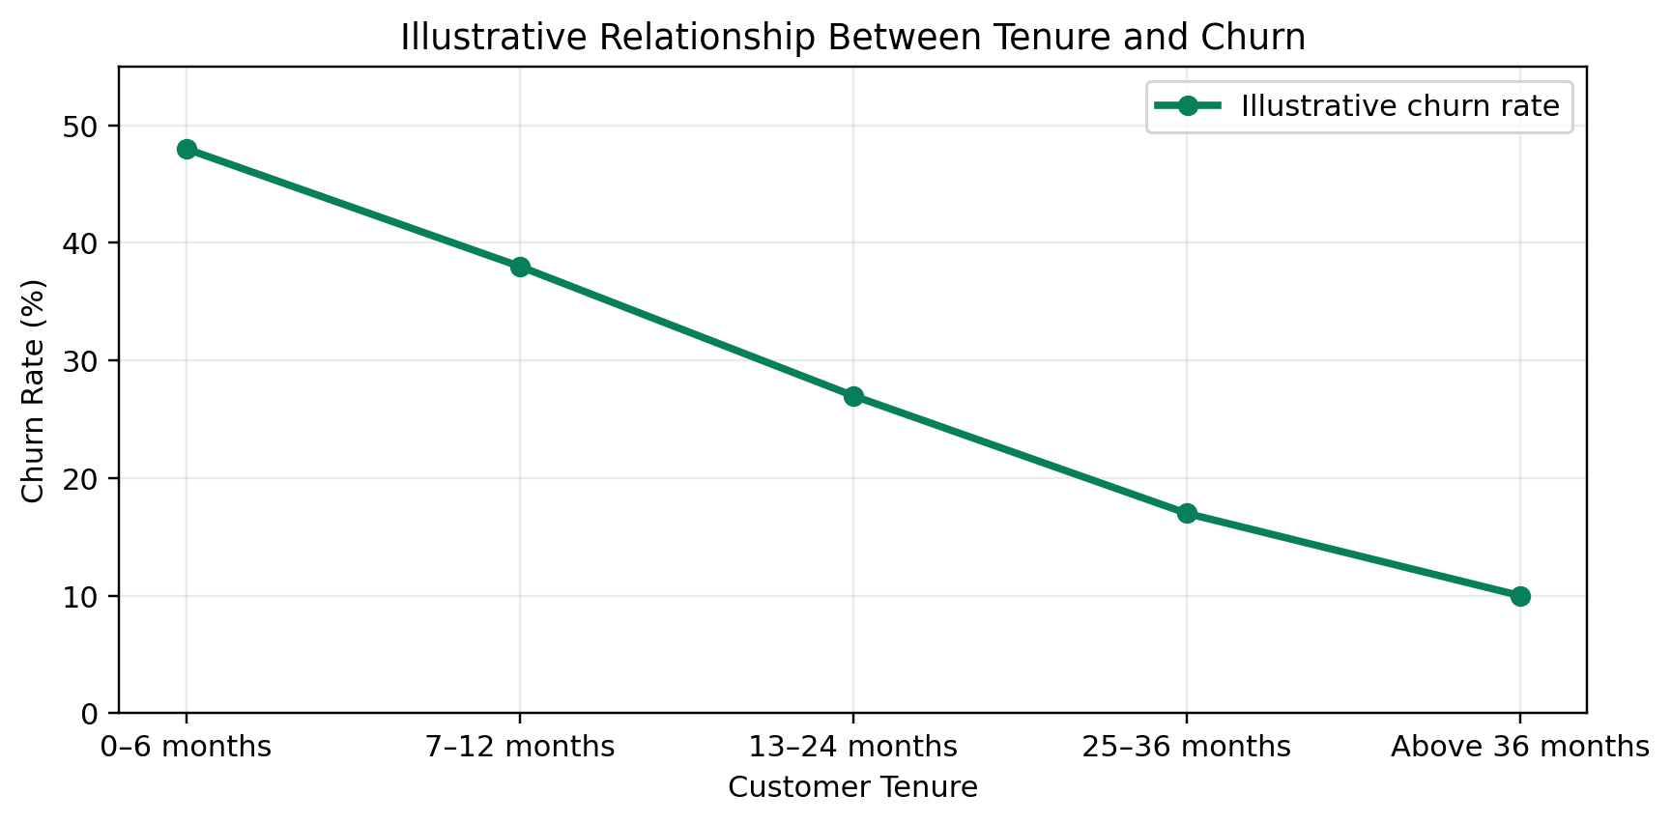
Figure 4: Illustrative Relationship Between Tenure and Churn
Interpretation: The example line declines as the customer tenure group increases.
Why this visualization is useful: A tenure chart helps identify customer stages where onboarding and retention support may be useful.

5.4 Monthly Charges and Churn
The illustrative average monthly charge is 62 units for customers who stayed and 84 units for customers who left. This example may suggest that higher charges are associated with churn. However, the relationship could also depend on service quality, customer income, plan benefits or competitor offers.
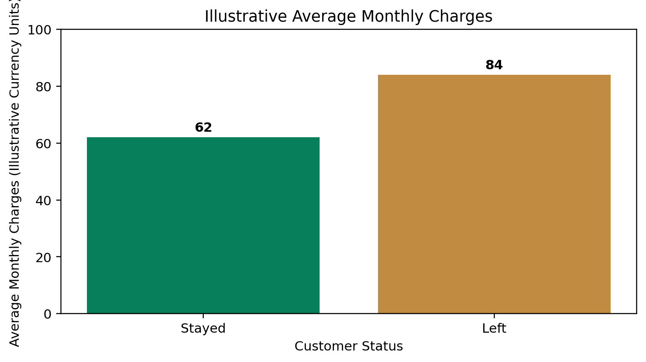
Figure 5: Illustrative Average Monthly Charges by Customer Status
Interpretation: The example shows a higher average monthly charge in the group that left.
Why this visualization is useful: This comparison can help a business review plan value, billing clarity and whether customers understand the services included in their plans.

5.5 Payment Method and Churn
The illustrative churn rates are 12% for bank transfer, 14% for credit card, 23% for debit card and 39% for electronic cheque. Payment method may be related to customer behaviour, payment convenience or the type of customers choosing each method. It should not be treated as a direct cause without additional investigation.
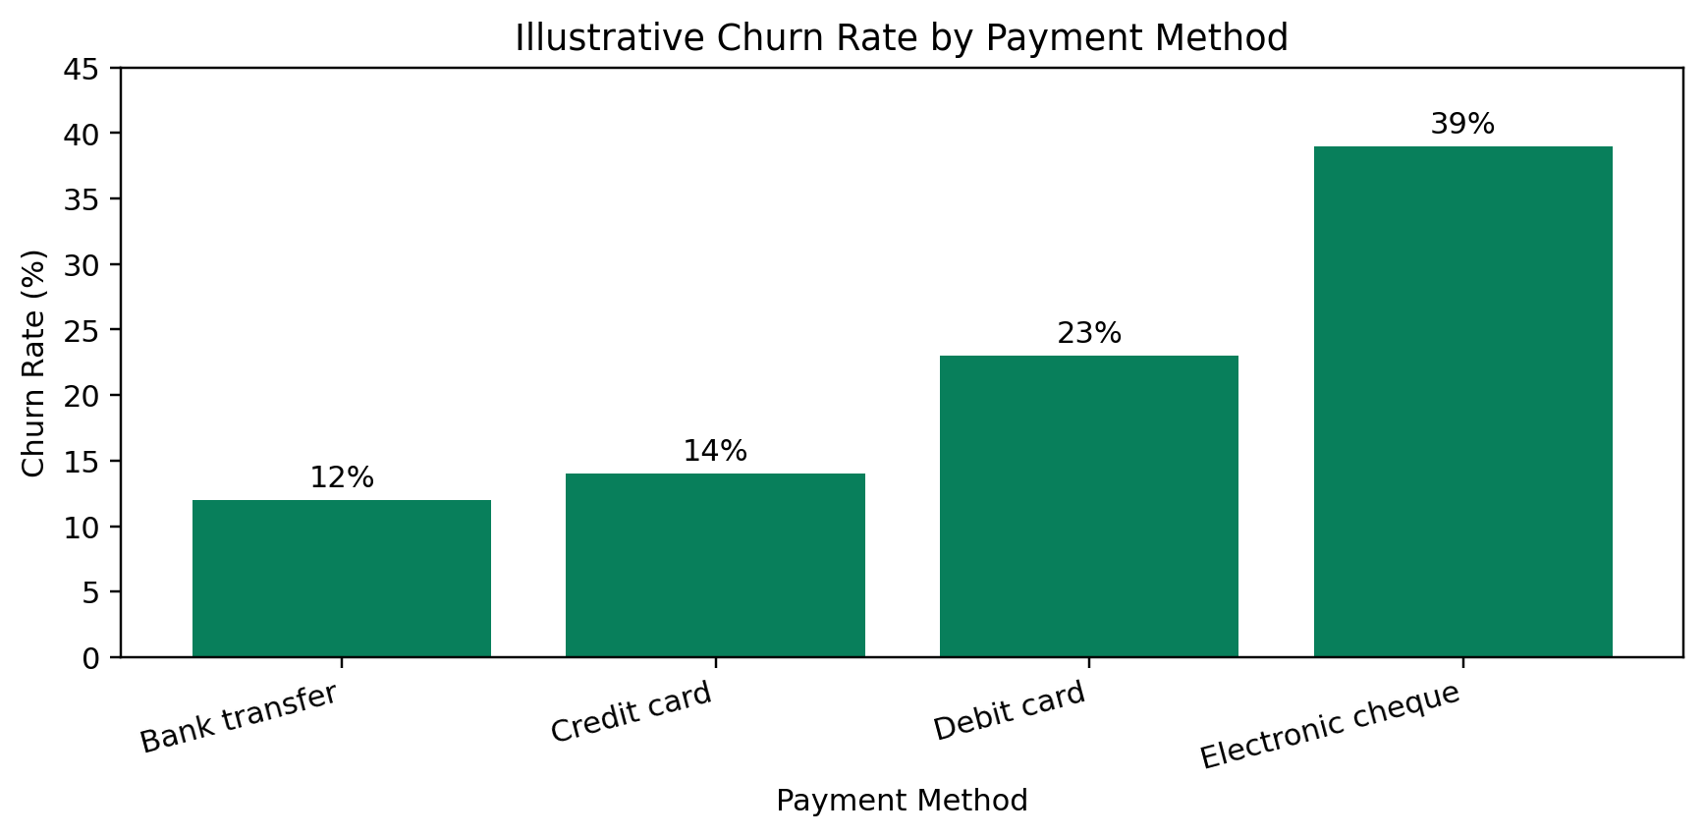
Figure 6: Illustrative Churn Rate by Payment Method
Interpretation: The example shows the highest churn percentage for electronic cheque users.
Why this visualization is useful: Payment comparisons can help identify whether payment friction, failed payments or billing communication should be investigated.

5.6 Customer Service Issues
Customer service interactions may provide useful context for churn analysis. A high number of unresolved complaints, repeated support requests or long response times could indicate customer dissatisfaction. A real analysis should distinguish between the number of contacts and the quality or outcome of those contacts. More contacts do not always mean a customer is unhappy.

5.7 Important Features
Possible Feature | Why It May Matter | Business Question
Contract type | May reflect commitment and flexibility. | Are customers on short contracts leaving more often?
Tenure | Shows how long the customer has stayed. | Are new customers at greater risk?
Monthly charges | Represents recurring customer cost. | Do customers understand the value of their plan?
Payment method | May reflect payment convenience. | Are there avoidable payment difficulties?
Support interactions | May indicate service needs or problems. | Are complaints resolved effectively?
Service type | Shows which services a customer uses. | Are some services linked with different churn patterns?

Feature importance should be interpreted carefully. A feature that helps a model make predictions is not automatically a cause of churn. Business teams should investigate possible explanations before changing policies.

6. Model Performance and Visualization
IMPORTANT: All numerical values, findings, charts and model scores in this report are illustrative hypothetical examples. They are not actual experimental or business results.

6.1 Illustrative Model Comparison
The following accuracy values are hypothetical examples created to show how model comparison could be presented. No models have been trained for this report, and these values must not be described as actual experimental performance.
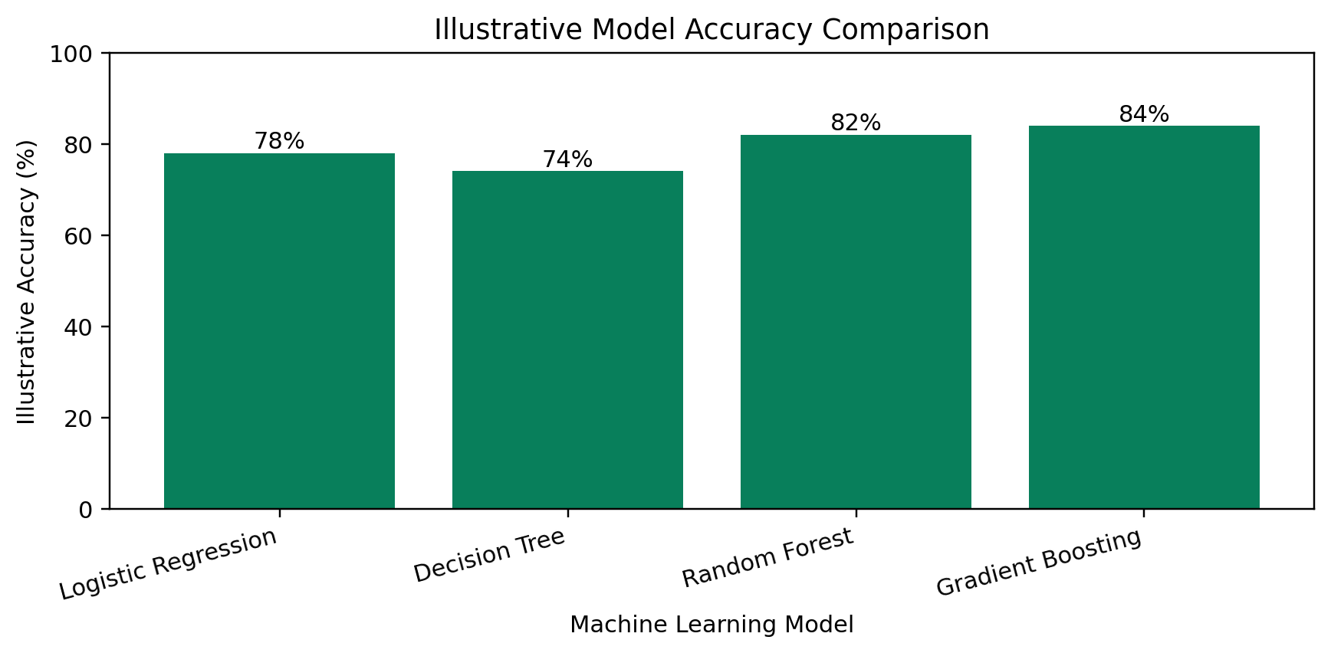
Figure 7: Illustrative Accuracy Comparison of Four Algorithms
Interpretation: The example assigns accuracy values of 78%, 74%, 82% and 84% to Logistic Regression, Decision Tree, Random Forest and Gradient Boosting.
Why this visualization is useful: The chart makes a comparison easy to understand. In an actual experiment, the models must be evaluated on the same held-out test data.
Model | Illustrative Accuracy | Interpretation
Logistic Regression | 78% | Baseline example.
Decision Tree | 74% | Illustrative lower score.
Random Forest | 82% | Illustrative stronger score.
Gradient Boosting | 84% | Highest illustrative accuracy.

6.2 Evaluation Measures
- Accuracy: the proportion of all predictions that are correct.
- Precision: among customers predicted to churn, the proportion who actually churn.
- Recall: among customers who actually churn, the proportion correctly identified.
- F1-score: a combined measure of precision and recall.
- Confusion matrix: a table showing correct and incorrect predictions for each class.
For customer churn, recall can be especially important because a false negative may mean a customer who is about to leave is not identified. However, precision also matters because contacting too many customers who are not at risk may waste time and resources. The suitable balance depends on the business cost of each type of prediction error.

6.3 Visualizations and Their Role in the Report
Visualization | What It Communicates | Where It Fits
Churn distribution | How many customers stayed or left. | Introduces the target variable.
Contract comparison | How churn differs by contract group. | Explains customer commitment patterns.
Tenure line chart | How churn varies across tenure groups. | Shows possible early-customer risk.
Monthly charge chart | Compares average charges by outcome. | Supports pricing and value discussion.
Payment chart | Compares churn across payment groups. | Highlights payment-related questions.
Model comparison | Shows illustrative model accuracy. | Explains how models may be compared.

7. Key Insights and Business Impact
IMPORTANT: All numerical values, findings, charts and model scores in this report are illustrative hypothetical examples. They are not actual experimental or business results.

7.1 Higher illustrative churn in month-to-month contracts
Observation: Higher illustrative churn in month-to-month contracts
Interpretation: The example rate is 42%, compared with lower rates for longer contracts.
Possible business impact: Customers may prefer flexibility or may not see enough value to continue.
Suggested action: Review plan communication and offer suitable options without pressuring customers.

7.2 Higher illustrative churn among newer customers
Observation: Higher illustrative churn among newer customers
Interpretation: The example shows a decline in churn across longer tenure groups.
Possible business impact: Customers may need more support during onboarding and early use.
Suggested action: Introduce welcome guidance, early check-ins and simple help resources.

7.3 Higher illustrative charges among customers who left
Observation: Higher illustrative charges among customers who left
Interpretation: The example average is 84 units compared with 62 units among those who stayed.
Possible business impact: Customers may question whether the service provides value for its cost.
Suggested action: Review billing clarity, plan benefits and suitable alternatives.

7.4 Payment method may be a useful signal
Observation: Payment method may be a useful signal
Interpretation: The illustrative payment comparison shows different churn rates by method.
Possible business impact: Payment convenience or billing problems may be relevant.
Suggested action: Investigate failed payments and provide clear payment support.

7.5 Customer service experience should be examined
Observation: Customer service experience should be examined
Interpretation: Repeated unresolved issues may indicate dissatisfaction.
Possible business impact: Customers may leave when problems are not solved effectively.
Suggested action: Monitor resolution time, complaint outcomes and customer feedback.

7.6 Model choice should consider more than accuracy
Observation: Model choice should consider more than accuracy
Interpretation: Different evaluation measures describe different types of prediction quality.
Possible business impact: A model with higher accuracy may still miss many churn customers.
Suggested action: Compare precision, recall, F1-score and business costs before selection.

8. Presentation Strategy for Non-Technical Audiences

8.1 Understanding the Audience
A presentation for business managers should explain the business problem before discussing algorithms. The audience may understand customer retention but may not know technical terms such as classification, feature engineering or overfitting. These terms should be explained briefly or replaced with everyday language.

8.2 Main Message
The central message is that customer information can help a business understand patterns linked with customer churn and plan suitable retention activities. A prediction is an estimate, not a guarantee that a particular customer will leave.

8.3 Storytelling Approach
- Begin with the business problem: losing customers affects growth.
- Explain why understanding churn matters.
- Introduce the type of customer information considered.
- Describe the analysis process in simple stages.
- Present the most useful illustrative patterns.
- Explain what the patterns could mean for the business.
- Recommend practical actions and explain their purpose.
- End with limitations and responsible use of customer data.

8.4 Suggested 12-Slide Presentation Structure
Slide | Main Content | Suggested Visual | Key Message
1. Title Slide | Project title, student name and internship details. | Simple title design with project name. | Introduce the project and its purpose.
2. What Is Customer Churn? | Explain what it means when customers stop using a service. | Simple customer journey illustration. | Churn is a customer-retention problem.
3. Why Churn Matters | Explain possible effects on revenue, growth and customer relationships. | Business impact icons or simple diagram. | Retaining customers is important for sustainable growth.
4. Project Objectives | Show the questions the project aims to explore. | Short objective list. | The project connects customer data with business questions.
5. Proposed Methodology | Show the stages from data understanding to interpretation. | Methodology flowchart. | A structured workflow supports reliable analysis.
6. Customer Churn Distribution | Show the illustrative stayed and left groups. | Churn distribution bar chart. | The chart introduces the outcome being studied.
7. Customer Patterns | Explain contract type and tenure examples. | Contract and tenure charts. | Some customer groups may need closer attention.
8. Charges and Payment | Discuss illustrative monthly charge and payment comparisons. | Monthly charge and payment charts. | Billing and payment experience may be worth investigating.
9. Machine Learning Models | Introduce the four algorithms in simple terms. | Four model names with short explanations. | Different models can identify patterns in different ways.
10. Model Evaluation | Explain illustrative comparison and evaluation measures. | Model comparison chart and metric definitions. | Model quality should be assessed using several measures.
11. Recommendations | Present customer support, onboarding and plan-review actions. | Action-priority diagram. | Insights become valuable when they guide practical action.
12. Conclusion and Questions | Summarize the message and invite stakeholder questions. | Three key takeaway statements. | Use data responsibly to support customer-retention decisions.

8.5 Explaining Machine Learning Simply
Machine learning can be explained as a method that allows a computer to learn patterns from examples. In this project, the examples would be customer records with known outcomes. After learning from training records, a model can estimate the churn category for new records. The estimate may be wrong, so it should be reviewed and evaluated.

8.6 Stakeholder Questions and Answers
Possible Question | Suggested Simple Answer
Can the model predict churn with certainty? | No. It estimates risk based on patterns and can make mistakes.
Why should a business use this approach? | It may help identify customer groups that need attention.
Does high accuracy mean the model is perfect? | No. Other measures such as recall and precision are also important.
Can the model explain every customer decision? | Not always. Interpretation depends on the algorithm and analysis.
Are the results in this report real? | No. The numerical examples are hypothetical and used for demonstration.

9. Sample Presentation Narrative
Good morning everyone. Today I am presenting my project titled Customer Churn Prediction Using Python. The project focuses on an important business problem: customers leaving a company or stopping the use of its services.
Customer churn matters because businesses invest time and resources in attracting and supporting customers. When customers leave, the business may lose recurring revenue and may need to spend additional resources to attract replacements. Understanding possible reasons for churn can therefore support better customer-retention planning.
The proposed project uses customer information such as contract type, tenure, monthly charges, payment method and customer service interactions. The first stage is to understand the dataset. The next stages involve checking data quality, preparing the information and studying patterns through exploratory data analysis.
After preparing the data, classification algorithms can be considered. Examples include Logistic Regression, Decision Tree, Random Forest and Gradient Boosting. These algorithms learn patterns from examples and can estimate whether a customer may belong to a higher-risk churn group.
The charts in this report use hypothetical values to demonstrate how results could be communicated. For example, the sample contract chart shows a higher churn rate for month-to-month customers. The sample tenure chart shows higher churn among newer customers. These patterns may guide further investigation, but they are not proof of cause and effect.
The business could consider improving the onboarding experience, reviewing plan value, making payment support easier and responding effectively to customer complaints. These actions should be tested and evaluated rather than assumed to work in every situation.
Finally, machine learning predictions should be used responsibly. Customer information must be protected, model errors must be considered and important decisions should involve human review. The main conclusion is that data science can help turn customer information into useful questions and evidence for better business decisions. Thank you.

10. Actionable Recommendations

10.1 Identify potentially high-risk customer groups
Purpose: Use an evaluated model or carefully reviewed indicators to identify groups that may need attention.
Expected business benefit: Helps the retention team prioritize follow-up. Predictions should not be treated as certain outcomes.

10.2 Improve the early customer experience
Purpose: Provide clear onboarding information, setup assistance and early check-ins during the first months.
Expected business benefit: May help customers understand the service and solve early difficulties.

10.3 Review pricing and plan value
Purpose: Explain charges clearly and review whether plan features match customer needs.
Expected business benefit: May reduce confusion and improve customers' understanding of value.

10.4 Encourage suitable long-term options
Purpose: Explain the benefits and conditions of longer-term contracts without using misleading or pressuring sales methods.
Expected business benefit: May help customers choose plans that suit their needs and expectations.

10.5 Strengthen customer support
Purpose: Track unresolved complaints, response times and repeated service issues.
Expected business benefit: May improve service experience and reduce avoidable dissatisfaction.

10.6 Create customer retention programmes
Purpose: Consider relevant assistance, service improvements or loyalty offers for customers who need support.
Expected business benefit: Can provide a structured way to respond to customer needs.

10.7 Monitor customer satisfaction
Purpose: Use feedback, surveys and service records with appropriate consent and privacy safeguards.
Expected business benefit: Helps the business understand customer experience beyond model scores.

10.8 Use predictions responsibly
Purpose: Limit access to customer data, review model errors and provide human oversight for important actions.
Expected business benefit: Supports privacy, fairness, trust and accountable decision-making.

11. Future Scope and Improvements

Use a larger and more representative dataset
A larger dataset covering different customer groups and time periods may help provide a more complete view of churn patterns.

Explore additional algorithms
Other suitable classification methods may be tested and compared using the same evaluation procedure.

Improve model tuning
Parameters can be adjusted using validation methods while keeping the final test data separate.

Improve feature engineering
Additional variables may be created from service history, billing patterns and customer interactions where data use is authorized.

Develop a visualization dashboard
A dashboard could display churn trends, customer segments and evaluation measures for authorized business users.

Create a prediction application
A simple application could accept approved customer information and display a risk estimate with suitable explanations.

Integrate with business workflows
A carefully governed system could help customer teams review possible retention cases.

Monitor model performance
The model should be checked over time because customer behaviour and business conditions may change.

Strengthen privacy and security
Future work should include access control, data minimization, secure storage and appropriate retention policies.

12. Limitations and Challenges
Challenge | Why It Matters | Possible Response
Hypothetical dataset | The example findings do not establish real customer behaviour. | Use an authorized real dataset for actual experimentation.
Missing data | Incomplete records may affect analysis and model quality. | Inspect missingness and choose a justified handling method.
Inconsistent data | Different labels or formats can create incorrect comparisons. | Standardize categories and validate data types.
Class imbalance | A model may perform well on the majority class but miss churn cases. | Review class distribution and use suitable metrics.
Overfitting | A model may learn training details that do not generalize. | Use validation, regularization and appropriate testing.
Incorrect predictions | False positives and false negatives can create business costs. | Review precision, recall and the cost of different errors.
Model interpretability | Some models are difficult to explain to stakeholders. | Use suitable explanation methods and simple summaries.
Privacy and ethics | Customer data can contain sensitive or identifying information. | Use authorized data, restrict access and minimize collected data.
Illustrative results | The report's example scores are not actual model results. | Clearly label examples and replace them only after real evaluation.

A key limitation of this report is that it is a planning and demonstration document. It does not contain verified findings from an actual customer dataset, a completed model-training experiment or a deployed business system. The illustrative values must not be used to make real customer decisions.

13. Proposed Week 4 Work Plan
The following proposed schedule allocates exactly 33 hours to the Week 4 reporting, interpretation and presentation-planning activities. The hours are a proposed work plan, not a claim of verified attendance or completed work.
Activity | Hours | Description
Report planning and requirement review | 3 | Review the Week 4 objectives and organize report sections.
Methodology review | 4 | Document the proposed data science workflow and algorithms.
Hypothetical findings preparation | 4 | Prepare clearly labelled demonstration values and comparisons.
Chart design and visualization | 5 | Create and review the required illustrative Matplotlib charts.
Insight interpretation | 4 | Explain possible meanings and business implications of patterns.
Presentation planning | 4 | Prepare the audience strategy and 12-slide structure.
Presentation narrative | 3 | Draft a simple spoken explanation for business managers.
Recommendations and future scope | 3 | Prepare possible retention actions, limitations and improvements.
Formatting and final review | 3 | Check consistency, spelling, tables, charts and report structure.

TOTAL PROPOSED WORKING HOURS: 33 HOURS

14. Expected Outcomes
The expected outcome of the Week 4 work is a structured report that explains the customer churn problem, describes a suitable data science methodology and demonstrates how analytical information can be communicated to a business audience.
- A clear written explanation of customer churn and its business importance.
- A documented methodology for a proposed churn prediction workflow.
- An understanding of how data cleaning and preprocessing support analysis.
- Illustrative charts that explain customer patterns.
- A basic understanding of classification algorithms and evaluation measures.
- The ability to distinguish a predictive relationship from a proven cause.
- Business-oriented insights and practical retention recommendations.
- A structured presentation plan for non-technical stakeholders.
- Improved report writing, visualization and professional communication skills.
- A clearer understanding of privacy, limitations and responsible data use.

15. Conclusion
Customer churn is an important business problem because customers leaving a service can affect revenue, growth and long-term customer relationships. Data science provides methods for studying customer information and identifying patterns that may be useful for retention planning.
This report has described a proposed workflow for Customer Churn Prediction Using Python. It covered problem definition, hypothetical data collection, exploratory analysis, cleaning, preprocessing, feature selection, train-test splitting, machine learning algorithms, evaluation and interpretation.
The illustrative charts demonstrate how churn distribution, contract type, tenure, monthly charges, payment method and model comparison could be presented. The example findings are not actual results and must not be treated as evidence about a real company or its customers.
An important part of data science is communicating results clearly. A business audience needs to understand what a pattern may mean, what action could be considered and what limitations remain. Recommendations should be evaluated and should respect customer privacy and fairness.
Overall, the project demonstrates how technical concepts can be connected with practical business questions. It also highlights the importance of responsible data use, careful model evaluation and clear presentation of insights.

16. References and Learning Resources
The following official documentation and learning resources can be used to understand the tools and concepts relevant to this project.

Python Documentation
Official Python language documentation.
https://docs.python.org/3/

Pandas Documentation
Documentation for data manipulation and analysis.
https://pandas.pydata.org/docs/

Matplotlib Documentation
Official guide for creating charts and visualizations.
https://matplotlib.org/stable/

Seaborn Documentation
Statistical data visualization library documentation.
https://seaborn.pydata.org/

Scikit-learn Documentation
Machine learning tools, model selection and evaluation.
https://scikit-learn.org/stable/

Scikit-learn Model Evaluation
Official guide to model evaluation metrics and scoring.
https://scikit-learn.org/stable/modules/model_evaluation.html

Google Machine Learning Crash Course
Learning resource covering machine learning fundamentals.
https://developers.google.com/machine-learning/crash-course

IBM - What is Customer Churn?
Introductory business explanation of customer churn.
https://www.ibm.com/think/topics/customer-churn

17. Suggested Project Folder Structure
A consistent folder structure helps organize reports, code, datasets, visualizations and documentation across the internship weeks. The following structure is a suggested organization for the complete Customer Churn Prediction project.
Customer-Churn-Prediction/
|
|-- Week-1/
| |-- Project-Planning-Report.docx
| |-- README.md
|
|-- Week-2/
| |-- EDA-Report.docx
| |-- README.md
|
|-- Week-3/
| |-- Machine-Learning-Plan.docx
| |-- README.md
|
|-- Week-4/
| |-- Final-Data-Science-Report.docx
| |-- README.md
| |
| |-- Visualizations/
| |-- 01_churn_distribution.png
| |-- 02_churn_by_contract.png
| |-- 03_tenure_vs_churn.png
| |-- 04_monthly_charges.png
| |-- 05_payment_method.png
| |-- 06_model_comparison.png
| |-- 07_methodology_flowchart.png
|
|-- README.md

17.1 Purpose of the Folder Structure
- Each week has a separate folder for easier organization.
- Reports are stored separately from code and visualizations.
- The Visualizations folder keeps chart files together.
- README files can explain the purpose and contents of each folder.
- The main project README can provide an overview and navigation guide.

