YUVA INTERN
DATA SCIENCE INTERNSHIP

WEEK 3 PROJECT REPORT
Python-Based Machine Learning Model
Development and Evaluation Plan

PROJECT TITLE
CUSTOMER CHURN PREDICTION USING PYTHON

Submitted by: Fathimath Zulfah
Programme: BCA, Mangalore University
Internship: YUVA INTERN – Data Science
Week: 3
Academic Year: 2026–2027

TABLE OF CONTENTS
- 1. Introduction
- 2. Understanding Machine Learning
- 3. Problem Definition
- 4. Machine Learning Approach
- 5. Dataset Description
- 6. Data Preprocessing and Feature Engineering
- 7. Model Selection
- 8. Model Training
- 9. Hyperparameter Tuning
- 10. Model Evaluation Metrics
- 11. Model Validation
- 12. Model Comparison and Selection
- 13. Machine Learning Workflow
- 14. Model Evaluation Workflow
- 15. Tools and Technologies
- 16. Sample Python Implementation
- 17. Model Deployment and Maintenance
- 18. Challenges and Solutions
- 19. Proposed 33-Hour Timeline
- 20. Expected Outcomes
- 21. Project Checklist
- 22. Conclusion
- 23. Suggested Project Folder Structure

1. Introduction
Machine Learning is an important area of Artificial Intelligence that enables computers to learn patterns from data and make predictions or decisions without being explicitly programmed for every situation.
This report presents the proposed development and evaluation plan for a machine learning project titled Customer Churn Prediction Using Python. The project focuses on understanding how customer information can be used to identify customers who may discontinue a company's services.
The work follows the earlier project planning and Exploratory Data Analysis framework. Week 3 focuses on preparing the data, selecting suitable machine learning algorithms, training models, tuning parameters and planning model evaluation.
This document is a development and evaluation plan. It does not claim that a real dataset has been trained or that any specific model accuracy has been achieved.

2. Understanding Machine Learning
Machine Learning is a branch of Artificial Intelligence in which computers learn from existing data and use the learned patterns to make predictions on new data.

2.1 Types of Machine Learning
Type | Description | Example
Supervised Learning | Learns using labelled data where the correct output is known. | Predicting whether a customer will leave.
Unsupervised Learning | Finds hidden patterns in data without predefined output labels. | Grouping customers based on purchasing behaviour.
Reinforcement Learning | Learns through actions, rewards and penalties. | Training an agent to play a game.

For this project, supervised learning is selected because the dataset is expected to contain a Churn Status column that identifies whether a customer has left the service.

3. Problem Definition
Customer churn refers to a situation in which a customer stops using a company's product or service. High customer churn can reduce revenue and increase the cost of acquiring new customers.

3.1 Problem Statement
The objective of this project is to develop a Python-based machine learning classification model that can analyse customer information and predict whether a customer is likely to leave a service.

3.2 Importance of the Project
- Helps businesses identify customers who may leave.
- Supports customer retention strategies.
- Helps companies understand factors related to churn.
- Can support better customer service decisions.
- Demonstrates a practical application of supervised learning.

3.3 Target Variable and Input Features
Component | Description
Target Variable | Churn Status
Input Features | Customer details, service usage, billing and contract information
Output | Predicted class: Churn or No Churn
Problem Type | Binary Classification

4. Machine Learning Approach
The project will use supervised machine learning, specifically binary classification. The model will learn from historical customer records where churn status is already available.
The target column will be converted into suitable numerical labels if required. The remaining relevant columns will be used as input features.
- Class 0: Customer does not churn.
- Class 1: Customer churns.
After training, the model will be used to predict the churn class for unseen customer records.

5. Dataset Description
The project will use a customer churn dataset. The following table describes the expected fields that may be available in the dataset. The actual columns will be confirmed after the dataset is obtained.
Field | Description | Data Type
Customer ID | Unique customer identification number. | Identifier
Age | Age of the customer. | Numerical
Gender | Gender category recorded in the dataset. | Categorical
Tenure | Duration of the customer's relationship with the company. | Numerical
Monthly Charges | Amount charged monthly. | Numerical
Total Charges | Total amount charged to the customer. | Numerical
Contract Type | Type of customer contract. | Categorical
Payment Method | Method used for making payments. | Categorical
Internet Service | Internet service subscribed by the customer. | Categorical
Customer Support Calls | Number of support calls made. | Numerical
Usage Information | Information about service usage. | Numerical/Categorical
Churn Status | Indicates whether the customer has left. | Target

Customer ID is an identifier and will normally be excluded from model training because it does not represent a useful customer behaviour feature.

6. Data Preprocessing and Feature Engineering
Data preprocessing is the process of preparing raw data before using it for machine learning. It helps improve data quality and makes the dataset suitable for model training.

6.1 Data Inspection
- Check the number of rows and columns.
- Understand column names and data types.
- Identify numerical and categorical variables.
- Inspect summary statistics.
- Check the target variable distribution.

6.2 Handling Missing Values
Missing values may affect model performance. Numerical missing values can be handled using mean or median imputation, depending on the data distribution. Categorical missing values can be replaced with the most frequent category or an appropriate unknown category.

6.3 Removing Duplicate Records
Duplicate records should be identified and investigated. Unnecessary duplicates can be removed to avoid repeated information influencing the model.

6.4 Encoding Categorical Variables
Technique | Purpose
Label Encoding | Converts categories into numerical labels.
One-Hot Encoding | Creates separate binary columns for categories.

6.5 Feature Scaling
Technique | Purpose
StandardScaler | Standardises values using mean and standard deviation.
MinMaxScaler | Scales values into a selected range, commonly 0 to 1.

Scaling is particularly useful for algorithms that are sensitive to the magnitude of numerical features, such as Logistic Regression. Tree-based models generally do not require feature scaling.

6.6 Outlier Handling
Outliers are unusually high or low values. They can be identified using box plots, the Interquartile Range method or domain knowledge. Outliers should not be removed automatically because some unusual customer behaviour may be meaningful.

6.7 Feature Engineering and Selection
Feature engineering involves creating or transforming features to improve the information available to the model. Feature selection identifies relevant variables and removes unnecessary or redundant information.

6.8 Train-Test Split
The dataset will be divided into training and testing sets. A proposed split is 80% training data and 20% testing data. Stratification can be used to preserve the proportion of churn and non-churn classes.
To prevent data leakage, preprocessing operations such as imputation, encoding and scaling should be fitted using training data only. A Scikit-learn Pipeline or ColumnTransformer can help implement this safely.

7. Model Selection
Different classification algorithms will be considered for the customer churn prediction task. Each algorithm has different advantages and limitations.
Algorithm | Description | Advantages | Limitations
Logistic Regression | Uses a mathematical function to estimate class probabilities. | Simple, fast and interpretable. | May not capture complex nonlinear relationships.
Decision Tree | Uses decision rules to divide data into branches. | Easy to understand and visualise. | Can overfit without proper control.
Random Forest | Combines multiple decision trees to make predictions. | Handles complex patterns and reduces individual-tree variance. | Less interpretable than a single tree.
Gradient Boosting | Builds models sequentially to correct previous errors. | Can provide strong predictive performance. | Requires careful tuning and may take longer to train.

7.1 Proposed Primary Candidate
Random Forest is proposed as the primary candidate for initial experimentation because it combines multiple decision trees and can capture complex relationships between customer features.
However, it will not be assumed to be the best model before evaluation. Logistic Regression, Decision Tree and Gradient Boosting will also be compared using the same evaluation approach.

8. Model Training
Model training is the process of providing the prepared training data to a machine learning algorithm so that it can learn patterns between input features and the target variable.
- Load the prepared dataset.
- Separate input features and target variable.
- Divide the data into training and testing sets.
- Select a classification algorithm.
- Fit the model using the training data.
- Generate predictions for the test data.
- Evaluate the model using suitable performance metrics.

8.1 Overfitting and Underfitting
Condition | Meaning | Possible Solution
Overfitting | The model learns training data too closely and performs poorly on unseen data. | Regularisation, pruning, cross-validation and simpler models.
Underfitting | The model fails to learn important patterns from the data. | Improve features, adjust model complexity or try another algorithm.

9. Hyperparameter Tuning
Hyperparameters are settings selected before or during the model training process. Tuning helps identify suitable settings that may improve model performance.
Method | Description
GridSearchCV | Tests a defined combination of hyperparameter values.
RandomizedSearchCV | Tests randomly selected combinations from specified distributions.
Cross-Validation | Evaluates a model across multiple data splits.

9.1 Example Hyperparameters
Model | Hyperparameter Examples
Decision Tree | max_depth, min_samples_split, criterion
Random Forest | n_estimators, max_depth, max_features
Logistic Regression | C, penalty, solver
Gradient Boosting | n_estimators, learning_rate, max_depth

Hyperparameter tuning will be performed using training data and cross-validation. The final test set will be kept separate until the final evaluation.

10. Model Evaluation Metrics
Model evaluation measures how effectively a trained classification model predicts customer churn. Different metrics provide different information about model performance.
Metric | Meaning
Accuracy | Percentage of all predictions that are correct.
Precision | Among predicted churn customers, the percentage who actually churn.
Recall | Among actual churn customers, the percentage correctly identified.
F1-Score | Harmonic mean of precision and recall.
Confusion Matrix | Shows true positives, true negatives, false positives and false negatives.
ROC Curve | Shows the relationship between true positive rate and false positive rate at different thresholds.
ROC-AUC | Measures the model's ability to distinguish between the two classes.

10.1 Importance of Recall and F1-Score
Recall is important in churn prediction because missing a customer who is actually going to leave may result in a lost retention opportunity.
F1-score provides a balance between precision and recall. Both metrics should be considered alongside business requirements and the cost of false predictions.

10.2 Confusion Matrix
 | Predicted: Churn | Predicted: No Churn
Actual: Churn | True Positive (TP) | False Negative (FN)
Actual: No Churn | False Positive (FP) | True Negative (TN)

No accuracy, precision, recall, F1-score or ROC-AUC values are reported in this plan because actual model training and evaluation have not yet been performed.

11. Model Validation
Model validation checks whether a model can generalise to unseen data instead of simply memorising training records.
- Holdout Validation: Uses separate training and testing datasets.
- K-Fold Cross-Validation: Divides data into K folds and evaluates across different splits.
- Stratified K-Fold: Maintains class proportions in each fold.
- Feature Importance: Helps identify which variables influence tree-based model predictions.
The validation strategy will also check for data leakage, class imbalance and unstable model performance.

12. Model Comparison and Selection
After training and validation, the candidate models will be compared using common evaluation metrics. The final model will be selected based on performance, reliability, interpretability and the business objective.
Model | Metrics to Compare | Selection Consideration
Logistic Regression | Accuracy, Precision, Recall, F1, ROC-AUC | Baseline and interpretability
Decision Tree | Accuracy, Precision, Recall, F1, ROC-AUC | Understandable decision rules
Random Forest | Accuracy, Precision, Recall, F1, ROC-AUC | Ensemble performance
Gradient Boosting | Accuracy, Precision, Recall, F1, ROC-AUC | Boosting performance

The final choice will not be based on accuracy alone. Recall and F1-score will receive particular attention because customer churn datasets may have imbalanced classes.

13. Machine Learning Workflow
The following diagram presents the proposed end-to-end workflow for developing the customer churn prediction model.
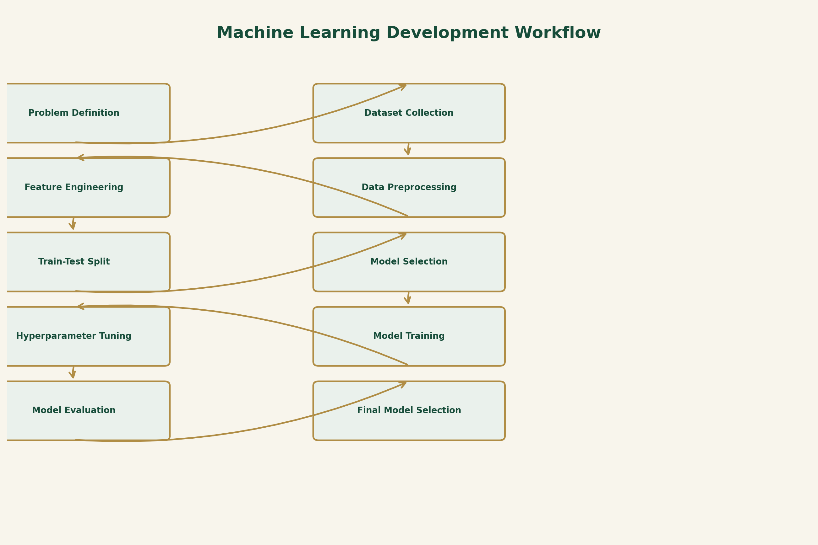
The process begins with defining the problem and obtaining the dataset. After preprocessing and feature engineering, the data is divided into training and testing sets. Suitable algorithms are trained, tuned and evaluated before selecting the final model.

14. Model Training and Evaluation Workflow
The following diagram illustrates the relationship between training data, model learning, testing, prediction and evaluation.
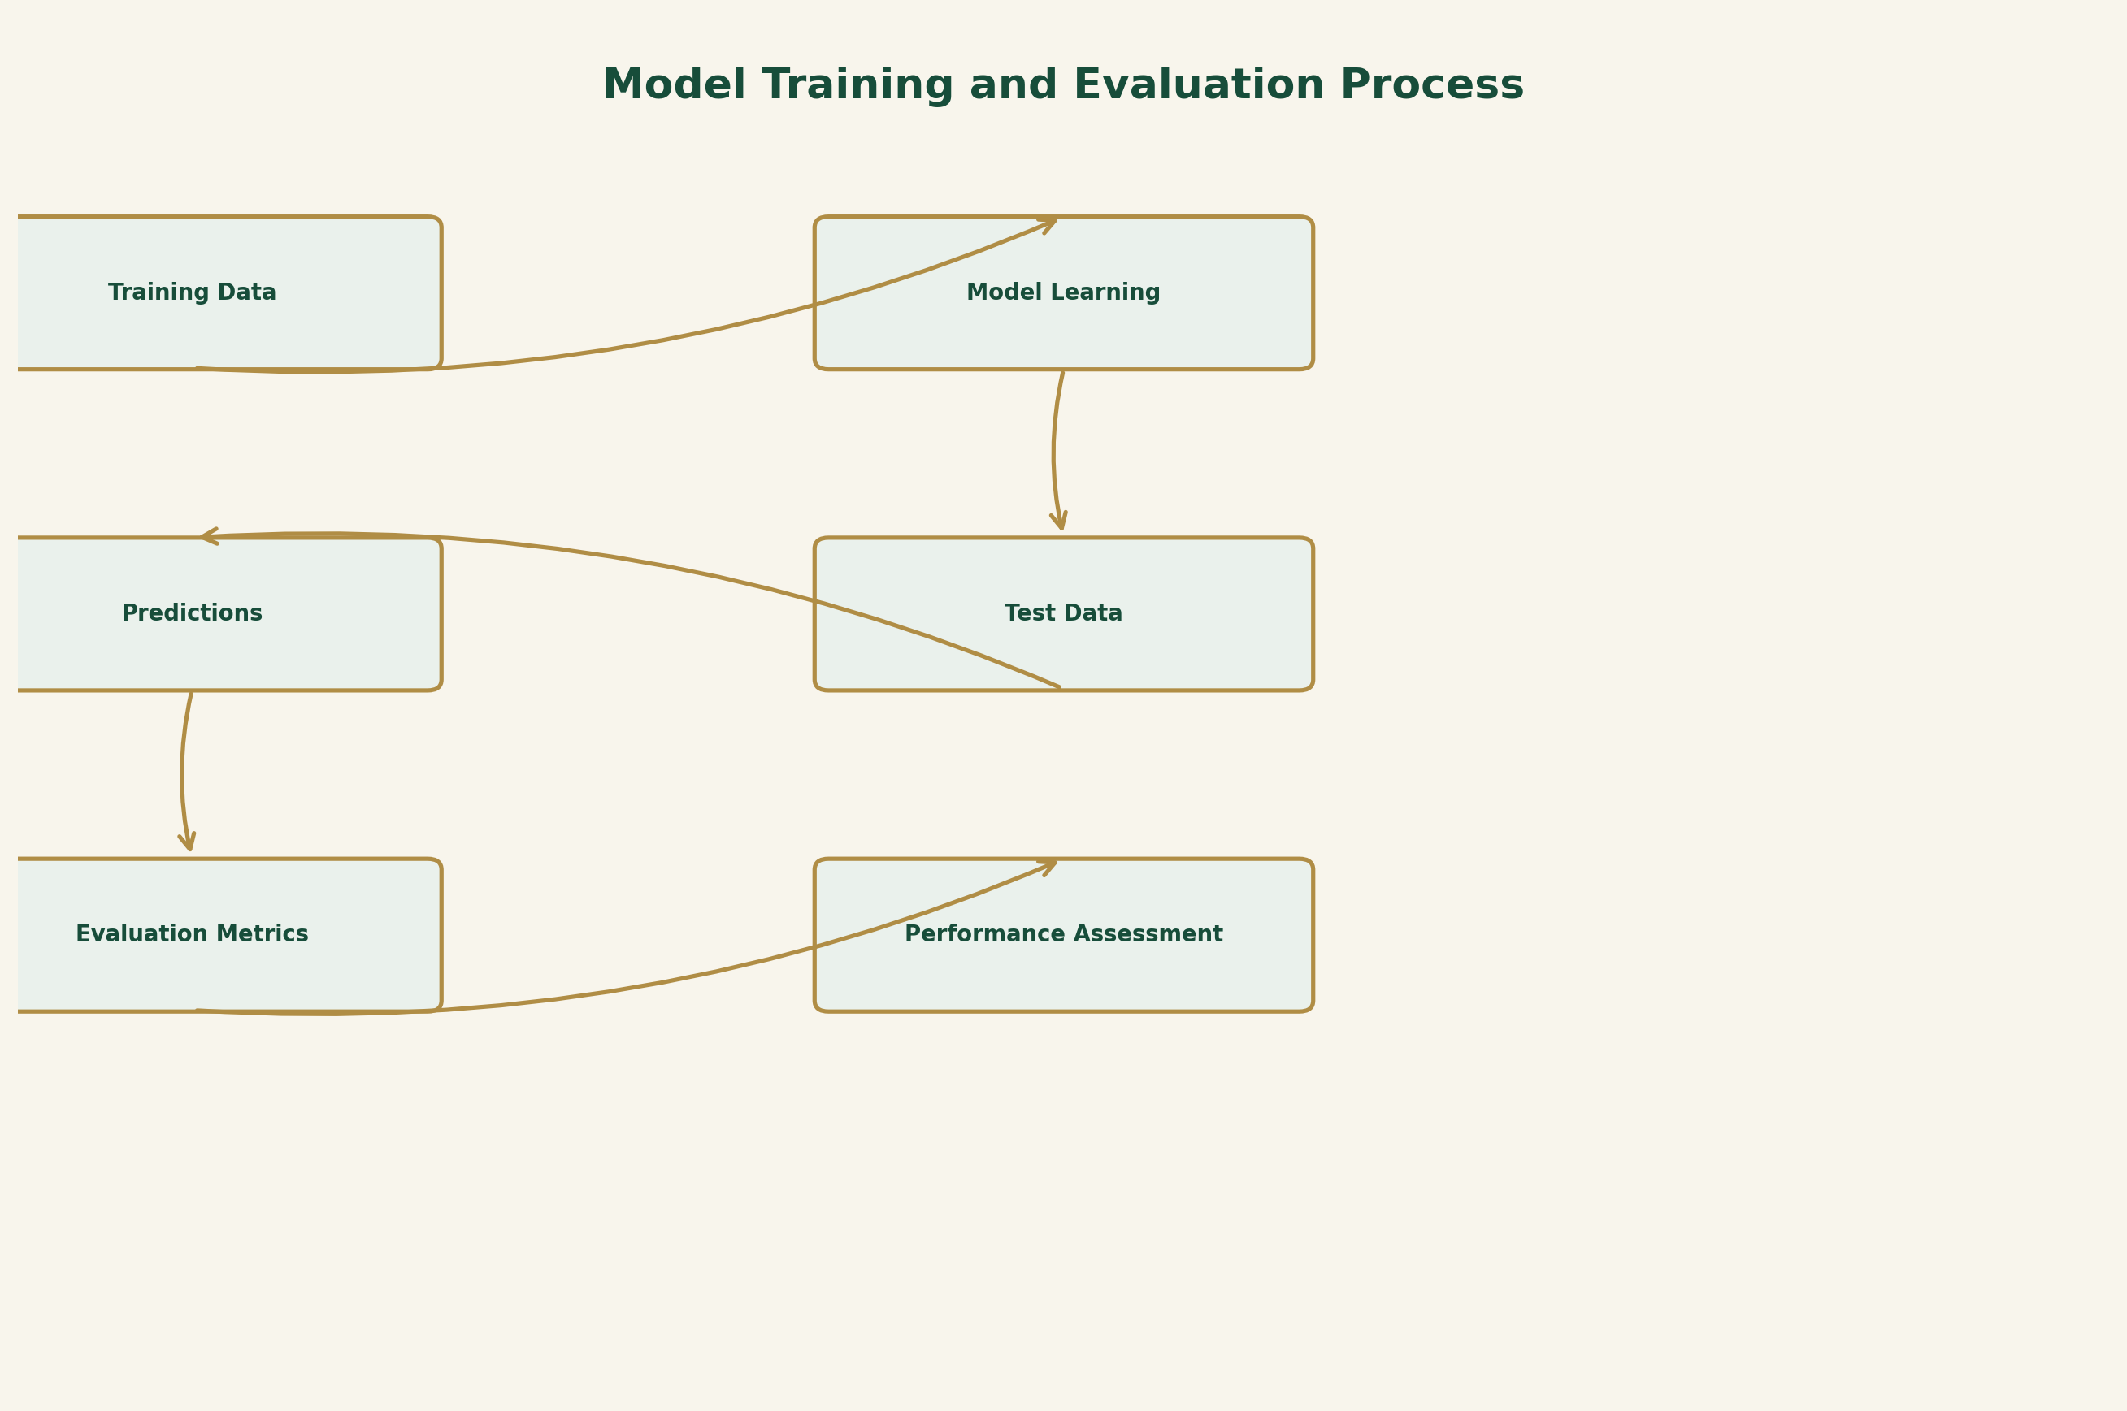
The model learns patterns from the training data. Test data is then supplied to generate predictions. These predictions are compared with actual labels to calculate performance metrics.

15. Tools and Technologies
Tool / Technology | Purpose
Python | Main programming language.
Pandas | Data loading, cleaning and manipulation.
NumPy | Numerical operations and array handling.
Scikit-learn | Preprocessing, classification, training and evaluation.
Matplotlib | Creating graphs and visualisations.
Seaborn | Statistical data visualisation.
Jupyter Notebook | Interactive development and experimentation.
VS Code | Code editing and project development.
Joblib | Saving and loading trained machine learning objects.
Git and GitHub | Version control and project management.

16. Sample Python Implementation
The following code demonstrates the general structure of a customer churn classification experiment. It is an illustrative template. The CSV filename and column names must be adjusted to match the actual dataset.

16.1 Importing Libraries
import pandas as pd
import numpy as np
from sklearn.model_selection import train_test_split
from sklearn.ensemble import RandomForestClassifier
from sklearn.linear_model import LogisticRegression
from sklearn.metrics import (
accuracy_score,
precision_score,
recall_score,
f1_score,
confusion_matrix,
classification_report
)

16.2 Loading the Dataset
df = pd.read_csv("customer_churn.csv")
print(df.head())
print(df.info())
print(df.isnull().sum())

16.3 Separating Features and Target
# Remove the customer identifier if present
df = df.drop(columns=["Customer ID"], errors="ignore")
# Separate input features and target
X = df.drop("Churn Status", axis=1)
y = df["Churn Status"]

16.4 Encoding Categorical Variables
# Convert categorical features into numerical columns
X = pd.get_dummies(X, drop_first=True)
# Convert target labels into binary values
y = y.map({"No": 0, "Yes": 1})

16.5 Splitting the Dataset
X_train, X_test, y_train, y_test = train_test_split(
X,
y,
test_size=0.20,
random_state=42,
stratify=y
)

16.6 Training Models
# Logistic Regression
logistic_model = LogisticRegression(max_iter=1000)
logistic_model.fit(X_train, y_train)
# Random Forest
random_forest = RandomForestClassifier(
n_estimators=100,
random_state=42
)
random_forest.fit(X_train, y_train)

16.7 Making Predictions
logistic_predictions = logistic_model.predict(X_test)
rf_predictions = random_forest.predict(X_test)

16.8 Evaluating the Model
print("Random Forest Evaluation")
print("Accuracy:",
accuracy_score(y_test, rf_predictions))
print("Precision:",
precision_score(y_test, rf_predictions, zero_division=0))
print("Recall:",
recall_score(y_test, rf_predictions, zero_division=0))
print("F1 Score:",
f1_score(y_test, rf_predictions, zero_division=0))
print("Confusion Matrix:")
print(confusion_matrix(y_test, rf_predictions))
print(classification_report(
y_test,
rf_predictions,
zero_division=0
))

Important implementation note: This short example is a conceptual starting point, not a complete production preprocessing pipeline. In the actual implementation, missing values, unknown categories, scaling where required and preprocessing leakage should be handled using Scikit-learn Pipeline and ColumnTransformer. The target mapping must also match the dataset's actual labels.
The code should be executed only after confirming the dataset columns and data quality. The example does not represent actual experimental results.

17. Model Deployment and Maintenance
After the model has been evaluated and approved, it may be prepared for future use in a business application. Deployment is outside the main scope of this development plan, but the following steps may be considered.
- Save the approved model using Joblib.
- Develop an API to receive customer information.
- Use the model to generate churn predictions.
- Display predictions in a simple dashboard if required.
- Monitor performance after deployment.
- Check for changes in customer behaviour and data distribution.
- Retrain the model when new and suitable data becomes available.
- Protect customer information and restrict unauthorised access.

18. Challenges and Proposed Solutions
Challenge | Possible Solution
Missing Values | Use suitable imputation methods after examining the data.
Class Imbalance | Use stratified splitting, suitable metrics and carefully selected balancing methods.
Overfitting | Use cross-validation, regularisation, pruning or parameter tuning.
Underfitting | Improve features or test a more suitable algorithm.
Irrelevant Features | Apply feature selection and domain knowledge.
Data Leakage | Fit preprocessing steps using training data only.
Model Complexity | Compare simpler and more complex algorithms.
Poor Generalisation | Use unseen test data and cross-validation.
Privacy Concerns | Protect customer information and use data responsibly.

19. Proposed 33-Hour Project Timeline
The following timeline provides a proposed allocation of 33 hours for the Week 3 machine learning development and evaluation activities.
Activity | Hours
Problem definition and objective setting | 2
Dataset inspection and understanding | 3
Data preprocessing | 5
Feature engineering and selection | 4
Model selection and planning | 3
Model training | 5
Hyperparameter tuning | 4
Model evaluation and comparison | 4
Documentation and final review | 3
TOTAL | 33

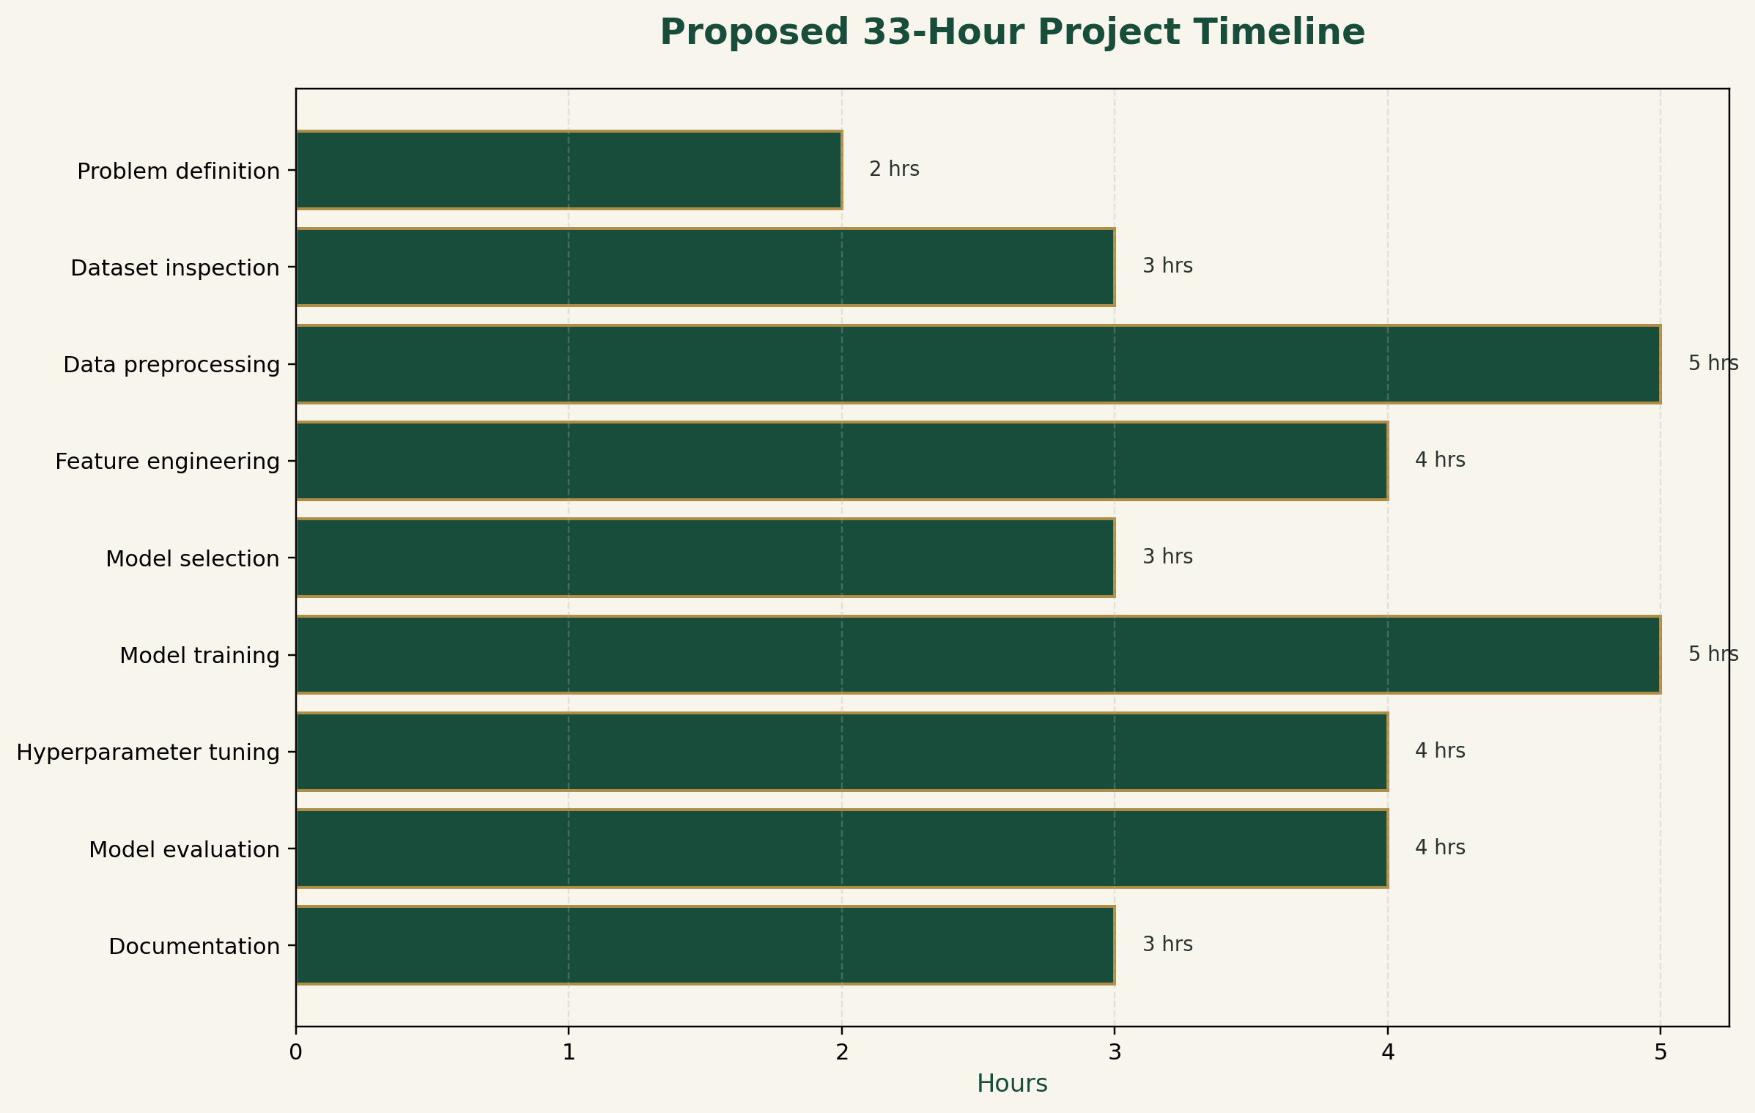
This schedule is a planning estimate. Actual time may vary depending on dataset size, data quality and the complexity of the experiments.

20. Expected Outcomes
At the end of the proposed Week 3 activities, the following outcomes are expected:
- A clear understanding of supervised machine learning and classification.
- A prepared customer churn dataset suitable for experimentation.
- An understanding of different classification algorithms.
- Initial training experiments using suitable models.
- A planned hyperparameter tuning process.
- Evaluation using appropriate classification metrics.
- A comparison framework for selecting a suitable model.
- A documented Python-based machine learning workflow.
- A structured project folder for future development.
These are expected outcomes of the planned work and should not be interpreted as completed experimental findings.

21. Project Checklist
☐ Define the customer churn prediction problem.
☐ Identify the target variable and input features.
☐ Inspect the dataset and its structure.
☐ Check missing values and duplicate records.
☐ Handle categorical and numerical variables.
☐ Prepare training and testing datasets.
☐ Select candidate classification algorithms.
☐ Train the selected models.
☐ Perform hyperparameter tuning.
☐ Evaluate using appropriate classification metrics.
☐ Compare the candidate models.
☐ Document limitations and observations.
☐ Organise project files and code.

22. Conclusion
This report presents a structured plan for developing a Python-based customer churn prediction model. It explains the problem, supervised learning approach, expected dataset features, preprocessing methods, candidate algorithms, training procedure, hyperparameter tuning and evaluation metrics.
Logistic Regression, Decision Tree, Random Forest and Gradient Boosting are proposed as candidate classification algorithms. Their performance will be compared using accuracy, precision, recall, F1-score, confusion matrix and ROC-AUC where appropriate.
Random Forest is considered a primary candidate for initial experimentation, but the final model will be selected only after proper validation and evaluation.
The planned work provides a foundation for building a reliable machine learning solution that can help businesses understand customer churn and support customer retention decisions.

23. Suggested Project Folder Structure
The following folder structure is suggested to keep the customer churn prediction project organised.
Customer_Churn_Prediction/
|
|-- data/
| |-- raw/
| |-- processed/
|
|-- notebooks/
| |-- data_preprocessing.ipynb
| |-- model_training.ipynb
| |-- model_evaluation.ipynb
|
|-- src/
| |-- preprocessing.py
| |-- train_model.py
| |-- evaluate_model.py
|
|-- models/
| |-- final_model.joblib
|
|-- outputs/
| |-- graphs/
| |-- evaluation/
|
|-- reports/
| |-- week3_report.docx
|
|-- README.md
|-- requirements.txt
|-- .gitignore

The data folder stores raw and processed datasets. The notebooks folder contains experiments. The src folder contains reusable Python scripts. The models folder stores approved trained models, while outputs contains graphs and evaluation files.

