YUVA INTERN
DATA SCIENCE INTERNSHIP

WEEK 2 TASK
Exploratory Data Analysis
and Visualization
Framework Design
A reusable, dataset-independent approach to understanding, cleaning,
analysing and communicating data

Submitted by | Fathimath Zulfah
Programme / Institution | BCA / Mangalore University
Internship | YUVA INTERN – Data Science
Submission | Week 2

CONTENTS
- 1. Introduction to EDA
- 2. Understanding Data Types
- 3. Dataset Inspection
- 4. Data Cleaning and Quality Checks
- 5. Exploratory Data Analysis Techniques
- 6. Visualization Strategies
- 7. Python Tools and Libraries
- 8. Python Code Examples
- 9. EDA Workflow Diagram
- 10. Visualization Framework Diagram
- 11. Reporting and Documentation
- 12. Proposed 33-Hour Timeline
- 13. Possible Challenges and Solutions
- 14. Expected Outcomes
- 15. Evaluation Checklist
- 16. Conclusion
- 17. Suggested Project Folder Structure
NOTE This report is a proposed framework. No dataset was supplied, so it contains methods, examples and code templates rather than measured results or claims about a real dataset.

1. INTRODUCTION TO EXPLORATORY DATA ANALYSIS (EDA)

1.1 Definition of EDA
Exploratory Data Analysis (EDA) is the process of examining and summarising a dataset before building models or drawing final conclusions. It combines statistical summaries, visual exploration and data-quality checks to understand what the data contains, how variables behave and whether the data is suitable for the intended task.
EDA is not simply the creation of charts. It is a structured investigation in which questions are asked, evidence is checked and analysis choices are refined. The process is iterative: an unexpected pattern may lead to a new inspection or a correction in the cleaning plan.

1.2 Importance of EDA in Data Science
- Builds familiarity with the dataset, its size, structure, units and meaning.
- Identifies missing, duplicated, inconsistent or invalid records before they affect analysis.
- Reveals distributions, unusual values, relationships, clusters and possible trends.
- Helps test whether assumptions behind statistical methods or machine-learning models are reasonable.
- Supports clear communication by turning raw values into understandable summaries and visual evidence.

1.3 Main Objectives
- Understand the problem and the meaning of each field.
- Assess completeness, consistency, validity and overall data quality.
- Describe individual variables and explore relationships between variables.
- Generate hypotheses for further investigation without treating early observations as proof.
- Select suitable preprocessing and modelling approaches.
- Communicate methods, observations, limitations and next steps transparently.

1.4 How EDA Supports Machine Learning and Decision-Making
For machine learning, EDA can identify target imbalance, highly skewed features, redundant variables, leakage risks, unusual scales and missing-data patterns. These checks inform choices such as imputation, encoding, scaling, feature engineering and evaluation metrics. EDA does not guarantee model performance, but it reduces avoidable errors and helps make modelling decisions more defensible.
For decision-making, EDA provides context: how often something occurs, how groups differ, whether values change over time and where uncertainty remains. Any recommendation should be linked to evidence and should acknowledge that association does not automatically mean causation.

2. UNDERSTANDING DATA TYPES
Correctly identifying a variable's data type is important because it determines which summaries, transformations and charts are appropriate. A numeric-looking code, such as a postal code or student ID, may be an identifier rather than a quantity.
Data type | Meaning and example | Suitable analysis techniques
Continuous numerical | Can take values within a range; e.g., height, temperature, elapsed time. | Mean, median, standard deviation, percentiles, histogram, density plot, box plot, scatter plot.
Discrete numerical | Countable values, often whole numbers; e.g., number of orders or visits. | Frequency table, count summaries, bar chart, histogram, count models where appropriate.
Nominal categorical | Labels without natural order; e.g., city, product category, colour. | Value counts, proportions, cross-tabulation, count plot, grouped bar chart.
Ordinal categorical | Categories with a meaningful order; e.g., low / medium / high or satisfaction levels. | Ordered frequency table, median category where meaningful, stacked bar chart, rank-aware comparisons.
Date and time | Calendar dates or timestamps; e.g., order date or login time. | Parse dates, extract components, time series plots, resampling, trend and seasonality checks.
Text | Free-form words or sentences; e.g., feedback comments. | Length and token summaries, text cleaning, keyword frequency, n-grams and qualitative review.
Boolean | Two logical states; e.g., subscribed / not subscribed. | Counts, proportions, cross-tabs, binary outcome comparisons.

NOTE Data type and measurement meaning are not always the same. Confirm the data dictionary or ask the data owner before interpreting unfamiliar fields.

3. DATASET INSPECTION
Dataset inspection creates a first profile of the data before any transformation. The exact results must be recorded after a dataset is supplied; the code below shows what to run.

3.1 What to Inspect
Inspection item | Purpose | Pandas approach
Dimensions | Number of rows and columns; indicates dataset scale. | df.shape
Column names | Check spelling, spaces, duplicates and meaningful labels. | df.columns; df.columns.tolist()
Data types | Check whether each column is stored appropriately. | df.dtypes; df.info()
Summary statistics | Review count, mean, spread, quartiles and category summaries. | df.describe(include='all')
Unique values | Understand category levels and possible inconsistent labels. | df.nunique(); df['column'].unique()
Data distribution | See frequency, range, skewness and unusual concentrations. | value_counts(), describe(), histograms, box plots

3.2 Initial Pandas Inspection
import pandas as pd

# Load the file after confirming its path and format.
df = pd.read_csv("data/raw_dataset.csv")

print("Dataset dimensions:", df.shape)
print("\nColumn names:")
print(df.columns.tolist())

print("\nData types and non-null counts:")
df.info()

print("\nSummary statistics:")
print(df.describe(include="all"))

print("\nUnique values per column:")
print(df.nunique(dropna=False))

# Example: inspect category frequencies.
# Replace 'category_column' with a real column name.
print(df["category_column"].value_counts(dropna=False))
Inspection should also include a review of the data dictionary, source, collection period, unit of measurement, row meaning and intended analytical question. A row may represent a person, transaction, event, daily measurement or another unit; this affects how counts and averages should be interpreted.

4. DATA CLEANING AND QUALITY CHECKS
Data cleaning aims to make data fit for analysis while preserving its meaning. Every change should be justified, documented and, where possible, performed on a working copy rather than overwriting the original source.
Quality issue | How to detect it | Possible response
Missing values | isna().sum(), missingness percentages, visual review. | Investigate cause; drop only when justified; impute using suitable statistics or domain rules; retain a missing indicator when useful.
Duplicate records | duplicated() and duplicated(subset=...). | Confirm whether rows are true duplicates; remove exact duplicates or resolve repeated entities using a documented rule.
Incorrect data types | dtypes, info(), failed parsing checks. | Convert with to_numeric/to_datetime; use errors='coerce' only with a review of values that fail.
Inconsistent values | value_counts(), string inspection, category lists. | Standardise case, whitespace, spelling and units; map values only when equivalence is confirmed.
Invalid records | Domain rules, ranges, impossible dates, constraint checks. | Correct from a trusted source, quarantine, or exclude with a recorded reason.
Outliers | Box plots, IQR fences, z-scores, domain thresholds. | Investigate first; retain valid extremes; correct errors; consider robust methods or transformations.

4.1 Missing Values
Missingness may occur because a question was not answered, a sensor failed, a value was not applicable or a system did not record it. The pattern matters: missing values concentrated in one group or time period can bias results.
- Remove rows only when the number is small and removal does not create meaningful bias.
- Use median imputation for skewed numerical variables when a simple baseline is suitable; use mean only when its assumptions are reasonable.
- Use mode or an explicit 'Unknown' category for categorical data when that interpretation is appropriate.
- Use time-aware interpolation only for ordered measurements where interpolation is defensible.
- Consider model-based or multiple imputation for more complex work, and compare results with sensitivity checks.

4.2 Duplicate, Type and Consistency Checks
# Missing values and their percentage
missing_count = df.isna().sum()
missing_percent = df.isna().mean().mul(100)

# Duplicate rows
duplicate_count = df.duplicated().sum()

# Convert columns after checking the source format
df["date_column"] = pd.to_datetime(df["date_column"], errors="coerce")
df["amount_column"] = pd.to_numeric(df["amount_column"], errors="coerce")

# Standardise whitespace in text columns
df["category_column"] = df["category_column"].astype("string").str.strip()

4.3 Outlier Detection: IQR Method
The Interquartile Range (IQR) is the distance between the third quartile (Q3) and first quartile (Q1). A common screening rule marks values below Q1 − 1.5 × IQR or above Q3 + 1.5 × IQR as potential outliers. These are flags for investigation, not automatic proof of errors.
q1 = df["numeric_column"].quantile(0.25)
q3 = df["numeric_column"].quantile(0.75)
iqr = q3 - q1

lower_bound = q1 - 1.5 * iqr
upper_bound = q3 + 1.5 * iqr

potential_outliers = df[
(df["numeric_column"] < lower_bound) |
(df["numeric_column"] > upper_bound)
]

4.4 Outlier Detection: Z-Score Method
A z-score expresses how many standard deviations a value is from the mean: z = (x − mean) / standard deviation. A frequently used screening threshold is an absolute z-score above 3. This method is sensitive to skewness and extreme values, so it is most interpretable for distributions that are reasonably well behaved.
from scipy.stats import zscore

# Drop missing values for this simple illustration.
z_values = zscore(df["numeric_column"].dropna())
flagged_positions = abs(z_values) > 3

4.5 Choosing an Outlier Treatment
- Verify whether the value is possible using domain knowledge and source records.
- Correct data-entry or measurement errors only when the correct value is known.
- Keep genuine extreme observations when they are part of the population being studied.
- If justified, use winsorisation, a log transformation, robust statistics or a model less sensitive to extremes.
- Document the number of affected records, the rule used and how conclusions change with and without treatment.

5. EXPLORATORY DATA ANALYSIS TECHNIQUES

5.A Univariate Analysis
Univariate analysis studies one variable at a time. It answers questions such as: What values occur? What is typical? How spread out are the values? Are categories balanced? Is the distribution skewed?
Techniques include frequency and proportion tables for categories; mean, median, mode, range, variance, standard deviation and quartiles for numerical data; and missing-value counts. Histograms and density plots show numerical distributions, while bar or count plots show category frequencies. Box plots provide a compact view of median, quartiles and potential extremes.
Example: for a hypothetical 'delivery_days' field, a histogram could show whether most deliveries fall within a narrow range or whether the distribution has a long right tail. This is an example of how to analyse a field, not a finding from a supplied dataset.

5.B Bivariate Analysis
Bivariate analysis explores the relationship between two variables. The method depends on the combination of data types.
Variable combination | Questions and techniques | Useful charts
Numerical vs numerical | Direction and strength of association; correlation (Pearson or Spearman), covariance, regression as exploratory description. | Scatter plot; line plot when x is ordered; joint plot.
Numerical vs categorical | How does a numeric measure vary across groups? Compare group summaries, medians, spread and sample sizes. | Box plot, violin plot, strip plot, grouped bar chart of summaries.
Categorical vs categorical | How do category combinations occur? Use contingency tables, row/column proportions and chi-square tests where suitable. | Grouped or stacked bar chart, mosaic plot, heat map of counts or proportions.

Example: comparing 'purchase_amount' across 'membership_type' can reveal differences in group distributions. Group sizes should be shown because a small group may produce unstable summaries.

5.C Multivariate Analysis
Multivariate analysis considers three or more variables together. It helps explore whether patterns depend on multiple factors and whether variables move together.
- Correlation analysis: calculate pairwise association between numerical variables. Pearson correlation measures linear association; Spearman correlation measures rank-based monotonic association. Neither proves causation.
- Pair plots: display pairwise scatter plots and single-variable distributions for a selected set of numerical features. They can become crowded for many columns.
- Heat maps: use colour to show a matrix such as correlations, group counts or missingness. Include a scale and labels.
- Group comparisons: compare a numerical measure across combinations of categories, while checking sample sizes and confounding factors.
- Principal Component Analysis (PCA): an optional dimensionality-reduction method that transforms correlated numerical features into components capturing directions of variance. Standardisation is commonly needed when scales differ. Components can be useful for exploratory visualisation, but interpretation requires care.

6. VISUALIZATION STRATEGIES
A good visualization answers a specific question, uses an appropriate scale, labels units and categories, and avoids unnecessary decoration. The same chart can be misleading if the axis is truncated, the denominator is unclear or too many groups are shown.
Chart | What it represents | Useful for revealing | Practical example
Histogram | Groups numerical values into bins to show a distribution. | Explore shape, spread, skewness, gaps and multiple peaks. | Distribution of a numeric measure such as age or transaction value.
Bar chart | Uses separate bars to compare values across categories. | Compare totals, averages or proportions between named groups. | Total orders by product category.
Count plot | A bar chart showing the number of observations in each category. | Check category frequency and class imbalance. | Number of records in each status category.
Box plot | Shows median, quartiles, whiskers and potential outliers. | Compare spread and central tendency across groups. | Delivery time by shipping method.
Scatter plot | Places paired numerical observations on x and y axes. | Reveal association, clusters, nonlinear patterns and unusual points. | Study time versus assessment score.
Line chart | Connects values in a meaningful order, often time. | Reveal trend, seasonality, sudden changes and gaps. | Monthly website visits.
Heat map | Encodes a matrix of values using colour. | Spot strong/weak associations or concentration patterns. | Correlation matrix of selected numeric variables.
Violin plot | Combines a distribution shape with group comparison. | Compare spread, density shape and possible multiple modes. | Distribution of income across regions.
Pair plot | Shows pairwise relationships among selected numeric variables. | Explore multiple relationships and distributions at once. | Initial screening of a small set of model features.
Pie chart | Shows parts of one whole as slices. | Only useful for a small number of mutually exclusive categories that sum to a meaningful whole. | Share of responses across three or four options; avoid for many categories or close values.

6.1 Chart Selection Table
Analytical question | Suggested chart | Key caution
How is one numeric variable distributed? | Histogram, box plot, violin plot | Choose sensible bins; show units and sample size.
Which categories are most common? | Bar chart or count plot | Sort meaningfully; avoid overcrowded labels.
How do two numeric variables relate? | Scatter plot; line chart for ordered time | Correlation is not causation; inspect overlap and outliers.
How do numeric values differ by group? | Box plot, violin plot, grouped summary bar | Show group sizes and avoid hiding within-group variation.
How do many numeric variables relate? | Correlation heat map, pair plot | Limit variables; disclose correlation method.
How does a measure change over time? | Line chart | Use a real time axis and consistent intervals.
What proportion belongs to each category? | Bar chart; pie chart only for a few categories | Ensure categories form the full denominator.

6.2 Notes on Pie Charts
Pie charts should generally be avoided when there are many categories, when values are close, when comparisons must be precise or when categories overlap. A sorted bar chart is usually easier to read. If a pie chart is used, categories should be mutually exclusive, collectively cover the whole and have a clearly stated denominator.

6.3 Principles for Clear Visuals
- Use descriptive titles that state the variable or question being explored.
- Label axes with units and use readable tick marks.
- Choose colour palettes with sufficient contrast and do not rely on colour alone to convey meaning.
- Show missing values or exclusions where they affect interpretation.
- Avoid 3D effects, unnecessary gradients and distorted axes.
- Include source, filters, date range and aggregation method when relevant.

7. PYTHON TOOLS AND LIBRARIES
Tool | Role in the framework | Typical use
Python | General-purpose language for analysis automation and reproducible workflows. | Write scripts, notebooks and reusable functions.
Pandas | Tabular data loading, cleaning, transformation and summarisation. | DataFrames, filtering, groupby, joins and missing-value checks.
NumPy | Efficient numerical arrays and mathematical operations. | Array calculations, masks and numerical transformations.
Matplotlib | Flexible foundational plotting library. | Customise figures, axes, labels and export images.
Seaborn | Statistical visualisation built on Matplotlib. | Distribution plots, categorical plots, pair plots and heat maps.
Plotly | Interactive visualisation library. | Hover details, zooming and interactive dashboards.
SciPy | Scientific computing and statistical functions. | Z-scores, statistical tests and scientific routines.
Jupyter Notebook | Interactive environment combining code, output and explanation. | Run analysis step by step and document decisions.
VS Code | Code editor with Python, notebook and Git support. | Organise scripts, projects and debugging.
Git and GitHub | Version control and remote collaboration/hosting. | Track changes, document work and share reproducible project files.

The framework can be completed with a small, consistent toolset: Python, Pandas, NumPy, Matplotlib, Seaborn and Jupyter. Plotly, SciPy, VS Code and Git/GitHub can be added when the project needs interactive charts, statistical methods, structured development or version control.

8. PYTHON CODE EXAMPLES
NOTE The examples are templates, not executed findings. Replace file paths and placeholder names such as numeric_column, category_column and x_column with column names from the actual dataset. Install required packages in the working Python environment before running.

8.1 Importing Libraries
import pandas as pd
import numpy as np
import matplotlib.pyplot as plt
import seaborn as sns

# Optional: configure a consistent plotting style
sns.set_theme(style="whitegrid")

8.2 Loading a CSV File
df = pd.read_csv("data/raw_dataset.csv")
print(df.head())

8.3 Displaying Dataset Information
print("Shape:", df.shape)
print("Columns:", df.columns.tolist())
print("\nData types:")
print(df.dtypes)
df.info()
print(df.describe(include="all"))

8.4 Checking Missing Values
missing_summary = pd.DataFrame({
"missing_count": df.isna().sum(),
"missing_percent": df.isna().mean() * 100
})
print(missing_summary.sort_values("missing_percent", ascending=False))

8.5 Checking Duplicates
print("Duplicate rows:", df.duplicated().sum())

# Review duplicates before removing them.
duplicate_rows = df[df.duplicated(keep=False)]
print(duplicate_rows.head())

# Remove exact duplicates only if they are confirmed to be redundant.
# df = df.drop_duplicates()

8.6 Descriptive Statistics
# Numerical summary
print(df.describe())

# Categorical summary
print(df["category_column"].value_counts(dropna=False))

# Group summary (replace names with actual columns)
print(df.groupby("category_column")["numeric_column"].agg(
["count", "mean", "median", "std", "min", "max"]
))

8.7 Histogram
plt.figure(figsize=(8, 5))
sns.histplot(data=df, x="numeric_column", bins=20, kde=True)
plt.title("Distribution of Numeric Variable")
plt.xlabel("Numeric variable (unit)")
plt.ylabel("Frequency")
plt.tight_layout()
plt.show()

8.8 Box Plot
plt.figure(figsize=(8, 5))
sns.boxplot(data=df, x="category_column", y="numeric_column")
plt.title("Numeric Variable Across Categories")
plt.xlabel("Category")
plt.ylabel("Numeric variable (unit)")
plt.xticks(rotation=30)
plt.tight_layout()
plt.show()

8.9 Scatter Plot
plt.figure(figsize=(8, 5))
sns.scatterplot(data=df, x="x_column", y="y_column", alpha=0.7)
plt.title("Relationship Between Two Numeric Variables")
plt.xlabel("X variable (unit)")
plt.ylabel("Y variable (unit)")
plt.tight_layout()
plt.show()

8.10 Correlation Heat Map
numeric_df = df.select_dtypes(include=np.number)
correlation_matrix = numeric_df.corr(method="pearson")

plt.figure(figsize=(9, 6))
sns.heatmap(correlation_matrix, annot=True, cmap="vlag",
center=0, fmt=".2f", linewidths=0.5)
plt.title("Correlation Heat Map")
plt.tight_layout()
plt.show()
Before running plotting code, confirm that the selected columns exist and have suitable types. For example, a scatter plot requires numerical x and y values. If data is very large, sample it for visual inspection while preserving a note that the chart is based on a sample.

9. EDA WORKFLOW DIAGRAM
The following workflow provides a repeatable sequence from understanding the dataset to communicating the analysis. In practice, the steps are iterative rather than strictly one-way.
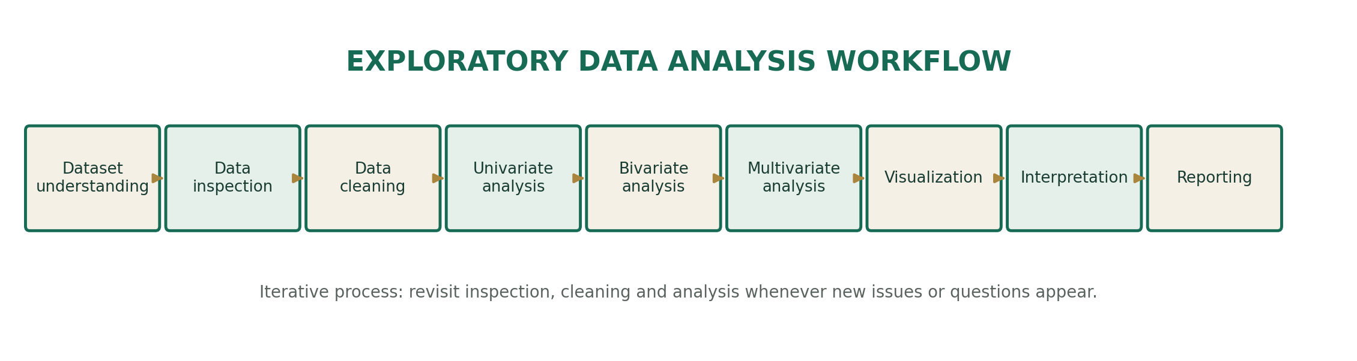
Figure 1. Dataset-independent EDA workflow.
At each stage, record the question, the method, the output and any decision made. If cleaning changes the data, repeat relevant summaries and charts so the final interpretation reflects the processed version.

10. VISUALIZATION FRAMEWORK DIAGRAM
Chart selection should begin with the analytical question and the variable types, not with a desire to use a particular chart. The diagram provides a quick decision guide.
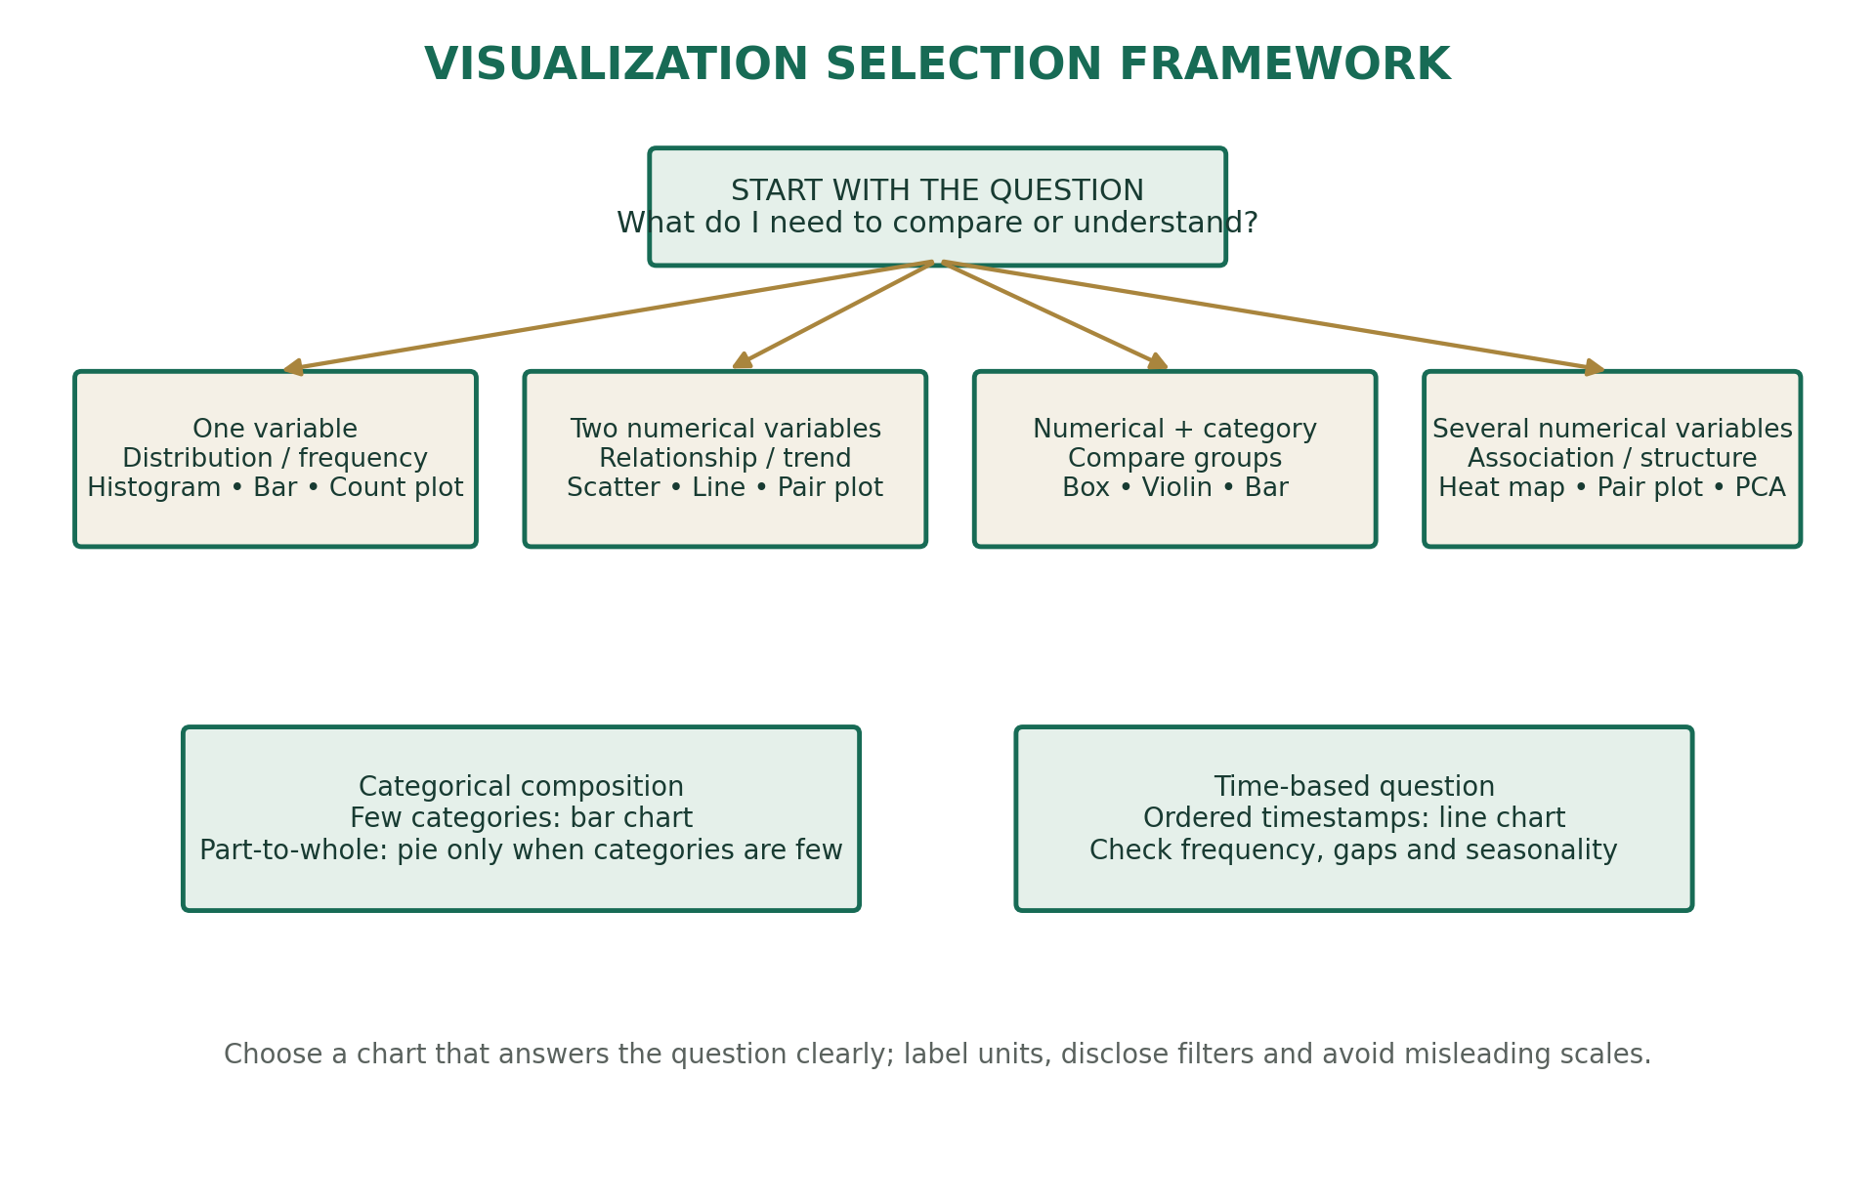
Figure 2. Mapping analytical questions and variable combinations to chart types.

11. REPORTING AND DOCUMENTATION
A good EDA report allows another person to understand what data was examined, what was changed, what was observed and what remains uncertain. Separate factual results from interpretations and recommendations.

11.1 What to Document
- Dataset source, version, collection period, row meaning and any data dictionary used.
- Original dimensions, variables, types and key definitions.
- Quality checks, missingness, duplicate handling, invalid values and outlier rules.
- Analysis questions, statistics, chart choices, filters and transformations.
- Observed patterns supported by actual tables or charts once data is available.
- Limitations, assumptions, privacy considerations and reproducibility details.

11.2 Proposed Final Report Structure
- Executive summary
- Introduction
- Dataset overview
- Data quality assessment
- Univariate analysis
- Bivariate analysis
- Multivariate analysis
- Visualizations
- Key findings
- Limitations
- Recommendations
- Conclusion
- Appendix
For each key finding, use a compact evidence format: question → method → result → interpretation → limitation. Avoid statements such as 'X causes Y' unless the study design supports causal inference. For this framework submission, the results section should remain a plan until a real dataset is supplied.

12. PROPOSED 33-HOUR TIMELINE
The following schedule is an approximate work plan. The allocation can be adjusted to dataset size, complexity and internship instructions.
Activity | Hours | Planned work / output
Planning and dataset context | 2 | Clarify objective, source, row meaning, data dictionary and questions.
Inspection and profiling | 4 | Dimensions, columns, types, summaries, unique values and first profile.
Cleaning and quality checks | 6 | Missingness, duplicates, type corrections, consistency, invalid values and outlier review.
Univariate analysis | 4 | Variable summaries, distributions and category frequencies.
Bivariate analysis | 4 | Relationships, group comparisons and cross-tabulations.
Multivariate analysis | 3 | Correlation, selected pair plots, heat maps and optional PCA.
Visualization development | 4 | Prepare clear, labelled and appropriately selected charts.
Interpretation and report drafting | 4 | Document evidence, limitations, key observations and recommendations.
Review and finalization | 2 | Check code, charts, citations/source notes, formatting and reproducibility.
TOTAL | 33 | Proposed allocation

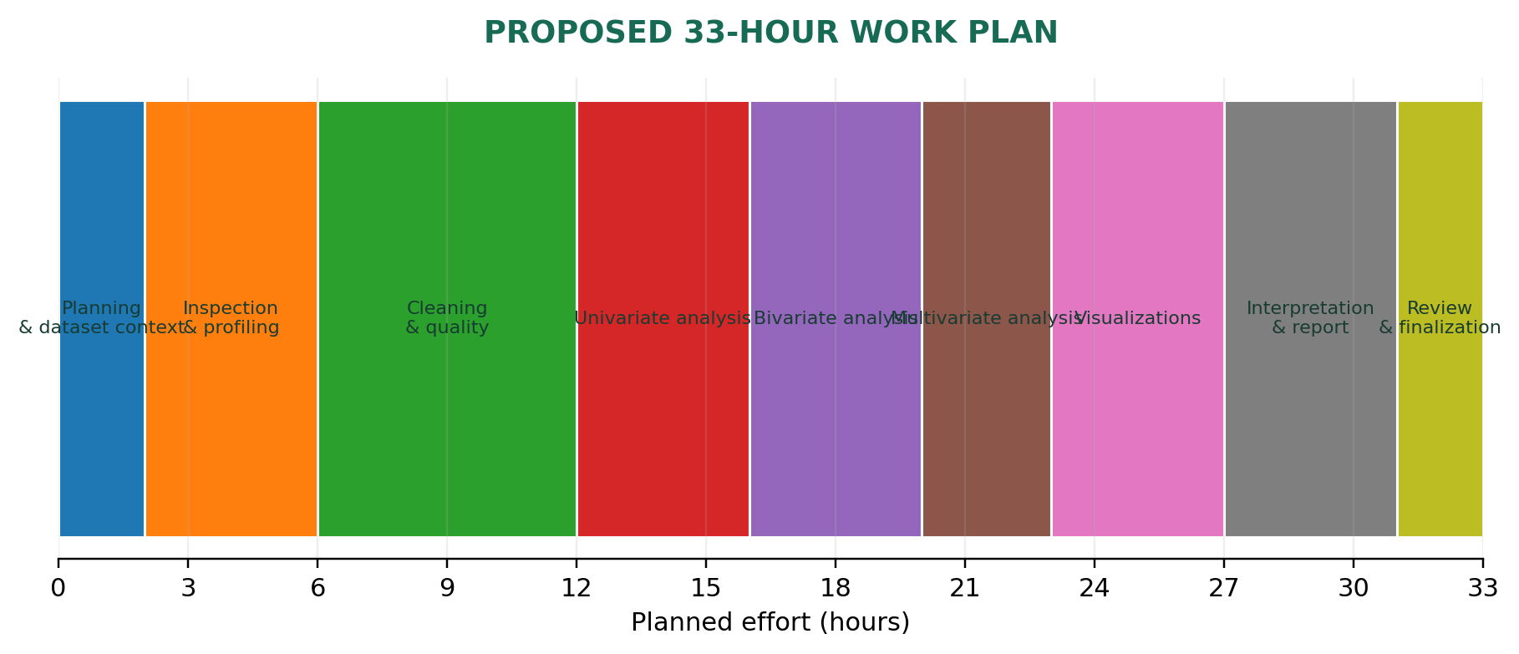
Figure 3. Proposed allocation of 33 working hours.
NOTE The 33 hours are a planning estimate, not a claim that this analysis has already been completed.

13. POSSIBLE CHALLENGES AND SOLUTIONS
Challenge | Why it matters | Practical response
Large datasets | Memory limits and slow plotting or processing. | Inspect samples first; select needed columns; use efficient dtypes, chunked reading or a database; document sampling.
Missing data | Can reduce sample size or bias results. | Study missingness patterns; select justified imputation or exclusion; compare sensitivity of results.
Outliers | May be errors or valid rare events. | Verify with domain context; use IQR/z-score as flags; retain genuine extremes and document treatment.
High-dimensional data | Many variables make charts crowded and relationships hard to interpret. | Use domain-based feature selection, correlation screening, pair plots on subsets and optional PCA.
Misleading visualizations | Poor scales, bins or denominators can distort the message. | Label axes and units; show sample sizes; use suitable scales and chart types; review with another person.
Privacy concerns | Personal or confidential information may be exposed. | Remove direct identifiers, restrict access, aggregate where appropriate and follow applicable policies.
Interpretation difficulties | Correlation, confounding or small groups may be misunderstood. | Use cautious language, check assumptions, examine group sizes and consult domain knowledge.

14. EXPECTED OUTCOMES
After applying this framework to a real dataset, the expected deliverables are:
- A documented understanding of the dataset's structure, variables and context.
- A data-quality profile covering missing values, duplicates, inconsistent types and potential outliers.
- A reproducible set of cleaning steps with reasons and a record of changes.
- Univariate, bivariate and multivariate summaries appropriate to the available variables.
- A set of clear visualizations selected to answer defined analytical questions.
- An EDA notebook or scripts that can be rerun and reviewed.
- A final report that distinguishes observed evidence, interpretation, limitations and recommended next steps.
NOTE These are expected outputs of the proposed process. They are not completed findings because no dataset has been provided.

15. EVALUATION CHECKLIST
- ☐ Objective and dataset context are clearly stated.
- ☐ Data types are identified using meaning as well as storage format.
- ☐ Dimensions, columns, data types and summary statistics are inspected.
- ☐ Missing values and duplicates are measured and reviewed.
- ☐ Type conversions and category standardisation are documented.
- ☐ Outliers are investigated rather than removed automatically.
- ☐ Univariate analysis covers relevant variables.
- ☐ Bivariate analysis uses methods suited to each variable combination.
- ☐ Multivariate techniques are used selectively and explained.
- ☐ Charts have clear titles, labels, units and appropriate scales.
- ☐ Interpretations are supported by actual evidence.
- ☐ Limitations, privacy and possible bias are acknowledged.
- ☐ Code is organised, reproducible and uses relative paths where possible.
- ☐ Final report and project files are reviewed before submission.

16. CONCLUSION
Exploratory Data Analysis is an essential foundation for responsible data science. It helps an analyst understand the structure and quality of data, select suitable statistical techniques, discover patterns and communicate information clearly. A systematic framework reduces the risk of drawing conclusions from incorrect types, missing values, duplicates or misleading charts.
This report presents a dataset-independent process that can be adapted to many domains. Once a dataset is made available, the steps should be applied in context, and all numerical findings should be generated from the actual data. The central principle is to let the analytical question and the evidence guide each decision.

17. SUGGESTED PROJECT FOLDER STRUCTURE
A consistent folder structure separates original data from processed data, code, outputs and documentation. The raw data should be preserved unchanged.
eda-visualization-framework/
│
├── data/
│ ├── raw/ # Original, unchanged dataset
│ └── processed/ # Cleaned or transformed data
│
├── notebooks/
│ ├── 01_dataset_inspection.ipynb
│ ├── 02_data_cleaning.ipynb
│ ├── 03_univariate_analysis.ipynb
│ ├── 04_bivariate_analysis.ipynb
│ └── 05_multivariate_analysis.ipynb
│
├── src/
│ ├── cleaning.py
│ ├── analysis.py
│ └── visualization.py
│
├── outputs/
│ ├── figures/
│ └── tables/
│
├── reports/
│ └── eda_report.docx
│
├── README.md
├── requirements.txt
└── .gitignore
Do not upload confidential or personally identifiable data to a public repository. Use a synthetic or anonymised sample when sharing code, and include setup instructions, package requirements and a short project description in README.md.

