Cricket Player Performance TrackingApplication : CRICKSTATS

1. Introduction
- CRICKSTATS is a Salesforce-based application developed to track and analyze the performance of cricket players.
- The system records match-by-match performance statistics of players.
- It helps administrators and teams analyze player performance through reports and dashboards.

2. Objectives of the Project
- To create a player performance tracking system in Salesforce.
- To store player details and match statistics.
- To maintain relationships between players and matches.
- To generate reports and dashboards for performance analysis.
- To support data-driven decision making.

3. Salesforce Technologies Used
- Salesforce Lightning UI
- Custom Objects
- Custom Fields
- Master-Detail Relationship
- Lookup Relationship
- Reports
- Dashboards
4.Data Flow Diagram
Data Flow
User → Salesforce UI → Player Object → Match Performance → Reports →Dashboard
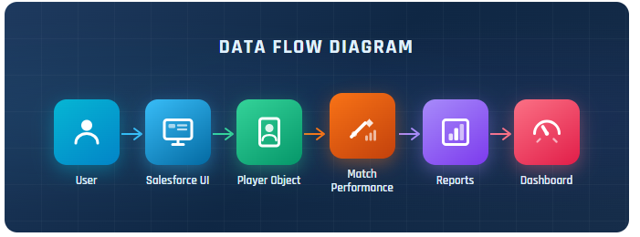

4. System Architecture / Application Overview
- Player
- Match Performance
Each player can have multiple match performance records. The Match Performance object stores detailed statistics such as runs scored, wickets taken, strike rate, etc.
5. Custom Objects Created
5.1 Player Object
Stores information about cricket players.
- Player Name
- Player number
- Profile Picture
- Date Of Birth.etc.,

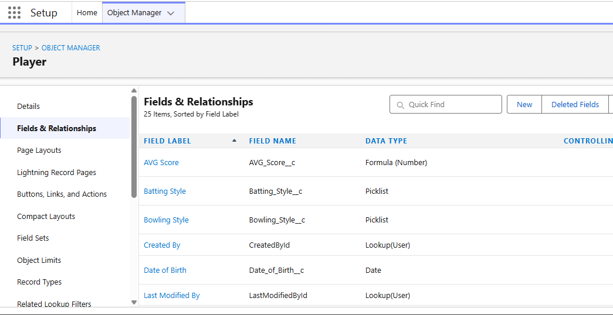
5.2 Match Performance Object
Stores match-by-match performance of players.
- Match Performance Name
- Player of the Match
- Match Result
- Runs Scored
- Balls Faced
- Fours
- Sixes
- Overs Bowled
- Wickets Tacken
- Runs Conceded
- Mainden Overs
- Stumpings
- Catches.etc.,

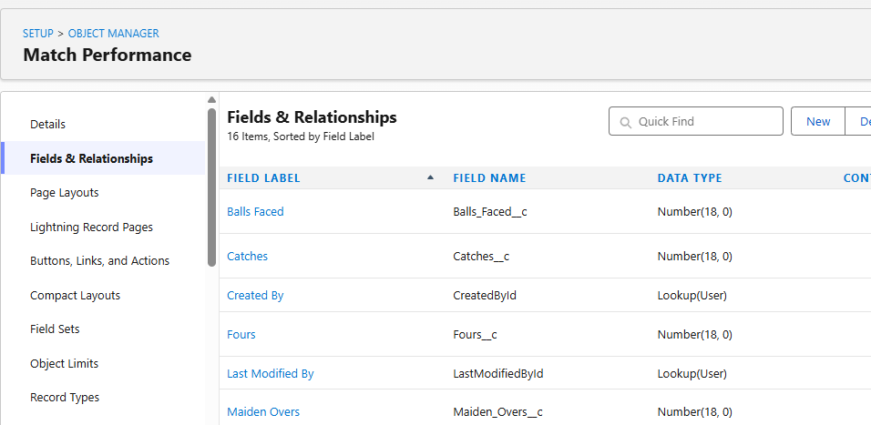
6. Relationships Between Objects
Master-Detail Relationship
Player → Match Performance
Advantages:
- Data integrity
- Roll-up summary fields

7.Flow
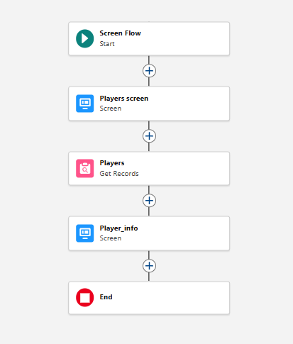

CRICKSTATS Navigation Bar
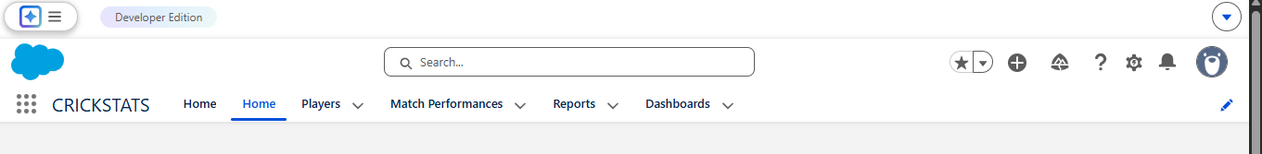

Reports Created

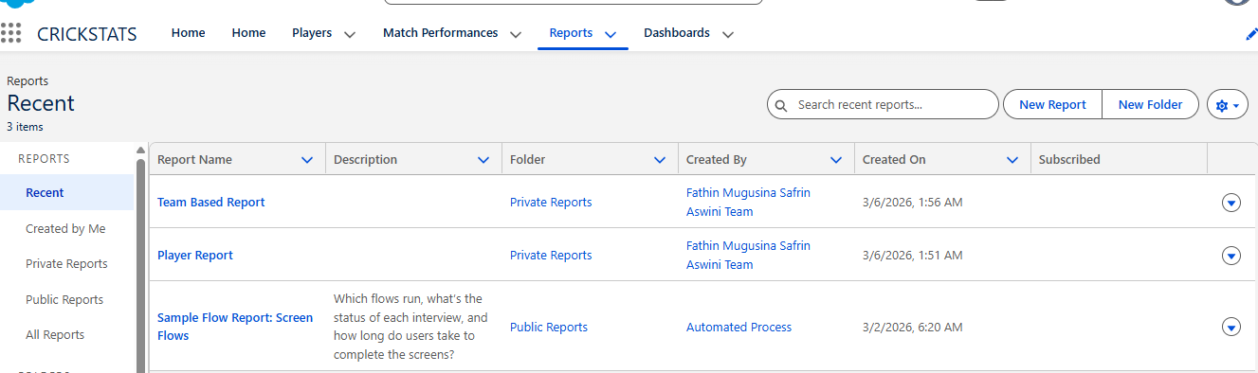
Dashboard
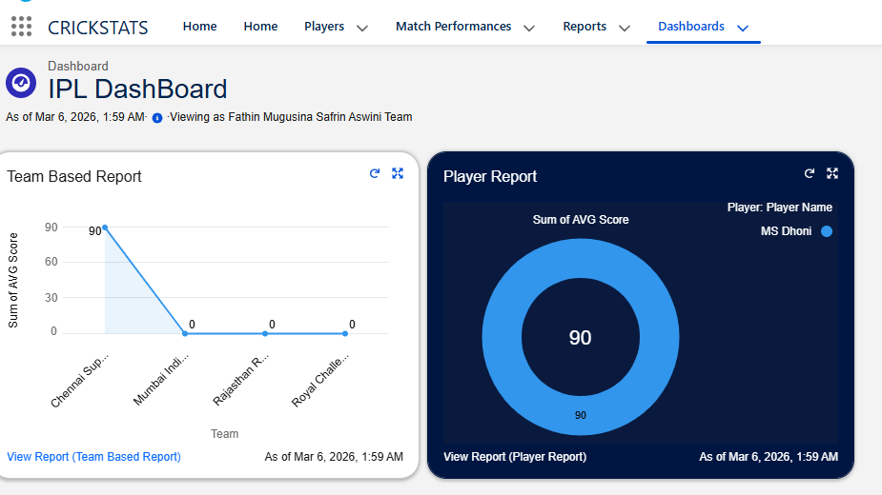

8.Testing and Results:
- Data was entered for players and matches.
- Reports correctly displayed player statistics.
- Dashboard visually represented performance data.
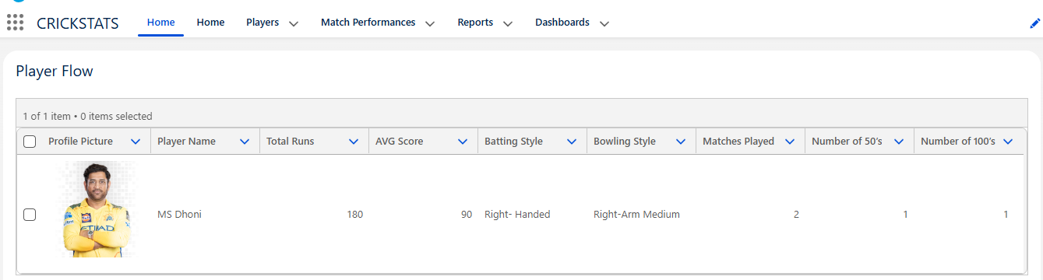
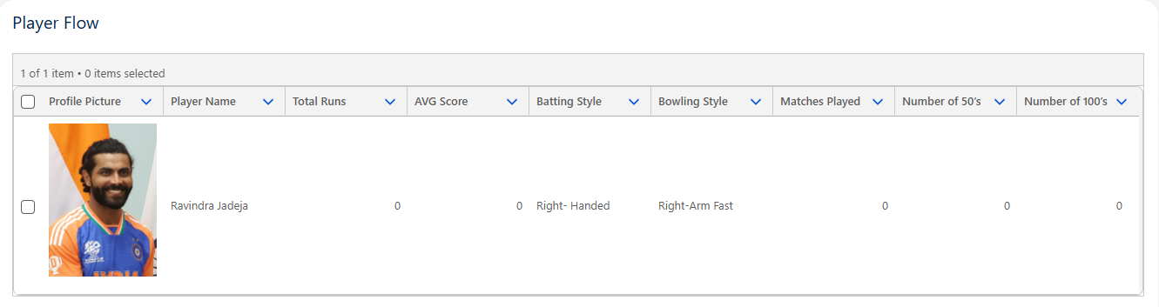
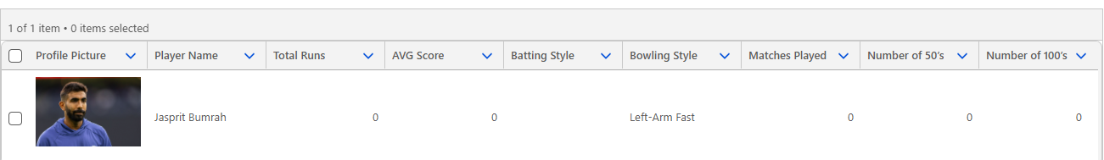
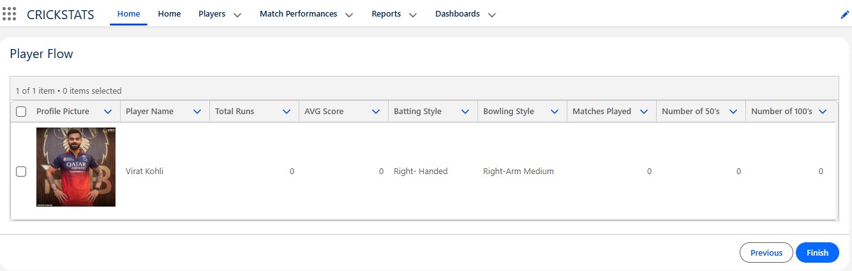
9.Screen Record:
https://docs.google.com/videos/d/1laYJnHgel1UR2qnBrTARixxR29FvcptE-E9uKiYecFk/edit?usp=sharing
10. Advantages of CRICKSTATS
- Easy performance tracking
- Centralized player data
- Better statistical analysis
- Supports team management decisions
- Automated reporting
11. Future Enhancements
- Add team object
- Add match object
- Predict player performance using analytics
- Integration with cricket APIs
12. Conclusion:
CRICKSTATS successfully demonstrates how Salesforce can be used to develop a custom application for sports analytics. The system efficiently manages player statistics, generates insightful reports, and supports performance analysis, making it a useful tool for cricket data management.
Done By:
- Team Leader: FATHIN FAZEERA .F
- Team Member: MUGUSINA SHIRIN .M
- Team Member: JAHABAR SAFRIN .S
- Team Member: ASWINI .A

Thank you.

