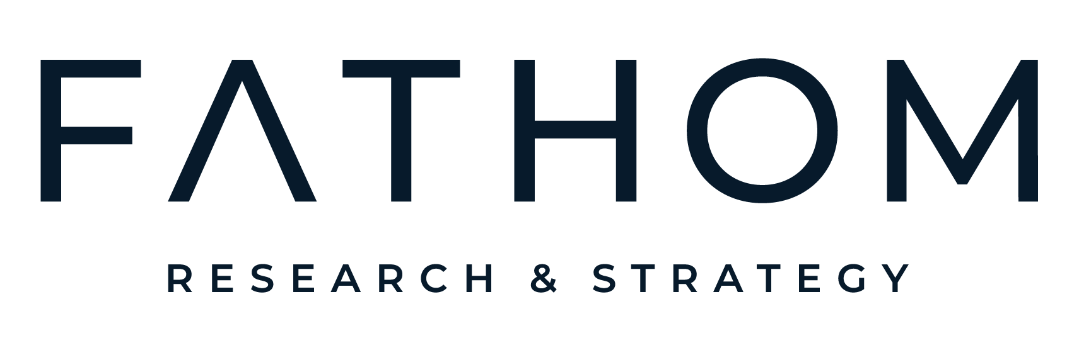
Products & Pricing
Fixed scope. Fixed price. No proposals. A 30-minute kickoff replaces the scoping process, and every project starts within a week of sign-off. Pricing, timing, and scope reflect basic tier, and can be adjusted on a per-project basis to fit specific research needs.
QUICK-TURN & AD-HOC
Survey Programming & Hosting
Your questions, professionally built and in the field.
$1,000 + sample fees (optional) · 3-5 business days
You get: your questionnaire programmed, tested, and hosted on a professional platform with logic, quotas, and quality checks in place, plus a live link ready to distribute (or optional Fathom sample sourcing) and a clean export of the raw data when you close it.
Questionnaire Audit
A second set of expert eyes before your survey goes to field.
$1,000 · 3 business days
You get: A line-by-line review of your survey with rewrites for biased, confusing, or wasted questions, and a revised recommended flow.
Analysis Sprint
You collected the data. We turn it into answers.
$2,500 · 72 hours from data handoff (clean, labeled data)
You get: Full crosstabs and data tables from your raw survey data, plus a topline report of the key findings.
Persona One-Pagers
Your segments, made real enough to put on the wall.
$2,500 · 1 week
You get: One-page profiles for each of your audience segments, built from your existing data. Covers who they are, what drives them, and how to reach them, in a format your marketing and sales teams can use day one.
Quick Pulse
One burning question, answered by real consumers this week.
$3,500 · 1 week · 300 respondents, up to 8 questions
You get: A fielded survey of your target audience with a topline report and clear takeaways.
TEST BEFORE YOU LAUNCH
Concept Testing
Know which idea wins before you spend on production.
From $8,000 · 3-4 weeks · 500 respondents, 3 concepts
You get: Concept scorecards with a statistically validated winner, go/no-go recommendations, and optimization guidance for refinement.
Message Testing
Find the claims your audience actually believes, and lead with them.
From $8,000 · 3-4 weeks · 500 respondents, up to 10 messages
You get: Message rankings on clarity, credibility, and persuasion, plus specific fixes for underperforming claims.
UNDERSTAND YOUR BRAND
Category Entry Points
Learn which buying moments your brand owns, and which ones your competitors do.
From $10,000 · 3-5 weeks · 1000 respondents, up to 30 entry points
You get: A map of purchase triggers versus brand association, competitive positioning across every entry point, and a priority list of moments to attack and defend.
Distinctive Brand Assets
Find out which parts of your brand people recognize without the logo.
From $10,000 · 4-5 weeks · 1000 respondents
You get: Recognition and ownership scores for each asset, competitive benchmarks, and a clear hierarchy of which elements to protect in every communication.
UNDERSTAND YOUR CUSTOMERS
Voice of the Consumer
Hear why people buy, switch, or walk away, in their own words.
From $12,000 · 4-8 weeks · 12 in-depth interviews or 4 focus groups
You get: Thematic findings with verbatim quotes, a video highlight reel, and strategic recommendations grounded in real conversations.
Consumer Journey Mapping
See where buyers drop off and which touchpoints actually move them.
From $20,000 · 6-10 weeks · 1000 respondent quant + 12 in-depth interviews or 4 focus groups
You get: A full journey map with pain points and moments of truth, decision drivers by stage, and a prioritized optimization roadmap.
Customer Segmentation
Know exactly who your best customers are and how to win more of them.
From $40,000 · 6-10 weeks · 2000 respondents
You get: 3-5 actionable segments derived by advanced clustering analysis with detailed personas and market sizing for each, and a typing tool for scoring new/existing customers.
ONGOING PARTNERSHIP
Fathom Insights Subscription
A research team on call, without the headcount.

From $2,500/month · 3-month minimum, cancel anytime after
You get: A monthly Quick Pulse survey, five hours of analyst time for ad-hoc questions and data requests, priority scheduling, and 10% off all full studies.
Quarterly trends readout available as an add-on.
Every project includes full data tables, raw data files (SPSS/CSV), a 60-minute presentation and Q&A, two rounds of revisions, and an additional week for ad-hoc follow-up questions.
Need it faster? Rush delivery (50% faster) is available for an additional fee. Larger samples, additional markets, and tracking studies scoped on request.
A note on pricing. Prices and timelines shown are starting points and are confirmed at project kickoff. Final figures depend on the complexity of the work, including audience and sampling requirements (low-incidence, specialized, or hard-to-reach populations such as specific ethnicities, income levels, job titles, or screened qualifications carry higher sample costs), number of respondents, number of markets or languages, number of concepts, messages, or assets tested, depth of analysis and number of data cuts or subgroups, and stimulus or translation requirements. Quoted prices exclude applicable taxes and any third-party costs (incentives, specialized panel, or recruiting fees) unless stated otherwise. A written scope confirmed at kickoff governs the engagement.

