Table of Contents
Right-click to update the table of contents.

🧪 Markdown Previewer Benchmark
Ini adalah file pengujian komprehensif untuk memverifikasi kemampuan rendering md-converter.

1. Typography & Basic Styles
Anda bisa menulis teks dengan format Tebal (Bold), Miring (Italic), atau Keduanya. Mendukung juga Teks Coret (Strikethrough) dan Kode Inline.
Blockquote Test: “Design is not just what it looks like and feels like. Design is how it works.” — Steve Jobs

2. GitHub Flavored Markdown (GFM)

Task Lists
- Implementasi React 19
- Integrasi Tailwind CSS v4
- Implementasi Backend Python
- Pengujian End-to-End

Tables
Feature | Status | Technology
Markdown Parsing | ✅ | react-markdown
Syntax Highlighting | ✅ | prism
LaTeX Math | ✅ | katex
Docx Conversion | ⏳ | python-docx

3. Code Highlighting (Syntax Highlighter)

JavaScript
function greet(name) {
const message = `Hello, ${name}!`;
console.log(message);
}
greet("Gemini CLI");

Python
class Converter:
def __init__(self, source):
self.source = source
def convert(self):
print(f"Converting {self.source} to Docx...")
app = Converter("test.md")
app.convert()

4. Mathematics (LaTeX)

Inline Math
Rumus Pythagoras: $a^{2}+b^{2}=c^{2}$

Block Math
$$f(x)=\int_{−∞}^{∞}{\hat{f}}(ξ)e^{2πiξx}dξ$$

5. Raw HTML Support
<h4 style="margin-top: 0; color: #FFFFFF;">HTML Rendering Test</h4>
<p>Kotak ini di-render menggunakan tag <code>&lt;div&gt;</code> HTML mentah dengan inline CSS.</p>
<ul style="color: #CCCCCC;">
<li>Sanitasi tetap aktif</li>
<li>Gaya inline diizinkan (jika dikonfigurasi)</li>
</ul>

6. Complex Lists
- Langkah Pertama
  - Sub-item A
  - Sub-item B
    - Detail B.1
    - Detail B.2
- Langkah Kedua
- Langkah Ketiga

7. Images & Links
Kunjungi Repositori
Placeholder Image
Placeholder Image

8. Mermaid Diagrams (Flowchart)
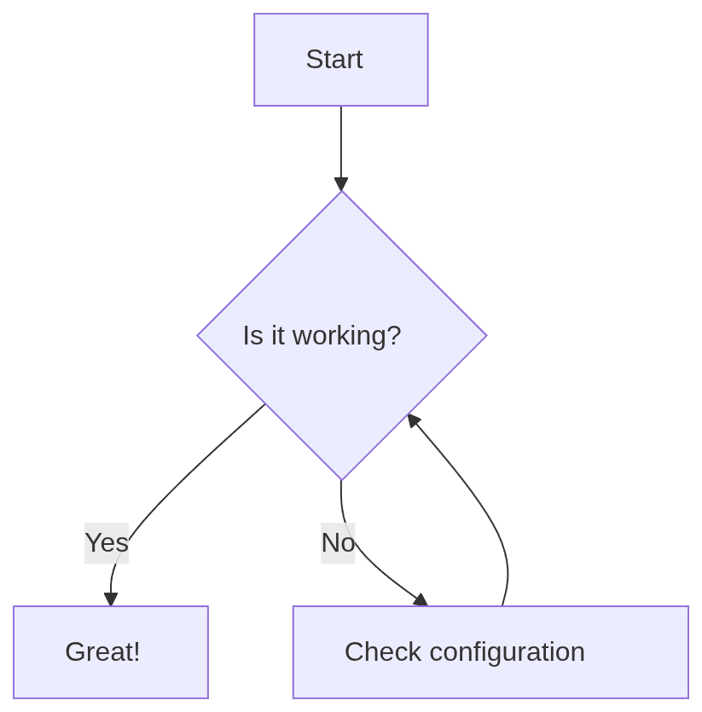
diagram

End of Benchmark File

