Parking App Manual Book



Disusun oleh

M. Ammar Fadhlur Rahman

1507506

Rd. M. Arman Blanesta Widjajapradja

1005231

Program Studi Ilmu Komputer, Departemen Pendidikan Ilmu Komputer

Fakultas Pendidikan Matematika dan Ilmu Pengetahuan Alam

Universitas Pendidikan Indonesia

2017

**Cara Penggunaan Program**

1. Main Menu

Main menu adalah antarmuka yang akan muncul pada saat pertama kali membuka aplikasi.

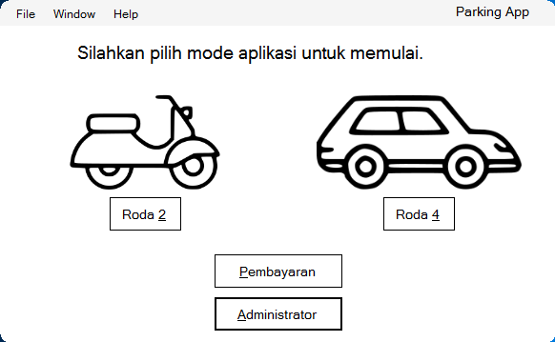

1. Motor

Ketika sudah muncul halaman Main Menu, anda bisa memilih jenis kendaraan baik itu Motor ataupun Mobil. Dalam hal ini, kita akan mencoba masuk ke menu motor

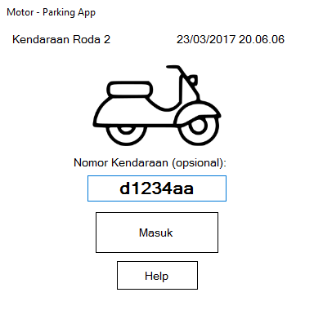

Setelah memilih menu motor, maka tampilan yang akan muncul adalah sebagai berikut. Disana kita bisa langsung memasukkan plat nomor, lalu akan muncul pop-up seperti dibawah ini

1. Nomor Tiket

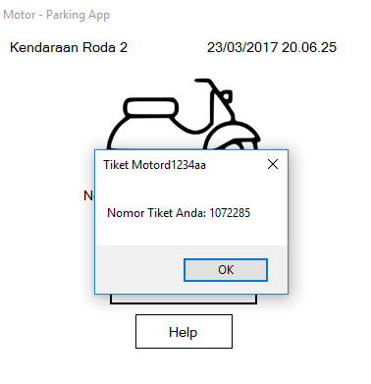

Pop-up yang menampilkan nomor tiket anda akan muncul. Pada program ini diasumsikan bahwa setiap orang yang telah menerima nomor tiket, akan mendapatkan kertas untuk digunakan pada saat pembayaran. Database nomor tiket, plat nomor, dan waktu masuk-keluar akan disimpan dalam bentuk txt.

Pop-up ini akan muncul selama 3 detik dan menghilang dengan sendirinya.

1. Help

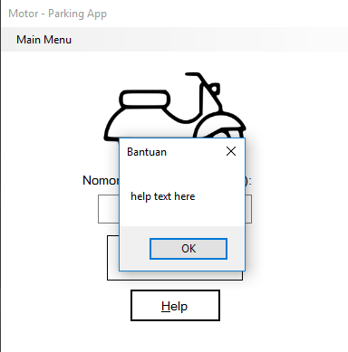

Setelah pop-up menghilang, anda dapat memilih tombol help untuk meminta bantuan staff parker.

1. Cara kembali

Untuk kembali ke main menu, anda harus memencet tombol Alt terlebih dahulu, lalu menu di sebelah kiri atas akan muncul seperti gambar dibawah ini:

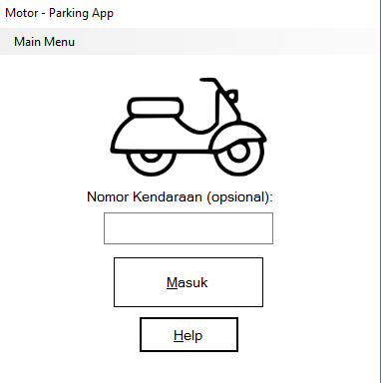

Setelah anda memilih tombol Main Menu, maka akan kembali ke menu semula dimana anda dapat memilih kembali jenis kendaraan.

1. Mobil dan Nomor Tiket

Menu pada mobil pun akan muncul dan menampilkan proses yang sama dengan motor, yang menjadi pembeda hanyalah tarif parkir perjamnya.

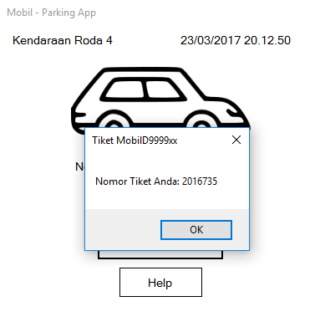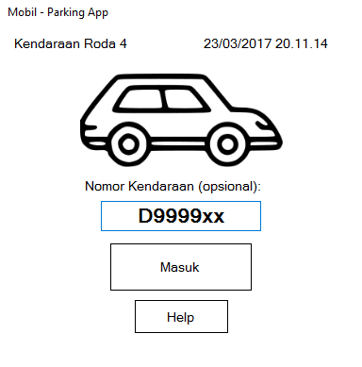

1. Admin, Admin View

Ketika di Main Menu, terdapat menu Administrator dan juga pembayaran. fungsi administrator pada program ini adalah untuk melihat daftar dan detail kendaraan yang telah masuk dan keluar.

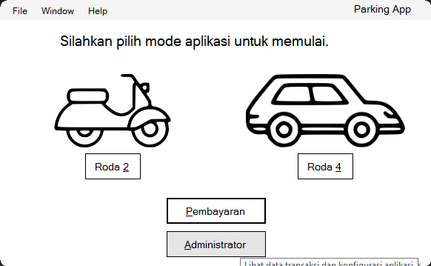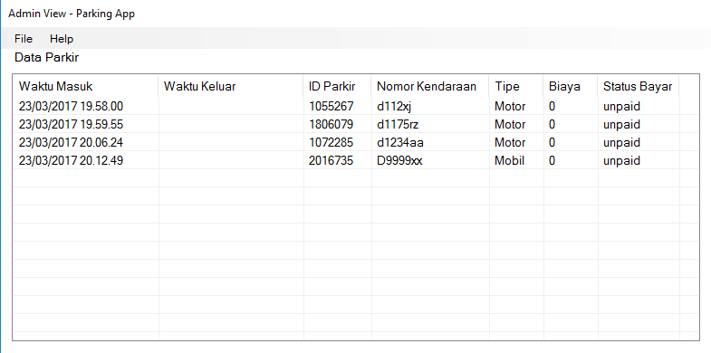

1. Pembayaran

Menu pembayaran adalah menu yang dapat dilihat ketika kendaraan akan keluar. Kotak akan diisi dengan nomor tiket. Setelah nomor tiket diisi, maka halaman detail pembayaran akan muncul untuk memberikan informasi transaksi.

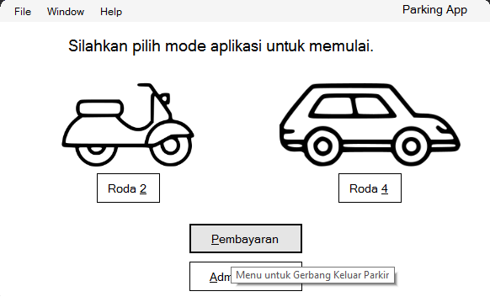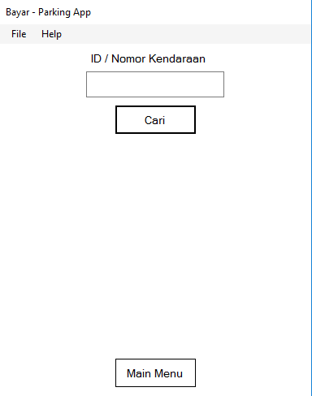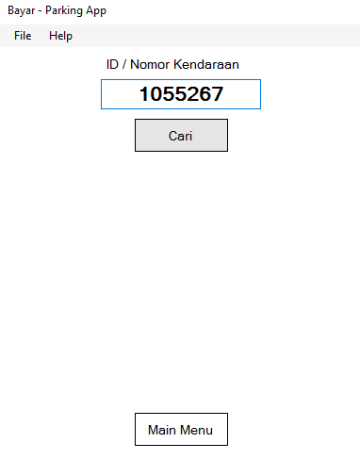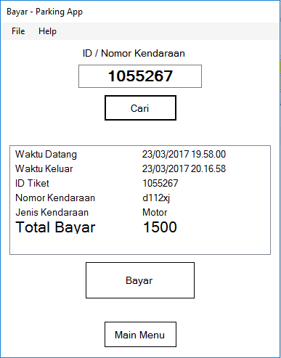

**Script Program**

1. Main menu form

using System;

using System.Windows.Forms;

using System.Runtime.InteropServices;

namespace Parking_App

{

public partial class MainForm : Form

{

[DllImport("Gdi32.dll", EntryPoint = "CreateRoundRectRgn")]

private static extern IntPtr CreateRoundRectRgn

(

int nLeftRect, // x-coordinate of upper-left corner

int nTopRect, // y-coordinate of upper-left corner

int nRightRect, // x-coordinate of lower-right corner

int nBottomRect, // y-coordinate of lower-right corner

int nWidthEllipse, // height of ellipse

int nHeightEllipse // width of ellipse

);

public MainForm()

{

InitializeComponent();

Region = System.Drawing.Region.FromHrgn(CreateRoundRectRgn(0, 0, Width, Height, 20, 20));

}

private void administratorButton_Click(object sender, EventArgs e)

{

(new AdminForm()).Show();

Hide();

}

private void paymentButton_Click(object sender, EventArgs e)

{

(new PaymentForm()).Show();

Hide();

}

private void carBox_Click(object sender, EventArgs e)

{

(new MobilForm()).Show();

Hide();

}

private void motorcycleBox_Click(object sender, EventArgs e)

{

(new MotorForm()).Show();

Hide();

}

private void exitToolStripMenuItem_Click(object sender, EventArgs e)

{

Close();

}

private void helpToolStripMenuItem1_Click(object sender, EventArgs e)

{

Parking_App.AutoClosingMessageBox.Show("help text here", "Bantuan", 2000);

}

private void aboutToolStripMenuItem_Click(object sender, EventArgs e)

{

Parking_App.AutoClosingMessageBox.Show("about text here", "Tentang", 2000);

}

private void roda2ToolStripMenuItem_Click(object sender, EventArgs e)

{

motorcycleBox_Click(sender, e);

}

private void roda4ToolStripMenuItem_Click(object sender, EventArgs e)

{

carBox_Click(sender, e);

}

private void pembayaranToolStripMenuItem_Click(object sender, EventArgs e)

{

paymentButton_Click(sender, e);

}

private void administratorToolStripMenuItem_Click(object sender, EventArgs e)

{

administratorButton_Click(sender, e);

}

private void MainForm_Load(object sender, EventArgs e)

{

}

}

}

1. Motor Form

using System;

using System.Windows.Forms;

namespace Parking_App

{

public partial class MotorForm : Form

{

private bool _altF4Pressed;

public MotorForm()

{

InitializeComponent();

}

private void helpBtn_Click(object sender, EventArgs e)

{

Parking_App.AutoClosingMessageBox.Show("help text here", "Bantuan", 2000);

}

private void MotorForm_KeyDown(object sender, KeyEventArgs e)

{

if (e.Alt) menuStrip.Visible = !menuStrip.Visible;

if (e.Alt && e.KeyCode == Keys.F4)

_altF4Pressed = true;

}

private void mainMenuToolStripMenuItem_Click(object sender, EventArgs e)

{

MainForm mf = Application.OpenForms["MainForm"] as MainForm;

if (mf != null) mf.Show();

Close();

}

private void MotorForm_Load(object sender, EventArgs e)

{

timeLabel.Text = DateTime.Now.ToString();

}

private void timer_Tick(object sender, EventArgs e)

{

timeLabel.Text = DateTime.Now.ToString();

}

private void masukBtn_Click(object sender, EventArgs e)

{

Int32 id = 1000000 + (new Random()).Next(1, 999999);

(new Transaction()).masuk(DateTime.Now, id, vehicleNumberTextBox.Text, "Motor", 0);

Parking_App.AutoClosingMessageBox.Show("Nomor Tiket Anda: " + id, "Tiket Motor" + vehicleNumberTextBox.Text, 3000);

vehicleNumberTextBox.Clear();

}

private void MotorForm_FormClosing(object sender, FormClosingEventArgs e)

{

if (_altF4Pressed)

{

if (e.CloseReason == CloseReason.UserClosing)

e.Cancel = true;

_altF4Pressed = false;

mainMenuToolStripMenuItem_Click(sender, e);

}

}

}

}

1. Mobil Form

using System;

using System.Windows.Forms;

namespace Parking_App

{

public partial class MobilForm : Form

{

private bool _altF4Pressed;

public MobilForm()

{

InitializeComponent();

}

private void MobilForm_Load(object sender, EventArgs e)

{

timeLabel.Text = DateTime.Now.ToString();

}

private void helpBtn_Click(object sender, EventArgs e)

{

Parking_App.AutoClosingMessageBox.Show("help text here", "Bantuan", 2000);

}

private void menuStrip_KeyDown(object sender, KeyEventArgs e)

{

}

private void mainMenuToolStripMenuItem_Click(object sender, EventArgs e)

{

MainForm mf = Application.OpenForms["MainForm"] as MainForm;

if (mf != null) mf.Show();

Close();

}

private void timer_Tick(object sender, EventArgs e)

{

timeLabel.Text = DateTime.Now.ToString();

}

private void masukBtn_Click(object sender, EventArgs e)

{

Int32 id = 2000000 + (new Random()).Next(1, 999999);

(new Transaction()).masuk(DateTime.Now, id, vehicleNumberTextBox.Text, "Mobil", 0);

Parking_App.AutoClosingMessageBox.Show("Nomor Tiket Anda: " + id, "Tiket Mobil" + vehicleNumberTextBox.Text, 3000);

vehicleNumberTextBox.Clear();

}

private void MobilForm_FormClosing(object sender, FormClosingEventArgs e)

{

if (_altF4Pressed)

{

if (e.CloseReason == CloseReason.UserClosing)

e.Cancel = true;

_altF4Pressed = false;

mainMenuToolStripMenuItem_Click(sender, e);

}

}

private void MobilForm_KeyDown(object sender, KeyEventArgs e)

{

if (e.Alt) menuStrip.Visible = !menuStrip.Visible;

if (e.Alt && e.KeyCode == Keys.F4)

_altF4Pressed = true;

}

}

}

1. Admin Form

using System;

using System.Windows.Forms;

using System.IO;

namespace Parking_App

{

public partial class AdminForm : Form

{

public AdminForm()

{

InitializeComponent();

}

private void backButton_Click(object sender, EventArgs e)

{

MainForm mf = Application.OpenForms["MainForm"] as MainForm;

if (mf != null) mf.Show();

Close();

}

private void exitToolStripMenuItem_Click(object sender, EventArgs e)

{

MainForm mf = Application.OpenForms["MainForm"] as MainForm;

if (mf != null) mf.Close();

Close();

}

private void AdminForm_Load(object sender, EventArgs e)

{

string defaultPath = Environment.GetFolderPath(Environment.SpecialFolder.ApplicationData) + "\\ParkingApp-transaction.csv";

if (defaultPath != "")

{

// Baca file dan simpan textnya di variabel data

if (File.Exists(Path.Combine(Environment.GetFolderPath(Environment.SpecialFolder.ApplicationData), "ParkingApp-transaction.csv")))

{

using (StringReader data = new StringReader(File.ReadAllText(defaultPath)))

{

string row;

while ((row = data.ReadLine()) != null)

{

string[] columns = row.Split(',');

// buat objek ListViewItem, diisi dengan kolom pertama

ListViewItem lvi = new ListViewItem(columns[0]);

// isi dengan kolom selanjutnya

for (int i = 1; i <= 6; i++)

{

lvi.SubItems.Add(columns[i]);

}

// tambahkan objek ListViewItem ke ListView

listView1.Items.Add(lvi);

}

}

}

}

}

private void mainMenuToolStripMenuItem_Click(object sender, EventArgs e)

{

backButton_Click(sender, e);

}

private void AdminForm_KeyDown(object sender, KeyEventArgs e)

{

if (e.Alt && e.KeyCode == Keys.F4) backButton_Click(sender, e);

}

private void helpToolStripMenuItem_Click(object sender, EventArgs e)

{

Parking_App.AutoClosingMessageBox.Show("help text here", "Bantuan", 2000);

}

}

}

1. Payment Form

using System;

using System.Text;

using System.Windows.Forms;

using System.IO;

namespace Parking_App

{

public partial class PaymentForm : Form

{

public PaymentForm()

{

InitializeComponent();

}

private void textBox1_TextChanged(object sender, EventArgs e)

{

}

private void backButton_Click(object sender, EventArgs e)

{

MainForm mf = Application.OpenForms["MainForm"] as MainForm;

if (mf != null) mf.Show();

Close();

}

private void exitToolStripMenuItem_Click(object sender, EventArgs e)

{

MainForm mf = Application.OpenForms["MainForm"] as MainForm;

if (mf != null) mf.Close();

Close();

}

private void helpToolStripMenuItem_Click(object sender, EventArgs e)

{

Parking_App.AutoClosingMessageBox.Show("help text here", "Bantuan", 2000);

}

private void cariButton_Click(object sender, EventArgs e)

{

if (String.IsNullOrEmpty(vehicleNumberTextBox.Text)) { return; }

string id = vehicleNumberTextBox.Text;

StringBuilder data = new StringBuilder();

if (File.Exists(Path.Combine(Environment.GetFolderPath(Environment.SpecialFolder.ApplicationData), "ParkingApp-transaction.csv")))

{

using (StringReader saved = new StringReader(File.ReadAllText(Path.Combine(Environment.GetFolderPath(Environment.SpecialFolder.ApplicationData), "ParkingApp-transaction.csv"))))

{

string row;

while ((row = saved.ReadLine()) != null)

{

string[] columns = row.Split(',');

if (columns[2] == id || columns[3] == id)

{

DateTime startTime = DateTime.Now;

DateTime endTime = DateTime.Now;

DateTime.TryParse(columns[0], out startTime);

columns[1] = endTime.ToString();

columns[5] = Convert.ToString((new Transaction()).calculateParkingCost(startTime, endTime, columns[4]));

// insert to listview as sub item

resultListView.Items[0].SubItems.Add(startTime.ToString());

resultListView.Items[1].SubItems.Add(endTime.ToString());

resultListView.Items[2].SubItems.Add(columns[2]);

resultListView.Items[3].SubItems.Add(columns[3]);

resultListView.Items[4].SubItems.Add(columns[4]);

resultListView.Items[5].SubItems.Add(columns[5]);

errorLabel.Hide();

resultListView.Show();

bayarButton.Show();

}

else { if (!resultListView.Visible) { errorLabel.Show(); } }

data.Append(string.Join(",", columns));

data.AppendLine();

}

}

}

File.WriteAllText(Path.Combine(Environment.GetFolderPath(Environment.SpecialFolder.ApplicationData), "ParkingApp-transaction.csv"), data.ToString());

}

private void bayarButton_Click(object sender, EventArgs e)

{

vehicleNumberTextBox.Clear();

resultListView.Hide();

bayarButton.Hide();

string id = vehicleNumberTextBox.Text;

StringBuilder data = new StringBuilder();

if (File.Exists(Path.Combine(Environment.GetFolderPath(Environment.SpecialFolder.ApplicationData), "ParkingApp-transaction.csv")))

{

using (StringReader saved = new StringReader(File.ReadAllText(Path.Combine(Environment.GetFolderPath(Environment.SpecialFolder.ApplicationData), "ParkingApp-transaction.csv"))))

{

string row;

while ((row = saved.ReadLine()) != null)

{

string[] columns = row.Split(',');

if (columns[2] == id || columns[3] == id)

{

columns[6] = "paid";

}

data.Append(string.Join(",", columns));

data.AppendLine();

}

}

}

File.WriteAllText(Path.Combine(Environment.GetFolderPath(Environment.SpecialFolder.ApplicationData), "ParkingApp-transaction.csv"), data.ToString());

}

private void PaymentForm_KeyDown(object sender, KeyEventArgs e)

{

if (e.Alt && e.KeyCode == Keys.F4) backButton_Click(sender, e);

}

private void mainMenuToolStripMenuItem_Click(object sender, EventArgs e)

{

backButton_Click(sender, e);

}

private void vehicleNumberTextBox_KeyDown(object sender, KeyEventArgs e)

{

if (e.KeyCode == Keys.Enter) { cariButton_Click(this, new EventArgs()); }

}

private void PaymentForm_Load(object sender, EventArgs e)

{

}

}

}