|  |  |
| --- | --- |
| **Assignment Case** |  |
| ISYS6123003  Introduction to Database Systems |
| **Information Systems** | **O223-ISYS6123-LC03202-01** |
| ***Valid on*** *Odd Semester Year 2021/2022* | **Revision 00** |

1. Seluruh mahasiswa tidak diperkenankan untuk:

*All students are not allowed to:*

* + 1. Berdiskusi dan/atau bekerja sama dengan mahasiswa lainnya

*Discuss and/or work together with other student participants*

* + 1. Melihat sebagian atau seluruh jawaban mahasiswa lain

*Seeing a part or the whole answer from another student*

* + 1. Membuka dan menyalin dari **BUKU** atau **CATATAN**, **VIDEO** dari pengajar (recording kelas, VBL, Youtube, dsb) dan **REFERENSI** lainnya

*Open and copy from any resources such as notes, videos (class recording, VBL, Youtube, etc) and other references*

* + 1. Membuka dan menyalin jawaban dari internet (google, stackoverflow, dsb)

*Open and copy answer from the internet (google, stackoverflow, etc)*

* + 1. Mengerjakan soal yang tidak sesuai dengan tema yang ada di soal,

*Working with another theme which is not in accordance with the existing theme in the matter of the case,*

* + 1. Melakukan tindakan kecurangan lainnya,

*Committing other dishonest actions,*

* + 1. Secara sengaja maupun tidak sengaja melakukan segala tindakan kelalaian yang menyebabkan hasil karyanya berhasil dicontek oleh orang lain / kelompok lain.

*Accidentally or intentionally conduct any failure action that cause the results of the project was copied by someone else / other groups.*

1. Jika mahasiswa terbukti melakukan tindakan seperti yang dijelaskan butir 1 di atas, maka **nilai mahasiswa** yang melakukan kecurangan (menyontek maupun dicontek) akan di – **NOL** – kan.

*If the student is proved to the actions described in point 1 above, the score of the student which committed dishonest acts (cheating or being cheated) will be “Zero”*

1. Perhatikan jadwal pengumpulan jawaban, segala jenis pengumpulan jawaban di luar jadwal tidak dilayani.

*Pay attention to the submission schedule, all kinds of submission outside the schedule will not be accepted*

1. Bila Anda tidak membaca peraturan ini, maka Anda dianggap telah membaca dan menyetujuinya

*If you have missed to read these regulations, so you are considered to have read and agreed on it*

1. Persentase penilaiaan untuk matakuliah ini adalah sebagai berikut:

*Marking percentage for this subject is described as follows:*

|  |  |  |
| --- | --- | --- |
| **Tugas Mandiri**  *Assignment* | **Proyek**  *Project* | **UAP**  *Final Exam* |
| 40% | 60% | 0% |

1. Software yang digunakan pada matakuliah ini adalah sebagai berikut:

*Software will be used in this subject are described as follows:*

|  |
| --- |
| **Software**  *Software* |
| SQL Server Management Studio 18.5.1  SQL Server Developer 2019  Microsoft Office 365  Visual Paradigm Community Edition 16.1 |

## Ekstensi file yang harus disertakan dalam pengumpulan tugas mandiri, proyek, dan uap untuk matakuliah ini adalah sebagai berikut:

*File extensions should be included in assignment and project collection for this subject are described as follows:*

|  |  |  |
| --- | --- | --- |
| **Tugas Mandiri**  *Assignment* | **Proyek**  *Project* | **UAP**  *Final Exam* |
| SQL | SQL, VPP, Image Files (JPG / PNG) | SQL |

## Tabel Relasional

*Relational Table*

**BlueJack Coin Market**

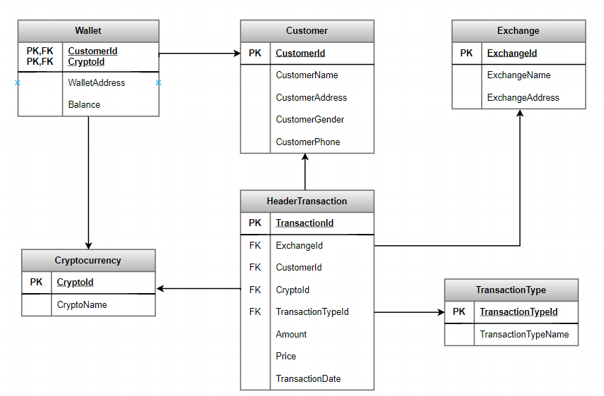

## Soal

*Case*

1. Create a table named ‘Staff’ with the following descriptions:

(**create table**, **like, or)**

|  |  |  |  |
| --- | --- | --- | --- |
| **Field Name** | **Data Type** | **Length** | **Description** |
| StaffId | CHAR | 5 | Primary key. And must start with ‘ST’ and followed by 3 digits of number. Example: **ST001** |
| StaffName | VARCHAR | 100 | Cannot be empty |
| StaffGender | VARCHAR | 20 | Cannot be empty. And StaffGender must be ‘**Male**’ or ‘**Female**’ |
| StaffSalary | INT |  | Cannot be empty |

1. Add a new column on **Exchange** tablenamed **ExchangeWebsite** with **varchar**(**75**) data type. Then add a constraint on **Exchange** table to validate that **ExchangeWebsite** length must between **10 and 75**.

**(alter table, add, add constraint, len, between)**

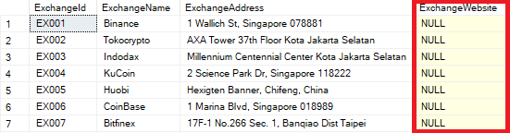

1. Insert these data into **Customer** table:

**(Insert)**

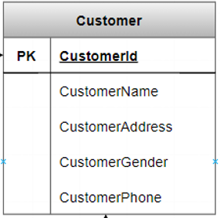

|  |  |  |  |  |
| --- | --- | --- | --- | --- |
| **CustomerId** | **Name** | **CustomerAddress** | **CustomerGender** | **Phone** |
| CU006 | Elon Musk | Jl Raya Serpong No. 3, Serpong | Male | 08181183333 |

1. Display CustomerId, CryptoId, Amount, and Price for every transaction that occurs on odd months.

**(Month)**

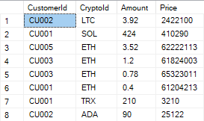

1. Update CustomerPhone from **Customer** table for every customer who has done transaction on **4th** day **into** ‘08185313713’.

**(Update, Day)**

**Before** update:

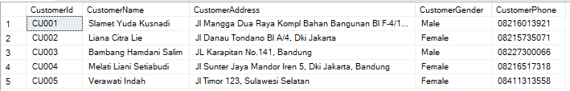

**After** update:

