**Tabel Relasional**

*Relational Table*

**MouseAN Shop**

**MouseAN Shop** is a Famous Mouse shop that located in Jakarta. **MouseAN** provides **transaction** for every **customer** who wants to **buy a good quality mouse** and will be handled by a **Cashier**. **MouseAN Shop** alsoprovidesmany kinds of Mouse. Here is the **Entity Relationship Diagram (ERD)** of **transaction** in **MouseAN Shop:**

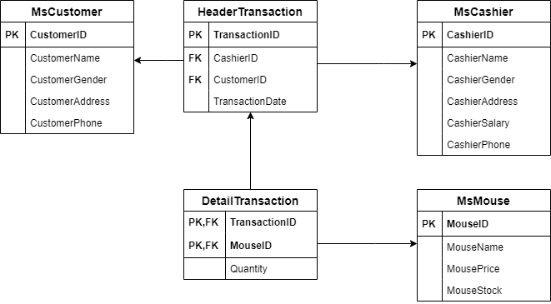

**Soal**

*Case*

1. Create a table named ‘**MsTypeMouse’** with the following descriptions :

**(create table, like)**

|  |  |  |  |
| --- | --- | --- | --- |
| **Column Name** | **Data Types** | **Length** | **Description** |
| TypeID | CHAR | 5 | Primary key and TypeMouseID must be started with ‘**TY**’ and followed by 3 digits of number. Example: TY001.  Cannot be empty. |
| TypeName | VARCHAR | 20 | Must be started with ‘**Mouse** ’.  Cannot be empty. |
| TypeDescription | VARCHAR | 255 | Cannot be empty. |

1. Add new column on **MsCashier** table named **CashierEmail** with **varchar(20)** data type and add a constraint on **MsCashier** table to validate that **CashierEmail** must be ended with ‘**.com**’.

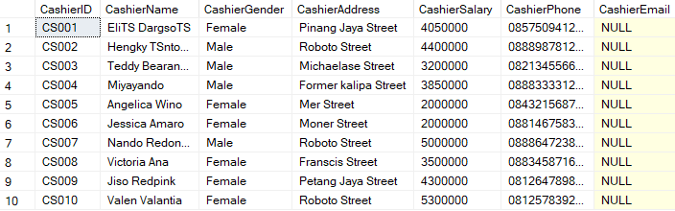 **(alter table, add, add constraint, like)**

1. Insert these data into **MsCustomer** table:

**(insert)**

|  |  |  |
| --- | --- | --- |
| **MsCustomer** | | |
| **PK** | **CustomerID** | **CHAR (5)** |
|  | CustomerName | VARCHAR (30) |
| CustomerGender | VARCHAR (10) |
| CustomerAddress | VARCHAR (100) |
| CustomerPhone | VARCHAR (15) |

|  |  |  |  |  |
| --- | --- | --- | --- | --- |
| **CustomerId** | **CustomerName** | **CustomerGender** | **CustomerAddress** | **CustomerPhone** |
| CU011 | Stefanus  Geory Michael | Male | 57, King Cobra Street | 08980418508 |

1. Display CustomerName, CustomerAddress, and CustomerGender for every Customer whose first letter of the name is started with the letter ‘A’.

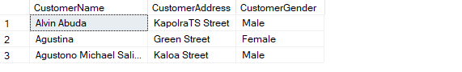**(like)**

1. Increase CashierSalary by 50000 on **MsCashier** table for every Cashier has done transaction on 6th month.

**(update, month)**

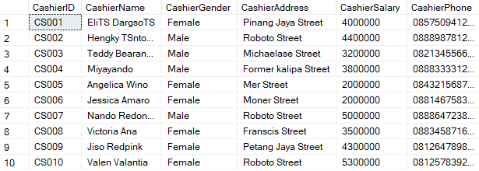**Before** update:

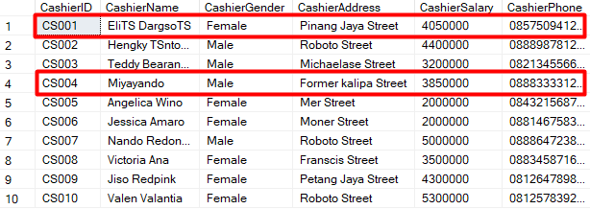 **After** update: