**Tabel Relasional**

*Relational Table*

**Music Store**

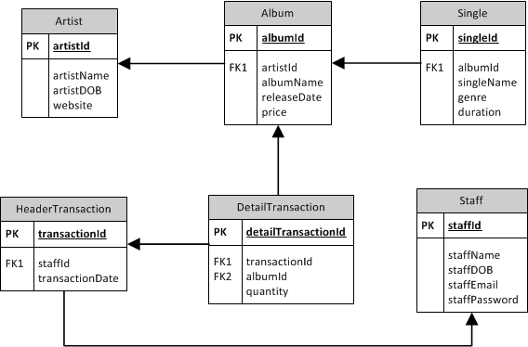

## 

## Soal

*Case*

1. Create table named **Customer** with the following description.  
   (**create** **table**, **like**)

|  |  |  |  |
| --- | --- | --- | --- |
| **Field Name** | **Data Type** | **Length** | **Notes** |
| customerId | CHAR | 5 | Primary key and customerId must be started with ‘CS’ and followed by 3 digits of number.  Example: CS001 |
| customerName | VARCHAR | 70 | Can’t be empty and customerName character length must be between 5 and 70 |
| customerDOB | DATE | - | Can’t be empty. |
| customerEmail | VARCHAR | 254 | Can’t be empty. |
| customerPassword | VARCHAR | 128 | Can’t be empty. |

1. Add a new column on **Staff** table named **staffAddress** with varchar (255) data type. Then add constraint to make sure that the staff’s email ends with ‘@musicstr.com’.  
   (**alter** **table**, **add**, **add** **constraint**, **like**)  
   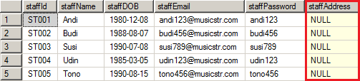
2. Insert the following data into **Artist** table.  
   (**insert**)  
   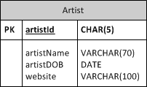

|  |  |  |  |
| --- | --- | --- | --- |
| **ID** | **Name** | **Date of Birth** | **Website** |
| AR011 | Bruno Mars | 08 October 1985 | brunomars.com |

1. Display Name (obtained from albumName in uppercase format) and Price for every album which price is greater than 180000.  
   (**upper**)  
   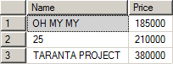
2. Update data on **Album** table to increase price by 8000 for every album whose artist was born on 1988.  
   (**update**, **year**)  
   **Before** update:  
   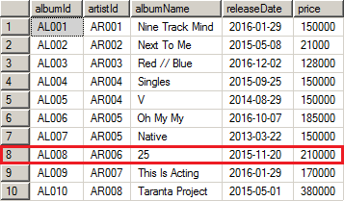  
     
   **After** update:  
   