Tabel Relasional
Relational Table

VOkin

VOkin is an offline store local skin care brand that selling variant types of skin care, such as face cleanser, face mask, face serum, face oil, face scrub, etc. VOkin presents with vegan, cruelty-free, and natural ingredients concept. VOkin also provides sales transaction for every customer that wants to buy skin care product and handled by a staff. The customer can buy more than one skin care product in a single transaction.

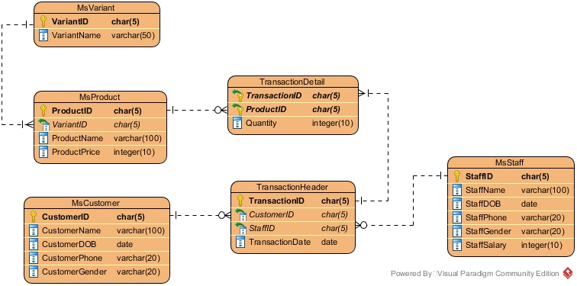

Figure 1 ERD

Soal
Case

- Create a table named ‘MsBranch’ with the following description:
(CREATE TABLE, LIKE)
Field Name | Data Type | Length | Description
BranchID | CHAR | 5 | - Primary Key.  - BranchID must be started with ‘BR’ and followed by 3 characters of number.  Example: BR001
BranchName | VARCHAR | 100 | - Cannot be empty.
BranchAddress | VARCHAR | 100 | - Cannot be empty.  - BranchAddress must contains ‘Street’ word.

- Add ‘CustomerEmail’ as new column on MsCustomer table with varchar data type and the length is 50. After that, add a constraint on MsCustomer table for ‘CustomerEmail’ must ends with ‘@gmail.com’ or ‘@yahoo.com’.
(ALTER TABLE, ADD, ADD CONSTRAINT, LIKE)
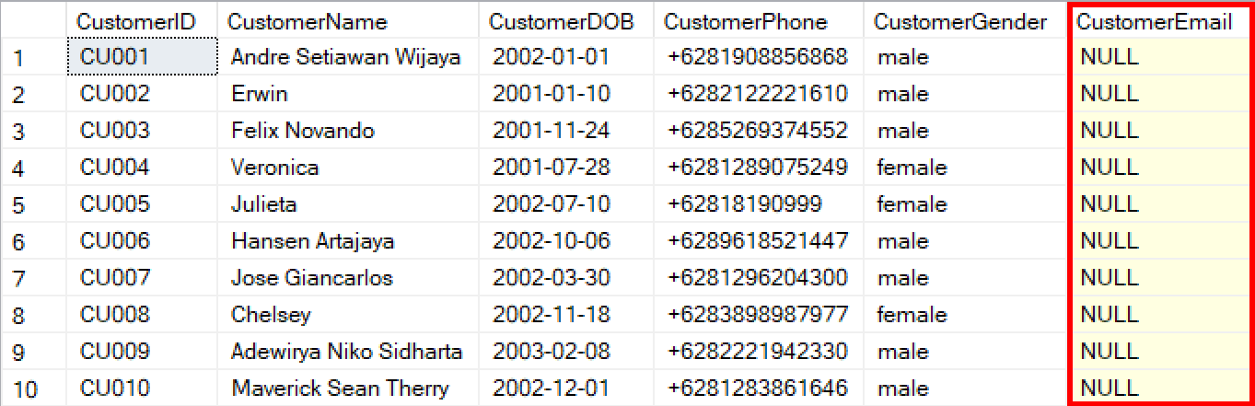

- Insert these data into MsStaff table:
(INSERT)
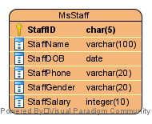
StaffID | StaffName | StaffDOB | StaffPhone | StaffGender | StaffSalary
ST011 | Felix | 1999-8-18 | +628228378387 | male | 10000000

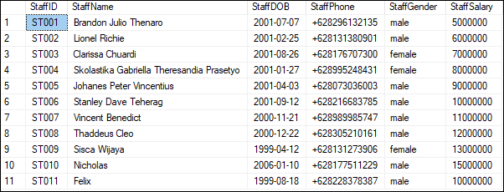

- Display ProductName (obtained from ProductName in uppercase format), and ProductPrice for every product which the price more than or equals 150000.
(UPPER)
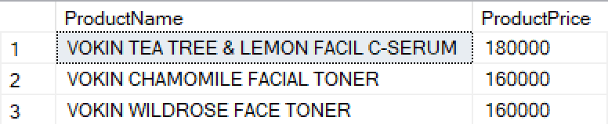

- Delete product data from MsProduct table for every product that has variant name is ‘hydrating’.
(DELETE, LIKE)
Before delete:
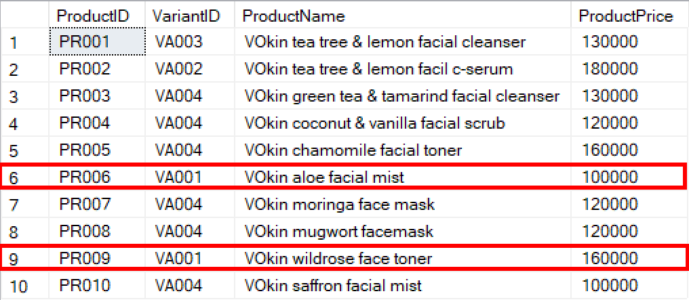
After delete:
