Exercice3:

Containerize an application:

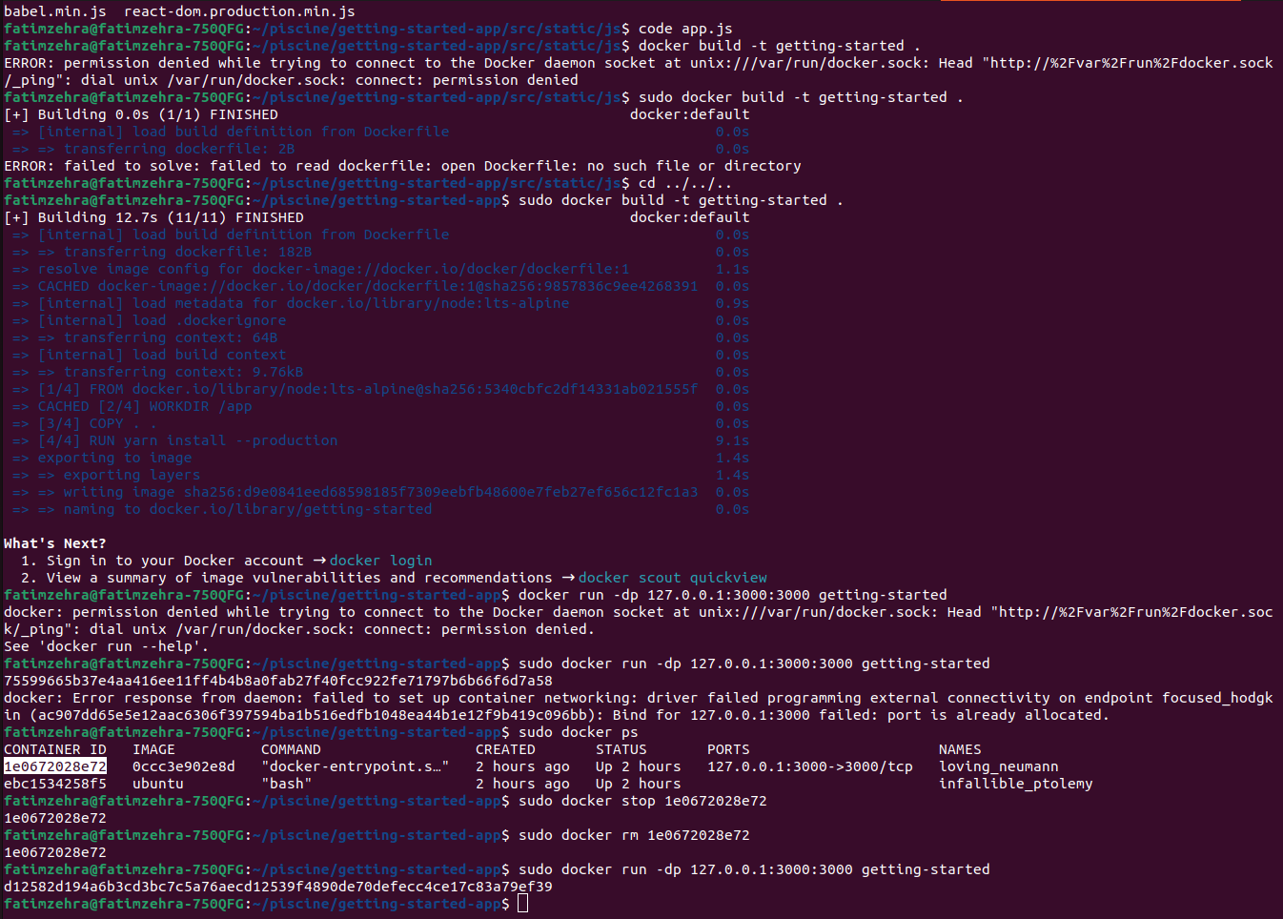
By apdating the code in the file app.js to change previous line “No items yet!Add one above!”
with” You have no todo items yet! Add one above!”
and running the port 3000 in the browser we get :

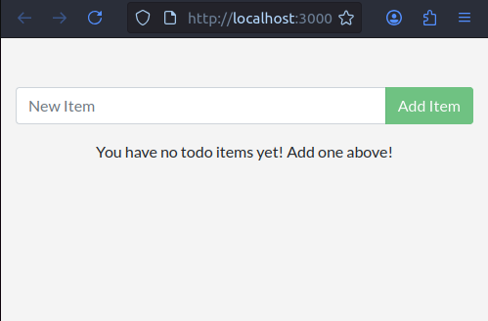
- Sharing images by pushing them to a registry:

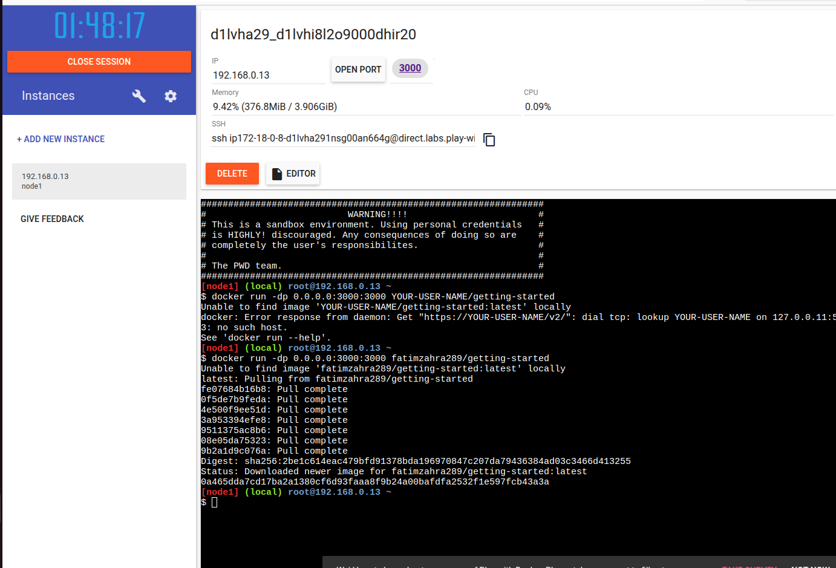

- MySQL:
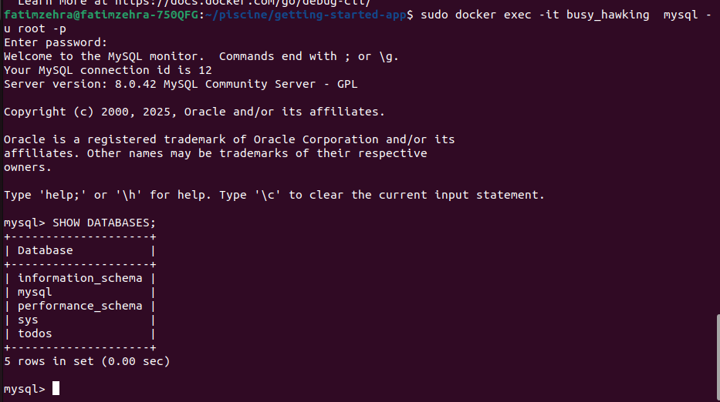

Connect to mySQL:
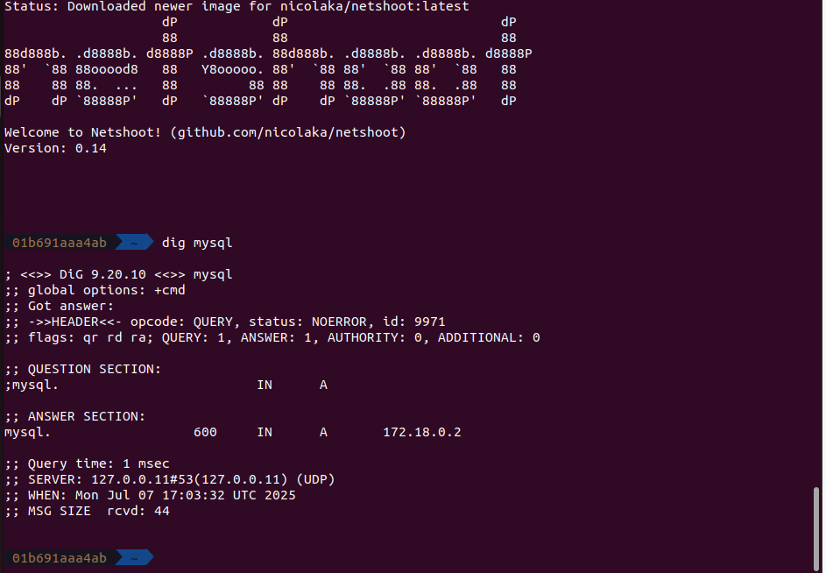

- Running the app with mySQL:

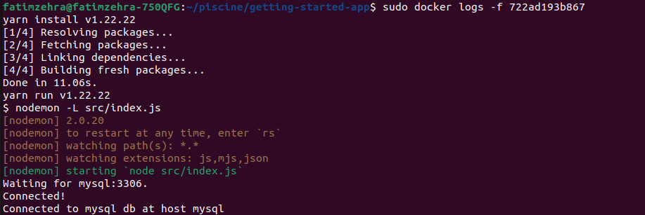

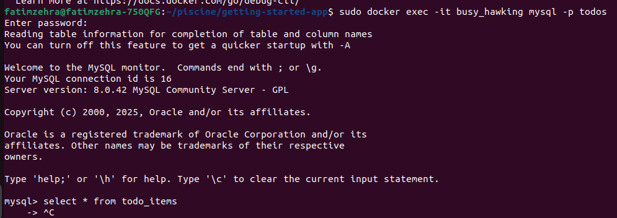
After adding the items : try,success,congrats:
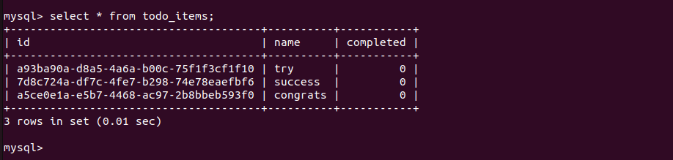

- The file : Compose.yaml

