**CMPE362 - HOMEWORK 1**

**Question 1:**

**Code Snippet:**

1. % ------------------------ Question 1 ------------------------
3. x = -100:1:+100;
5. subplot(4,2,1)
6. y1 = sin(x);
7. plot(y1)
8. title('Subplot 1: sin(x)')
10. subplot(4,2,2);
11. y2 = sin(50*x);
12. plot(y2)
13. title('Subplot 2: sin(50*x)')

16. subplot(4,2,3);
17. y3 = 50.*sin(x);
18. plot(y3)
19. title('Subplot 3: 50*sin(x)')
21. subplot(4,2,4);
22. y4 = sin(x)+50;
23. plot(y4)
24. title('Subplot 4: sin(x)+50')
26. subplot(4,2,5);
27. y5 = sin(x+50);
28. plot(y5)
29. title('Subplot 5: sin(x+50)')
31. subplot(4,2,6);
32. y6 = 50.*sin(50*x);
33. plot(y6)
34. title('Subplot 6: 50*sin(50*x)')
36. subplot(4,2,7);
37. y7 = x.*sin(x);
38. plot(y7)
39. title('Subplot 7: x*sin(x)')
41. subplot(4,2,8);
42. y8 = sin(x)./x;
43. plot(y8)
44. title('Subplot 8: sin(x)/x')

**What did I learn?**

**I learned how adding a number to sin and multiplying sin with a number affect sin function. The differences are so clear in the figures below.**

**Figures (Q1)**

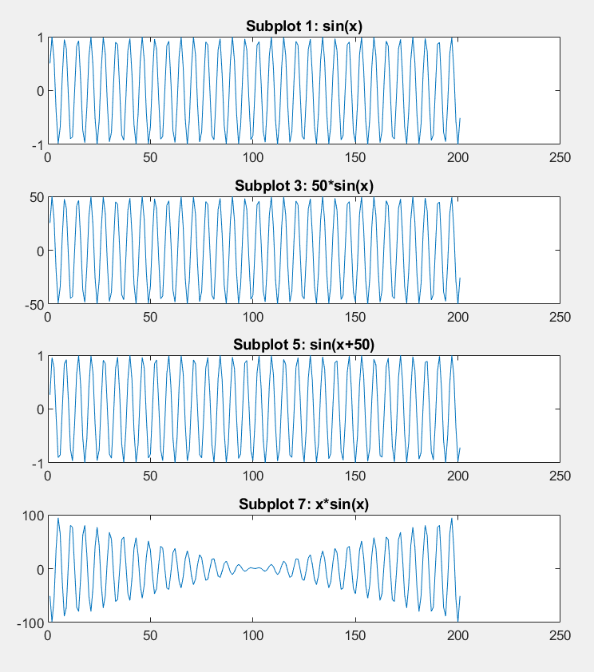

**Figures (Q1):**

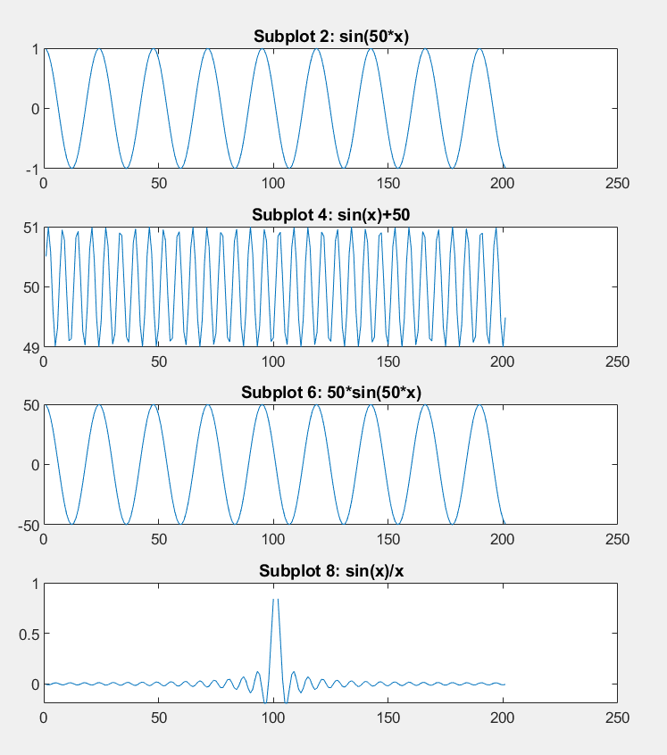

**Question 2:**

**Code Snippet:**

1. % ------------------------ Question 2 ------------------------
3. x = -20:1:+20;
5. subplot(5,2,1)
6. y1 = sin(x);
7. plot(y1)
8. title('Subplot 1: sin(x)')
10. subplot(5,2,2);
11. y2 = sin(50*x);
12. plot(y2)
13. title('Subplot 2: sin(50*x)')
15. subplot(5,2,3);
16. y3 = 50.*sin(x);
17. plot(y3)
18. title('Subplot 3: 50*sin(x)')
20. subplot(5,2,4);
21. y4 = sin(x)+50;
22. plot(y4)
23. title('Subplot 4: sin(x)+50')
25. subplot(5,2,5);
26. y5 = sin(x+50);
27. plot(y5)
28. title('Subplot 5: sin(x+50)')
30. subplot(5,2,6);
31. y6 = 50.*sin(50*x);
32. plot(y6)
33. title('Subplot 6: 50*sin(50*x)')
35. subplot(5,2,7);
36. y7 = x.*sin(x);
37. plot(y7)
38. title('Subplot 7: x*sin(x)')
40. subplot(5,2,8);
41. y8 = sin(x)./x;
42. plot(y8)
43. title('Subplot 8: sin(x)/x')
45. subplot(5,2,9);
46. y9 = y1+y2+y3+y4+y5+y6+y7+y8;
47. plot(y9)
48. title('Subplot 9: y1+y2+y3+y4+y5+y6+y7+y8')

**What did I learn?**

**This was not much different than the first question. I just reinforced what I had learned in Q1.**

**Figures (Q2):**

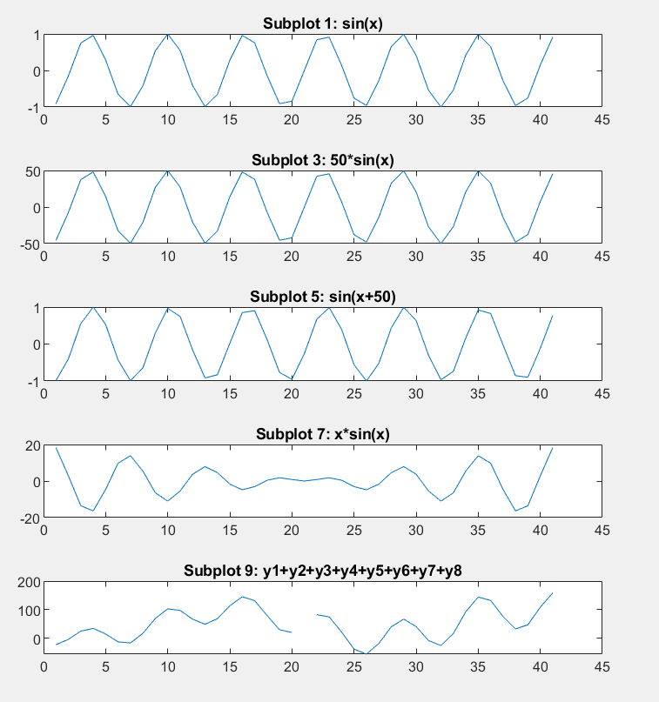

**Figures (Q2):**

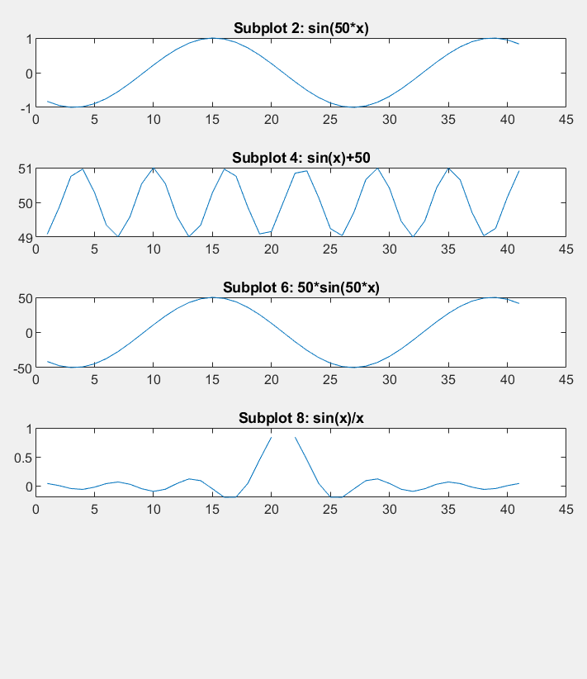

**Questions 3:**

**Code Snippet:**

1. % ------------------------ Question 3 ------------------------
3. z = randn(1, 41);
5. subplot(5,2,1)
6. y10 = z;
7. plot(y10)
8. title('Subplot 1: z')
10. subplot(5,2,2);
11. y11 = z + x;
12. plot(y11)
13. title('Subplot 2: z+x')
15. subplot(5,2,3);
16. y12 = z + sin(x);
17. plot(y12)
18. title('Subplot 3: z+sin(x)')
20. subplot(5,2,4);
21. y13 = z.*sin(x);
22. plot(y13)
23. title('Subplot 4: z*sin(x)')
25. subplot(5,2,5);
26. y14 = x.*sin(z);
27. plot(y14)
28. title('Subplot 5: x*sin(z)')
30. subplot(5,2,6);
31. y15 = sin(x+z);
32. plot(y15)
33. title('Subplot 6: sin(x+z)')
35. subplot(5,2,7);
36. y16 = z.*sin(50*x);
37. plot(y16)
38. title('Subplot 7: z*sin(50*x)')
40. subplot(5,2,8);
41. y17 = sin(x+50*z);
42. plot(y17)
43. title('Subplot 8: sin(x+50*z)')
45. subplot(5,2,9);
46. y18 = sin(x)./z;
47. plot(y18)
48. title('Subplot 9: sin(x)/z')
50. subplot(5,2,10);
51. y19 = y11+y12+y13+y14+y15+y16+y17+y18;
52. plot(y19)
53. title('Subplot 10: y11+y12+y13+y14+y15+y16+y17+y18')

**What did I learn?**

**I learned that how adding a Gaussian random variable to sin and multiplying sin with a Gaussian random variable affect the behavior of sin function.**

**Figures (Q3):**

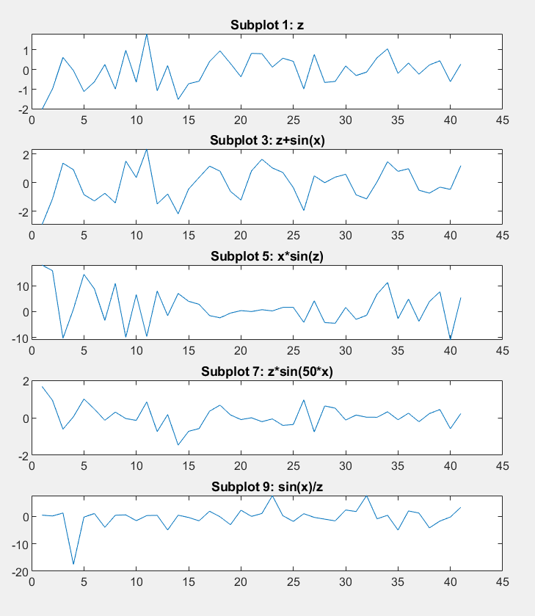

**Figures (Q3):**

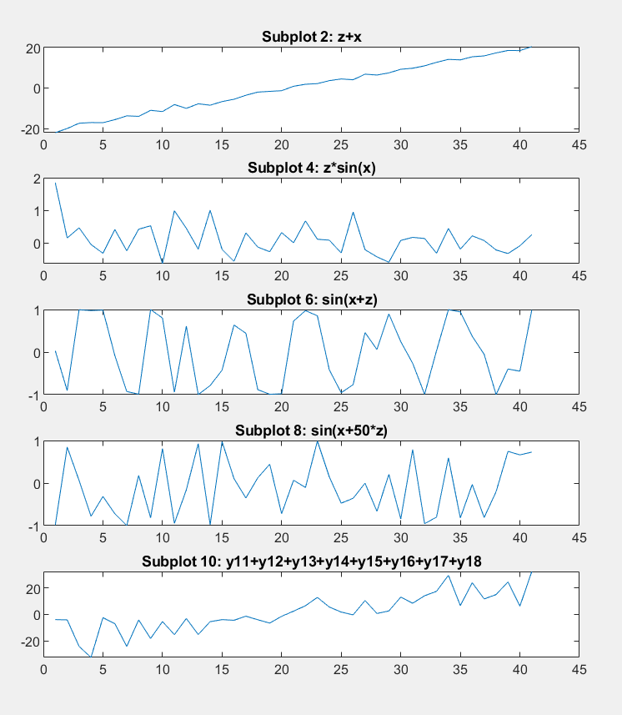

**Questions 4:**

**Code Snippet:**

1. % ------------------------ Question 4 ------------------------
3. z = rand(1,41);
5. subplot(5,2,1)
6. y20 = z;
7. plot(y20)
8. title('Subplot 1: z')
10. subplot(5,2,2);
11. y21 = z + x;
12. plot(y21)
13. title('Subplot 2: z+x')
15. subplot(5,2,3);
16. y22 = z + sin(x);
17. plot(y22)
18. title('Subplot 3: z+sin(x)')
20. subplot(5,2,4);
21. y23 = z.*sin(x);
22. plot(y23)
23. title('Subplot 4: z*sin(x)')
25. subplot(5,2,5);
26. y24 = x.*sin(z);
27. plot(y24)
28. title('Subplot 5: x*sin(z)')
30. subplot(5,2,6);
31. y25 = sin(x+z);
32. plot(y25)
33. title('Subplot 6: sin(x+z)')
35. subplot(5,2,7);
36. y26 = z.*sin(50*x);
37. plot(y26)
38. title('Subplot 7: z*sin(50*x)')
40. subplot(5,2,8);
41. y27 = sin(x+50*z);
42. plot(y27)
43. title('Subplot 8: sin(x+50*z)')
45. subplot(5,2,9);
46. y28 = sin(x)./z;
47. plot(y28)
48. title('Subplot 9: sin(x)/z')
50. subplot(5,2,10);
51. y29 = y21+y22+y23+y24+y25+y26+y27+y28;
52. plot(y29)
53. title('Subplot 10: y21+y22+y23+y24+y25+y26+y27+y28')

**What did I learn?**

**I learned that how adding a uniformly distributed random variable to sin and multiplying sin with a uniformly distributed random variable affect the behavior of sin function.**

**Figures (Q4):**

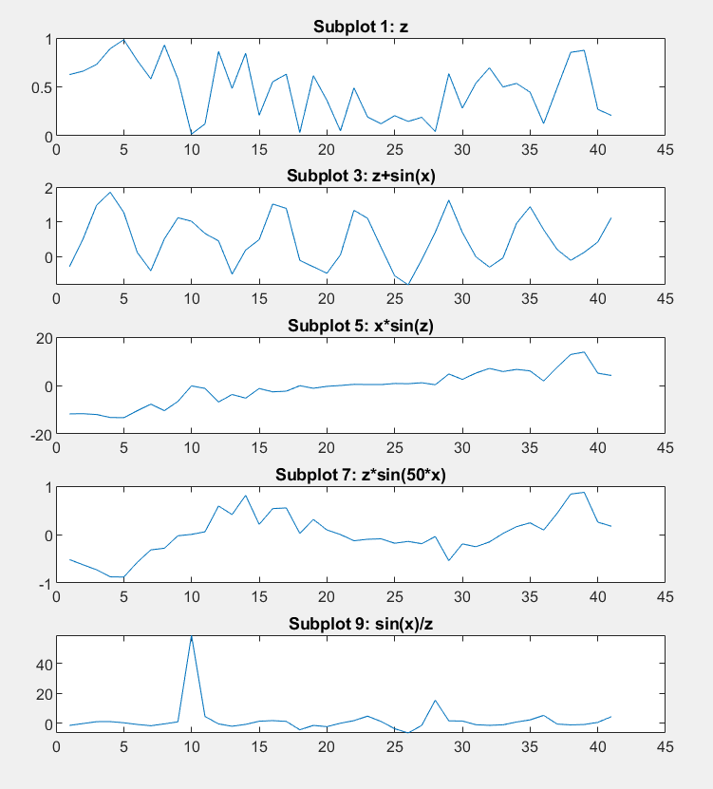

**Figures (Q4):**

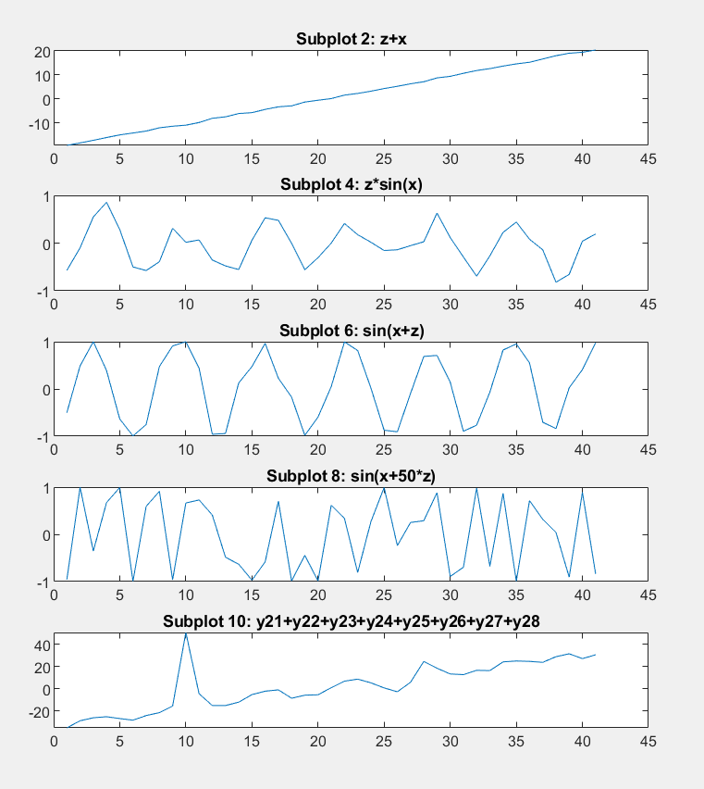

**Questions 5:**

**Code Snippet:**

1. % ------------------------ Question 5 ------------------------
3. r1 = 0 + 1.*randn(10000,1);
4. r2 = 0 + 4.*randn(10000,1);
5. r3 = 0 + 16.*randn(10000,1);
6. r4 = 0 + 256.*randn(10000,1);
8. figure
9. subplot(2,2,1)
10. hist(r1)
11. subplot(2,2,2)
12. hist(r2)
13. subplot(2,2,3)
14. hist(r3)
15. subplot(2,2,4)
16. hist(r4)

**Figures (Q5):**

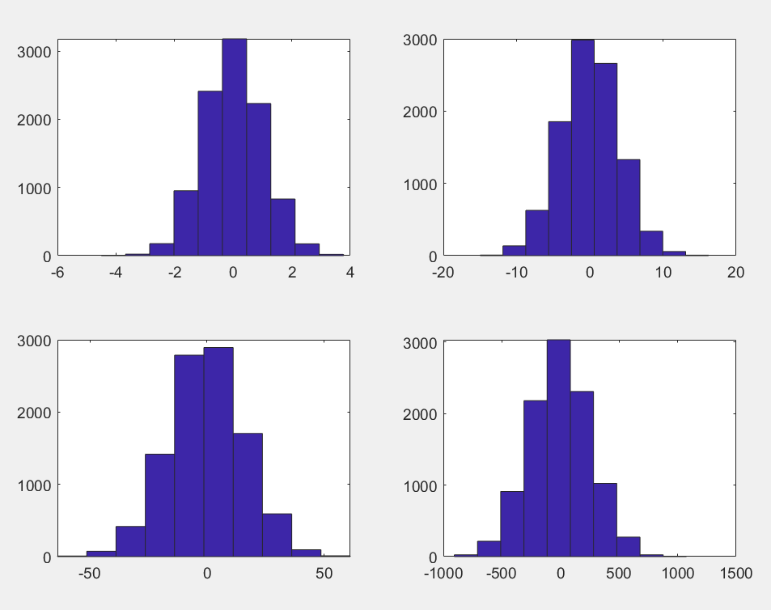

**What did I learn?**

**I learned how to transform Gaussian distribution to any normal distribution.**

**Questions 6:**

**Code Snippet:**

1. % ------------------------ Question 6 ------------------------
3. r5 = 10 + 1.*randn(10000,1);
4. r6 = 20 + 4.*randn(10000,1);
5. r7 = -10 + 1.*randn(10000,1);
6. r8 = -20 + 4.*randn(10000,1);
8. figure
9. subplot(2,2,1)
10. hist(r5)
11. subplot(2,2,2)
12. hist(r6)
13. subplot(2,2,3)
14. hist(r7)
15. subplot(2,2,4)
16. hist(r8)

**Figures (Q6):**

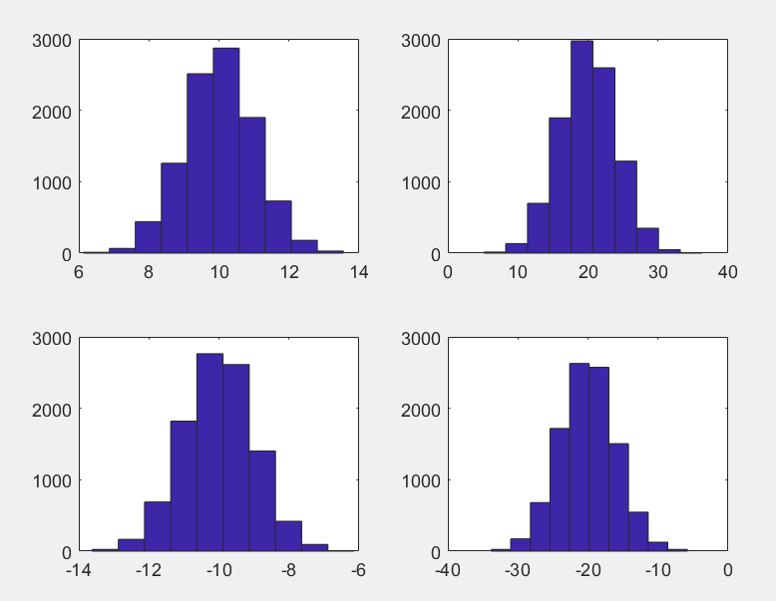

**What did I learn?**

**I learned how to transform Gaussian distribution to any normal distribution.**

**Questions 7:**

**Code Snippet:**

1. % ------------------------ Question 7 ------------------------
3. r11 = 0 + sqrt(2)*1*erfinv(2*rand(10000,1)-1);
4. r21 = 0 + sqrt(2)*4*erfinv(2*rand(10000,1)-1);
5. r31 = 0 + sqrt(2)*16*erfinv(2*rand(10000,1)-1);
6. r41 = 0 + sqrt(2)*256*erfinv(2*rand(10000,1)-1);
8. figure
9. subplot(2,2,1)
10. hist(r11)
11. subplot(2,2,2)
12. hist(r21)
13. subplot(2,2,3)
14. hist(r31)
15. subplot(2,2,4)
16. hist(r41)

**Figures (Q7):**

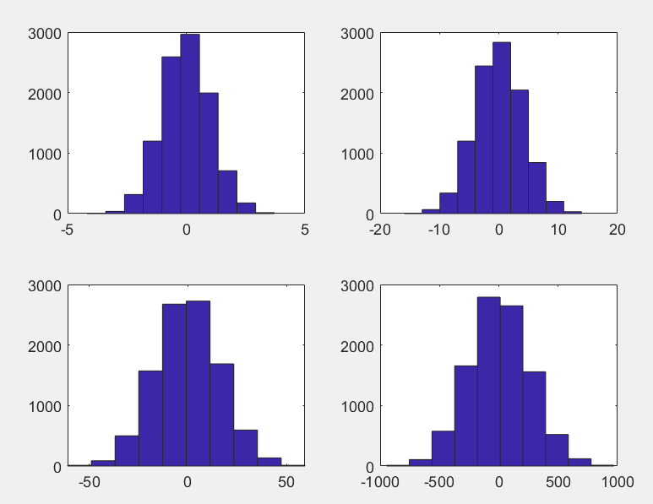

**What did I learn?**

**I learned how to transform uniform distribution to any normal distribution.**

**Questions 8:**

**Code Snippet:**

1. % ------------------------ Question 8 ------------------------
3. r61 = 10 + sqrt(2)*1*erfinv(2*rand(10000,1)-1);
4. r71 = 20 + sqrt(2)*4*erfinv(2*rand(10000,1)-1);
5. r81 = -10 + sqrt(2)*1*erfinv(2*rand(10000,1)-1);
6. r91 = -20 + sqrt(2)*4*erfinv(2*rand(10000,1)-1);
8. figure
9. subplot(2,2,1)
10. hist(r61)
11. subplot(2,2,2)
12. hist(r71)
13. subplot(2,2,3)
14. hist(r81)
15. subplot(2,2,4)
16. hist(r91)

**Figures (Q8):**

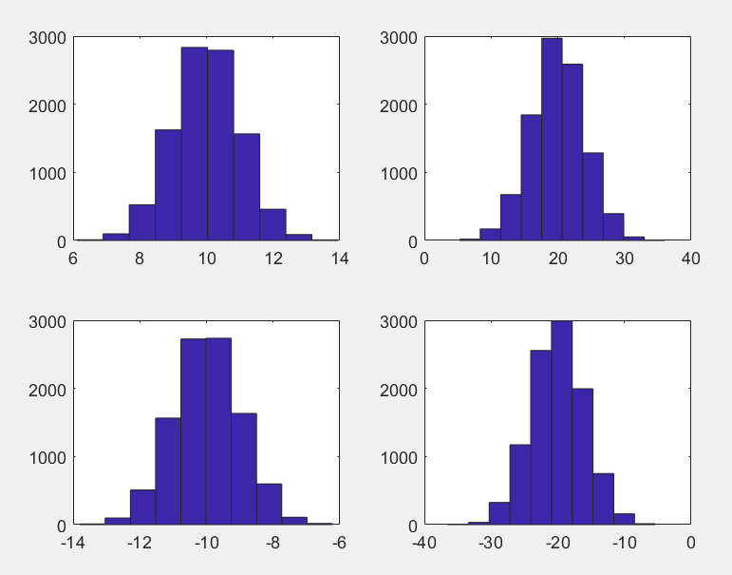

**What did I learn?**

**I learned how to transform uniform distribution to any normal distribution.**

**Questions 9:**

**Code Snippet:**

1. % ------------------------ Question 9 ------------------------
2. M = csvread('exampleSignal.csv');
4. findpeaks(M)

**Figures (Q9):**

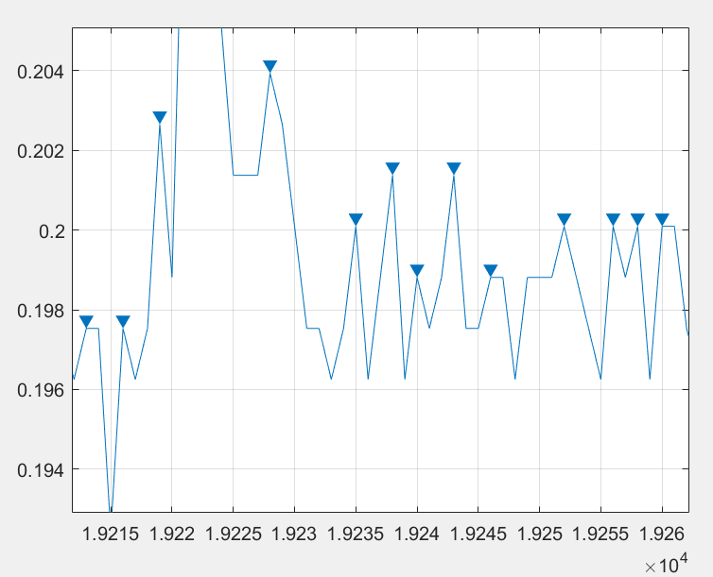

**\*Just a sample**

**What did I learn?**

**I learned how to read a CSV file and find peaks in it. In addition to that I learned why findpeaks function does not show all the peaks. The reason is that the function just does not prefer to show. For example, if figure includes a flat part, findpeaks only show the first point of the flat part. This function accepts a point as a peak if it is larger or lower than its two neighbor point.**

**Questions 10:**

**Code Snippet:**

1. % ------------------------ Question 10 ------------------------
2. lena = imread('lena.png');
4. lenaGray = rgb2gray(lena);
6. Mean = mean2(lenaGray)
7. SD = std2(lenaGray)
9. Max = max(lenaGray, [], 'all');
10. [xmax,ymax] = find(lenaGray==Max)
12. Min = min(lenaGray, [], 'all');
13. [xmin,ymin] = find(lenaGray==Min)

**Output (Q10):**

1. >> Mean = 124.0425
3. >> SD = 47.8556
5. >> xmax = 274  ymax = 396
7. >> xmin = 72 ymin = 4

**What did I learn?**

**I learned how to calculate the mean, standard deviation, maximum and minimum of a matrix. In addition to that I learned how to read an image and transform it into a grayscale image.**

**Feedback:**

**This is my first-time using MATLAB. It has so many predefined functions and this make calculations easier. I was able to read an image into a matrix, then calculate its standard deviation with only two function calls. I think this is the biggest advantage of MATLAB over other languages, it makes the calculations a lot easier. However, as a disadvantage, since MATLAB includes so many functions and features it will take a while to learn and get used to it**