CMPE362 - Assignment 3

Cut-Off Frequencies versus Number of Peaks

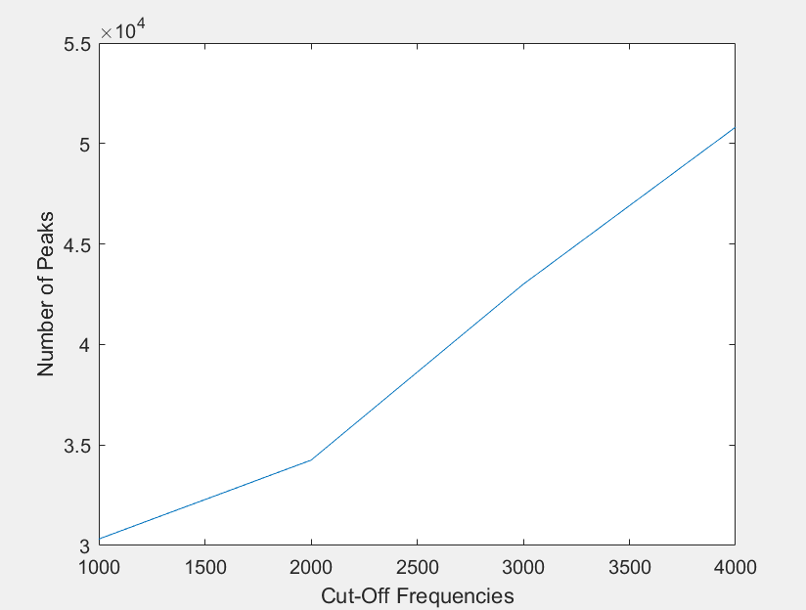

As it is clear from the figure above, when we increase the cut-off frequency, the number of peaks increase. This is because the way how low filter works. Lowpass filters only allow low frequency signals from 0 Hz to specified cut-off frequency. However, we need to be careful. The chart you see above depends on the given sound data.