CMPE362 – HOMEWORK 2

Question 1:

For each window size from 1 to N, calculate the number of peaks in the filtered signal, then plot.

1. x = csvread('exampleSignal.csv');
3. N = 30;
4. x_axis = 1:N;
5. y_axis = zeros(N);
7. for index = x_axis
8. **windowSize = index;**
9. b = (1/windowSize)*ones(1,windowSize);
10. a = 1;
11. y = filter(b,a,x);
12. number_of_peaks = findpeaks(y);
13. **y_axis(index) = numel(number_of_peaks);**
14. end
15. plot(x_axis,y_axis)

It can be easily seen from the plot below that the number of peaks decrease when the window size is increased. The reason for that is having smoother signal after increasing the window size since we are calculating a moving average, more numbers join the calculation, more smooth results we get.

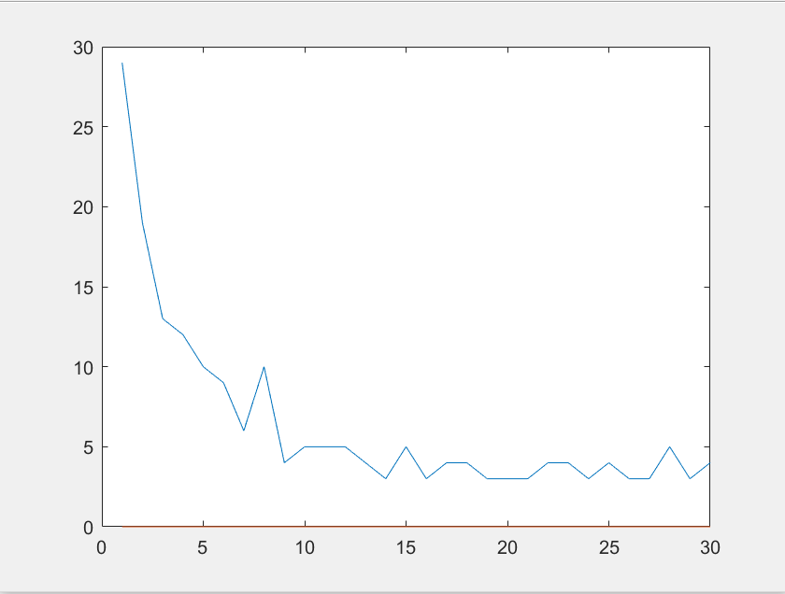

Question 2:

In the first two exercises, we change the arrangement of the data so that the frequency come to a point that is desired. In order to do that, we use up and down sampling. When we down sample a signal without giving an offset which is optional, we only get the data points which is the multiple of the given factor by starting indexing from 0 so we lose information. However, since we want to increase the frequency, down sampling is a solution. When we up sample, we add zeros as the given factor after each data point. When we try to read the signal with the original sampling frequency, we see that frequency of the new signal is decreased since we add zeros after each data point. We don’t lose information, but we make up information. In the 3rd and 4th exercises, we only change the sampling frequency which results in the change in the frequency without losing or adding any data point. However, since we change the original sampling frequency, when we play the signal, it will be very hard to understand.

1. %% EXERCISE I
2. %%%%%%%%%%%%%%%%%%%%%%%%%%%%%%%%%%%
3. % Re-arrange the data so that %
4. % the frequency is quadrupled and play the file %
5. **%%%%%%%%%%%%%%%%%%%%%%%%%%%%%%%%%%%**
7. sound(downsample(y, 4), Fs);
9. %% EXERCISE II
10. **%%%%%%%%%%%%%%%%%%%%%%%%%%%%%%%%%%%**
11. % Re-arrange the data so that %
12. % the frequency is halved and play the file %
13. %%%%%%%%%%%%%%%%%%%%%%%%%%%%%%%%%%%
15. **sound(upsample(y,2), Fs)**
17. %% EXERCISE III
18. %%%%%%%%%%%%%%%%%%%%%%%%%%%%%%%%%%%
19. % Double Fs and play the sound %
20. **%%%%%%%%%%%%%%%%%%%%%%%%%%%%%%%%%%%**
22. sound(y, 2*Fs);
24. %% EXERCISE IV
25. **%%%%%%%%%%%%%%%%%%%%%%%%%%%%%%%%%%%**
26. % Divide Fs by two and play the sound %
27. %%%%%%%%%%%%%%%%%%%%%%%%%%%%%%%%%%%
29. sound(y, 0.5*Fs);

Question 3:

Alpha Changes:

1. N = 50;
2. K = 0.1;
3. results = zeros(1, 101);
4. position = 1;
5. **for alpha = 0.00:0.01:1.00**
6. result = y;
7. delayed = y;
8. for index = 1:N
9. delayed = delayseq(delayed, K, Fs);
10. **result = result + delayed * (-alpha).^index;**
11. end
12. SNR = 10*log10(sum(y.^2) / sum((result - y).^2));
13. results(position) = SNR;
14. position = position + 1;
15. **end**
16. plot(results);

While changing alpha, after a point we start to get negative SNR values with the given configuration. Negative SNR value means that the signal is less than the noise.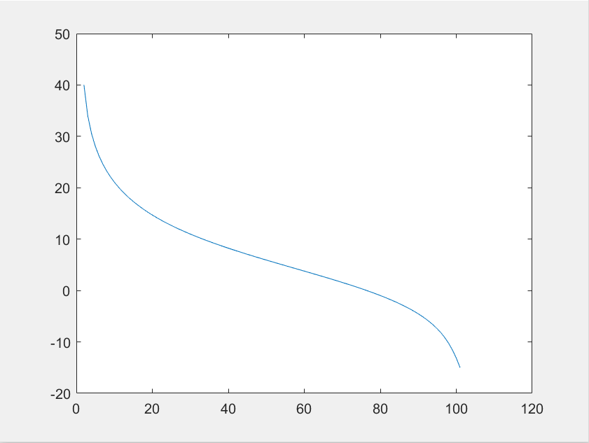

N Changes:

1. K = 0.1;
2. alpha = 1;
3. results = zeros(1, 50);
4. position = 1;
5. **for N = 1:50**
6. result = y;
7. delayed = y;
8. for index = 1:N
9. delayed = delayseq(delayed, K, Fs);
10. **result = result + delayed * (-alpha).^index;**
11. end
12. SNR = 10*log10(sum(y.^2) / sum((result - y).^2));
13. results(position) = SNR;
14. position = position + 1;
15. **end**
16. plot(results);

Increasing N with this configuration, results for SNR values to be negative which means recovered signal level is less than the original signals level.

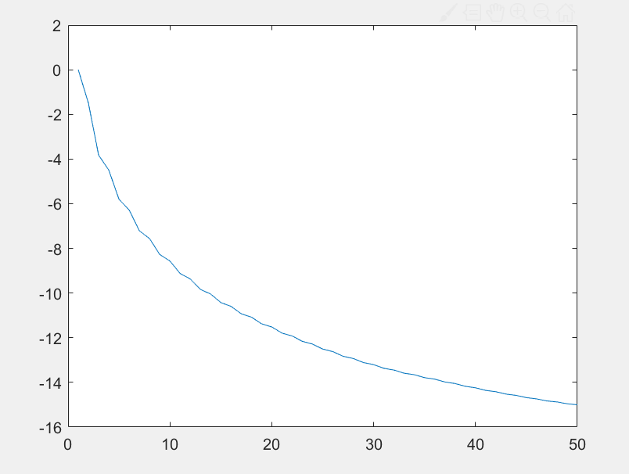

K Changes:

1. N = 50;
2. alpha = 1;
3. results = zeros(1, 4);
4. position = 1;
5. **for K = 0.1:0.1:0.4**
6. result = y;
7. delayed = y;
8. for index = 1:N
9. **delayed = delayseq(delayed, K, Fs);**
10. result = result + delayed * (-alpha).^index;
11. end
12. SNR = 10*log10(sum(y.^2) / sum((result - y).^2));
13. results(position) = SNR;
14. **position = position + 1;**
15. end
17. results
18. plot(1:4, results);

With this configuration, increasing the K results SNR values to increase in the positive direction.

