

CSE 3063

Object Oriented Software Design Project

**“LABEL.IT”**

*By repository 23:*

*Oğuzhan Toker 150118049*

*Berk Engin 150117014*

*Turgut Kural 150120534*

*Fatih Akgündüz 150117032*

*Cenk Kaan Kanar 150117021*

*Mevlüt Eren Topal 150117025*

*Ahmed Hami Orak 150118018*

1

***TABLE OF CONTENTS FOR SRS DOCUMENT***

1. **INTRODUCTION**

***1.1 Purpose***

***1.2 Intended Audience and Intended Use***

***1.3 Project Scope***

1. **OVERALL DESCRIPTION**

***2.1 Product Perspective***

***2.2 Product Features***

***2.3 Users***

2

1. **Introduction**

The purpose of this document is to specify the system requirements and the overall description of the concept of this project. It contains the constraints of the system, the system functionality using diagrams. It also contains the user and system interfaces. In addition, Logical database design is specified by ER and Class diagrams. This document is an initial reference for developing the first version of the system for development team.

**1.1 Purpose**

The purpose of the project is to provide a data labeling mechanism where the users can label a group of instances which is also known as a dataset via a user interface. These labeled datasets can be used for the training of Artificial Intelligence models such as Machine Learning models.

**1.2 Intended Audience and Intended Use**

This Software Requirements document is intended for:

* Developers who can review project and understand where their efforts should be targeted to improve or add more features to it. (It is a guideline for future developers)
* Project testers can use this document as a base for their testing strategy as some bugs are easier to find using a requirements document. This way testing becomes more methodically organized.

oOur customer who wants to fully understand how our development team fulfill their desires about project.

* End users of this application who wish to read about what this project can do.

**1.3 Project Scope**

The purpose of the project is to provide a data labeling mechanism where the users can label a group of instances which is also known as a dataset via a user interface. These labeled datasets can be used for the training of Artificial Intelligence models such as Machine Learning models.

3

1. **Overall Description**

**2.1 Product Perspective**

* **User Details:**

It includes our users information such as user name, password and id.

* **Labels Details:**

It includes labels data such as label id, label text and instances that labelled by that particular label. (We store instances in labels data because maybe we want to search some instances by their labels in further iterations.)

* **Instance Details:**

It includes instances information such as instance id, instance text and labels which labels that particular instance. So we can reach that instances labels that labeled by user.

* **Dataset Details:**

It includes datasets data such as dataset id, dataset name, max labels that an instance can take and labels and instances in dataset.

4

**2.2 Product Features**

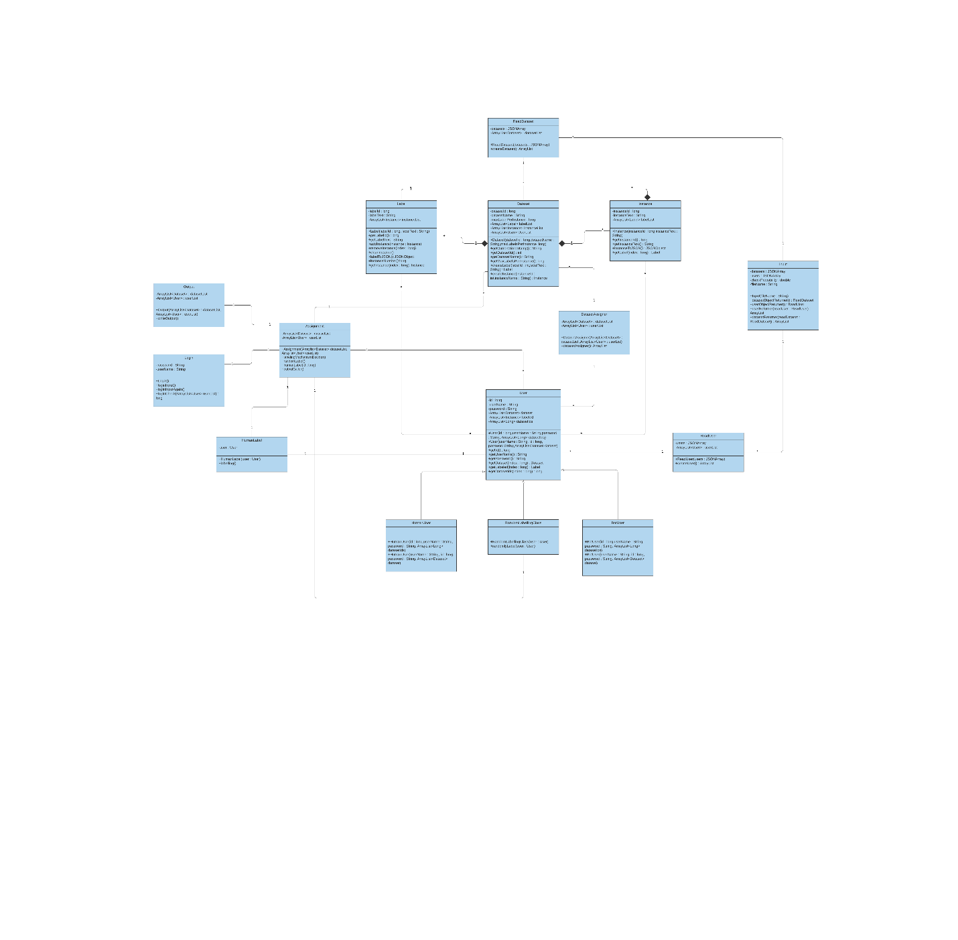

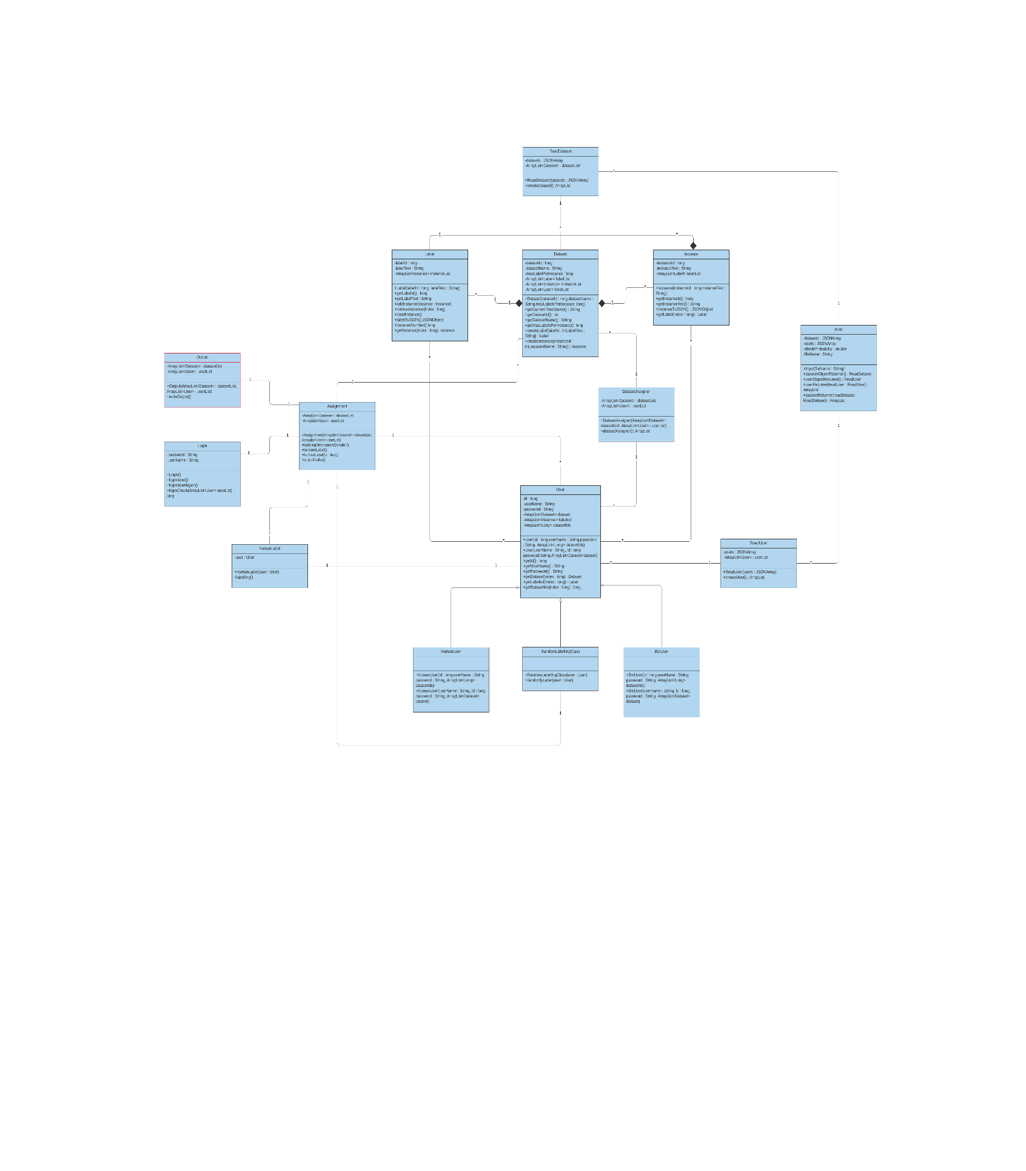

**2.3 Users**

In label.it there are multiple types of users. At first stage of our program we only have RandomLabellingBot that labels instances randomly.

At the second stage of our program we still only have RandomLabellingBot that labels instances randomly. In addition to that we add reporting functionality for user performance and labeling operation for a particular dataset. The purpose of this is to collect statistics for users and compare users with each other via their Consistency Check Probability.

At the third and the last stage of our program we add a user interface for human users. Human user can interact with our program and choose possible labels from a list to assign an instance. There can be more than one user and when the user runs the program it will ask for username and password. If the username and password does not match with any user login information in our config file, the program will display wrong user name/password message and ask user name and password again. If the user name and password entered blank, then the program will behave as the RandomLabellingBot as our second stage.

5