BLM 4800 DATA MINING PROJECT

In this project, you will classify actions from the given dataset.

Dataset is constructed from training videos. About 500 videos of people doing the exercises have been used. The videos are from [Countix](https://www.deepmind.com/open-source/kinetics) Dataset which contains several human activity videos. From every video, at least 2 frames are manually extracted. The extracted frames represent the terminal positions of the exercise.

For every frame, [MediaPipe](https://google.github.io/mediapipe) framework is used for applying pose estimation, which detects the human skeleton of the person in the frame. The landmark model in MediaPipe Pose predicts the location of 33 pose landmarks (see figure below). Visit Mediapipe [Pose Classification page](https://google.github.io/mediapipe/solutions/pose_classification.html) for more details. Thereafter, the distances and angles between some important landmarks are calculated and represented in the dataset tables.

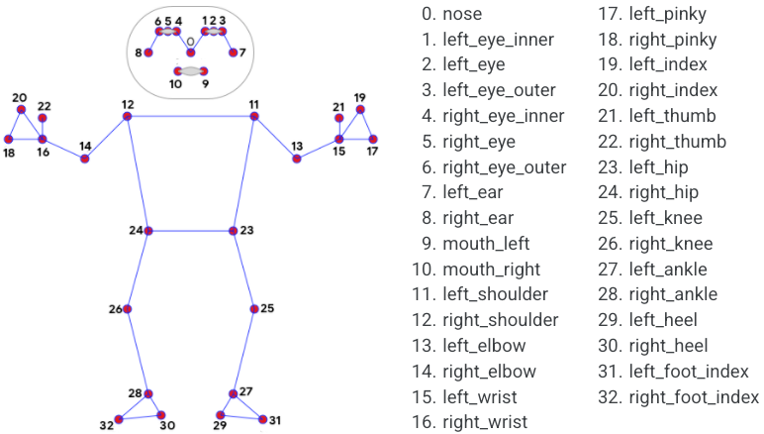

You should use landmarks.csv and labels.csv files for training and testing. The codes will be uploaded to Google drive.

You should derive new features like (angles, distances, etc.) for better classification results.

Also, we will open a contest on Kaggle and make a competition to an unknown test dataset.

After implementing the Project:

* You should submit a Project report that shows the preprocessing, statistical analysis of data, used methods and results. The format will be available soon.