|  |
| --- |
| **PROJECT PLANNING & MANAGEMENT FORM**  **CMSE 201**  **GROUP NO : 5**  **PROJECT NAME : Efficient Doctor Patient Portal**  **PROJECT START DATE : 17/03/2023**  **PROJECT END DATE : 22/05/2023**  **SUPERVISOR : Prof. Dr. Alexander Chefranov**  **SEMESTER TERM : Spring**  Project Type: Software Design & Development Project  Template updated: 20.08.2019 |

A.1. Preliminary Project Information

# A.1.1

|  |  |
| --- | --- |
| **Project No** | 5 |
| **Project Name** | Efficient Doctor Patient Portal |
| **Start Date** | 17/03/2023 |
| **End Date** | 22/05/2023 |
| **Time** | 65 Days |

# s

|  |  |  |  |
| --- | --- | --- | --- |
| **Project Manager** | | | |
| **Name Surname** | Doğukan Bilal Örs | **ID No** | 21000157 |
| **Title/Role** | Project Manager / Network Developer | | |
| **Address** | Famagusta / TRNC | | |
| **Phone** | +90 551 590 9932 | | |
| **Email** | 21000157@emu.edu.tr | | |

A.2 Group Information

# A.2.1

|  |  |  |  |
| --- | --- | --- | --- |
| **Student 1** | | | |
| **Name Surname** | Fatih Çakır | **ID No** | 21000128 |
| **Title/Role** | Database Developer / Interface Developer | | |
| **Address** | Famagusta / TRNC | | |
| **Phone** | +90 534 395 5066 | | |
| **Email** | 21000128@emu.edu.tr | | |

|  |  |  |  |
| --- | --- | --- | --- |
| **Student 2** | | | |
| **Name Surname** | Burhan Ata Köktürk | **ID No** | 21000152 |
| **Title/Role** | Programmer  / Database Developer / Tester | | |
| **Address** | Famagusta / TRNC | | |
| **Phone** | +90 539 116 6700 | | |
| **Email** | 21000152@emu.edu.tr | | |

|  |  |  |  |
| --- | --- | --- | --- |
| **Student 3** | | | |
| **Name Surname** | Barış Gündoğdu | **ID No** | 21000141 |
| **Title/Role** | Business Analyst / Interface Designer / Advertiser | | |
| **Address** | Famagusta / TRNC | | |
| **Phone** | +90 536 878 4995 | | |
| **Email** | 21000141@emu.edu.tr | | |

# A.2.2

|  |
| --- |
| **List of Completed / Ongoing Projects of Team** |
| •Software Security of Web Portal – PHP encrypting user informations and login process.  •Software Requirements Analysis – Course scheduling system of EMU computer engineering department. |

B.1 Introduction to Project

# B.1.1

|  |
| --- |
| **Summary of Project** |
| •Project is an online platform designed to connect doctors and patients in a streamlined and efficient way. The portal allows patients to book appointments with doctors, view their medical history, and communicate with healthcare professionals in real-time through a secure messaging system. |

# B.1.2

|  |
| --- |
| **Key Words** |
| * Health * Doctor * Patient * Portal * Medicine * Vaccine |

# B.1.3

|  |
| --- |
| **Aim of Project** |
| • People can easily interact their doctor and check health information. |

# B.1.4

|  |
| --- |
| **Innovative Aspects/Contributions of Project** |
| * People can check their health informations without even go to hospital. * Web-based information flow using technology. |

# B.1.5

|  |
| --- |
| **Methods to be Applied** |
| * Electronic Health Records (EHRs) * MySQL * PHP * JavaScript |

# B.1.6

|  |
| --- |
| **Economic and National Outcomes** |
| This is not a national project. It is for whole world. We assume that this project gets a lot of foreign currency. |

B.2 Reason of Starting the Project, Methods and R&D Stages

# B.2.1

|  |
| --- |
| **1- Explain the reason of starting this project. (Max 500 characters)** |
| There was no efficient portal as reliable as our portal on the market that would facilitate and make communication between patients and doctors more efficient, so we wanted to create such a portal and started this project. |

|  |
| --- |
| **2- Explain the purpose of this project.** |
| To create a efficient portal where people can easily find out their personal information, diseases, vaccinations, check-ups, appointments, past examinations from one place and establish healthy relationships with their doctors. |

|  |
| --- |
| **3- Explain**   * **output of project** * **national / international standards if exist** * **the specific objectives of the project** * **success criterias** * **realistic constraints** |
| At the end of our project, we have designed a simple, effective and understandable also a secure portal where access will only be between doctors and patients. We have conducted research and used which programming languages are suitable for building portals in our project. |
| **4- Explain**   * **the methods to be applied during R&D activities** * **applications** * **technics and tools to be used** * **standards to be followed under the workflow** |
| **Explain, Project Workflow:**  We are going to use the waterfall development software process model. We are planning to develop a portal and almost all the requirements are determined. Therefore, our ideas are stable about this project. Our project is also simple, not complicated and understandable to focus on it . We will handle the parts before passing the other step. We have a small project development team, and we have limited time. Because of all these factors, we decided to use waterfall model.   1. **Feasibility and Pre-research:**   There are many health portals around, but almost all of them only offer certain features, such as making an appointment, but there must be a more intimate relationship between doctors and patients. Therefore, some additions need to be made, for example, the doctor should know about the diseases he had before, the vaccines he had, the medicines he used, without asking the patient.   1. **System Design:**   We are going to use the waterfall software process model at system design as a methodology because there are no unclear requirements and not changing frequently. Everything necessary to make a portal is ready and we have adjusted the task distribution in our team in accordance with this method.   1. **Software development:**   We will complete the software development part with the waterfall model. This model provides more convenient document control and also will help us we will do the development step by step and we do not see any risk factors.   1. **Prototype implementation and testing work:**   We have already determined the software we use in the prototype and code implementation step. We are planning to create a portal and so we will work in the field of web design. PHP, JavaScript, MySQL will be used as programming languages in this project.   1. **Maintenance:**   There will be a 24/7 active live support on the portal and will help people who need help. At the same time, this live support will be in contact with the technical team and will notify the technical team when there is a technical problem. After that the technical team will try to debug glitches and bugs. |
| **5- Explain**   * **the contribution of national/international technological development if exist** * **starting a new research and development projects within or outside the team** * **launch new applications or research studies in different technology areas**   **With whom we can cooperate?**  **Expectations:**  **Published work:**  **Can your output be an input for other similar national/international projects?** |
| With whom can we cooperate? Web Designer  We think our project will contribute to many other projects, especially in health. Because the issue of health is particularly important nowadays and it should become much easier and more efficient in terms of access. Doctors need to establish a more intimate and detailed relationship with their patients. The output of this project can be an input for other projects because of web-design making companies to work and use our project as a case work as global. |

B.3 Innovative and Unique Aspects

# B.3.1

|  |
| --- |
| **1- Describe**   * **differences** * **advantages** * **superiority**   **compared to other similar projects.** |
| Our biggest difference compared to other similar projects is reliability. Everything is between the doctor and the patient in this portal, where only the doctor and the patient interact. As for the advantages, compared to other portals, our portal has a simple and understandable design. It is quite at the forefront compared to other portals in terms of ease of use. |

# B.4.1

|  |
| --- |
| **2- Who can contribute to this project in your team?** |
| •Project Manager  •Network Developer  •Interface Developer  •Tester  •Business Analyst  •Advertiser |

C.1 Gantt Chart and Work Packages

# C.1.1 Gantt Chart

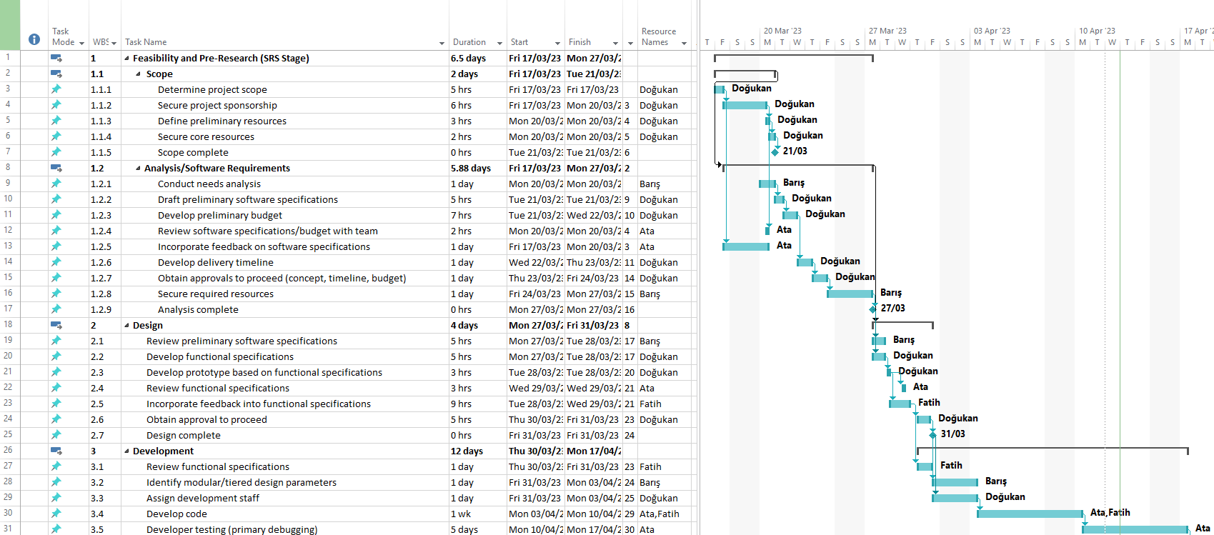

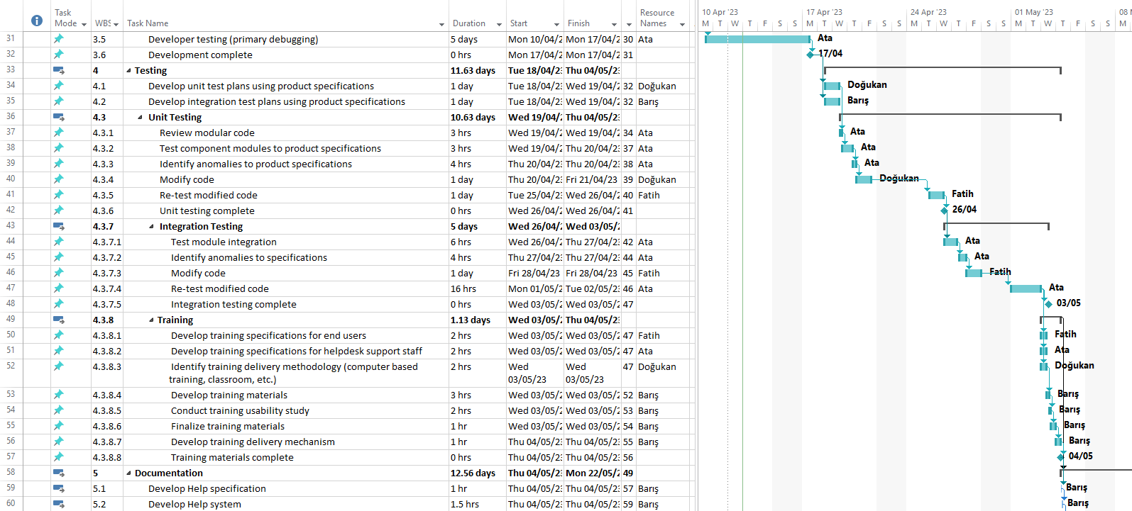

masa içeren bir resim

Açıklama otomatik olarak oluşturuldu

# C.1.2 List of Work Packages

|  |  |
| --- | --- |
| **Work Package No** | 1 |
| **Work Package Name** | **Project Feasibility and Pre-Research (Feasibility Analysis)** |
| **Start-End Date and Time** | 17/03/23 – 27/03/23 |
| **Related Organizations** |  |

|  |
| --- |
| **1- List the activities of work packages.** |
| **1.1 Project Process and Economic Feasibility:**   * + Scope   **1.2 Technological Feasibility:**   * + Analysis/Software Requirements |
| **2- Describe the methods and parameters that will be used for work package.** |
| Electronic Health Records (EHRs) |
| **3- List the experiments, tests and analysis in the work package.** |
| * 1. **Scope** * Determine project scope * Secure project sponsorship * Define preliminary resources * Secure core resources * Scope complete   1. **Analysis/Software Requirements** * Conduct needs analysis * Draft preliminary software specifications * Develop preliminary budget * Review software specifications/budget with team * Incorporate feedback on software specifications * Develop delivery timeline * Obtain approvals to proceed (concept, timeline, budget) * Secure required resources * Analysis complete |
| **4- List the output of work package and its success criterias.** |
| **Outputs:**   * Check researches. * Determine the effective portal format. * Find sponsorship. * Check budget.   **Success Criterias:**   * Market analysis done. * Project approved. * Team members approved **.** |
| **5- Explain the relation of output with other work packages** |
| Analysis, Feasibility and Scope are the most important parts of a project since these parts are directly related with other work packages. |

|  |  |
| --- | --- |
| **Work Package No** | 2 |
| **Work Package Name** | **Based System Design Technology (Analysis & Design stage)** |
| **Start-End Date and Time** | 27/03/23 – 31/03/23 |
| **Related Organizations** |  |

|  |
| --- |
| **1- List the activities of work packages.** |
| 1. **Design** |
| **2- Describe the methods and parameters that will be used for work package.** |
| None. |
| **3- List the experiments, tests and analysis in the work package.** |
| 1. **Design** 2. Review preliminary software specifications. 3. Develop functional specifications. 4. Develop prototype based on functional specifications. 5. Review functional specifications. 6. Incorporate feedback into functional specifications. 7. Obtain approval to proceed. 8. Design complete |
| **4- List the output of work package and its success criterias.** |
| **Outputs:**   * Prototype of portal * Analyzing user requests * Determine background   **Success Criterias:**   * Well-prepared background * Easy user interface * Can be diversified admin panel |
| **5- Explain the relation of output with other work packages** |
| The system design part is so important in our project since we are planning to establish a portal. The design part is related to all other work packages. We are going to design all the codes according to this design part. |

|  |  |
| --- | --- |
| **Work Package No** | 3 |
| **Work Package Name** | **Development of System Software (Development Stage)** |
| **Start-End Date and Time** | 30/03/23 - 17/04/23 |
| **Related Organizations** |  |

|  |
| --- |
| **1- List the activities of work packages.** |
| 1. **Development** |
| **2- Describe the methods and parameters that will be used for work package.** |
| We will be using waterfall method in this stage. |
| **3- List the experiments, tests and analysis in the work package.** |
| 1. **Development**    * Review functional specifications    * Identify modular/tiered design parameters    * Assign development staff    * Develop code    * Developer testing (primary debugging)    * Development complete |
| **4- List the output of work package and its success criterias.** |
| **Outputs:**  **•**Running and sending written codes to testing  •Check the format of portal  •Ready to be testing  **Success Criterias:**  • Low error rate  • Simple and effective portal design |
| **5- Explain the relation of output with other work packages** |
| The project is totally related this work package since other work packages are preparatory for this step. Also the coding step is really important to improve a project. After this work package there will be only test and maintenance steps. |

|  |  |
| --- | --- |
| **Work Package No** | 4 |
| **Work Package Name** | **Prototype Implementation and Test Study and Maintenance (Test & Maintenance stage)** |
| **Start-End Date and Time** | 18/04/23 – 04/05/23 |
| **Related Organizations** |  |

|  |
| --- |
| **1- List the activities of work packages.** |
| 1. **Unit Testing** 2. **Integration Testing** 3. **Training** |
| **2- Describe the methods and parameters that will be used for work package.** |
| It is unknown at the point. |
| **3- List the experiments, tests and analysis in the work package.** |
| 1. **Testing**   Develop unit test plans using product specifications. Develop integration test plans using product specifications   1. **Unit Testing** 2. Review modular code 3. Test component modules to product specifications 4. Identify anomalies to product specifications 5. Modify code 6. Re-test modified code 7. Unit testing complete 8. **Integration Testing** 9. Test module integration 10. Identify anomalies to specifications 11. Modify code 12. Re-test modified code 13. Integration testing complete 14. **Training** 15. Develop training specifications for end users 16. Develop training specifications for helpdesk support staff 17. Identify training delivery methodology (computer based training, classroom, etc.) 18. Develop training materials 19. Conduct training usability study 20. Finalize training materials 21. Develop training delivery mechanism 22. Training materials complete |
| **4- List the output of work package and its success criterias.** |
| **Outputs:**   * Testing datas, debugging the bugs and glitches * Verification the results   **Success Criterias:**   * Testing successfully completed with all the errors and bugs successfully fixed * Confirmation about codes from testers |
| **5- Explain the relation of output with other work packages** |
| After successfully testing the system, next stages in the software life cycle are the documentation and delivery stages. The project should deliver to patients and to doctors through our business analyst and advertisers. Also, technical team should give feedback in this part. Accordingly, the portal need to be updated or upgraded. |

|  |  |
| --- | --- |
| **Work Package No** | 5 |
| **Work Package Name** | **Documentation and Delivery** |
| **Start-End Date and Time** | 4/05/23 – 22/05/23 |
| **Related Organizations** |  |

|  |
| --- |
| **1- List the activities of work packages.** |
| 1. **Pilot** 2. **Deployment** 3. **Post İmplement Review** |
| **2- Describe the methods and parameters that will be used for work package.** |
| None. |
| **3- List the experiments, tests and analysis in the work package.** |
| 1. **Documentation**    1. Develop Help specification    2. Develop Help system    3. Review Help documentation    4. Incorporate Help documentation feedback    5. Develop user manuals specifications    6. Develop user manuals    7. Review all user documentation    8. Incorporate user documentation feedback    9. Documentation complete 2. **Pilot** 3. Identify test group 4. Develop software delivery mechanism 5. Install/deploy software 6. Obtain user feedback 7. Evaluate testing information 8. Pilot complete 9. **Deployment** 10. Determine final deployment strategy 11. Develop deployment methodology 12. Secure deployment resources 13. Train support staff 14. Deploy software 15. Deployment complete 16. **Post Implementation Review** 17. Document lessons learned 18. Distribute to team members 19. Create software maintenance team 20. Post implementation review complete 21. Software development template complete |
| **4- List the output of work package and its success criterias.** |
| **Outputs:**   * Published the online portal succesfuly * Advertisement where neccesary   **Success Criterias:**   * Well documented * A lot of click on the portal ads |
| **5- Explain the relation of output with other work packages** |
| This part totally related with all other work packages as it is the last part of the project. All other steps will be wasted if we fail to market. |

# C.1.3 List of Milestones (should be matched in the Gantt chart)

|  |  |  |
| --- | --- | --- |
|  | **Description of Output** | **Expected Time Interval** |
| 1 | Scope Determination | 17.03.2023-21.03.2023 |
| 2 | Analysis/Software Requirements | 17.03.2023-27.03.2023 |
| 3 | Design | 27.03.2023-31.03.2023 |
| 4 | Development Stage | 30.03.2023-17.04.2023 |
| 5 | Unit Testing | 19.04.2023-26.04.2023 |
| 6 | Integration Testing | 26.04.2023-03.05.2023 |
| 7 | Training | 03.05.2023-04.05.2023 |
| 8 | Documentation | 04.05.2023-05.05.2023 |
| 9 | Pilot | 05.05.2023-08.05.2023 |
| 10 | Deployment | 08.05.2023-15.05.2023 |
| 11 | Post Implementation Review | 15.05.2023-22.05.2023 |

# C.1.4 List of Risks *(see following example, write possible risks for your project!)*

|  |  |  |  |
| --- | --- | --- | --- |
| Risk | Probability | Effects | Your Strategy |
| The time required to develop the software is underestimated. | High | Serious | To enable employees to work efficiently and quickly |
| Software tools cannot work together in an integrated way. | High | Tolerable | Purchasing a software tool that can work more efficiently and in an integrated way |
| Customers fail to understand the impact of requirements changes. | Moderate | Tolerable | To convey to customers that more efficient results can be achieved with various tools |
| The rate of defect repair is underestimated. | Moderate | Tolerable | Replace potentially defective components with more reliable bought-in components. |
| The size of the software is underestimated. | High | Serious | Investigate buying sw components;  Investigate use of a program generator. |
| Code generated by code generation tools is inefficient. | Moderate | Insignificant | Find or produce a more efficient and quality code research tool |
| Key staff are ill at critical times in the project. | Moderate | Serious | Reorganize team so that there is more overlap of work and people therefore understand each other’s jobs. |
| The database used in the system cannot process as many transactions per second as expected. | Moderate | Serious | Investigate the possibility of buying a higher-performance database. |

C.2 Project Management and Organization

# C.2.1 Project Team

|  |  |  |  |  |  |  |
| --- | --- | --- | --- | --- | --- | --- |
| **Personnel Name** | **Title** | **ID** | **Education Status** | **Graduation Date** | **Date of Starting Work** | **Idea Owner** |
| Doğukan Bilal Örs | Project Manager | 21000157 | Undergraduate | February  2026 | 17/03 /2023 | Yes |
| Doğukan Bilal Örs | Developer | 21000157 | Undergraduate | February  2026 | 17/03 /2023 | Yes |
| Fatih Çakır | Database Developer | 21000128 | Undergraduate | February  2026 | 17/03 /2023 | Yes |
| Fatih Çakır | Interface Developer | 21000128 | Undergraduate | February  2026 | 17/03 /2023 | Yes |
| Burhan Ata Köktürk | Programmer | 21000152 | Undergraduate | February  2026 | 17/03 /2023 | Yes |
| Burhan Ata Köktürk | Database Developer | 21000152 | Undergraduate | February  2026 | 17/03 /2023 | Yes |
| Burhan Ata Köktürk | Tester | 21000152 | Undergraduate | February  2026 | 17/03 /2023 | Yes |
| Barış Gündoğdu | Business Analyst | 21000141 | Undergraduate | February  2026 | 17/03 /2023 | Yes |
| Barış Gündoğdu | Interface Designer | 21000141 | Undergraduate | February  2026 | 17/03 /2023 | Yes |
| Barış Gündoğdu | Advertiser | 21000141 | Undergraduate | February  2026 | 17/03 /2023 | Yes |

# C.2.2 Organization Scheme

diyagram içeren bir resim

Açıklama otomatik olarak oluşturuldu

D.1 Economic Forecasts

|  |
| --- |
| **1- Evaluate the commercialization potential of project outcomes. List possible risks here?** |
| Commercialization of our product can begin as soon as it is most developed and tested. The commercialization of this project is advertising and will be determined by request. Our project in health centers with a well-established portal layout may not be preferred in terms of commercialization risk.   * May pose a risk in health centers that have advanced communication with their patients. * May pose a commercial risk in hospitals that already have a portal. |

|  |  |
| --- | --- |
| **2- List your expectations to your team which are come by your project** | |
| Time-to-market (month): | June 2023 |
| The expected increase in sales revenue (%): | %15 |
| The expected increase in market share (%): | %25 |
| Time to start to gain: | September 2023 |

D.2 National Outcomes

|  |
| --- |
| **1- Specify the output that may be subject to patent, utility model and industrial design registration in the project.** |
| We can adapt our project differently for each health center, we can produce different industrial designs for each health center in line with the demands. |
| **2- Explain the potential of project and its outputs that may have an effect on social life, education, health and etc.** |
| Since our project is based on health in a technological way, it contributes to social life as well as to the health sector. |
| **3- Explain the positive and negative effects of project outputs for environment and human being.** |
| Since our project is a project that will leave a mark on the health sector, it has many positive aspects and no negative aspects. Some of its positive aspects are as follows. It is a project that will facilitate communication with the doctor of the person who can control your personal health from a single place. |

(M013) Instrument / Equipment / Software / RELEASE PURCHASES

|  |  |  |  |  |  |  |  |  |  |  |  |
| --- | --- | --- | --- | --- | --- | --- | --- | --- | --- | --- | --- |
| **Project Name** | | **Efficient Doctor Patient Portal** | | | | | | | | | |
| **Line no** | **Instrument / Equipment / Software / Publication Name** | | **No. of Item** | **Capacity** | **Technical specification** | **Purpose of Project Activities** | **Post-Project Place of Use / Purpose** | | **Unit Price (USD)** | **Unit Price (TL)** | **Total Amount (TL)** |
| **R & D** | **Production** |
| **1** | **Monster Abra A7** | | **2** | **256 GB** | **I7- 16 GB RAM** | **Organization** | **-** | **NO** | **1250 $** | **25.000 TL** | **50.000 TL** |
| **2** | **Macbook Pro** | | **2** | **1 TB** | **M1** | **Coding** | **-** | **YES** | **1650 $** | **33.000 TL** | **66.000 TL** |
| **3** | **Computer server** | | **1** | **500 GB** | **2.4 GHz**  **64 GB Ram** | **Connectivity**  **testing and**  **storage** | **-** | **NO** | **500 $** | **10.000TL** | **10.000 TL** |
| **4** | **Internet Connection** | | **1** | **-** | **Min. 50 Mbit** | **Connecting** | **-** | **YES** | **20 $** | **400 TL** | **400 TL** |
| **5** | **Microsoft Project** | | **4** | **-** | **Project**  **Management**  **Software** | **Schedule and organization** | **-** | **NO** | **49 $** | **995.50 TL** | **3982 TL** |
| **6** | **Microsoft Office** | | **4** | **-** | **An office suite**  **of**  **applications,**  **servers, and**  **services** | **Organization and Editing** | **-** | **NO** | **20 $** | **389.99 TL** | **1559,96 Tl** |
| **7** | **Virtual machine** | | **2** | **-** | **Testing and Implementation** | **Testing** | **-** | **NO** | **Free** | **Free** | **Free** |
| **8** | **Firewall** | | **1** |  | **Security** | **Security for DDoS** |  | **NO** | **700 $** | **14.000 TL** | **14.000 TL** |
| **9** | **SQL** | | **1** |  |  | **Database** |  | **NO** | **30 $** | **589,99 TL** | **589,99 TL** |
|  |  | |  |  |  |  |  |  |  | **TOTAL** | **146.531,95TL** |

(M030) Quarterly Estimated Cost Form (TL)

|  |  |  |  |  |
| --- | --- | --- | --- | --- |
| **Project Name : Efficient Doctor Patient Portal** | | | | |
| **Cost Item** | **2018-2019** | | **TOTAL**  **(TL)** | **TOTAL COST RATE OF CONTENTS (%)** |
| **I** | **II** |
| **Personnel** | 20.000 | 20.000 | 40.000 | 12.1 |
| **Travel** | 500 | 500 | 1000 | 0.31 |
| **Instrument / Equipment / Software / Publications** | 146.531,95 |  | 146.531,95 | 44.31 |
| **Domestic Works Made By R & D and Testing Institutions** | 10.000 | 10.000 | 20.000 | 6.05 |
| **International Works Made By R & D and Testing Institutions** | 10.000 | 10.000 | 20.000 | 6.05 |
| **Domestic Services Procurement** | 20.000 | 20.000 | 40.000 | 12.1 |
| **Overseas Service Procurement** | 30.000 | 30.000 | 60.000 | 18.15 |
| **Material** | 1500 | 1500 | 3000 | 0.93 |
| **TOTAL COST** | 238.531,95 | 92.000 | 330.531,95 | 100 |
| **CUMULATIVE COST** |  |  |  | 100 |
| **IN THE PROJECT TOTAL MAN-MONTH** | | | 330.531,95 | |

APPENDIX

**KLOC** = 400

**E**(effort) ≈ *3977.34 person – month*

**D**(deployment time) ≈ *35.45 months*

**SS**(staff size) ≈ *112.16 persons*

**P**(productivity) ≈ *0.10*

|  |  |  |  |  |
| --- | --- | --- | --- | --- |
| Basic Cocomo | | | | |
| Project / Coefficients | a | b | c | d |
| Embedded Mode | 3.6 | 1.20 | 2.5 | 0.32 |

|  |  |  |  |
| --- | --- | --- | --- |
| Tasks | Description | Predictase | Estimated Time (day) |
| A | *Project Feasibility and Pre-Research* | - | 6.5 |
| B | *Scope* | - | 2 |
| C | *Analysis/Software Requirements* | A,B | 5.88 |
| D | *Design* | C | 4 |
| E | *Development* | D | 12 |
| F | *Testing* | E | 11.63 |
| G | *Unit Testing* | E | 10.63 |
| H | *Integration Testing* | E,F,G | 5 |
| I | *Training* | H | 1.13 |
| J | *Documentation* | E | 12.56 |
| K | *Pilot* | I | 1.75 |
| L | *Deployment* | K | 4.75 |
| M | *Post Implementation Review* | L | 5 |

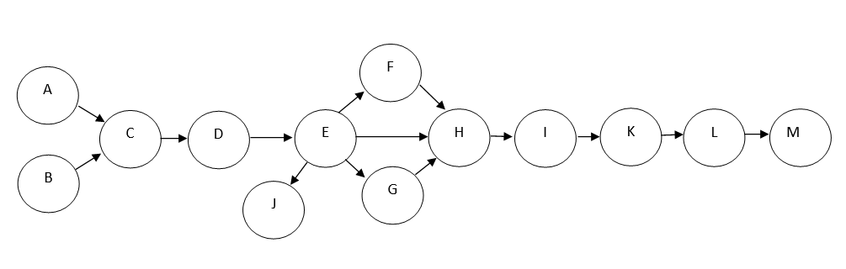

|  |  |  |  |  |  |  |
| --- | --- | --- | --- | --- | --- | --- |
| **Tasks** | **Description** | **Predicates** | **O**  **(min)es** | **M**  **(Most likely)ef** | **P**  **(max)lf** | **Duration**  **(Expected Time)** |
| **A** | *Project Feasibility and Pre-Research* | **-** | 4 | 6.5 | 10 | 6.67 |
| **B** | *Scope* | **-** | 1 | 2 | 4 | 2.17 |
| **C** | *Analysis/Software Requirements* | **A,B** | 3 | 5.88 | 9 | 5.92 |
| **D** | *Design* | **C** | 2 | 4 | 8 | 4.33 |
| **E** | *Development* | **D** | 8 | 12 | 20 | 12.67 |
| **F** | *Testing* | **E** | 7 | 11.63 | 18 | 11.92 |
| **G** | *Unit Testing* | **E,** | 6 | 10.63 | 18 | 11.08 |
| **H** | *Integration Testing* | **E,F, G** | 3 | 5 | 10 | 5.5 |
| **I** | *Training* | **H** | 0.65 | 1.13 | 3 | 1.36 |
| **J** | *Documentation* | **E** | 9 | 12.56 | 20 | **13.20** |
| **K** | *Pilot* | **I** | 1.10 | 1.75 | 4 | **2.01** |
| **L** | *Deployment* | **K** | 3 | 4.75 | 9 | **5.17** |
| **M** | *Post Implementation Review* | **L** | 3 | 5 | 10 | **5.5** |

**Calculate the expected time for each activity and each path according to PERT analysis? Write the PERT Expected Time formula? (Use following tables for your answers) Formula: (O+4M+P)/6**

|  |  |  |
| --- | --- | --- |
| **Paths** | **Show Calculations** | **Total Expected Time for each Path** |
| A+C+D+E+F+H+I+K+L+M | 6.67+5.92+4.33+12.67+11.92+5.5+1.36+2.01+5.17+5.5 | 61.05 CP |
| B+C+D+E+H+I+K+L+M | 2.17+5.92+4.33+12.67+5.5+1.36+2.01+5.17+5.5 | 44.63 |

Critical Path : A+C+D+E+F+H+I+K+L+M