1. **indicate which options are completed**

Everything is completed

1. **indicate which options are not completed**

None

1. **indicate which parts work as expected/gives correct output**

Everything work correctly

1. **indicate which options do not work/unexpected output**

None

1. **Provide screenshot of output for each option**

**1 – 2**

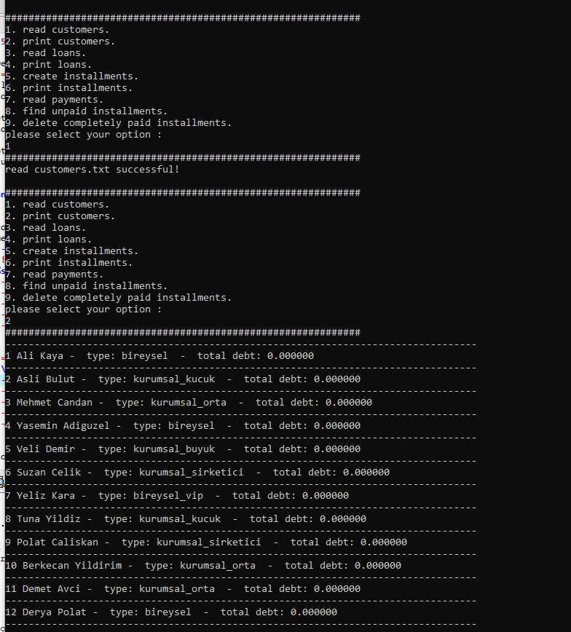

3-4

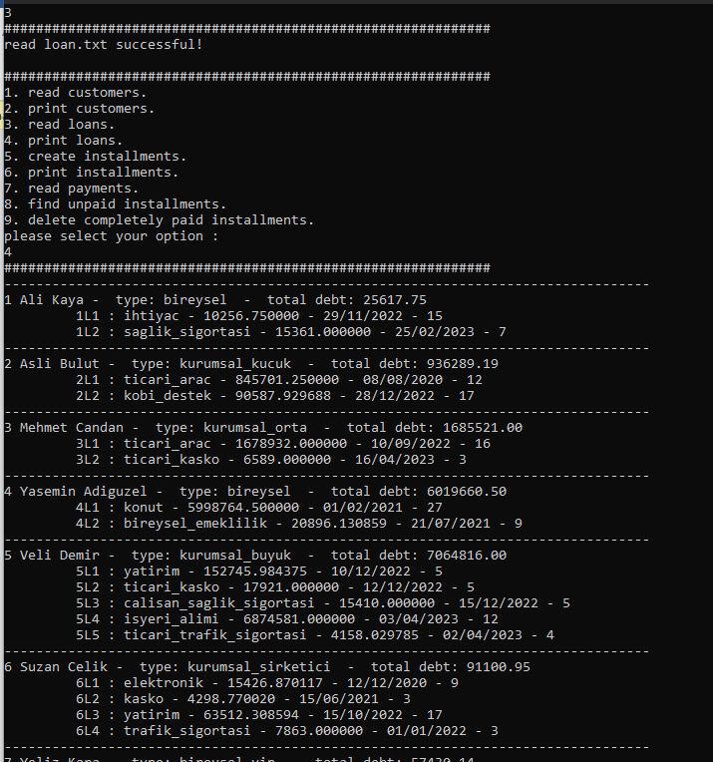

5-6

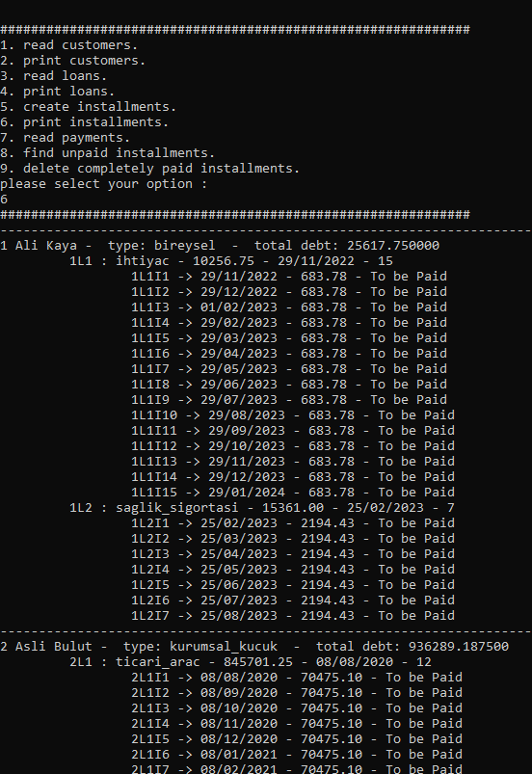

7 – 6

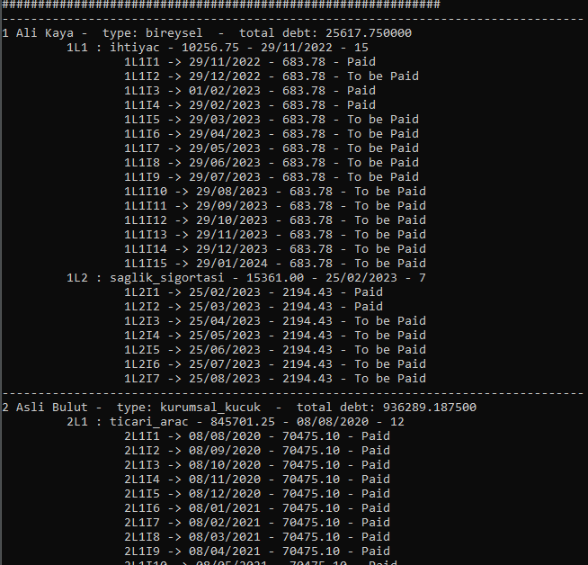

8

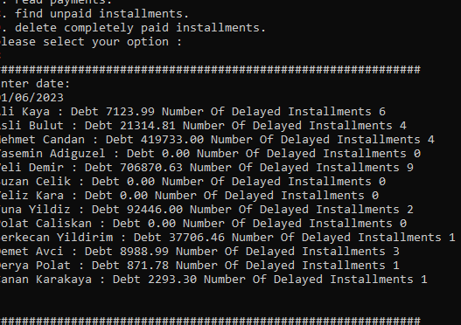

9 – 6

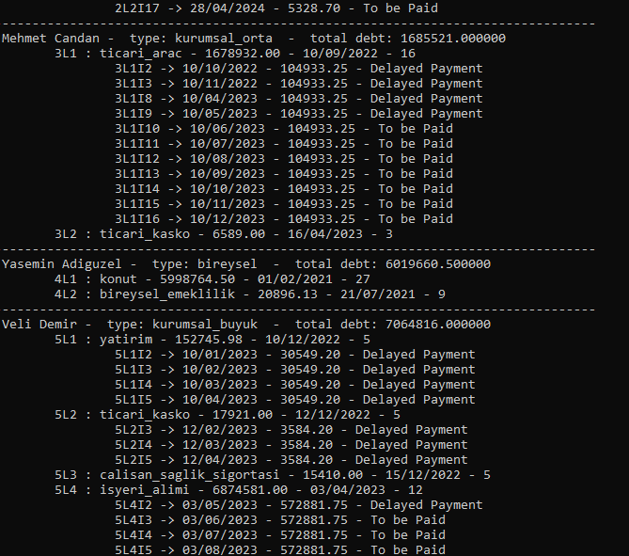

1. **Write explanations about the functions you have written. Include the purpose of the function and how it does which task.**

void customer_append(Customer** head_ref, char* name,char* surname,int customerid,char* customertype, double totaldebt);

add a customer node to the end of customer linked list

void read_customers(Customer** head);

read customers data from files ,then add all of customers to linked list

void printCustomers(Customer* head);

print customers

int customersSize(Customer* head);

find total customers

Customer* getCustomer(Customer* head,char* name,char* surname);

Find customer by name and surname

void printLoans(Customer* head);

print loans

Loan* loan_append(Loan* head_ref, char* loanid,char* type,float totalamount,int totalinstallmentnum, char* processdate);

add a loan node to the loan linked list, (sorted insert )

Installment* installment_append(Installment* head_ref, char* insid, char* installmentdate,float amount,short ispaid );

add a installment node to the end of installment linked list

int compareDate(char* d1,char* d2);

compare 2 date string

void read_loans(Customer** head);

read data from loan.txt

void createInstallments(Customer* head);

create installments for each loan

char* addMonth(char* date,int monthToAdd);  
 use for : add 1 moth to date

void printInstallments(Customer* head);

print installmments

void read_payment(Customer** head);

read payments.txt

Loan* getLoan(Customer* head,char* id);

Find loan by loanID

void payALl(Loan* loan);

pay all installments

void payAt(Loan* loan,int at);

pay installments by number

void findUnpaidInstallments(Customer* head);

find unpaid installments

void payDelay(Customer* head,char* date);

use for findUnpaidInstallments

change isPaid = 3 for delay installments

Installment* findPaidIns(Installment* head_ref);

Find paid installment

Installment* DeleteInstallment(Installment* head_ref,Installment* deleteNode);

Delete a node in installments linked list

void deletePaidInstallments(Customer* head);

delete all paid installments

1. **Explain where and how the linked lists are created and elements of a linked list are deleted. If a linked list has a sorted structure, please explain where and how it is sorted.**

**linked list are deleted:**

+ in delete paid installment

Find exist paid installment node

Delete that node

**lists are created:**

+ in read customers,loans,payments

+ each line add a new node to the linked list

**list sorted:**

+ in insert loan

+ compare the processdate to each node in the linked list then place it at correct order!