**Resizing images using MATLAB**

We extract only the gray regions and then reduce both the number of rows and columns by half.

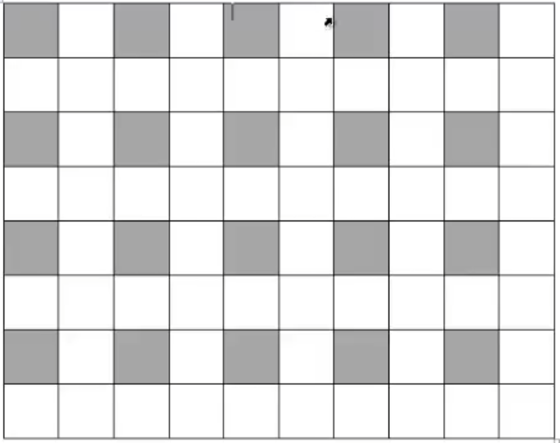

% Section 1

myimage = imread('cameraman.tif');

%% Section 2

% get the rows and columns

[rows,columns] = size(myimage);

%%  Section 3

% Initiate indexes

i = 1;

j = 1;

% New image

newimage = zeros(rows/2,columns/2);

for x=1:2:rows

    for y = 1:2:columns

        newimage(i,j) = myimage(x,y);

        j = j + 1;

    end

    i = i + 1;

    j = 1;

end

%%  Section 4

% Print

figure, imshow(myimage);

figure, imshow(newimage/255);

% Scale up image to see how informations are lost, blurred

figure, imagesc(newimage), colormap(gray)

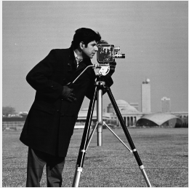

Figure 1.myimage

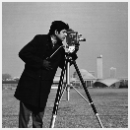

Figure 2. newimage

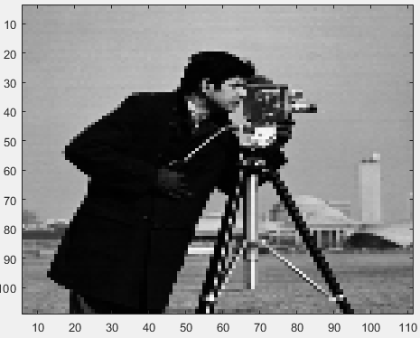

Figure 3. Scaled Image