Low Pass Filter
- Low pass filters block high frequency content of the image
- High frequency content correspond to boundaries of the object.
Noise Removal
- To remove speckles/dots on an image
- Dots can be modeled as impulses or continuously varying (Gaussian noise)
- Can be removed by taking mean or median values of neighboring pixels (e.g 3x3 window)
- Equivalent to low pass filtering
Problem with low pass filtering
- May blur edges
- More advanced techniques: adaptive, edge preserving
Mean/Averaging Filter
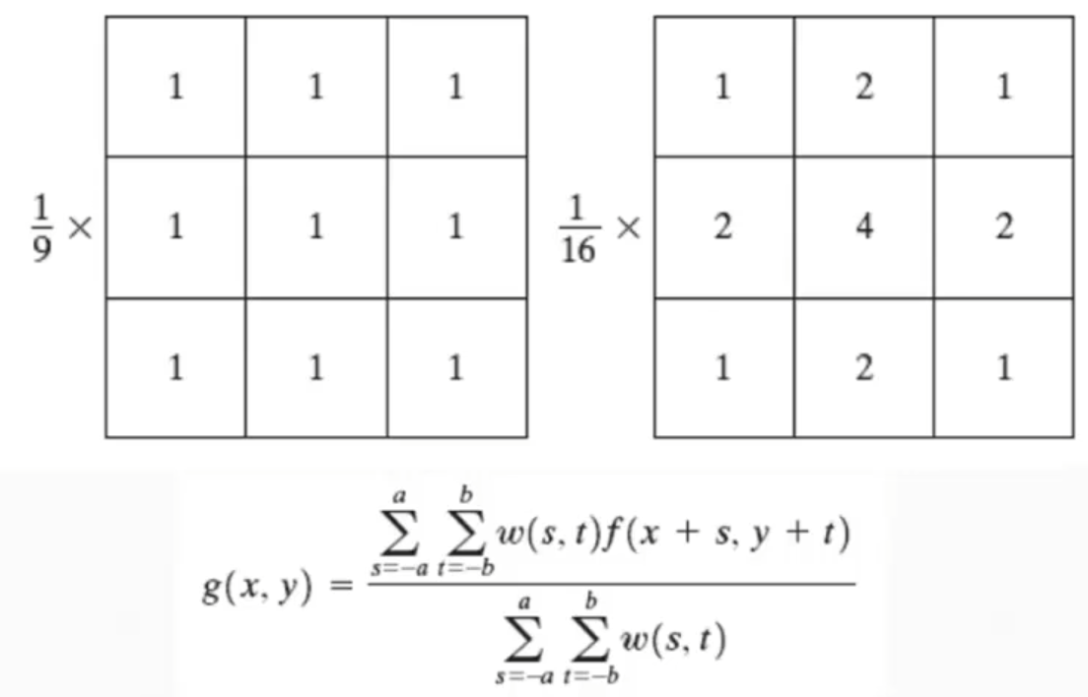
Median Filter
- Median filter replaces the pixel at the center of the filter with the median value of the pixels falling beneath the mask.
- Median filter does not blur the image but it rounds the corners

Matlab Implementation
% xxxxxxxxxxxxxxxxxxxxxxxxxxxxxxxxxxxxxxxxxxxxxxxxxxxxxxxxxxxxxxxx
%% Section 1
% xxxxxxxxxxxxxxxxxxxxxxxxxxxxxxxxxxxxxxxxxxxxxxxxxxxxxxxxxxxxxxxx
% Print on Matlab
figure(Name="Section 1");
myimage = imread('cameraman.tif');
imshow(myimage)
% Convert Image into Double for processing on matlab
id_double = (myimage/255);
% Assign image height and width to r and c variables
[r,c] = size(id_double);

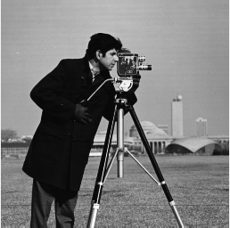
% xxxxxxxxxxxxxxxxxxxxxxxxxxxxxxxxxxxxxxxxxxxxxxxxxxxxxxxxxxxxxxxx
%% Section 2 :
% xxxxxxxxxxxxxxxxxxxxxxxxxxxxxxxxxxxxxxxxxxxxxxxxxxxxxxxxxxxxxxxx
% Array with ones
f = ones(3,3)/9;
% filter2 :
% Y = filter2(H,X) applies a finite impulse response filter to a matrix of
% data X according to coefficients in a matrix H.
% Y = filter2(H,X,shape) returns a subsection of the filtered data according
% to shape. For example, Y = filter2(H,X,'valid') returns only filtered
% data computed without zero-padded edges.
figure(Name="Section 2");
i1 = filter2(f,myimage,'same');
imshow(i1/255);
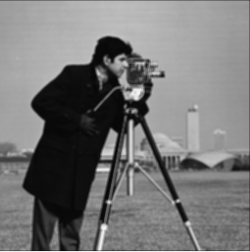

% xxxxxxxxxxxxxxxxxxxxxxxxxxxxxxxxxxxxxxxxxxxxxxxxxxxxxxxxxxxxxxxx
%% Section 3 :
% xxxxxxxxxxxxxxxxxxxxxxxxxxxxxxxxxxxxxxxxxxxxxxxxxxxxxxxxxxxxxxxx
% Same result via using fspecial function
figure(Name="Section 3");
f1= fspecial('average',[3,3]);
i2 = filter2(f1,myimage,'same');
imshow(i2/255);

