Point Transformations using MATLAB
Original Image:
% Section 1
myimage = imread('cameraman.tif');
imshow(myimage)

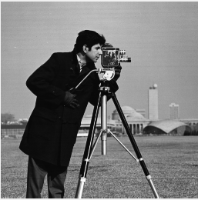
Thresholding : Select Pixels with given values to produce binary image
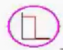
%% Section 2
% Thresholding
i1 = myimage>120;
figure(Name="Section 2");
imshow(i1)

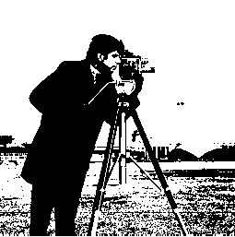
Increase the Intensity :
S = r + C where C is constant and r is pixel value of the image and S is the output image.
%% Section 3
% Increase the intensity of the pixel
id = double(myimage); % Have to convert double before doing math operations
id1 = id + 100; % We are trying to get every image close to white.
% Embed function for this is
% id1 = imadd(myimage,100);
figure(Name="Section 3");
imshow(uint8(id1))

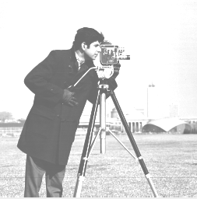
Decrease the Intensity :
S = r - C where C is constant and r is pixel value of the image and S is the output image.
%% Section 4
% Decrease the intensity of the pixel
id2 = id - 100; % We are trying to get every image close to black.
% Embed function for this is
% id2 = imsubtract(myimage,100);
figure(Name="Section 4");
imshow(uint8(id2))

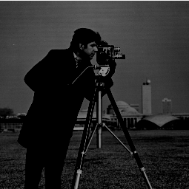
Multiply Image Pixels :
%% Section 5
% Multiply image pixels
id3 = immultiply(myimage,0.5);
figure(Name="Section 5");
imshow(uint8(id3))

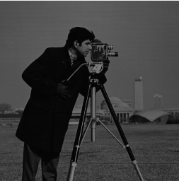
Divide Image Pixels :
%% Section 6
% Divide image pixels
id4 = imdivide(myimage,0.5);
figure(Name="Section 6");
imshow(uint8(id4))

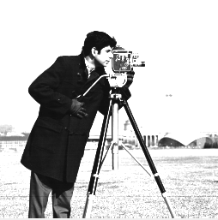

Complement of Image:
%% Section 7
% Complement
% In the complement of a binary image, zeros become ones and ones become zeros.
% Black and white are reversed.
% In the complement of a grayscale or color image, each pixel value is subtracted
% from the maximum pixel value supported by the class (or 1.0 for double-precision images).
% The difference is used as the pixel value in the output image. In the output image,
% dark areas become lighter and light areas become darker. For color images,
% reds become cyan, greens become magenta, blues become yellow, and vice versa.
% --
% Get the maximum value of the image
max_value_image= max(myimage(:));
% Max value for 8 bits monochrome image is 255 (0-255)
id5 = abs(id - 255);
% Embed function for this is
% id5 = imcomplement(myimage);
figure(Name="Section 7");
imshow(uint8(id5))

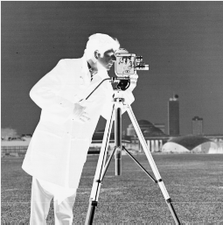

Logarithm Operator : Reducing contrast of brighter regions
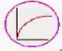
S = C * log(1 + r) where C is constant and r is pixel value of the image and S is the output image.
%% Section 8
% Logarithm Operator : Reducing contrast of brighter regions
id_double = im2double(myimage);
% Equation
% S = C * log(1 + r) where C is constant and r is pixel value of the image and S is the output image.
% Assign image height and width to r and c variables
[r,c] = size(id_double);
% Define 5 Constant value for C
factor = [1 6 12 25 100];
% Plot the original image to compare
subplot (1,6,1); imshow(id_double); title("Original Image");
% Run image processing equation for 5 Constant value
for im_num = 1:5 % for each constant value , means for each image
for i = 1:r
for j = 1:c
S(i,j) = factor(im_num) * log(1 + id_double(i,j)); % C = factor(im_num) , r = id(i,j)
end
end
%
subplot (1,6,im_num+1); imshow(S); title(sprintf("Constant Value C = %d", factor(im_num)));
end

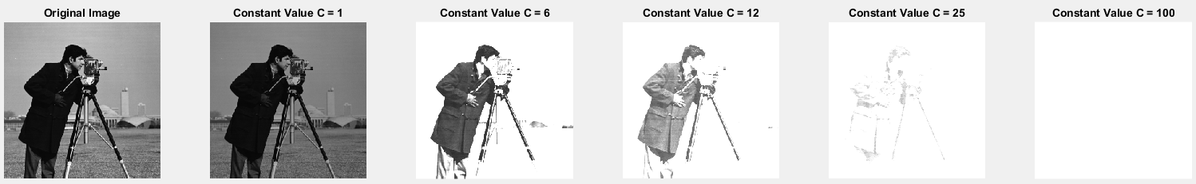

Exponential/Raise to Power Operator : Enhancing contrast of brighter regions
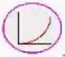
Power function: S = C * ( r ^ Y ) where 0<=s <=1 , 0<=r <=1
%% Section 9
% Power Function : Enhancing contrast of brighter regions

id_double = im2double(myimage);
% Equation
% S = C * ( r ^ Y ) where C is constant and r is pixel value of the image and S is the output image.
% Y = 2 in this example.
% Assign image height and width to r and c variables
[r,c] = size(id_double);
% Define 5 Constant value for C
factor = [1 6 12 25 100];
% Plot the original image to compare
subplot (1,6,1); imshow(id_double); title("Original Image");
% Run image processing equation for 5 Constant value
for im_num = 1:5 % for each constant value , means for each image
for i = 1:r
for j = 1:c
S(i,j) = factor(im_num) * id_double(i,j) ^ 2; % C = factor(im_num) , r = id(i,j)
end
end
%
subplot (1,6,im_num+1); imshow(S); title(sprintf("Constant Value C = %d", factor(im_num)));
end

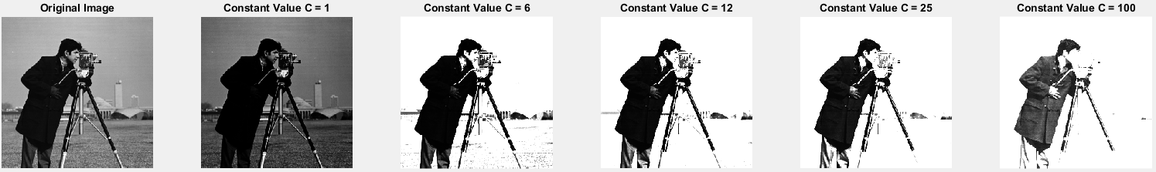

Histogram Equalization: General method of modifying intensity distribution

Spatial filters : To change the grey level of a given pixel we need only know the value of the grey levels in small neighbourhood of pixels around the given pixel.
Point Operations: A pixels grey value is changed without any knowled of its surrounds.
Contrast Stretching : Spreading out gray level distribution
