Personal Leadership Reflection
Using a personal TO-DO list to plan, monitor, and improve my learning
Project / portfolio area | GenAI Portfolio - Personal Leadership
Learning Outcome focus | LO7 - Personal Leadership
Evidence type | Personal planning notes, progress tracking, appointment confirmation, and research evidence
Purpose of this document | To explain how I used a self-created TO-DO list to become more aware of my goals, divide larger goals into smaller actions, and reflect on what worked and what still needs improvement.

1. Context
For my personal leadership development, I created a large personal TO-DO list. The list is written in a mix of English and Turkish. I did not intentionally choose to mix the languages; it simply happened naturally while I was thinking and writing quickly. For this reflection, the language mix is not the important part. The important part is that the list helped me make my goals visible and easier to manage.
The list includes both small daily actions and larger long-term goals. For example, one goal is about getting my driver licence, another is about improving my understanding and listening skills, and another is about spending more time learning. These goals are not equal in size. Some can be completed quickly, while others require time, repetition, and smaller sub-goals.
Evidence: [Add evidence link or title here: Photos of my handwritten TO-DO list and progress tracking pages.]
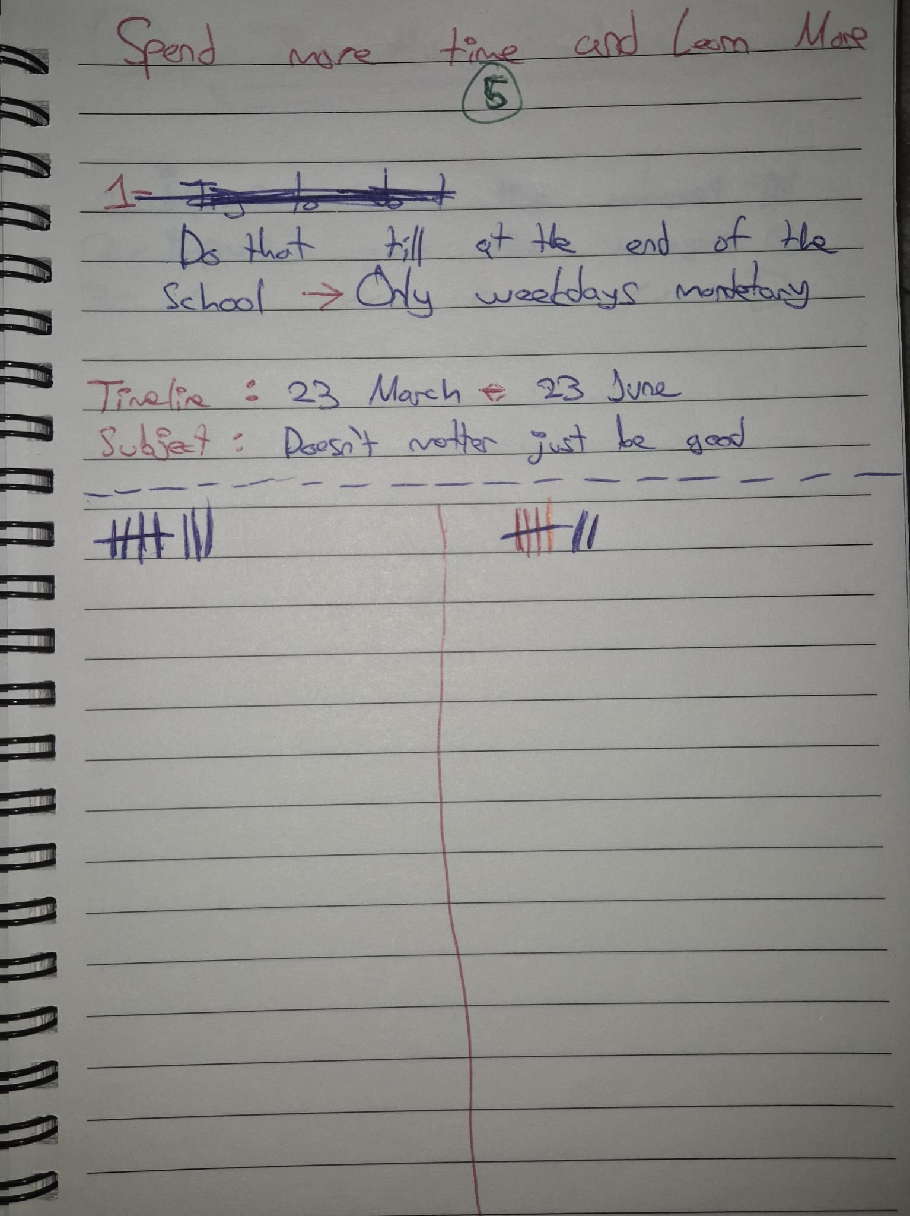
Figure 1 - Overview of my handwritten personal TO-DO list.

2. Why I Created the TO-DO List
Creating the TO-DO list made me more aware of what I actually needed to do. Instead of keeping everything in my head, I could see my goals on paper. This helped me think more clearly about what was important, what was urgent, and what needed to be divided into smaller steps.
I applied this approach because my research suggested that large goals become easier when they are divided into smaller sub-goals. A big goal can feel vague or heavy, but a small sub-goal feels more realistic and achievable. This made me more motivated because I could focus on one concrete step at a time instead of only thinking about the final result.
A clear example is my driver licence goal. Passing the theory exam required research and studying over roughly forty days. However, because I divided the process into smaller actions, it did not feel as overwhelming. The method did not remove the effort, but it made the effort feel more manageable.
I also learned that not every goal has to be completed perfectly. Some goals are crucial and deserve more focus, while others are useful but less urgent. This helped me avoid treating the whole list as a strict obligation. Instead, I used it as a personal leadership tool to guide my attention and monitor progress.

3. Main Areas in the TO-DO List
Area | Example from my list | Purpose
Discipline and routine | Cold shower and morning phone screen blocker | Start the day with more control and energy.
Future preparation | Search for internships and prepare for the process | Make next semester less stressful and more concrete.
Learning growth | Spend more time learning and improve understanding skills | Build stronger long-term ICT and communication skills.
Health and self-awareness | Check hearing level and investigate focus/processing issues | Understand possible reasons behind difficulty following complex explanations.
Project methodology | Apply the DOT Framework as much as possible | Use a more systematic way to research, test, and reflect on project decisions.

4. Example 1 - Cold Shower and Morning Phone Screen Blocker
One concrete example from my list is the combination of taking short cold showers and avoiding phone use in bed in the morning. I used this as a personal challenge and tracked whether I applied it with plus and minus marks.
The cold shower habit came from my own research through YouTube and AI chatbots. The idea was that after working for several hours, a short cold shower could help refresh my body and mind. In practice, this worked well for me. By sacrificing around five minutes, I often felt more awake and was able to continue working for several more productive hours.
The morning phone blocker goal was connected to time management. I noticed that the beginning of the day strongly affects the rest of my day. When I wake up and immediately start scrolling, I often stay in bed much longer and become mentally foggy. Sometimes this can lead to standing up very late, around 15:00 or 16:00, which makes the whole day less productive.
Based on my research, I understood this as a dopamine and attention problem. If I begin the day with phone scrolling, I create a strong short-term stimulation pattern before doing anything meaningful. When I avoid that and start the day more calmly, I can do the important tasks earlier and then rest later without feeling that I wasted the day.
Evidence: [Add evidence link or title here: My tracking page showing plus/minus marks for the cold shower and morning phone challenge.]
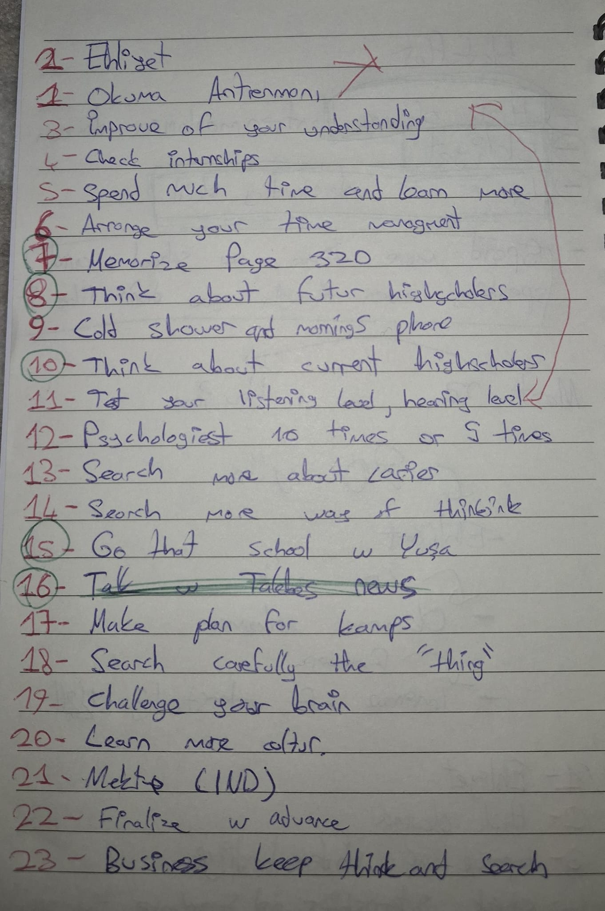
Figure 2 - Tracking the cold shower and morning phone blocker challenge.

5. Example 2 - Internship Preparation
Another important goal is internship preparation. I need to do an internship next semester, so I started checking internship opportunities regularly. Instead of waiting until the last moment, I wanted to create a daily or near-daily habit of looking at LinkedIn and other internship sources.
By doing this, I realized that I am especially interested in internships related to Machine Learning. This matters because the process did not only help me find possible opportunities; it also helped me clarify what kind of direction I want. I also checked internship conversations and information about the process, which helped me understand what companies might expect and what preparation steps I still need.
Evidence: [Add evidence link or title here: Internship search notes, LinkedIn search screenshots, or internship process research.]
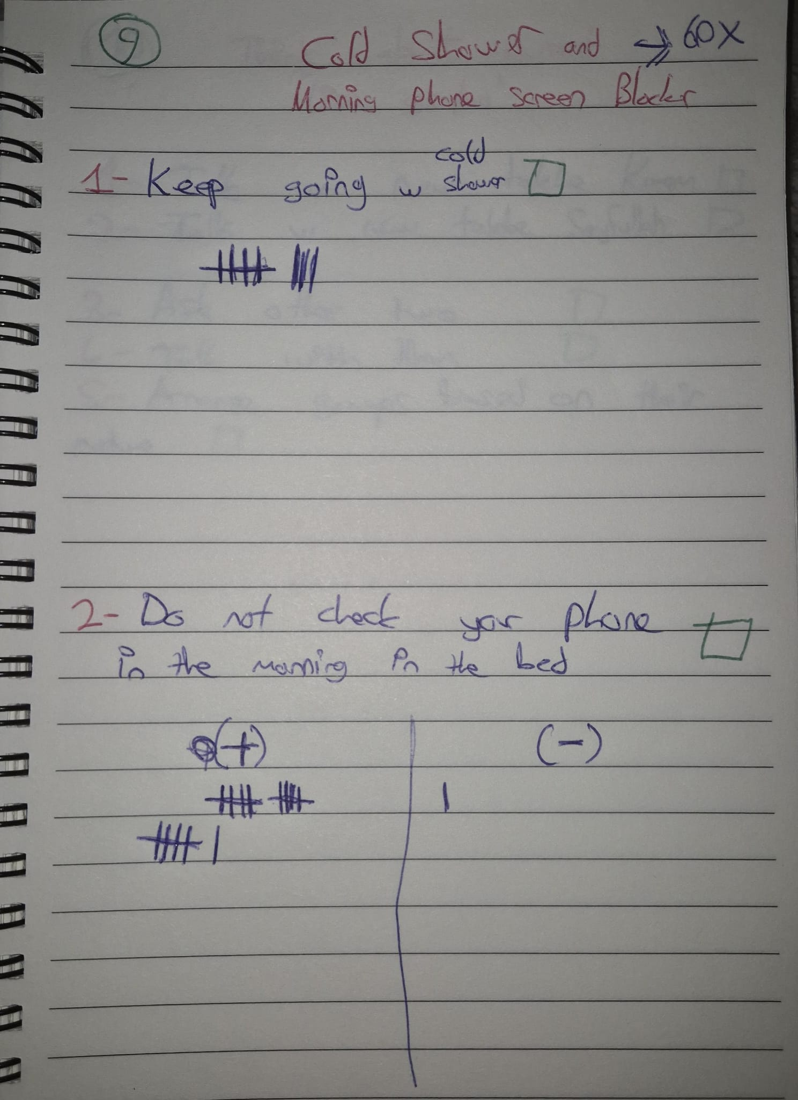
Figure 3 - Internship preparation list and progress tracking.
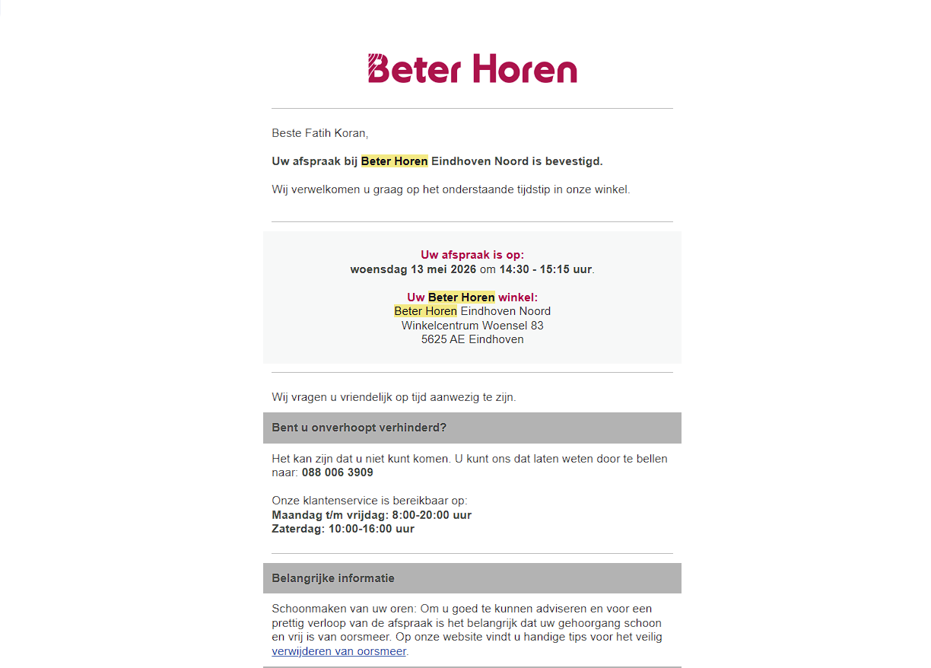
Figure 4 - Appointment evidence related to hearing check preparation.

6. What Did Not Fully Work Yet
Not every goal on the list is going perfectly. One example is my goal to study or learn ICT-related topics daily. This did not go as strongly as I wanted. I am still happy that I manage to spend time on it regularly, sometimes every two days, but I cannot honestly say that this goal is fully successful yet.
The main reason is that school and other serious responsibilities sometimes require a lot of focus and time. When I have to concentrate on important school work, my additional ICT learning goal becomes harder to maintain. This does not mean the goal failed completely, but it shows that I need a more realistic schedule and better prioritization.
Evidence: [Add evidence link or title here: Notes showing learning goals, ICT-related study plans, or weekly progress.]
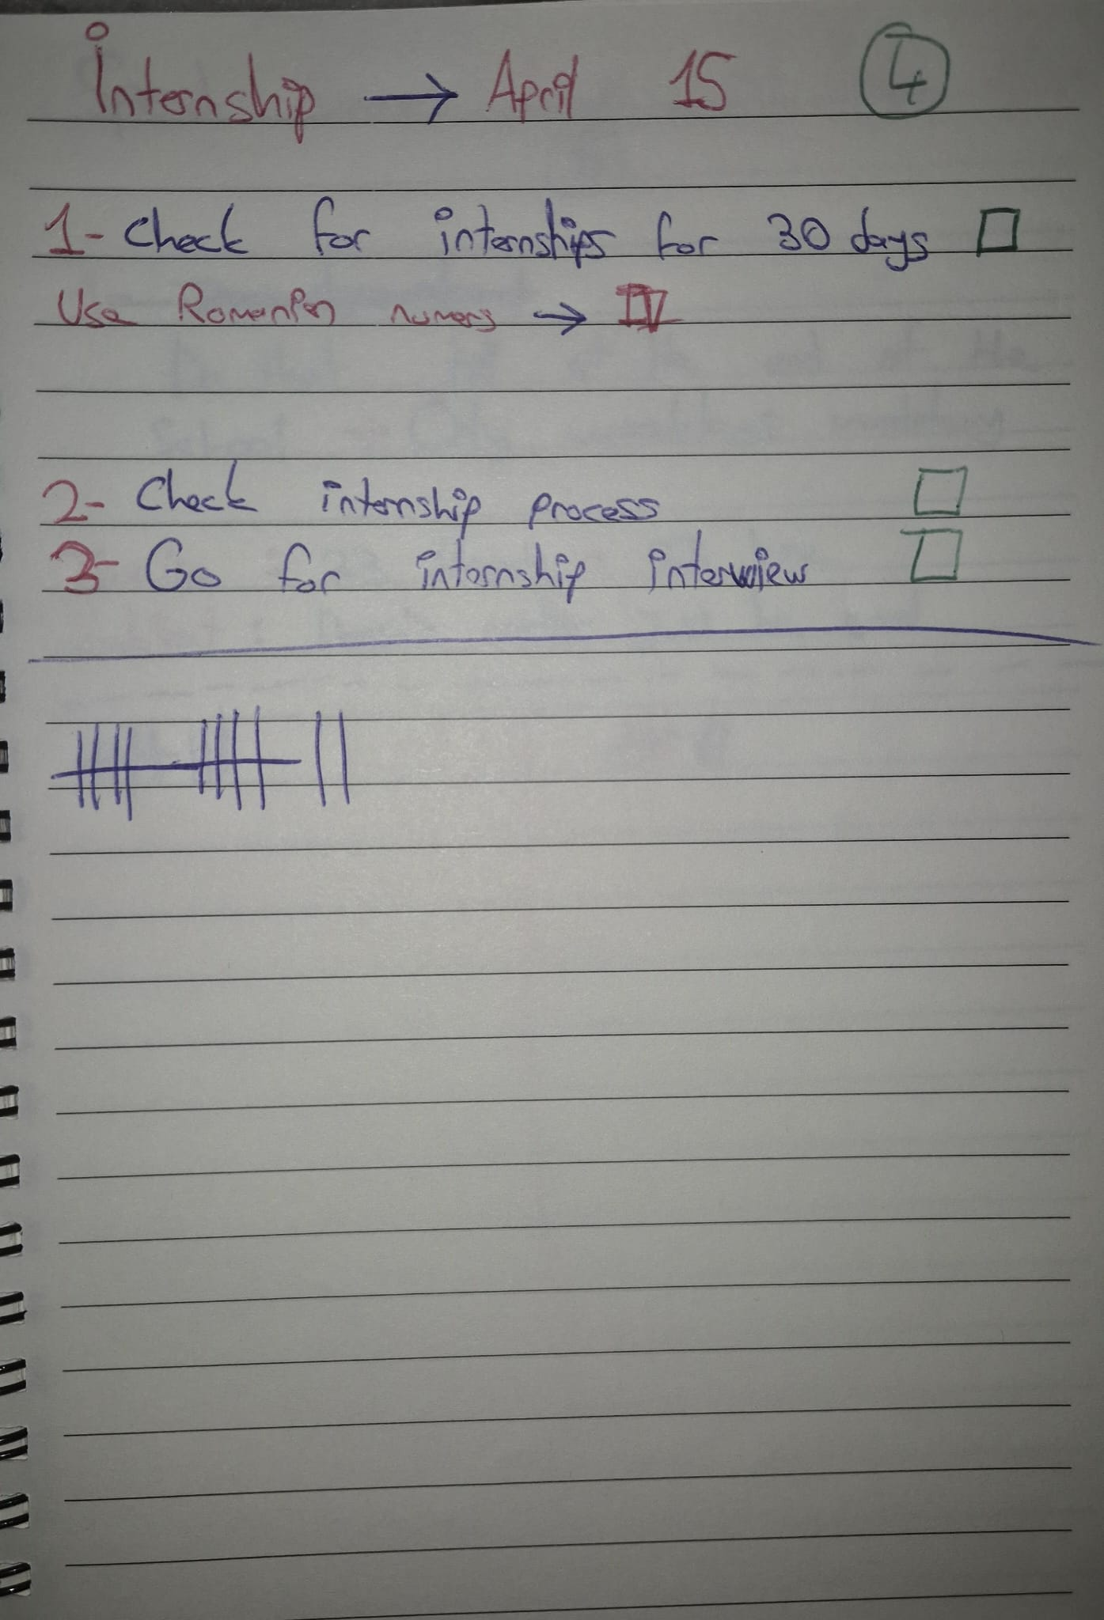
Figure 5 - Additional progress tracking and sub-goals.

7. Understanding, Listening, and Self-Awareness
A more personal goal on the list is improving my ability to understand and follow difficult topics. I started thinking about why I sometimes struggle to follow complex explanations, especially when a topic becomes very technical or full of terminology.
One possibility I considered is my hearing. I might be hearing less clearly than other people, which could affect how well I follow explanations. Because of this, I made an appointment related to my hearing. This is an important personal leadership action because I am not only saying that I want to improve; I am checking whether there is a concrete reason behind the problem.
Another possibility is that my brain processes information a bit slower when a topic becomes overloaded with terminology. It could also be a focus issue. I am still researching these possibilities. After the hearing test, I expect the situation to become clearer, and then I can decide what kind of action makes sense next.
Evidence: [Add evidence link or title here: Beter Horen appointment confirmation and later hearing test result if available.]

8. Applying the DOT Framework in My Project Work
Lastly, I also tried to apply the DOT Framework methodology as much as I could in my project work. I already mentioned this in my reflection from last year, but this time I tried to apply it more consciously. I used the framework to analyze, test, experiment, and support project-related decisions with evidence instead of only relying on assumptions.
This connects to personal leadership because it shows that I am trying to improve the way I work, not only the final result. I want to become better at making decisions through research and evidence. For my GenAI project, this fits my development as someone who wants to test models, compare results, and explain decisions clearly.
Evidence: [Fatih will add here: evidence of research based on the DOT Framework, such as research notes, decision logs, experiments, or screenshots.]

9. Conclusion
Overall, the TO-DO list helped me turn vague goals into visible and manageable actions. It made me more aware of what I want to improve, what is already working, and what still needs more structure. The strongest examples are my driver licence preparation, the morning routine challenge, internship preparation, and my investigation into hearing and understanding difficulties.
The list is not perfect, and I did not complete every goal. However, that is also part of the reflection. Personal leadership is not only about writing goals; it is about monitoring myself honestly, learning from what works, and adjusting when something is unrealistic. This TO-DO list became a practical tool for that process.

