Research Report on Aerial Vehicle Navigation in Gps-Denied Environments

Abstract

In this project, we are aiming to develop a navigation system for aircraft that will be used in gps-denied environments. This navigation system will be based on the visual and inertial sensor data fusion. Moreover, the system output will be the map of the environment and the location of the aircraft in that environment. Location consist of the position and the orientation of the aircraft in that map. Initially, we have started a literature survey to investigate the potential solutions in the current research field. In literature, this problem called as visual inertial navigation. Throughout the literature survey we have worked on state-of-art algorithms that applies different methods to solve the visual inertial odometry problem and we have ended up with an ideas to how to build the structure of our system and algorithm that could be applicable to our case.

Even there are several state of art works that propose a solution for visual-inertial navigation systems for aerial vehicles, we focused on most common and the ones that gave the most accurate results. We have picked two of them according to their performances and the publish dates. They are the most recent ones, called SVO(semi-visual odometry) and VINS-MONO. Moreover, I found a benchmark paper that compares those most common visual-inertial algorithms in different platforms in terms of their performance. According to the performance results of the given paper, I decided to focus on the ones with the best performance values. Those are stated as again VINS-MONO and SVO.

As it is mentioned in the abstract part, we have ended up with ideas to roughly build the structure of the algorithm that provides the outputs that we demanded. According to the results of our survey, we have decided to build tightly-coupled monocular visual inertial odometry system as a solution to the GNSS problem. In the steps of building the VIO system structure, there are several variables that needs to be decided. Those variables selecting according to the needs of the system that it will be applied. As an outcome of our literature survey we have stated the most suitable configuration for our system. There are reasons behind the selection of the system properties. In that section we are going to explain them briefly.

Sensor Type(s):
(sensor type-monocular-stereo-lidar) First of all there are several options to gather the measurements from the environment in SLAM systems. For that purpose, most used sensors are LIDAR’s and the cameras. For the cameras, most common ones that are using in the SLAM systems are the monocular and stereo cameras. There are pros and cons of each sensor type in terms of the measurement properties for different use cases. LIDAR’s and the stereo cameras have the advantage of the gathering scale data with measuring the depth in the environment. This property would be very helpful in the data association process of the any SLAM system. But on the other hand, for instance for LIDAR’s due to the type of the sensor which is an active sensor and its sending rays to the environment in the process of taking the measurements, we cannot use that sensor because of it prevents the aircraft to be stealth. Therefore, in order to preserve the stealth property of the aircraft, we are going to use camera as a passive sensor. In terms of the camera, there are stereo and monocular cameras. Stereo cameras are useful and robust in small scale, mostly indoor applications of the SLAM. They are not applicable in large environments because in order to get the accurate depth information in stereo cameras; camera base line and distance to the landmark ratio should not be too small. In our case, when think about the base line - altitude ratio, it is too small to get the accurate depth information from the stereo camera directly. Therefore, we are ended up with selecting the monocular camera as our sensor in SLAM system. There is a disadvantage of monocular cameras that they are incapable of recovering the metric scale. The IMU comes in to play as a solution to this lack of capability of observing the metric scale of monocular cameras. In order to observe the metric scale we need acceleration in at least two axes, this information will provided by the IMU.

Fusion Method:
(fuse type-tightly coupled- loosely coupled)
Another aspect to decide in VIO algorithm is whether the built the structure upon tightly or loosely coupled fashion. In loosely coupled fusion, the pose of the platform is estimated with both camera and IMU measurements separately and at the end, fusion applied to their estimation. Because, in loosely coupled approach fusing visual and inertial information is not considered in raw data level, this makes the system incapable of correcting the drifts in vision only pose estimation. On the other hand, in the tightly coupled approach, raw measurements of the camera and IMU used together to estimate the position of the platform. Tightly coupled approach needs more computational power but it’s more accurate than the loosely coupled approach. We don’t have any issue with that much efficiency in computational power, therefore in order to increase the accuracy we are going to build the algorithm structure upon tightly coupled fashion.

Front-end and Back-end Structure:
(Front-end, back-end)(filtering- smoothing)
We can state that there are two main parts of the generic SLAM algorithms. Those are stated as front-end and back-end. In other terms we can name them as data association and optimization parts respectively. In front-end part, the pose graph is built with using the measurements from the sensors. In that pose graph there are nodes represents the position of the platform and the landmarks in the environment. Moreover there are arrows between those nodes which represents the measurement constraints between those nodes. In back-end part, there are two approaches stated as filtering based and optimization based. In filtering approach, there is no re-linearization process for old measurements. It uses older state information to estimate latest state and drop the older states permanently. That result in making the linearization errors and erroneous measurements permanent. On the other hand in the optimization method, in other terms smoothing, there is re-linearization for older states. When the estimate is updated, older measurements re-linearized and multiple states estimated instead of only latest state. That need more computational power than the filtering approach but more accurate. We are caring the accuracy more than the computational efficiency, therefore we are aiming to build our algorithm structure upon optimization in back-end rather than filtering.

Additional Properties:
(loop closure, keyframe selection)
Additionally, our system has some properties which enhance the VIO system’s accuracy and robustness. Firstly, there will be loop closure in the structure. Loop closure means that, when the platform become the same position with one of the older states, it detects the state and optimize the whole path. Moreover, in the data association part, we are going to implement keyframe selection algorithm. That will helps us to build an efficient algorithm. In other terms, we are going eliminate not useful frames taken by the sensors. We are going to build an algorithm to calculate how much important is the frame with detecting the parallax and amount of different features. There will be a threshold for both aspect. For instance, if the number of different features not exceed a stated threshold, then that means there is no need to consider this frame as new frame. That helps us to prevent storing unnecessary data.

Another issue is about the VIO algorithm is being online or offline. In offline approach, the optimization process runs after the whole data association completed. On the other hand, in online approach, data association and optimization processed in same frame nearly real time. Therefore we are going to build our algorithm as online visual inertial odometry system.

IMU Pre-integration:
(imu preintegration)
In visual inertial odometry system, the data collection frequencies of the visual and inertial sensors are different. For instance for standard camera the working frequency is around 100Hz and on the other hand for standard IMU the working frequency is around 1000Hz. In order to make the estimation accurately, the fusing should be on the same time stamp that means there should be a calibration between the visual inertial sensors. On the other hand, there is IMU pre-integration approach which helps to use the inertial data when there is no visual data taken that time period. In IMU pre-integration, all measurements between two consecutive visual measurements summarized in a single measurement. That compound measurement used as a constraint between two consecutive frames.

Requirements

- The system should work properly in gps-denied environments.
- The system should create a map of the environment and localize the aircraft on that map. Localization consist of the position and the orientation of the aircraft on that map.
- The system will use monocular camera data as visual data and IMU measurement for inertial data.
- Camera intrinsic and extrinsic parameters will be parametric in the algorithm where the extrinsic parameters are the location and orientation of the camera with respect to the world frame and intrinsic parameters of the camera are focal length, geometric distortion of lens and transformation matrix between the camera frame and the pixel coordinates.
- Proposed VIO system should work properly in low altitude flight.
- The initial algorithm will be tested on the KITTI and EuRoc MAV datasets. After the 8 month process, the algorithm will be tested in drone with pre-built path in the known map.
- The system will match the created point cloud data with the pre-known and loaded terrain map to identify the position of the aircraft in that terrain map.

Visual Measurements:

The system uses both the visual and inertial measurements in order to get the relative orientation and location of the consecutive frames in the pose graph.

VINS-MONO:

In that section, in order to show the general structure of the VIO algorithm, the VINS-MONO algorithm is briefly explained. We picked the VINS-MONO because it’s the closest algorithm to our planned structure. Before introducing the algorithm, some of the state-of-art algorithms are compared in terms of the efficiency and accuracy.
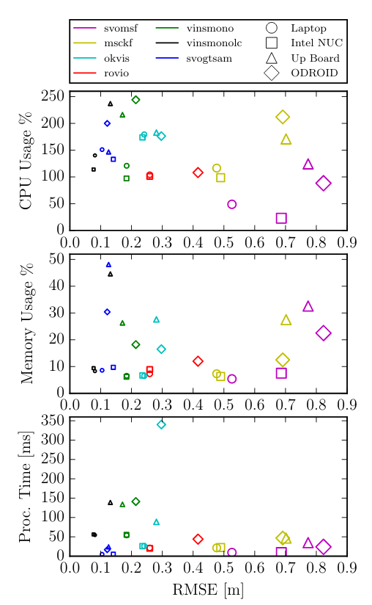
Illustration 1: Performance results of common VIO algorithms based on root mean square error. Adapted from "A Benchmark Comparison of Monocular Visual-Inertial Odometry Algorithms for Flying Robots" by J. Delmerico and D. Scaramuzza, IEEE International Conference on Robotics and Automation(ICRA), 2018

In referenced paper [3] the algorithms tested on the EuRoC Mav dataset. As it can be seen from the comparison graph above, VINS-MONO has the least root mean square error. In addition, it has acceptable CPU usage for the small platforms that could be used as mounted to the drones. That’s why I have more focused on VINS-MONO algorithm at primarily. Thus, I am going to explain some general concepts and concepts specifically related with VINS-MONO study throughout this report.

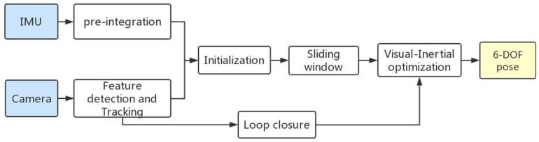Illustration 2: General base structure of the VIO algorithm. Adapted from "Robust Stereo Visual-Inertial Odometry Using Nonlinear Optimization" by S. Ma, X. Bai, Y. Wang, R. Fang, Sensors(Basel), 2019, 19(17): 3747

Illustration 2 represents the general framework of the visual inertial pose estimation structure. Basically most of the VIO systems use a camera for the visual data and the IMU sensor. In terms of the type of the camera, there are two approaches. One of them is building the system with using stereo cameras and the other one is using monocular cameras. In our case, I will go over on the monocular camera approaches. Because in the stereo camera approaches, there is a need for large baseline length for the accurate results. Baseline is the distance between the two lenses of the stereo camera and it influences the depth range that can be observed and depth resolution. In that sense, in high altitudes there is need for huge baselines, thats why in our case the system should be independent of this feature. Thus, I decided to go over monocular camera approaches.

In this general structure in illustration 2, inputs are the image from the monocular or stereo cameras and the IMU data which contains the acceleration and angular velocity measurements. Based on those inputs, the output is the 6-dof pose estimation of the platform. The system starts with feature extraction and IMU pre-integration. The inertial and visual poses are combined for initial estimation of the platform with its pose, velocity, gyroscope bias, gravity vector. These values are iteratively updated by the visual-inertial odometry algorithm. At the end, the 6-DOF pose of the platform calculated.
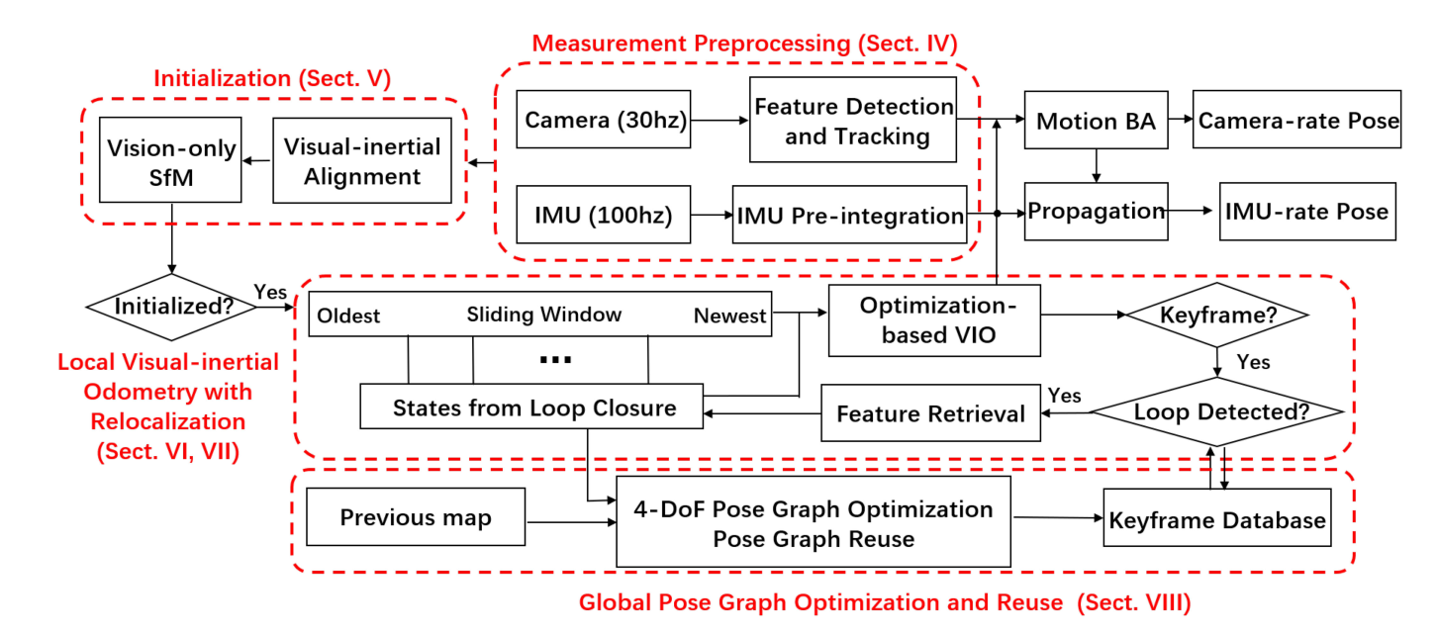Illustration 3: VINS-MONO system structure. Adapted from "VINS-MONO: A Robust and Versatile Monocular Visual-Inertial State Estimator" by T. Qin, P. Li, and S. Shen, IEEE Transactions on Robotics, Vol. 34, No. 4, 2018

Illustration 3 represents the detailed structure of the VINS-MONO algorithm. In the structure of the VINS-MONO algorithm, it starts with measurement preprocessing step. That part is common in stated popular VIO, visual-slam algorithms. As it is mentioned in the general structure model of the VIO algorithms, measurement preprocessing part contains the feature extraction from camera data and the IMU measurements between two consecutive camera frames. In initialization step, values of pose, velocity, gravity vector, gyroscope bias, 3d location of the features in the environment are obtained. In further step, in VIO module, pre-integrated IMU measurements and feature observations are fused to re-localize the system. Finally, there is pose graph optimization module which used for eliminating the drift. In proposed system, relocalization and graph optimization run simultaneously.

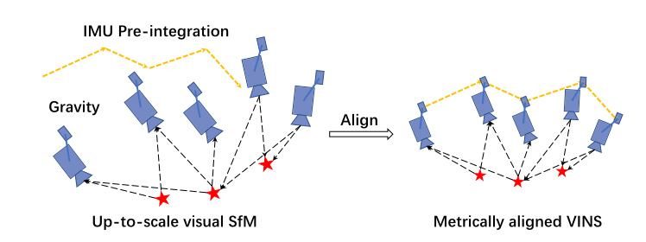Illustration 4: Adapted from "VINS-MONO: A Robust and Versatile Monocular Visual-Inertial State Estimator" by T. Qin, P. Li, and S. Shen, IEEE Transactions on Robotics, Vol. 34, No. 4, 2018

Illustration 4 represents the IMU preintegration and the sample path of the IMU – camera couple with the observed feature points in the environment. In this concept, the basic idea is matching the visual structure with the IMU pre-integration.

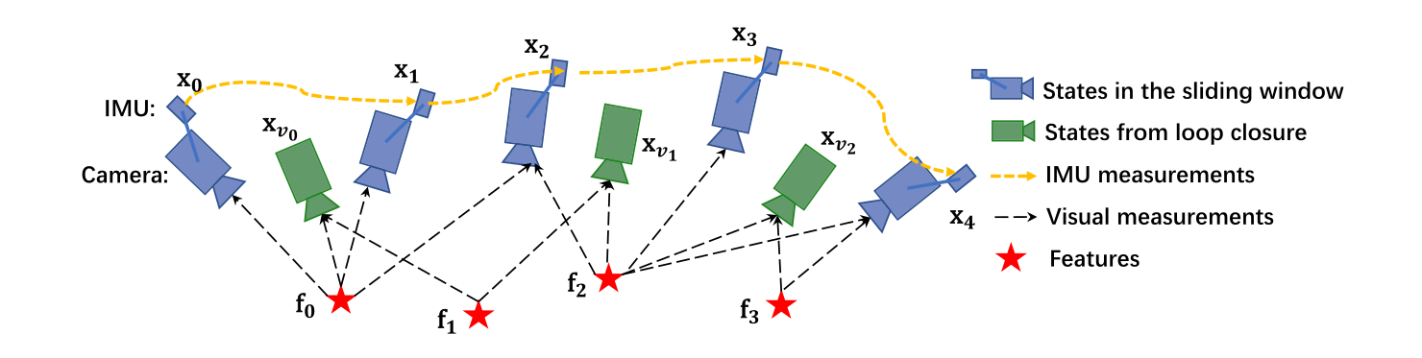Illustration 5: Adapted from "VINS-MONO: A Robust and Versatile Monocular Visual-Inertial State Estimator" by T. Qin, P. Li, and S. Shen, IEEE Transactions on Robotics, Vol. 34, No. 4, 2018

Above model represents the flow after the initialization step. This approach called as sliding window based tightly couples monocular VIO for state estimation.
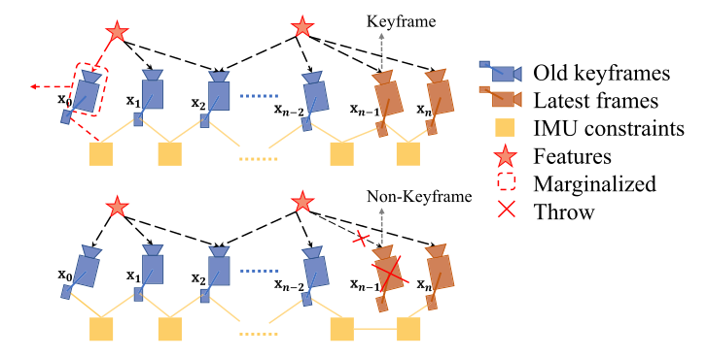Illustration 6: Adapted from "VINS-MONO: A Robust and Versatile Monocular Visual-Inertial State Estimator" by T. Qin, P. Li, and S. Shen, IEEE Transactions on Robotics, Vol. 34, No. 4, 2018

This model explains the marginalization strategy. In that approach, algorithm checks whether the second last frame is keyframe or not. If it is key frame, then it is kept in the window and the oldest frame marginalized. The marginalized visual and inertial measurements used as prior. But if the second last frame is not keyframe, then it is removed with its visual measurements. But the inertial measurements always kept for the IMU pre-integration process for the further frames.

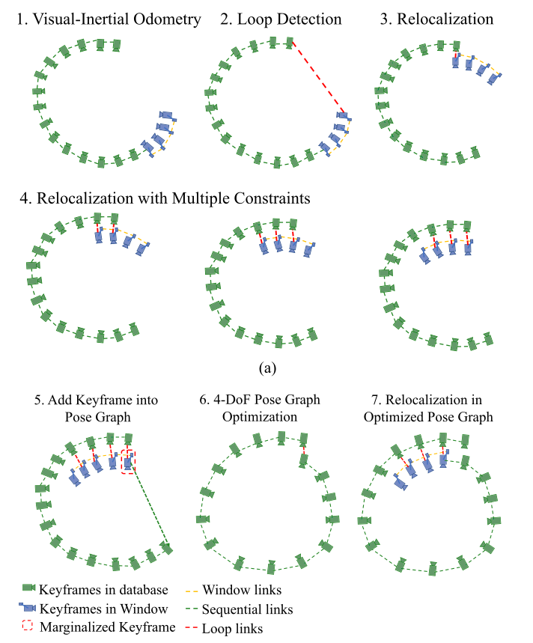
Illustration 7: Relocalization and pose graph optimization procedure. Adapted from "VINS-MONO: A Robust and Versatile Monocular Visual-Inertial State Estimator" by T. Qin, P. Li, and S. Shen, IEEE Transactions on Robotics, Vol. 34, No. 4, 2018
In the diagram above, relocalization, pose graph optimization and loop closure are illustrated. In the sliding window process, when loop detected with the upcoming keyframe, that keyframe marginalized and relocalization occurred. According to relocalization, all poses are optimized in another thread.

References:

[1] T. Qin, P. Li, and S. Shen, "VINS-MONO: A Robust and Versatile Monocular Visual-Inertial State Estimator" in IEEE Transactions on Robotics, Vol. 34, No. 4, 2018

[2] C. Forster, M. Pizzoli, D. Scaramuzza, "SVO: Fast Semi-Direct Monocular Visual Odometry" in IEEE International Conference on Robotics and Automation(ICRA), 2014

[3] J. Delmerico and D. Scaramuzza, "A Benchmark Comparison of Monocular Visual-Inertial Odometry Algorithms for Flying Robots" in IEEE International Conference on Robotics and Automation(ICRA), 2018

[4] S. Ma, X. Bai, Y. Wang, R. Fang, "Robust Stereo Visual-Inertial Odometry Using Nonlinear Optimization" in Sensors(Basel), 2019, 19(17): 3747

