DOKUZ EYLUL UNIVERSITY
ENGINEERING FACULTY
DEPARTMENT OF COMPUTER ENGINEERING

CME1252 PROJECT BASED LEARNING – II
FINAL REPORT
PROJECT – I

CARS
by
2015510134 Safa ÇEVİK
2018510110 Büşra TURAN
2019510036 Ceren ERSÖZ
2019510068 Fatih SEMİRGİN

Lecturers
Tanzer ONURGİL
Gökmen KATİPOĞLU

IZMIR
16.04.2021

CHAPTER ONE
PROGRESS DESCRIPTION
Purpose of this project is to create a simulation which is about a car rental company. We started to work on this project at 15.03.2021 and finished at 15.04.2021. To create this simulation, we should know how a rental company works first. To do so we discussed our solution strategies a lot, then we decided on our classes and their objects. We followed suggested weekly program which given at the very beginning of this project to follow precise steps and create a solid program.
First week, we discussed and designed our solution strategies and created necessary variables and structures.
Second week, we created our classes which we discussed on them before and added their attributes. Created necessary methods and wrote add and list commands for office and employee. We postponed file operations for later becasue we wanted to see how the project will be going first.
Third week was a little tricky, we wrote add and list commands for car and customer and delete command for offices and employees but as we mentioned above, we already postponed file operations and it was very necessary for the project so we needed to add it. We had some difficulties implementing it to our project and lingered there a bit thus we barely rear third weeks tasks.
We followed remaining tastks on schedule and managed to finish all the other tasks on time.

CHAPTER TWO
TASK SUMMARY

Completed Tasks
Ceren Ersöz

We have finished our 5-week car rental system project. We proceeded according to the timeline. In the first week, we defined the necessary variables and created classes. We decided which operation should be done in which class. The second week we did the add command. We have done the procees of adding offices to company, adding cars and employees to offices. In the 3rd week, we added and listed car, employees. In addition, we made the delete command of Office and employees. The next week we started the addcarrequest command. We determined which vehicle requests will turn into a contract. For this we have made date, car and employee checks. We have also done the command to list the requests that turn into contract. Last week we started the nextday command. We ensured the calculation and printing of income, expense and statistics specific to each office. After that, we did our test phase such as in which cases an error message should be given. Finally, we prepared our presentation and poster.

Büşra Turan

First of all, we came together as a group and decided which classes we will create. Then we created the variables and methods of classes. In the second week, we wrote the addOffice, listOffice, addEmployee and listEmployee methods. We also created a method for the code we write to read files. We have completed the list and add methods for car and customer. In the third week, we prepared the part of getting commands from the user and a loop for the system. After finishing all these processes, we started to write car requests. First, we have completed the requests with each parameter, and we have determined under which conditions the requests will turn into contracts. We wrote the listContract and listCarRequest commands. Then we wrote the addCarRequestRandom and addCarRequestNRandom commands and finished the request and contract parts. In the last week, we calculated the profits of the offices by keeping the income and expenses in the variables. We also used these profits to calculate statistics. Finally, after we finished the statistics, we completed our project on time by giving system recommendations.

Safa Çevik:
First week, we discussed what classes should to create and what methods should they include. Then we created necessary variables. Second week, we finally decided and pleased with our classes and filled them with their attributes, constructors and created necessary methods. We wrote add and list commands for the employees, offices and cars, we also add counters for object ids to know how many employees which office has and know their unique ids. Right before third week’s tasks, we started to implement file operations to what we wrote so far because we wanted to see what our programs going to look like. It was kind of a test actually but we didn’t notice until it’s too late. Third week we wrote add and list commands for cars and customer; delete commands for employees and offices. This part was quite challenging for us. Fourth week we wrote add and list commands for car requests and if requests are legit, turned them into contracts. We also added listing method to display all contracts. Last week, we focused only to the project and finished all the tasks here such as profit calculations, tracking statisticks and system recommendations. We still are testing and debugging our source code.

Fatih Semirgin
We have completely completed ‘Car Rental System Prjoect’. In the first week, we determined the necessary variables, the structures and classes we will use for the project. In the second week, we added the ‘add’ and ‘list’ commands by reading from the file. In the 3rd week, we made the program accessible with the command requested by the user and the delete command was added. In our 4th week, we have completed the vehicle requests. We already had the required classes for this. We added add and list commands for tool requests. We also added the necessary functions. After the vehicle requests, we turned these requests into contracts and we also made the method of listing these contracts. In the last week, we added the nextday command. With this command, we have completed office expenses, statistics and system suggestions. After completing the basic parts, we have also completed the error checks. Finally, we prepared the report, poster and presentation.

Incomplete Tasks: Reasons and Explanations
We did every step. There is no part that cannot be completed.

CHAPTER THREE
EXPLANATION of algorıthms

Screenshots
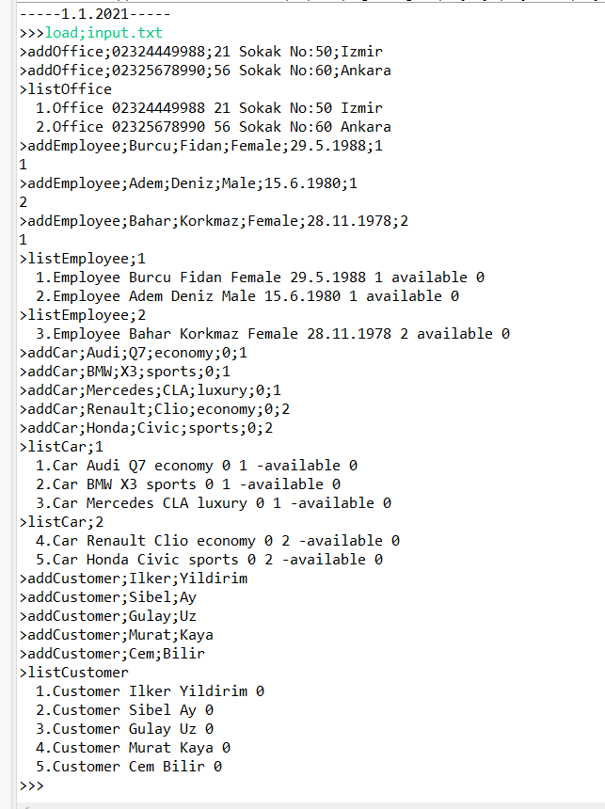
Figure 3.1 Example screenshot.

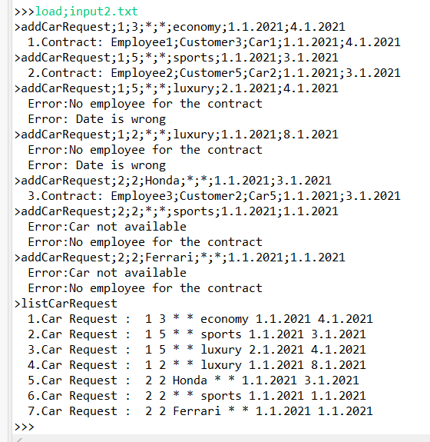
Figure 3.2 Example screenshot.

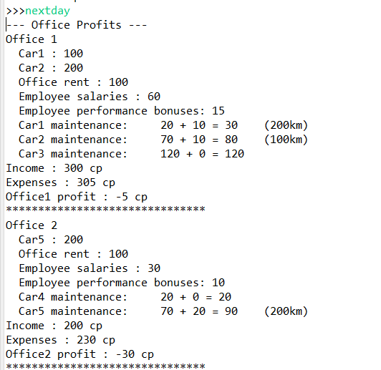
Figure 3.3 Example screenshot.

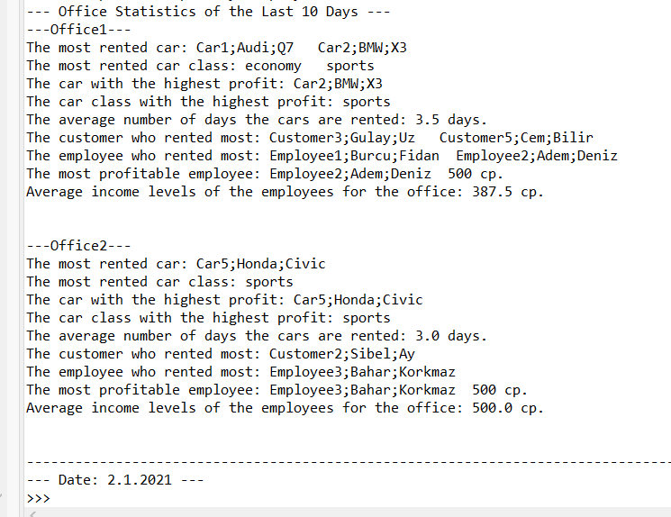
Figure 3.4 Example screenshot.

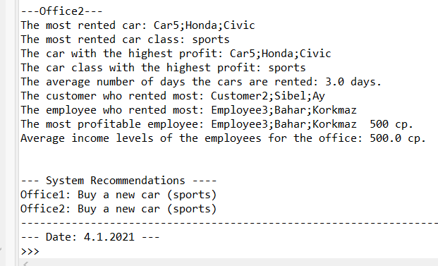

Functions
Class CarRequest:
- isAvailable - Checking whether the request is suitable for the contract or not.

Class Company:
- dateKontrol – Makes control of the days. It checks if the car request matches the current date.
- listContraact – Lists the contracts.
- addCarRequest – Command to add car requests.
- addCarRequestRandom – Command to add random car requests.
- listCarRequest – Lists car requests.
- addCustomer – Adds customer.
- listCustomer – Lists the customers.
- addOffice – Adds office.
- listOffice – Lists the customer
- deleteOffice – Deletes office by id.

Class Date:
- formatControl – The system consists of 30 days each month. If the days pass to 31, the control is done like increasing the month.

Class Employee:
- EmployeeAvailable – Returns employees who have made a contract as not available and those who do not.

Class Office:
- addEmployee – Adds employee (by office id).
- listEmployee- Lists employee.
- deleteEmployee – Delete employee (by employee id).
- addCar – Adds car (by office id).
- listCar – Lists car.
- statistic – Calculates the statistics of offices.
- profit – Calculates the income and expense of offices.
- employeeKontrol – Returns the id of the employee if there is an employee suitable for the contract.
- carKontrol – Checks whether the car is suitable for the contract
- carKontrolRandom – Returns the id of the car if there is an car suitable for the contract.
- rentCount – Counts how many times which employee or car is included in the contract.

Algorithms and Solution Strategies
Ceren Ersöz

First of all, we created classes. We wrote constructors belonging to classes and crested their getter setters. We made Office’s and Customer’s add and list commands to the Company class. We made the commands to add and list cars and employees to the Office class. We have had added, reading from all kinds of file sor actions to be taken by the user to the company class. In addition to these classes, we have created car request, contract and main classes. In the main class, we created the object where the company’s capacities are given. And we wrote the code that calls loop.
An important point is that in the listing part, each employee id does not progress specific to Office. For example, there are two employees in the first Office. Let there be one employee in the second Office. The id of the employee in the second Office is processed as three. We kept another counter in it.
We kept the office statistics in the office clas because we had to write special calculations and suggestions suitable for each office. In addition, we made the car and employee controls, which should be checked for the contract, in the office clas. Thus, we reached the office and employees easily by using the office id.

Büşra Turan

We created office, customer, cars, contract, employee, car request, company and date classes. Since the customers and offices belong to the company, we wrote the add / list customer and add / list office methods in the company class. Likewise, since cars and employees also belong to offices, we created the add / list methods in the office class. We started the system by calling these methods in the company class as commands came from the file or user commands were entered. We just created a company object in the main class and tried to do all the operations in the company class. We kept the objects we created in the arrays under the related classes when each add command came. Since each id must be unique and must increase starting from 1, we kept counters for these ids. In order to add employee and car information to the system correctly, we used the array that holds the office information. While typing the deleteOffice and deleteEmployee commands, instead of removing the deleted element completely, we kept it in the background by adding the phrase "deleted". As the car requests came in, we kept them in an array in the company class. After writing the AddCarRequestRandom method, we used it in AddCarRequestNRandom. We used the available attributes of cars and employees while checking the contracts of requests and checked if the dates were correct. When we came to the nextday command, we created a method in the company class and added "profit" method to the office class. Profit method calculated the income and expenses of that office by using the information in the office class. Then, we had to calculate the statistics by writing "statistic" method to the office class. We run these two methods in the nextday command so that the user can see the information. Finally, based on the calculations made in the statistics section, we completed the system recommendations section.

Safa Çevik:
At the very beginning, we needed to decide which class should include which attributes, methods, variables etc. Therefore we mapped every step that we’ll follow.
Later on, we created company class and office class to create offices inside company; employee, car and customer classes to create employees inside offices.
User may enter commands by hand or by a file. To do that we created methods inside company class which are deciding to what operation should execute in order to input type.
We need to track employees at offices which they’re currently working at, also give them unique ids. To do that we created arrays and stored employees in them.
The program should continue unless user wants to end it so it should do a cycle all the time. To ensure that we wrote all input operations in a while loop.
Every car, employee, customer and office has it’s uniqe id. To ensure that, we created counters and increased them in necessary methods but, employees were starting from 0 again because when a new office opens, the counter were forming as a new object. To prevent it, we kept additional counter and assigned them as employee id’s.

Fatih Semirgin

We initially created all the required classes (Car Request, Car, Customer, Company, Contract, Employee, Office and Main). We created constructor methods and getter setters of these classes. After that, we wrote the methods inside the classes. We wrote the addcar and addemployee methods by adding the car and employee arrays to the office class. We also wrote the list and delete methods to the class where the arrays are. Delete methods work by taking office or employee ID. We created an office array in the company class and added add, list and delete methods in the same class. We have added the operations of reading from file and getting commands as a method in company class. Thus, the user can access the program with the command she/he wants. Also the user can see the vehicles or employees in the office they want. We created the car requests array by adding and listing methods to the company class. We did the same with the Random and Nrandom vehicle requests. If these requests are met with the data in the system, we have made them into a contract. We also have a method of adding and listing for the contract. Finally, we added the nextday method to the company class. We created methods in office class for statistics and profits and called these methods in command the next day. Thus, when the next day command is called, statistics and profit calculations are made. Finally, we create a company object in the main class and call the read method. Thus, the program starts to receive commands.

CHAPTER FOUR
PROBLEMS ENCOUNTERED

Ceren Ersöz

We had some problems as to which command to write to where. For example, we tried to maket he “addOffice” command to the Office part, however we noticed that offices were added to the Company part. In addition, we wrote the in the main part of parts such as reading from file. Later we learned that these commands were company owned commands and moved to the part. In this way, this was solved.
In addition to the things I mentioned above, we had to check later in some places to see if the employee or car inside the office was null. For this, there is a control like ‘’cars [i]! = null’’ in most places. In the very beginning we did not make this check. It caused us trouble while navigating the arrays, and we solved it by checking this.

Büşra Turan
The first problem we faced was to do the operations we had to do in the company class in the main class. After realizing this, we moved the operations in the main class to the company.
Another problem was that employees could not be properly added to offices because we created more than one object from the office class. We solved this by creating a single office object under the addOffice command, storing these objects in the offices array and using this array when the add Employee command came.
We got too many "NullPointerException" errors while printing the employee and car arrays to the screen. We solved this by checking whether the array elements are null or not.

Safa Çevik:
We created arrays and stored employees in them to track employees which office they’re working at and count their ids. But later on we faced some problems such as employee and car ids. When a new office opens, id counter starts from 0. Because, for example, when a new office opens, also a new array opens for employees and its entry starts at 0 again. We solved it by adding additional counter for employees and also for cars and made them static to call them in any class we want.
We basically faced with null pointer exception almost everywhere, but solved it by controlling if the aforementioned array is null or not by if() statement.

Fatih Semirgin
Sometimes the extra list commands worked on user-entered commands, but later some conditions were added and resolved. Also, when a new office was opened, the IDs of vehicles and employees were reset. Then we made the IDs different by adding another variable. In addition, while returning an array in many parts of our project, we got errors indicating that the array element is empty, but we removed these errors by adding conditions.

CHAPTER FIVE
conclusıon
We have finished our car rental system project.It was a long and busy period for us. It was a 5-week process. In the first weeks we were new to object oriented programming and java. As time passed, we made progress both in object oriented programming and in java. We have improved in progressing on the same code as a team. Going over the same code can sometimes be challenging. However, we gathered together on discord and progressed. We wrote the code by screen sharing. It has been a faster and more effective system for us. These were the technical contributions of the project to us.

As for their social contributions, we have adapted more to how the project will be carried out as a team. It was like an example to our future life. We carried forward our project by holding meetings. There were places where we didn't think the same thing, but so we brainstormed. In some places, we worked until the night without understanding how time passes by having fun.

To summarize in short, this project has contributed to us both technically and socially as we mentioned above.

REFERENCES
- https://docs.oracle.com/javase/tutorial/essential/io/file.html
- https://www.w3schools.com/java/java_oop.asp
- https://stackoverflow.com/questions/19426758/basic-object-oriented-programming
- https://www.canva.com/

AppendIx A
Poster/Web page of the Project
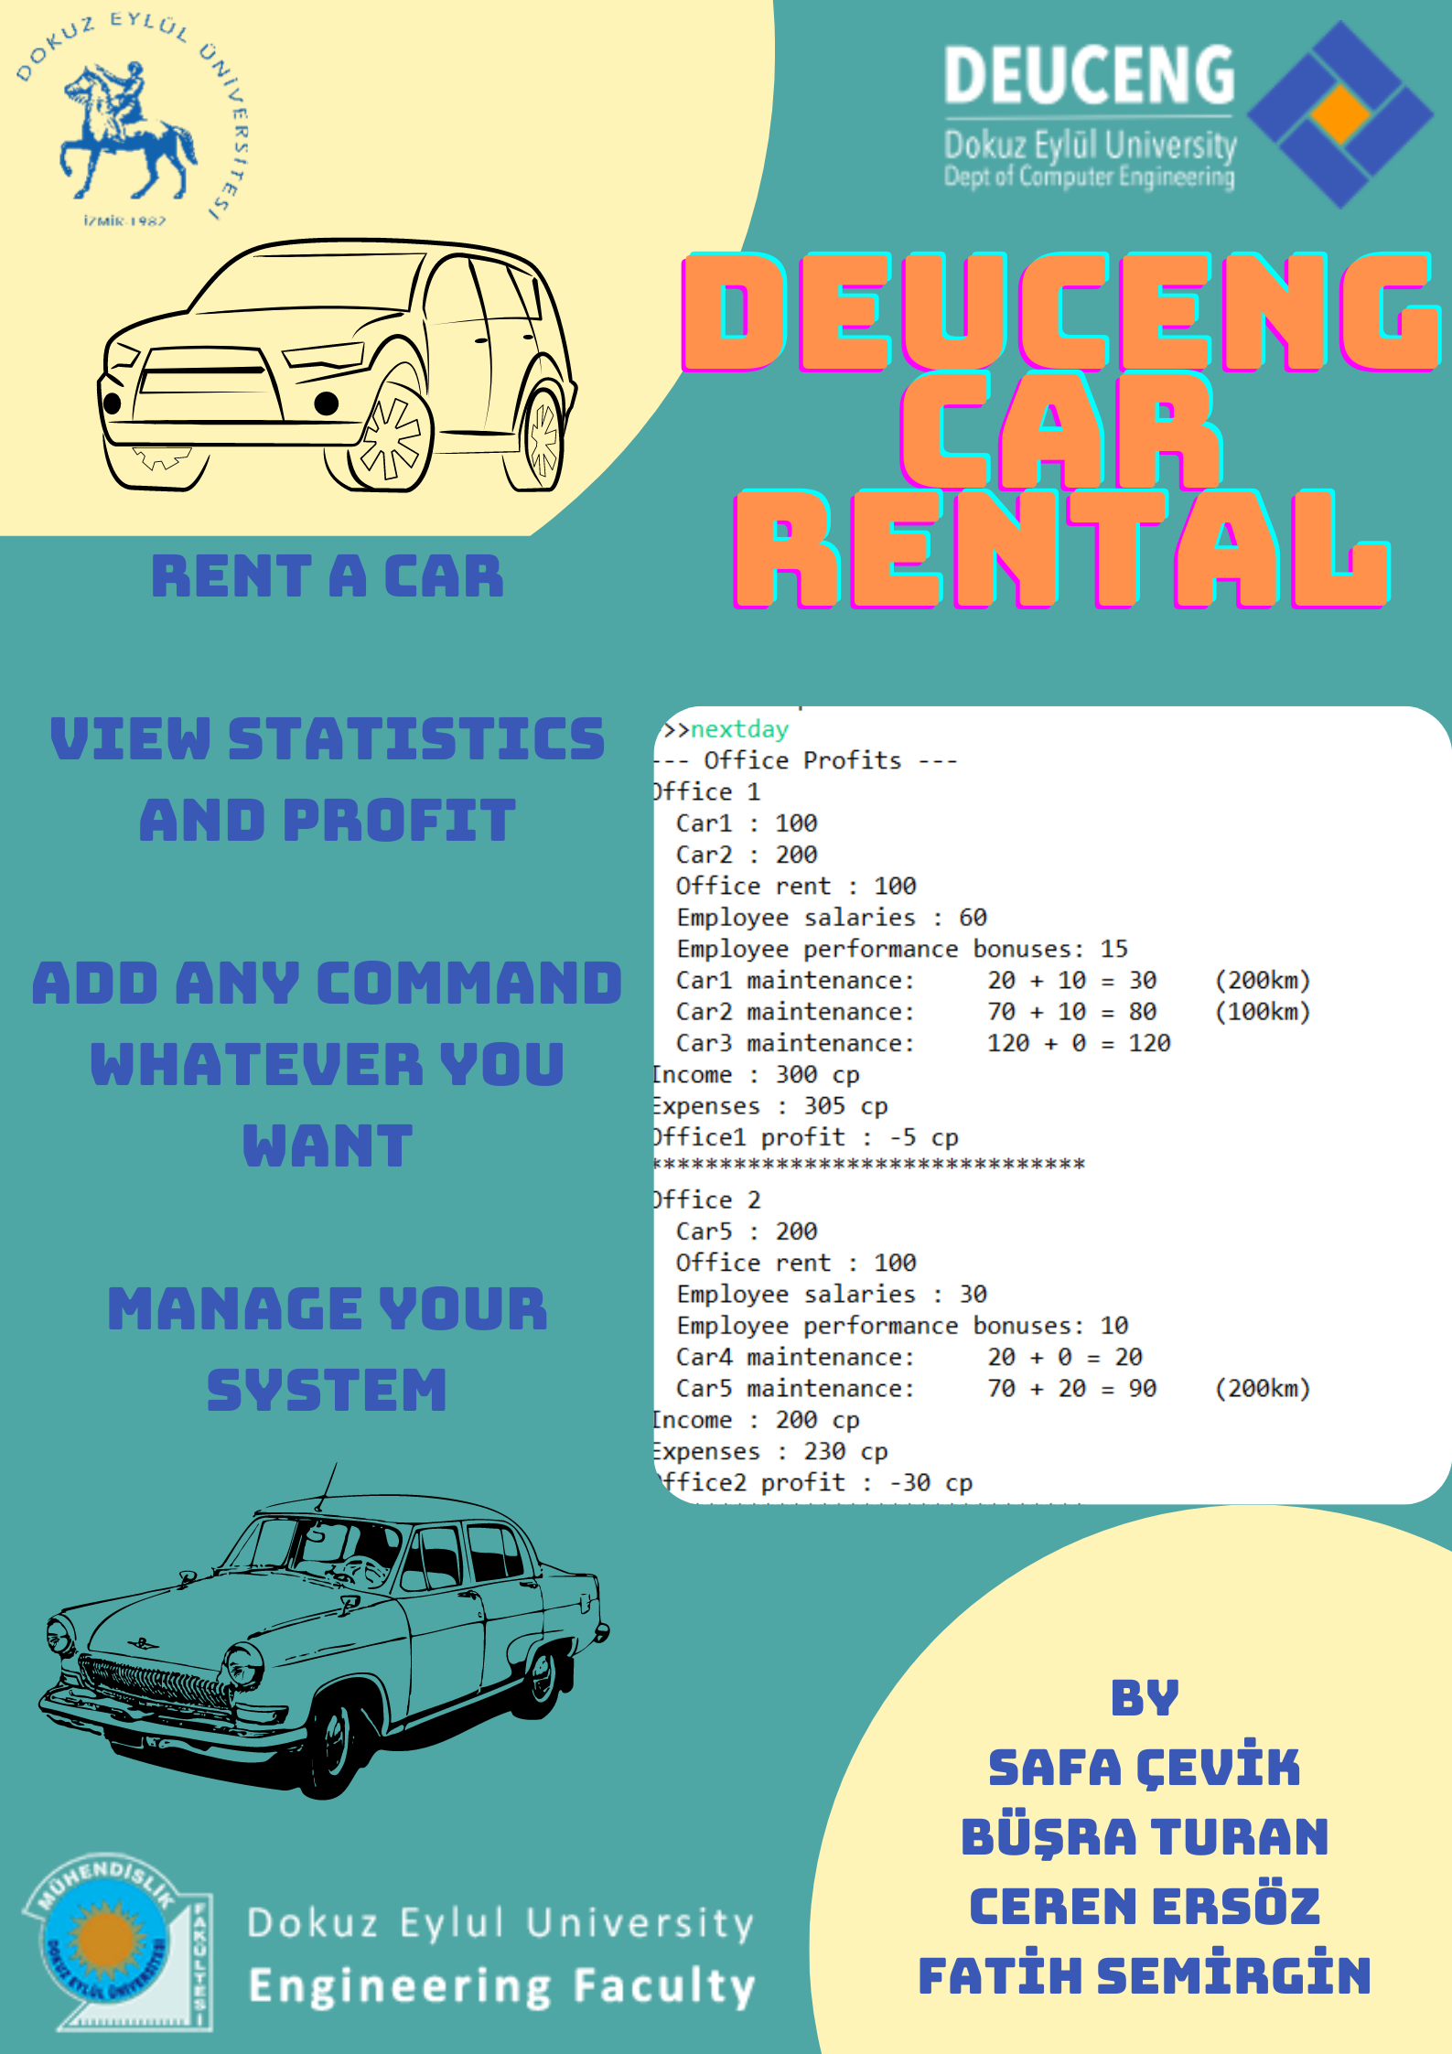
AppendIx B
Code of the ProjecT
