REQUIREMENTS ANALYSIS DOCUMENT
for
Personal Library Management System (PLMS)

Issue 1.1
30 October 2026

Prepared by Coastline Software
Ramazan Atakan Giray – 230104004011
Yalçın Eren Onat – 230104004002
Fatih Mehmet Serenli – 220104004012

TABLE OF CONTENTS
1 Introduction 3
1.1 Purpose of the system 3
1.2 Scope of the system 3
1.3 Objectives and success criteria of the project 4
1.4 Definitions, acronyms, and abbreviations 4
1.5 References 5
1.6 Overview 5
2 Current system 6
3 Proposed system 7
3.1 Overview 7
3.2 Functional requirements 7
3.3 Nonfunctional requirements 12
3.3.1 Usability 12
3.3.2 Reliability 12
3.3.3 Performance 12
3.3.4 Supportability 13
3.3.5 Implementation 13
3.3.6 Interface 13
3.3.7 Packaging 13
3.3.8 Legal 13
3.4 System models 14
3.4.1 Scenarios 14
3.4.2 Use case model 16
3.4.3 Object model 27
3.4.4 Dynamic model 31
3.4.5 User interfaces and Mock-ups 35
4 Glossary of Terms 38
5 Priority 39
6 Traceability 40

Introduction
Many people own large private collections of books and films. Over the years such a collection becomes hard to manage: the owner forgets which titles and copies they have, lends items to friends and family without a record, cannot remember who asked for a popular item first, and has no simple way to keep track of what they are reading or watching. Information about an item, such as its synopsis, cover or ratings, has to be searched for by hand on different web sites.
The Personal Library Management System (PLMS) is a multi-platform application that brings the useful functions of a library system to a home collection. It is a progressive web application (PWA): it runs in a web browser and can be installed like a native application on desktop computers (Windows, macOS, Linux) and on mobile devices (Android, iOS). The owner of the collection, called the librarian, registers an account, catalogs books and DVDs and their physical copies, lends copies to patrons, tracks due dates, reservations and fines, keeps custom lists and reading or viewing progress, and receives reminders when something needs attention. The library data of an account is stored in a cloud database and synchronised between all devices of the user; every device also keeps a local copy, so that the system can be used without an internet connection. Descriptive information about items can be retrieved from public internet services.
This document is the Requirements Analysis Document (RAD) of the project. It is based on the problem statement “Personal Library Management System” given by the client [2] and on the elicitation and analysis work of the team. Issue 1.1 aligns the document with the platform requirements of the problem statement: desktop and mobile access, user accounts and synchronisation of the library between devices.

Purpose of the system
The purpose of PLMS is to help the owner of a personal library keep a complete and correct record of the collection and of everything that happens to it. In particular, the system shall make sure that no lent item is forgotten, that popular items are shared fairly through a reservation queue, that overdue returns are handled by clear and configurable rules, and that the owner can organise the collection and follow their own reading and viewing – on any of their devices, with or without an internet connection.
The system exists because the current methods (memory, notebooks, spreadsheets and general note-taking applications, see Section 2) do not keep loan history, do not remind anybody of due dates, cannot manage waiting lists and cannot retrieve information about an item automatically, and are not available on all of the owner’s devices at the same time.

Scope of the system
The system covers the following functional areas:
- Catalog: books and DVDs as media items, each with one or more physical copies (shelf location, condition, status); search and filtering; duplicate detection; barcode input with a USB scanner or the device camera.
- Online metadata: retrieval of descriptive information (synopsis, cover, ratings, page count or runtime) from Google Books and OMDb, with manual entry as a fall-back.
- Accounts and access: registration and login of librarians, password management and sign-out; patron accounts managed by the librarian; optional patron self-service.
- Circulation: lending, returning and renewing copies; reservation queue and holds; fines, payments and waivers; blocking of patrons.
- Inventory: inventory overview and low-stock notifications.
- Notifications: due-soon, overdue, reservation-ready, hold-expired and low-stock notifications inside the application, and optional e-mail reminders.
- Personal collection: custom lists with suggestions; reading/viewing progress with session history, reminders and milestone notifications.
- Administration: library policy settings, reports, backup, restore, CSV import and CSV export.
- Multi-device access: progressive web application for desktop and mobile browsers, installable on Windows, macOS, Linux, Android and iOS; cloud database with automatic synchronisation; offline work with a local copy on each device.
Out of scope. The following are outside the scope of this release: playing or reading digital media (e-books, video streaming); real payment processing; separate native applications distributed through app stores (mobile devices use the PWA); RFID gates and other special hardware (USB barcode scanners and device cameras are supported); commercial bookstore functions.

Objectives and success criteria of the project
The objectives of the project and the criteria by which their achievement will be judged are listed below.
Objective | Description | Success criterion and verification
O-1 No lost items | Every lent copy is recorded with borrower, loan date and due date. | 100 % of loans visible with borrower and due date; system tests of UC-7 and UC-8.
O-2 Fair circulation | Reservations, holds and fines follow the library policy without manual calculation. | All fine and hold calculations in the test suite give the expected result.
O-3 Fast cataloging | Adding an item is quick, with or without internet. | A book with an ISBN is added with online metadata in under 60 seconds; manual entry works offline.
O-4 Timely reminders | The librarian is reminded of due, overdue and ready items. | Loans and holds are checked at least every hour and the notifications are produced (FR-49 – FR-52).
O-5 Personal insight | The owner can organise the collection and follow their progress. | Custom lists and progress tracking pass their system tests (UC-14, UC-15).
O-6 Ease of use | A new user can perform the core tasks without training. | In the acceptance session the client adds, lends and returns an item without help.
O-7 Reliable data | No data is lost or corrupted, and the system works offline. | No data loss in crash and offline tests; backup and restore succeed.
O-8 Project success | The project deliverables are accepted by the client. | RAD, SDD, implementation and test documents delivered on time and accepted at the final demonstration.
O-9 Access anywhere | The library can be used on desktop and mobile devices and is the same on all of them. | A change made on a phone is visible on a laptop of the same account within 10 seconds (FR-78); changes made offline are synchronised without loss (system tests of UC-23).

Definitions, acronyms, and abbreviations
Domain terms are defined in the glossary (Section 4). The acronyms and abbreviations used in this document are:
Acronym | Meaning
API | Application Programming Interface – here, the web services of Google Books and OMDb and the interface between the PLMS client and server.
CSV | Comma-Separated Values – a plain-text table format used for export.
DVD | Digital Versatile Disc – an optical disc that contains a film or series.
EARS | Easy Approach to Requirements Syntax – sentence templates for requirements [5].
FR / NFR | Functional requirement / nonfunctional requirement.
FURPS+ | Functionality, Usability, Reliability, Performance, Supportability, plus implementation, interface, packaging and legal requirements [1].
HTTPS | Hypertext Transfer Protocol Secure – encrypted communication over the internet.
IndexedDB | A database built into web browsers; PLMS uses it for the local copy of the library on each device.
ISBN | International Standard Book Number – a 10- or 13-digit book identifier.
JDBC | Java Database Connectivity – the Java interface for relational databases.
JSON | JavaScript Object Notation – a text format for exchanging data.
KVKK | Turkish Personal Data Protection Law No. 6698 [10].
MoSCoW | Must have, Should have, Could have, Won't have – a prioritisation scheme.
OMDb | The Open Movie Database – a web service that provides film information.
PLMS | Personal Library Management System – the system specified in this document.
PostgreSQL | An open-source relational database server; used for the cloud database of PLMS.
PWA | Progressive Web Application – a web application that can be installed on desktop and mobile devices and can work offline.
RAD | Requirements Analysis Document – this document.
REST | Representational State Transfer – a style of web service interface based on HTTP.
UC | Use case.
UML | Unified Modeling Language.

References
[1] B. Bruegge and A. H. Dutoit, Object-Oriented Software Engineering Using UML, Patterns, and Java, 3rd ed. Prentice Hall, 2010.
[2] K. İnce, “Personal Library Management System – Problem Statement,” CSE 443 term project, Gebze Technical University, Fall 2026.
[3] CSE 443 Project Deliverable #1 – Requirements Analysis Document, assignment specification, Fall 2026.
[4] CSE 443 RAD Template (CSE443 - RAD_Template.docx), Fall 2026.
[5] A. Mavin, P. Wilkinson, A. Harwood and M. Novak, “Easy Approach to Requirements Syntax (EARS),” in Proc. 17th IEEE International Requirements Engineering Conference, 2009, pp. 317–322.
[6] Google Books APIs documentation, https://developers.google.com/books
[7] OMDb API – The Open Movie Database, https://www.omdbapi.com/
[8] PostgreSQL documentation, https://www.postgresql.org/docs/
[9] Coastline Software, PLMS Team Handbook, version 1.0, October 2026 (internal project document).
[10] Law No. 6698 on the Protection of Personal Data (KVKK), Republic of Türkiye, 2016.
[11] MDN Web Docs, “Progressive web apps,” https://developer.mozilla.org/en-US/docs/Web/Progressive_web_apps

Overview
Section 2 describes how personal collections are managed today and why this is not satisfactory. Section 3 specifies the proposed system: an overview, the functional requirements written in EARS form and grouped by module, the nonfunctional requirements grouped by the FURPS+ categories, and the system models – scenarios, the use case model, the analysis object model, the dynamic model and user interface mock-ups. Section 4 is the glossary of domain terms. Section 5 gives the priority of every functional requirement, and Section 6 contains the traceability tables that link the problem statement, the functional requirements, the use cases and the analysis classes.

Current system
There is no existing software system to be replaced. Today, owners of personal libraries perform the tasks that PLMS will support with one or more of the following methods:
- Memory: many owners keep no record at all and rely on remembering what they own and to whom they lent it.
- Paper notebooks and bookmarks: titles and loans are written down by hand; reading progress is kept with a bookmark.
- Spreadsheets: more organised owners keep a table of titles and, sometimes, of loans in Excel or Google Sheets.
- General note or chat applications: loans are agreed in a message ("you can keep it for two weeks") and lists such as "to read" are kept as short notes.
- Web searches: information about an item (summary, cover, reviews, author or director) is looked up by hand on different web sites.
These methods have the following problems:
- Forgotten loans: there is no reliable record of who has which copy and since when, and nobody is reminded of the due date, so items are often lost.
- No fair handling of popular items: when several people want the same item, the owner has to remember who asked first; there is no waiting list.
- No agreed rules for late returns: loan periods and fines, if any, are not recorded, which leads to misunderstandings between friends.
- Duplicate purchases and unknown inventory: the owner cannot quickly check whether a title, or a second copy of it, is already in the collection, or how many copies are available.
- Manual data entry: entering title, author, publisher, year, page count and other data by hand takes several minutes per item, so records are rarely kept up to date.
- No progress or list support: reading and viewing progress and personal lists are scattered over bookmarks and notes and have no history.
- No history or reports: it is impossible to answer questions such as "which books are borrowed most?" or "what did this person borrow last year?".
- Bound to one place: a notebook or a spreadsheet is available only where it is kept, so the owner cannot check the collection or record a loan when away from home.
The table below compares the current practice with the proposed system.
Task | Current practice | Proposed system
Who has which item | Memory or chat messages | Loan record per copy and patron (FR-27)
Due dates and reminders | None | Due date from the library policy and automatic notifications (FR-49 – FR-52)
Popular items | Owner remembers who asked first | First-come, first-served reservation queue and holds (FR-36 – FR-40)
Late returns | Informal, often forgotten | Configurable fines, payments and waivers (FR-41 – FR-45)
Adding an item | Typing every field (several minutes) | Online metadata from Google Books or OMDb (FR-21 – FR-25)
Finding an item | Scrolling a list or a notebook | Search and filters (FR-18, FR-19)
Progress and lists | Bookmarks, notes | Progress sessions and custom lists (FR-55 – FR-63)
Using the library on several devices | A spreadsheet on one computer or a notebook at home | The same library on desktop and mobile, synchronised and usable offline (FR-78 – FR-80)

Proposed system
This section specifies the proposed system: its overview, functional and nonfunctional requirements, and the analysis models.

Overview
PLMS is a progressive web application (PWA) that runs in current web browsers and can be installed on desktop computers (Windows, macOS, Linux) and on mobile devices (Android, iOS). Each library belongs to one account. The main user is the librarian – the owner of the library – who registers the account, logs in with an e-mail address and password on any of their devices and performs all management tasks. Patrons are the people who borrow items; they are registered by the librarian and, where patron self-service is enabled, they can log in from their own devices to search the catalog, reserve items, renew loans and see their own account. A visitor is a person without an account who can register. A clock (time) actor triggers regular checks of loans, holds and reading progress, and two external systems – Google Books and OMDb – provide online metadata. A mail server sends account e-mails (verification, password reset) and, where enabled, reminders to patrons. Figure 3.1 shows this context.
The functions of the system are organised in twelve modules: (M1) accounts and access, (M2) catalog, (M3) online metadata, (M4) lending and returning, (M5) reservations, (M6) fines, (M7) inventory, (M8) notifications, (M9) custom lists, (M10) progress tracking, (M11) reports, policy and data, and (M12) multi-device access and synchronisation. The rules of the library – loan period, renewals, borrowing limit, fines, blocking and holds – are stored in one library policy that the librarian can change. The library data of an account is kept in a cloud database, and every device on which the user is logged in keeps a local copy. Changes are synchronised automatically; while a device is offline, all functions except registration, password reset, online metadata and e-mail remain available, and the changes are sent when the connection returns.
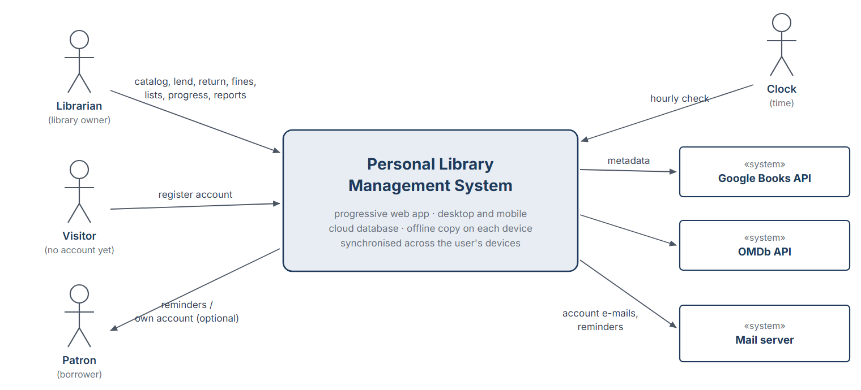
Figure 3.1: Context of PLMS – actors and external systems

Functional requirements
Functional requirements are grouped by module. Each requirement has a unique identifier (FR-1 to FR-82) and is written with one of the EARS patterns [5]: ubiquitous (“The system shall …”), event-driven (“When …, the system shall …”), state-driven (“While …, the system shall …”), unwanted behaviour (“If …, then the system shall …”) and optional feature (“Where …, the system shall …”). The terms used in the requirements are defined in the glossary (Section 4) and correspond to the analysis classes in Section 3.4.3. Values such as the loan period or the fine rate are parameters of the library policy (FR-65). The use cases that realise each requirement are listed in Section 6. Requirements FR-70 to FR-82 were added in issue 1.1; they are listed in the module they belong to, and the existing identifiers were not renumbered so that the traceability links stay valid.
Module 1 – Accounts and access
ID | Requirement
FR-1 | The system shall require the librarian to log in with the e-mail address and password of the account before any library data is displayed.
FR-2 | If the librarian enters an incorrect password three times in a row, then the system shall block further login attempts for 60 seconds.
FR-3 | When the librarian enters the current password and a new password, the system shall replace the current password with the new one.
FR-4 | When the librarian registers a patron with a name and at least one contact detail (e-mail address or phone number), the system shall create a patron account with the status Active.
FR-5 | When the librarian changes the details of a patron, the system shall save the new details without changing the patron’s loan history.
FR-6 | When the librarian deactivates a patron who has no active loan and no unpaid fine, the system shall set the patron’s status to Deactivated and keep the patron’s history.
FR-7 | If the librarian tries to deactivate a patron who has an active loan or an unpaid fine, then the system shall refuse the deactivation and list the open loans and fines.
FR-8 | Where patron self-service is enabled, the system shall allow a patron to log in from any supported device and to view only their own loans, reservations and fines.
FR-70 | When a visitor registers with a name, an e-mail address that is not yet registered and a password of at least 8 characters, the system shall create a librarian account with an empty library and send a verification e-mail.
FR-71 | When a user requests a password reset for a registered e-mail address, the system shall send a single-use reset link that is valid for 30 minutes.
FR-72 | When a user logs out on a device, the system shall end the session on that device and remove the local copy of the library data from it.

Module 2 – Catalog
ID | Requirement
FR-9 | The system shall manage two kinds of media items: books and DVDs.
FR-10 | When the librarian adds a book with at least a title and one author, the system shall store the book together with the ISBN, publisher, publication year, genre, language, page count, tags and notes that were entered.
FR-11 | When the librarian adds a DVD with at least a title, the system shall store the DVD together with the director, studio, release year, genre, language, runtime, disc format, tags and notes that were entered.
FR-12 | When the librarian adds a copy to a media item, the system shall record the shelf location, condition and acquisition date of the copy and set its status to Available.
FR-13 | When the librarian enters an ISBN – typed, read by a USB barcode scanner or scanned with the camera of the device – the system shall show the media item with that ISBN if it already exists in the catalog.
FR-14 | If the librarian adds a media item whose ISBN, or whose title and creator, match an existing media item, then the system shall warn about a possible duplicate and offer to add a new copy to the existing media item instead.
FR-15 | When the librarian changes the data of a media item or of a copy, the system shall save the changes.
FR-16 | When the librarian removes a media item or a copy that has no active loan and no waiting reservation, the system shall remove it from the catalog and from all custom lists.
FR-17 | If the librarian tries to remove a media item or a copy that has an active loan or a waiting reservation, then the system shall refuse the removal and state the reason.
FR-18 | When a user enters a search text, the system shall list the media items whose title, creator, ISBN, genre or tags contain the text, ignoring upper and lower case.
FR-19 | When a user selects one or more filters (media type, genre, availability, condition, custom list), the system shall list only the media items that satisfy all selected filters.
FR-20 | When a user opens a media item, the system shall display its data, its copies with status and shelf location, the current borrowers, its reservation queue and its loan history.

Module 3 – Online metadata
ID | Requirement
FR-21 | When the librarian requests online metadata for a book by ISBN or title, the system shall retrieve the title, authors, publisher, publication year, page count, synopsis, cover image and average rating from the Google Books service.
FR-22 | When the librarian requests online metadata for a DVD by title, the system shall retrieve the title, director, release year, runtime, synopsis, poster image and rating from the OMDb service.
FR-23 | When online metadata has been retrieved, the system shall show it to the librarian for review and store only the fields that the librarian accepts.
FR-24 | If retrieved online metadata differs from a value already entered by the librarian, then the system shall show both values and keep the value that the librarian selects.
FR-25 | If the online service cannot be reached or does not return a result within 5 seconds, then the system shall inform the librarian and allow all fields to be entered manually.
FR-26 | When a user views a media item that has online metadata, the system shall display the synopsis, cover image and rating together with a link to the item’s page on the source web site.

Module 4 – Lending and returning
ID | Requirement
FR-27 | When the librarian lends a copy to a patron, the system shall create a loan with the current date as loan date and a due date equal to the loan date plus the loan period.
FR-28 | If the patron is blocked or has reached the borrowing limit, or the copy is neither Available nor held for that patron, then the system shall refuse the loan and show the reason.
FR-29 | When a loan is created, the system shall set the status of the lent copy to OnLoan.
FR-30 | When the librarian records the return of a copy, the system shall set the return date of the loan to the current date and close the loan.
FR-31 | When a copy is returned, the system shall set the copy’s status to Held for the first patron in the reservation queue of its media item, or to Available if that queue is empty.
FR-32 | When the librarian renews a loan that has not reached the maximum number of renewals and whose media item has no waiting reservation, the system shall extend the due date by the loan period.
FR-33 | If a renewal is requested for a loan that has reached the maximum number of renewals or whose media item has a waiting reservation, then the system shall refuse the renewal and state the reason.
FR-34 | When the librarian records a copy as lost or damaged, the system shall update the status or condition of the copy and record the event in the history of the copy.
FR-35 | The system shall keep every loan, return and renewal in the history of the copy and of the patron.

Module 5 – Reservations
ID | Requirement
FR-36 | When a reservation is requested for a media item that has no Available copy, the system shall add the patron to the end of the reservation queue of the media item and show the queue position.
FR-37 | If a reservation is requested for a media item that has an Available copy, or by a patron who already has a loan or a reservation for that media item, then the system shall refuse the reservation and state the reason.
FR-38 | When a copy becomes Held for a patron, the system shall set the patron’s reservation to Ready with a hold expiry date equal to the current date plus the hold period.
FR-39 | When the hold expiry date of a Ready reservation has passed and the held copy has not been lent to the patron, the system shall set the reservation to Expired and hold the copy for the next patron in the queue, or make it Available if the queue is empty.
FR-40 | When a reservation is cancelled, the system shall remove it from the queue and move each following patron up by one position.

Module 6 – Fines
ID | Requirement
FR-41 | When a copy is returned later than its due date plus the grace period, the system shall create a fine equal to the daily fine rate multiplied by the number of days beyond the grace period, limited to the maximum fine per loan.
FR-42 | When the librarian records a payment for a fine, the system shall reduce the outstanding amount of the fine by the paid amount and set the fine to Paid when the outstanding amount reaches zero.
FR-43 | When the librarian waives a fine and enters a reason, the system shall set the fine to Waived and store the reason.
FR-44 | While a patron has an overdue loan or unpaid fines above the blocking threshold, the system shall show the patron’s status as Blocked.
FR-45 | When the librarian records a copy as lost during a loan, the system shall create a replacement fine for the patron with the amount entered by the librarian.

Module 7 – Inventory
ID | Requirement
FR-46 | The system shall show, for every media item, the number of copies owned and the number of copies currently Available.
FR-47 | When the number of Available copies of a media item falls below its low-stock threshold, the system shall issue a low-stock notification.
FR-48 | When the librarian opens the inventory view, the system shall show the number of media items, copies, copies on loan, overdue loans, lost copies and damaged copies, and the list of media items in low stock.

Module 8 – Notifications
ID | Requirement
FR-49 | The system shall check all active loans and all Ready reservations at least once every hour, also while no device of the user is open.
FR-50 | When the due date of an active loan is within the reminder period, the system shall issue a due-soon notification.
FR-51 | When an active loan is past its due date, the system shall issue an overdue notification once per day until the copy is returned.
FR-52 | When a reservation becomes Ready or Expired, the system shall issue a reservation-ready or hold-expired notification.
FR-53 | The system shall display each notification inside the application and, where the user has allowed it, as a notification of the device, and shall keep it in a notification list in which it can be marked as read.
FR-54 | Where e-mail reminders are enabled, the system shall send due-soon, overdue and reservation-ready reminders to the e-mail address of the patron concerned.

Module 9 – Custom lists
ID | Requirement
FR-55 | When the librarian creates a custom list with a name that is not used by another list, the system shall create an empty custom list.
FR-56 | When the librarian adds a media item to a custom list, the system shall show the media item in that list; a media item may belong to several custom lists.
FR-57 | When the librarian removes a media item from a custom list or deletes a custom list, the system shall remove only the membership or the list and keep the media items in the catalog.
FR-58 | When the librarian reorders a custom list manually or sorts it by title, creator, date added or personal rating, the system shall display its media items in that order.
FR-73 | When the librarian asks for suggestions for a custom list, the system shall propose up to 10 media items of the catalog that are not in the list and share a genre, creator or tag with its items, and add the suggestions that the librarian accepts.

Module 10 – Progress tracking
ID | Requirement
FR-59 | When the librarian records a reading session for a book with the number of pages read and, optionally, the chapters completed and the duration, the system shall add a progress session with the date and advance the current position of the book.
FR-60 | When the librarian records a viewing session for a DVD with the number of minutes watched and, optionally, the scenes viewed, the system shall add a progress session with the date and advance the current position of the DVD.
FR-61 | While a media item has the progress status InProgress, the system shall display the percentage completed, the remaining pages or minutes and, for books, the estimated remaining reading time based on the average reading speed of the recorded sessions.
FR-62 | If a progress value greater than the total page count or runtime is entered, then the system shall set the current position to the total and inform the librarian.
FR-63 | When the current position reaches the total page count or runtime, the system shall set the progress status to Completed and allow the librarian to enter a personal rating and review.
FR-74 | Where reading reminders are enabled, when no progress session has been recorded for an InProgress media item during the reading reminder interval, the system shall issue a reading reminder.
FR-75 | When the progress of a media item passes 25 %, 50 % or 75 %, or reaches Completed, the system shall issue a milestone notification.
FR-76 | When the librarian opens the progress history of a media item, the system shall list its progress sessions with date, amount completed and duration.

Module 11 – Reports, policy and data
ID | Requirement
FR-64 | When the librarian requests a report, the system shall produce the selected report: overdue loans, outstanding fines, most borrowed media items, borrowing history of a patron, or reading and viewing statistics.
FR-65 | When the librarian changes the library policy (loan period, maximum renewals, borrowing limit, daily fine rate, grace period, maximum fine per loan, blocking threshold, hold period, reminder period or reading reminder interval), the system shall apply the new values to loans, reservations and fines created after the change.
FR-66 | The system shall store the library data of each account in a cloud database and keep a local copy on every device on which the user is logged in.
FR-67 | When the librarian requests a backup, the system shall copy all library data to a file at a location chosen by the librarian.
FR-68 | When the librarian selects a backup file and confirms the restore, the system shall replace the current library data with the data in the backup file.
FR-69 | When the librarian requests an export, the system shall write the catalog, the patrons and the loans to CSV files.
FR-77 | When the librarian selects a CSV file in the format written by FR-69, the system shall import its media items and copies and list the rows that could not be imported.

Module 12 – Multi-device access and synchronisation
ID | Requirement
FR-78 | When library data is changed on a device that is online, the system shall store the change in the cloud database and show it on the other devices of the account within 10 seconds.
FR-79 | While a device has no internet connection, the system shall provide all functions except registration, password reset, online metadata and e-mail, and shall keep the changes made on the device in a local queue.
FR-80 | When the internet connection of a device is restored, the system shall send the queued changes to the cloud database in the order in which they were made.
FR-81 | If a queued change conflicts with a change made on another device, then the system shall show both versions to the librarian and keep the version that the librarian selects.
FR-82 | When the librarian opens the device list, the system shall show every device on which the account is logged in with the time of its last synchronisation and allow the librarian to sign out a device.

Nonfunctional requirements
The nonfunctional requirements are grouped by the FURPS+ categories of the template [1]. Requirements NFR-14 to NFR-18 are implementation constraints chosen by the team within the options given in the problem statement [2]. Requirements NFR-30 to NFR-33 were added in issue 1.1.

Usability
ID | Requirement
NFR-1 | The system shall let a user who knows ordinary desktop or mobile applications lend a copy with at most five interactions after the media item has been found.
NFR-2 | The system shall show every error or refusal message together with its cause and a possible next step.
NFR-3 | The system shall make every main view (dashboard, catalog, patrons, loans, reservations, fines, lists, reports, settings) reachable with one click or tap from a navigation menu – a side menu on wide screens and a bottom bar on phones.
NFR-4 | The system shall use English for all texts of the user interface and shall show dates in the format DD.MM.YYYY and amounts in Turkish lira (TL).
NFR-30 | The system shall adapt its layout to screen widths from 360 pixels (phones) to 1920 pixels (desktops) and shall support both touch input and mouse and keyboard input.

Reliability
ID | Requirement
NFR-5 | The system shall perform every change of library data as one atomic transaction, so that a crash or power cut never leaves partially saved data.
NFR-6 | While no internet connection is available, the system shall provide the functions listed in FR-79 and shall not lose any change made offline.
NFR-7 | The system shall create an automatic backup of the cloud data of every account once a day and keep the seven most recent automatic backups.

Performance
ID | Requirement
NFR-8 | The system shall display search results within 1 second for a library of up to 10,000 copies.
NFR-9 | The system shall be ready for use within 5 seconds after start on a typical laptop or mid-range smartphone.
NFR-10 | While online metadata is being retrieved, the system shall keep the user interface responsive and shall stop waiting after 5 seconds.

Supportability
ID | Requirement
NFR-11 | The system shall allow all library policy values to be changed through the settings view without changing program code.
NFR-12 | The system shall separate the business rules from the user interface so that the rules can be tested automatically with unit tests.
NFR-13 | The system shall be structured so that a new kind of media item can be added without changing the lending, reservation and fine functions.
NFR-31 | The system shall use one client code base for the desktop and the mobile platforms.

Implementation
ID | Requirement
NFR-14 | The client shall be implemented as a progressive web application in TypeScript with the React library, and the server, which contains the business rules and the synchronisation service, in Java (version 17 or later).
NFR-15 | The server shall store the data in a PostgreSQL database accessed through JDBC; each device shall keep its local copy in the IndexedDB storage of the browser.
NFR-16 | The notification function shall be designed with the Observer pattern.
NFR-17 | Rule violations in lending and fines (for example a blocked patron or an exceeded borrowing limit) shall be signalled with exceptions and turned into user messages.
NFR-18 | The source code, documents and issues shall be managed in a GitHub repository, and the UML models shall be created with a UML tool such as Visual Paradigm.

Interface
ID | Requirement
NFR-19 | The system shall communicate with the Google Books API over HTTPS and exchange data in JSON format.
NFR-20 | The system shall communicate with the OMDb API over HTTPS in JSON format, using an API key that the librarian enters in the settings.
NFR-21 | The system shall accept barcode input from USB barcode scanners that work as a keyboard and from the camera of the device.
NFR-22 | The system shall write export files as UTF-8 encoded CSV files with a header row.
NFR-23 | The system shall send e-mail – account e-mails and, where enabled, reminders – through an SMTP server.
NFR-32 | The client and the server shall communicate only over HTTPS through a REST interface that exchanges data in JSON format.

Packaging
ID | Requirement
NFR-24 | The system shall be delivered as a progressive web application that can be opened in current versions of Chrome, Edge, Firefox and Safari and installed without an app store on Windows, macOS and Linux computers and on Android and iOS devices; the same client should also be packaged as a desktop application with Electron.
NFR-25 | The system shall not require the user to install a database server or any software other than a web browser; a new account shall start with an empty library.

Legal
ID | Requirement
NFR-26 | The system shall store personal data of users and patrons only in the cloud database of the account and on the user’s own devices, only to the extent needed for lending, and shall allow it to be deleted, in line with KVKK [10].
NFR-27 | The system shall store passwords only as salted hashes.
NFR-28 | The system shall use online metadata in accordance with the terms of use of Google Books and OMDb and shall show the source of the data.
NFR-29 | All third-party libraries used by the system shall have licences that allow their use in this project.
NFR-33 | The system shall encrypt the cloud database at rest and shall make the data of an account accessible only to the users of that account.

System models
The system models describe the requirements from different points of view: scenarios and use cases (functional model), the analysis object model (structure), and sequence, activity and state machine diagrams (dynamic model). All diagrams use UML 2 notation. User interface mock-ups illustrate the main screens.

Scenarios
Scenarios are concrete, informal descriptions of the use of the system by particular actor instances [1]. The following scenarios were used to find and validate the use cases. The policy values in the scenarios (loan period 14 days, grace period 1 day, 2 TL per day, hold period 3 days) are examples.
Scenario: addDuneWithOnlineMetadata
Participating actor instances | ayse:Librarian, googleBooks:GoogleBooksAPI
Flow of events | 1. Ayşe has bought a second-hand copy of Dune. She starts PLMS, logs in and selects “Add item”.  2. She scans the ISBN 978-0441013593 with her USB barcode scanner. PLMS reports that Dune is not yet in the catalog and asks googleBooks for its data.  3. PLMS shows the title, author Frank Herbert, publisher, year, page count (896), synopsis, cover and average rating. Ayşe accepts all fields.  4. Ayşe enters the shelf location “A3” and the condition “Good” for the copy and saves. Dune now appears in the catalog with one Available copy.

Scenario: addSecondCopy
Participating actor instances | ayse:Librarian
Flow of events | 1. A friend gives Ayşe another copy of Dune. She scans the ISBN again.  2. PLMS finds the existing media item Dune and warns that it is already in the catalog. It offers to add a new copy instead of a new item.  3. Ayşe accepts, enters shelf “A3” and condition “Worn”. Dune now has two copies; the low-stock threshold of Dune is 1.

Scenario: lendDune
Participating actor instances | ayse:Librarian, mehmet:Patron
Flow of events | 1. On 1 November Mehmet visits Ayşe and wants to borrow Dune. Ayşe searches for “dune” and opens the media item.  2. She selects copy #1 and chooses “Lend”, then selects Mehmet. PLMS checks that Mehmet is not blocked and has 2 of 5 allowed loans.  3. PLMS shows the due date 15 November (loan period 14 days). Ayşe confirms. Copy #1 is now OnLoan.  4. Later Elif borrows copy #2. No copy of Dune is Available any more, so PLMS shows a low-stock notification for Dune.

Scenario: reserveHotRead
Participating actor instances | ayse:Librarian, zeynep:Patron
Flow of events | 1. On 8 November Zeynep asks for Dune. Ayşe opens Dune; both copies are OnLoan, so PLMS offers “Reserve”.  2. Ayşe reserves Dune for Zeynep. PLMS shows that Zeynep is number 1 in the queue.

Scenario: lateReturnWithFine
Participating actor instances | ayse:Librarian, mehmet:Patron, zeynep:Patron, clock:Clock
Flow of events | 1. On 13 November the clock triggers the hourly check, and PLMS shows that Mehmet’s loan of Dune is due in two days.  2. Mehmet does not return the book on 15 November. On 16 November PLMS shows an overdue notification; Mehmet is now Blocked.  3. Mehmet returns copy #1 on 19 November. Ayşe records the return. With a grace period of 1 day and a daily rate of 2 TL, PLMS creates a fine of 3 × 2 TL = 6 TL.  4. Because Zeynep is waiting, PLMS sets copy #1 to Held for her until 22 November and shows a reservation-ready notification.  5. Mehmet pays 6 TL. Ayşe records the payment; the fine becomes Paid and Mehmet is Active again.

Scenario: trackReadingProgress
Participating actor instances | ayse:Librarian
Flow of events | 1. Ayşe is reading The Name of the Wind (662 pages). After an evening of reading she opens the book and selects “Log session”.  2. She enters 45 pages. PLMS adds a progress session and shows 412 of 662 pages (62 %) and 250 pages remaining.  3. When she finishes the book a week later, PLMS sets the progress to Completed and asks for a personal rating; Ayşe gives 5 stars.

Scenario: createSciFiList
Participating actor instances | ayse:Librarian
Flow of events | 1. Ayşe wants a list for a science-fiction weekend. She creates the custom list “Sci-Fi Weekend”.  2. She adds the books Dune and Neuromancer and the DVDs Blade Runner 2049 and Interstellar, then sorts the list by her personal rating.  3. She later removes Neuromancer from the list; the book stays in the catalog.

Scenario: registerAndInstall
Participating actor instances | ayse:Visitor, mailServer:MailServer
Flow of events | 1. Ayşe opens the web address of PLMS in the browser of her laptop and selects “Create account”.  2. She enters her name, her e-mail address and a password. PLMS creates the account with an empty library and sends a verification e-mail, which she confirms.  3. She selects “Install” in the browser; from now on PLMS starts from the desktop like a native application.  4. On her phone she opens the same address, logs in with the same e-mail address and password and adds PLMS to the home screen. Both devices show the same library.

Scenario: logReadingOnTheTrain
Participating actor instances | ayse:Librarian
Flow of events | 1. Ayşe continues The Name of the Wind (412 of 662 pages) on the train, where her phone has no connection. PLMS shows that it is offline.  2. She logs a session of 85 pages and 95 minutes. PLMS shows 497 of 662 pages (75 %) and about 3 hours of reading left, issues a milestone notification for 75 %, and shows that one change is waiting to be synchronised.  3. She scans the barcode of a book that she bought at the station with the phone camera. The online lookup is not possible, so she enters the title and the author by hand.  4. When the phone is online again, PLMS sends both changes to the cloud database. In the evening her laptop shows the new progress and the new book, and she requests the online metadata of the book there.

Use case model
Actors. The following actors interact with the system:
Actor | Kind | Description
Librarian | Human, primary | The owner of the personal library. Logs in, manages the catalog, patrons, loans, reservations, fines, lists, progress, settings and data, and receives notifications.
Patron | Human, secondary | A person who borrows items from the library. Registered by the librarian. Where patron self-service is enabled, a patron can log in from their own devices, search the catalog, reserve items, renew loans and view their own account.
User | Abstract actor | Generalisation of Librarian and Patron for the use cases both can perform (Log In, Search Catalog).
Visitor | Human, primary | A person without an account. Can register an account (UC-21) and then becomes the librarian of a new library.
Clock | Time actor | Triggers the periodic check of loans, holds and reading progress at least every hour.
Google Books API | External system | Public web service that returns metadata of books.
OMDb API | External system | Public web service that returns metadata of films (DVDs).
Mail server | External system | SMTP server used for account e-mails (verification, password reset) and, where enabled, for reminders to patrons.

The use case model is shown in three diagrams. Figure 3.2 contains the use cases for the catalog and the personal collection, Figure 3.3 the circulation use cases and Figure 3.4 the use cases for accounts, devices and synchronisation. Librarian and Patron are specialisations of the abstract actor User. UC-3 Add Media Item always includes UC-4 Retrieve Online Metadata, UC-8 Return Copy always includes UC-9 Assess Fine, and UC-22 Reset Password extends UC-1 Log In when the user has forgotten the password. Associations drawn with dashed lines apply only where the optional features (patron self-service, e-mail reminders) are enabled.
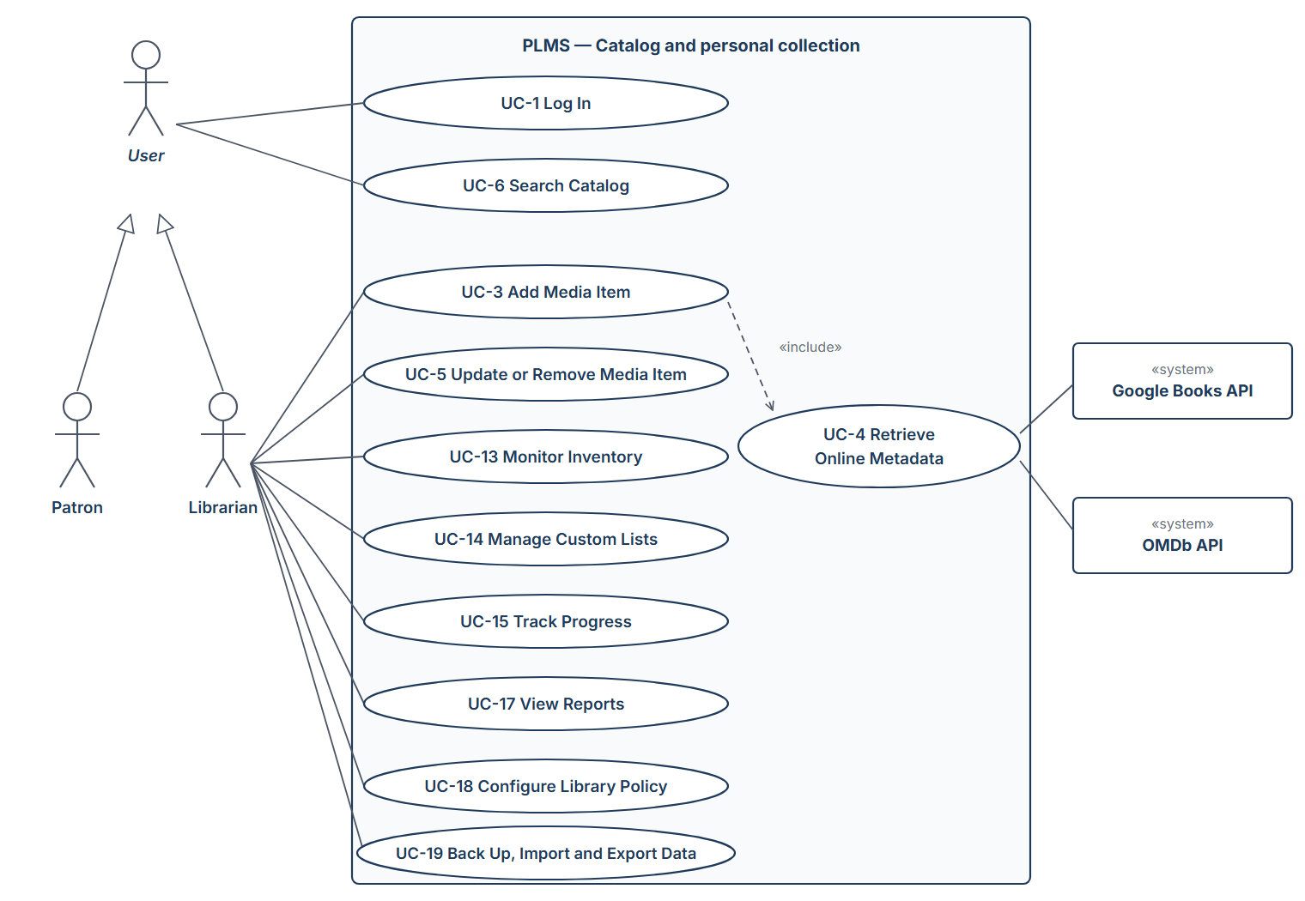
Figure 3.2: Use case diagram – catalog and personal collection
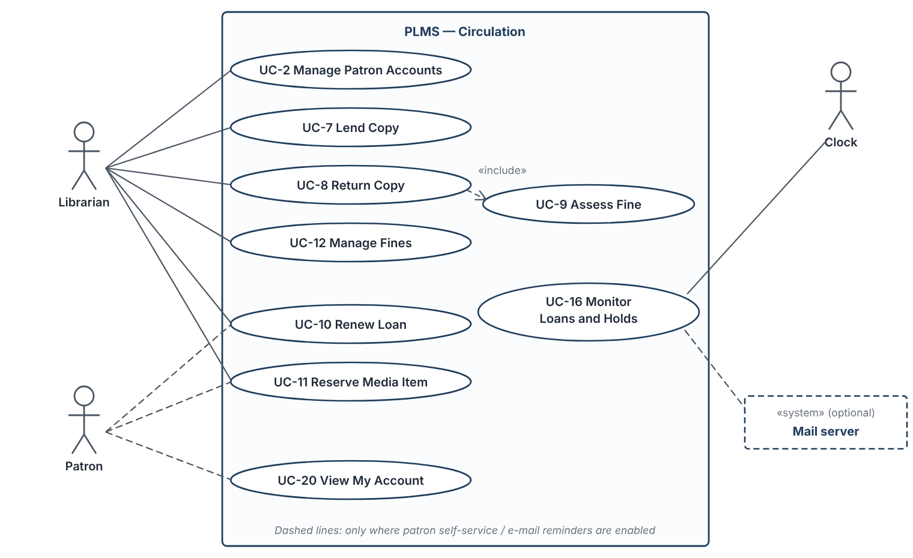
Figure 3.3: Use case diagram – circulation
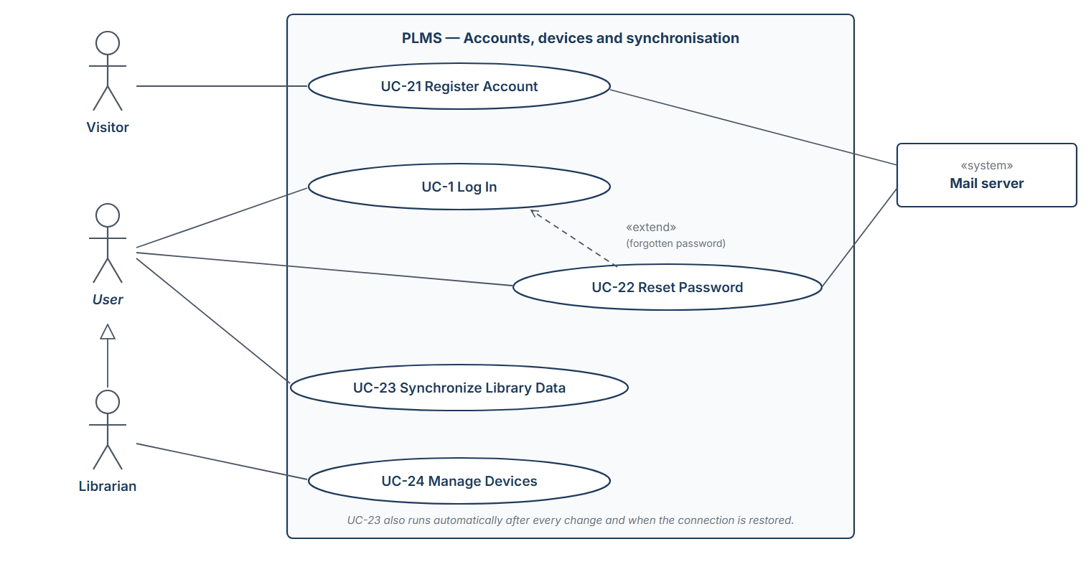
Figure 3.4: Use case diagram – accounts, devices and synchronisation
Use case summary.
ID | Use case | Actors | Related requirements
UC-1 | Log In | User (Librarian, or Patron where self-service is enabled) | FR-1, FR-2, FR-3, FR-8, FR-72
UC-2 | Manage Patron Accounts | Librarian | FR-4, FR-5, FR-6, FR-7
UC-3 | Add Media Item | Librarian | FR-9, FR-10, FR-11, FR-12, FR-13, FR-14, FR-25
UC-4 | Retrieve Online Metadata | Librarian | FR-21, FR-22, FR-23, FR-24, FR-25
UC-5 | Update or Remove Media Item | Librarian | FR-12, FR-15, FR-16, FR-17, FR-34
UC-6 | Search Catalog | User (Librarian, or Patron where self-service is enabled) | FR-13, FR-18, FR-19, FR-20, FR-26
UC-7 | Lend Copy | Librarian (patron present) | FR-27, FR-28, FR-29, FR-35, FR-44, FR-47
UC-8 | Return Copy | Librarian | FR-30, FR-31, FR-34, FR-35, FR-38, FR-45, FR-52
UC-9 | Assess Fine | Librarian (initiated by UC-8) | FR-41, FR-45
UC-10 | Renew Loan | Librarian | FR-32, FR-33, FR-35
UC-11 | Reserve Media Item | Librarian | FR-36, FR-37, FR-38, FR-40
UC-12 | Manage Fines | Librarian | FR-42, FR-43, FR-44
UC-13 | Monitor Inventory | Librarian | FR-46, FR-47, FR-48
UC-14 | Manage Custom Lists | Librarian | FR-55, FR-56, FR-57, FR-58, FR-73
UC-15 | Track Progress | Librarian | FR-59, FR-60, FR-61, FR-62, FR-63, FR-75, FR-76
UC-16 | Monitor Loans and Holds | Clock (initiating) | FR-39, FR-49, FR-50, FR-51, FR-52, FR-53, FR-54, FR-74
UC-17 | View Reports | Librarian | FR-64
UC-18 | Configure Library Policy | Librarian | FR-65
UC-19 | Back Up, Import and Export Data | Librarian | FR-66, FR-67, FR-68, FR-69, FR-77
UC-20 | View My Account | Patron (where self-service is enabled) | FR-8
UC-21 | Register Account | Visitor; Mail server | FR-70
UC-22 | Reset Password | User; Mail server | FR-71
UC-23 | Synchronize Library Data | User (Librarian, or Patron where self-service is enabled) | FR-66, FR-78, FR-79, FR-80, FR-81
UC-24 | Manage Devices | Librarian | FR-72, FR-82

Use case descriptions. Each use case is described with the template of [1]. Steps in the flow of events alternate between the actor and the system.
UC-1 Log In
Participating actors | User (Librarian, or Patron where self-service is enabled)
Entry condition | PLMS is opened in a browser or as an installed application on a device, and no user is logged in on that device.
Flow of events | 1. The user enters the e-mail address and password of the account.  2. The system checks the credentials.  3. The system loads the library data to the device (UC-23) and opens the dashboard of the librarian, or the account view of the patron.
Exit condition | The user is logged in and sees only the data permitted for the role.
Alternative flows and exceptions | 2a. Wrong credentials: the system shows an error; after three failures it blocks logins for 60 seconds (FR-2).  3a. The librarian may change the password from the settings (FR-3).  2b. Forgotten password: the user starts UC-22 Reset Password.  4a. The user logs out: the system ends the session on this device and removes the local copy (FR-72).
Quality requirements | Login takes less than 2 seconds.
Related requirements | FR-1, FR-2, FR-3, FR-8, FR-72

UC-2 Manage Patron Accounts
Participating actors | Librarian
Entry condition | The librarian is logged in.
Flow of events | 1. The librarian opens the patron list and selects “New patron” or an existing patron.  2. The librarian enters or changes the name and contact details.  3. The system validates that a name and at least one contact detail are present.  4. The system saves the patron; a new patron gets the status Active.  5. To deactivate a patron, the librarian selects “Deactivate”; the system checks for active loans and unpaid fines and sets the status to Deactivated.
Exit condition | The patron account is created, changed or deactivated; the loan history is unchanged.
Alternative flows and exceptions | 3a. Required data missing: the system marks the fields and does not save.  5a. Open loans or unpaid fines: the system refuses and lists them (FR-7).
Related requirements | FR-4, FR-5, FR-6, FR-7

UC-3 Add Media Item
Participating actors | Librarian; Google Books API and OMDb API through UC-4
Entry condition | The librarian is logged in.
Flow of events | 1. The librarian selects “Add item” and chooses Book or DVD.  2. The librarian enters the ISBN, reads it with a USB barcode scanner or with the camera of the device, or enters the title.  3. The system checks the catalog for an existing item with the same ISBN, or the same title and creator.  4. The librarian requests online metadata; this includes UC-4 Retrieve Online Metadata.  5. The librarian completes the remaining fields and enters shelf location and condition of the first copy.  6. The system saves the media item and its copy with the status Available.
Exit condition | A new media item with at least one Available copy is in the catalog.
Alternative flows and exceptions | 3a. Possible duplicate: the system warns and offers to add a new copy to the existing item (FR-14).  4a. No internet or no result: the librarian enters all fields manually (FR-25).  6a. Required field missing (title, or author for a book): the system does not save.
Quality requirements | With online metadata, an item can be added in under 60 seconds.
Related requirements | FR-9, FR-10, FR-11, FR-12, FR-13, FR-14, FR-25

UC-4 Retrieve Online Metadata
Participating actors | Librarian; Google Books API (books); OMDb API (DVDs)
Entry condition | Included by UC-3 or started from UC-5 (“Refresh info”). An ISBN or title is known.
Flow of events | 1. The system sends the ISBN or title to Google Books (book) or OMDb (DVD).  2. The external service returns the data.  3. The system shows the retrieved values next to the values already entered.  4. The librarian accepts all or some fields, and selects a value where both differ.  5. The system stores the accepted fields as online metadata of the media item.
Exit condition | Accepted online metadata is linked to the media item.
Alternative flows and exceptions | 1a. No connection, no result or no answer within 5 seconds: the system informs the librarian and the use case ends; manual entry remains possible.
Quality requirements | The user interface stays responsive while waiting (NFR-10).
Related requirements | FR-21, FR-22, FR-23, FR-24, FR-25

UC-5 Update or Remove Media Item
Participating actors | Librarian
Entry condition | The librarian has opened a media item.
Flow of events | 1. The librarian changes data of the media item or of one of its copies, or adds a new copy.  2. The system saves the changes.  3. To remove an item or copy, the librarian selects “Remove”; the system checks that there is no active loan and no waiting reservation and asks for confirmation.  4. The system removes the item or copy from the catalog and from all custom lists.
Exit condition | The catalog contains the updated data.
Alternative flows and exceptions | 3a. Active loan or waiting reservation: the system refuses the removal and states the reason (FR-17).  1a. The librarian marks a copy as lost or damaged; the system records the event (FR-34).
Related requirements | FR-12, FR-15, FR-16, FR-17, FR-34

UC-6 Search Catalog
Participating actors | User (Librarian, or Patron where self-service is enabled)
Entry condition | The user is logged in.
Flow of events | 1. The user enters a search text or scans an ISBN, and optionally selects filters.  2. The system lists the matching media items with their availability.  3. The user opens a media item.  4. The system shows its data, online metadata, copies, borrowers, reservation queue and loan history (a patron sees no data of other patrons).
Exit condition | The user has found the media item or knows that it is not in the catalog.
Alternative flows and exceptions | 2a. No match: the system shows an empty result and offers to clear the filters.
Quality requirements | Results appear within 1 second for 10,000 copies (NFR-8).
Related requirements | FR-13, FR-18, FR-19, FR-20, FR-26

UC-7 Lend Copy
Participating actors | Librarian (patron present)
Entry condition | The librarian is logged in; the media item and the patron exist.
Flow of events | 1. The librarian selects a copy and chooses “Lend”.  2. The librarian selects the patron.  3. The system checks that the patron is not blocked and is below the borrowing limit, and that the copy is Available or held for this patron.  4. The system shows the due date (loan date plus loan period).  5. The librarian confirms.  6. The system creates the loan, sets the copy to OnLoan, fulfils the patron’s reservation if there was one, and updates the low-stock status.
Exit condition | An active loan exists and the copy is OnLoan.
Alternative flows and exceptions | 3a. Patron blocked or borrowing limit reached: the system refuses and shows the reason (FR-28).  3b. Copy held for another patron: the system refuses and offers UC-11 Reserve Media Item.  6a. Available copies fall below the threshold: a low-stock notification is issued (FR-47).
Quality requirements | At most five interactions after the item is found (NFR-1).
Related requirements | FR-27, FR-28, FR-29, FR-35, FR-44, FR-47

UC-8 Return Copy
Participating actors | Librarian
Entry condition | The copy has an active loan.
Flow of events | 1. The librarian finds the loan by copy or by patron and chooses “Return”.  2. The librarian optionally notes the condition of the copy.  3. The system closes the loan with the current date as return date.  4. If the return is late, the system includes UC-9 Assess Fine.  5. If the media item has a waiting reservation, the system sets the copy to Held for the first patron, sets the reservation to Ready and issues a reservation-ready notification; otherwise it sets the copy to Available.  6. The system shows the result.
Exit condition | The loan is closed; the copy is Available or Held; any fine is recorded.
Alternative flows and exceptions | 2a. Copy damaged: the librarian records the damage (FR-34).  1a. Copy lost: the librarian records the loss; the system closes the loan and may create a replacement fine (FR-45).
Related requirements | FR-30, FR-31, FR-34, FR-35, FR-38, FR-45, FR-52

UC-9 Assess Fine
Participating actors | Librarian (initiated by UC-8)
Entry condition | Included by UC-8; the loan has been closed.
Flow of events | 1. The system computes the days late beyond the grace period.  2. If the result is greater than zero, the system computes daily fine rate × days, limited to the maximum fine per loan.  3. The system creates a fine with the status Unpaid and shows it.  4. The system updates the patron’s status (Blocked if the blocking threshold is exceeded).
Exit condition | A fine exists for every late return.
Alternative flows and exceptions | 1a. Return within the grace period: no fine is created.  1b. Copy reported lost: a replacement fine with the amount entered by the librarian is created (FR-45).
Quality requirements | The calculation follows the policy that was valid when the loan was created (FR-65).
Related requirements | FR-41, FR-45

UC-10 Renew Loan
Participating actors | Librarian; Patron where self-service is enabled
Entry condition | The loan is active.
Flow of events | 1. The actor opens the loan and selects “Renew”.  2. The system checks the renewal count and the reservation queue of the media item.  3. The system extends the due date by the loan period and increases the renewal count.
Exit condition | The loan has a new due date.
Alternative flows and exceptions | 2a. Maximum renewals reached or reservation waiting: the system refuses and states the reason (FR-33).
Related requirements | FR-32, FR-33, FR-35

UC-11 Reserve Media Item
Participating actors | Librarian; Patron where self-service is enabled
Entry condition | No copy of the media item is Available.
Flow of events | 1. The actor opens the media item and selects “Reserve” (the librarian also selects the patron).  2. The system checks that the patron has no loan or reservation for this item.  3. The system adds the patron to the end of the queue and shows the position.  4. Later, when a copy is returned (UC-8), the reservation becomes Ready.
Exit condition | A reservation with the status Waiting exists.
Alternative flows and exceptions | 2a. A copy is Available: the system suggests lending instead (FR-37).  2b. The patron already has the item or a reservation for it: the system refuses.  3a. The actor cancels the reservation: the system removes it and moves the queue up (FR-40).
Related requirements | FR-36, FR-37, FR-38, FR-40

UC-12 Manage Fines
Participating actors | Librarian
Entry condition | The patron has at least one Unpaid or PartiallyPaid fine.
Flow of events | 1. The librarian opens the patron’s fines.  2. The librarian records a payment with its amount, or selects “Waive” and enters a reason.  3. The system updates the outstanding amount and the fine status (PartiallyPaid, Paid or Waived).  4. The system updates the patron’s status; the patron is Active again when the blocking condition no longer holds.
Exit condition | The fine and the patron status are up to date.
Alternative flows and exceptions | 2a. Payment larger than the outstanding amount: the system refuses the payment.  2b. No reason entered for a waiver: the system does not save the waiver.
Related requirements | FR-42, FR-43, FR-44

UC-13 Monitor Inventory
Participating actors | Librarian
Entry condition | The librarian is logged in.
Flow of events | 1. The librarian opens the inventory view.  2. The system shows the numbers of media items, copies, copies on loan, overdue loans, lost and damaged copies.  3. The system lists the media items whose Available copies are below the low-stock threshold.  4. The librarian may change the threshold of a media item (UC-5).
Exit condition | The librarian knows the state of the collection.
Related requirements | FR-46, FR-47, FR-48

UC-14 Manage Custom Lists
Participating actors | Librarian
Entry condition | The librarian is logged in.
Flow of events | 1. The librarian creates a custom list with a unique name, or opens an existing list.  2. The librarian adds media items to the list, removes them, reorders or sorts the list.  3. The system saves the list and its order.  4. The librarian may delete the list; the media items stay in the catalog.
Exit condition | The custom list contains the selected media items in the chosen order.
Alternative flows and exceptions | 1a. Name already used: the system asks for another name.  2a. The librarian asks for suggestions: the system proposes media items with the same genre, creator or tags, and adds the accepted ones (FR-73).
Related requirements | FR-55, FR-56, FR-57, FR-58, FR-73

UC-15 Track Progress
Participating actors | Librarian
Entry condition | The media item is in the catalog.
Flow of events | 1. The librarian opens the media item and selects “Log session”.  2. The librarian enters the pages read and, optionally, the chapters completed and the duration (book), or the minutes watched and, optionally, the scenes viewed (DVD).  3. The system adds a progress session and updates the current position, the percentage, the remaining amount and, for books, the estimated remaining reading time.  4. When the total is reached, the system sets the progress to Completed and asks for a personal rating and review.
Exit condition | The progress of the media item is up to date.
Alternative flows and exceptions | 2a. Value above the total: the system sets the position to the total and informs the librarian (FR-62).  4a. The librarian restarts a completed item; the progress becomes InProgress again.  3a. A milestone (25 %, 50 %, 75 %) is passed: the system issues a milestone notification (FR-75).  1a. The librarian opens the session history: the system lists the sessions with date, amount and duration (FR-76).
Related requirements | FR-59, FR-60, FR-61, FR-62, FR-63, FR-75, FR-76

UC-16 Monitor Loans and Holds
Participating actors | Clock (initiating); Librarian (receives); Mail server where e-mail reminders are enabled
Entry condition | The application is running.
Flow of events | 1. At least every hour, the clock triggers a check; the check runs on the server, also when no device of the user is open.  2. The system finds loans due within the reminder period and loans past their due date.  3. The system finds Ready reservations whose hold expiry date has passed, sets them to Expired and passes the copy to the next patron or makes it Available.  4. The system issues the notifications (due soon, overdue, reservation ready, hold expired) and shows them in the application, as notifications of the user’s devices and in the notification list.  5. Where enabled, the system e-mails the reminders to the patrons concerned.
Exit condition | All due, overdue and expired situations have produced a notification.
Alternative flows and exceptions | 5a. The mail server cannot be reached: the notification is still shown in the application and the failure is recorded.  3a. Where reading reminders are enabled, the system also finds InProgress media items without a session during the reading reminder interval and issues a reading reminder (FR-74).
Quality requirements | An overdue notification is issued at most once per day per loan.
Related requirements | FR-39, FR-49, FR-50, FR-51, FR-52, FR-53, FR-54, FR-74

UC-17 View Reports
Participating actors | Librarian
Entry condition | The librarian is logged in.
Flow of events | 1. The librarian opens the reports view and selects a report (overdue loans, outstanding fines, most borrowed items, patron history, reading and viewing statistics).  2. The librarian optionally selects a period or a patron.  3. The system produces and displays the report.
Exit condition | The report is shown.
Alternative flows and exceptions | 3a. No data for the selection: the system shows an empty report.
Related requirements | FR-64

UC-18 Configure Library Policy
Participating actors | Librarian
Entry condition | The librarian is logged in.
Flow of events | 1. The librarian opens the settings view.  2. The librarian changes values of the library policy or other settings (OMDb API key, e-mail reminders, patron self-service).  3. The system validates the values (positive numbers, maximum fine not below daily rate).  4. The system saves the policy; it applies to loans, reservations and fines created afterwards.
Exit condition | The new policy is in effect.
Alternative flows and exceptions | 3a. Invalid value: the system marks the field and does not save.
Related requirements | FR-65

UC-19 Back Up, Import and Export Data
Participating actors | Librarian
Entry condition | The librarian is logged in.
Flow of events | 1. The librarian selects “Back up”, “Restore”, “Import” or “Export”.  2. For a backup, the system creates a backup file with all library data and saves it at a location chosen by the librarian.  3. For a restore, the librarian chooses a backup file and confirms; the system replaces the current data.  4. For an export, the system writes the catalog, patrons and loans to CSV files.  5. For an import, the librarian selects a CSV file; the system adds its media items and copies and lists the rows that could not be imported.
Exit condition | The backup, restore, import or export is complete.
Alternative flows and exceptions | 3a. The file is not a valid backup: the system refuses and keeps the current data.
Quality requirements | The current data is never lost by a failed restore (NFR-5).
Related requirements | FR-66, FR-67, FR-68, FR-69, FR-77

UC-20 View My Account
Participating actors | Patron (where self-service is enabled)
Entry condition | The patron is logged in (UC-1).
Flow of events | 1. The patron opens “My account”.  2. The system shows the patron’s active loans with due dates, reservations with queue positions, and fines.  3. The patron may start UC-10 Renew Loan or UC-11 Reserve Media Item.
Exit condition | The patron knows the state of their account.
Related requirements | FR-8

UC-21 Register Account
Participating actors | Visitor; Mail server
Entry condition | The visitor has opened PLMS on a device with an internet connection and has no account.
Flow of events | 1. The visitor selects “Create account”.  2. The visitor enters a name, an e-mail address and a password.  3. The system checks that the e-mail address is not registered and that the password has at least 8 characters.  4. The system creates a librarian account with an empty library and a default library policy, and sends a verification e-mail through the mail server.  5. The visitor confirms the e-mail address with the link and is logged in (UC-1).
Exit condition | A librarian account with an empty library exists.
Alternative flows and exceptions | 3a. E-mail address already registered or password too short: the system shows the reason and does not create the account.  4a. No internet connection: the system informs the visitor that registration needs a connection (FR-79).
Quality requirements | The verification e-mail is sent within 1 minute.
Related requirements | FR-70

UC-22 Reset Password
Participating actors | User; Mail server
Entry condition | The user has forgotten the password and selects “Forgot password” on the login screen (extends UC-1).
Flow of events | 1. The user enters the e-mail address of the account.  2. The system sends a single-use reset link to that address.  3. The user opens the link within 30 minutes and enters a new password.  4. The system replaces the password; the user can log in with it (UC-1).
Exit condition | The account has a new password.
Alternative flows and exceptions | 1a. The address is not registered: the system shows the same message as for a registered address, so that registered addresses cannot be discovered.  3a. The link has expired or was already used: the system asks the user to request a new link.
Quality requirements | The reset e-mail is sent within 1 minute.
Related requirements | FR-71

UC-23 Synchronize Library Data
Participating actors | User (Librarian, or Patron where self-service is enabled)
Entry condition | The user is logged in on at least one device. The use case starts after log-in, after every change of library data and when a device goes online.
Flow of events | 1. The system records every change of library data made on the device.  2. While the device is online, the system stores the change in the cloud database and shows it on the other devices of the account.  3. While the device is offline, the system keeps the change in the local queue and shows the number of waiting changes.  4. When the connection is restored, the system sends the queued changes in the order in which they were made.  5. The system updates the time of the last synchronisation of the device.
Exit condition | All devices of the account show the same library data.
Alternative flows and exceptions | 4a. A queued change conflicts with a change from another device: the system shows both versions; the librarian selects one and the system keeps it (FR-81).  4b. The connection is lost again: the remaining changes stay in the queue.
Quality requirements | Changes made online are visible on the other devices within 10 seconds (FR-78).
Related requirements | FR-66, FR-78, FR-79, FR-80, FR-81

UC-24 Manage Devices
Participating actors | Librarian
Entry condition | The librarian is logged in.
Flow of events | 1. The librarian opens the device list in the settings.  2. The system shows every device on which the account is logged in, with its platform and the time of its last synchronisation.  3. The librarian selects a device and chooses “Sign out”.  4. The system ends the session on that device; the device removes its local copy when it is online again.
Exit condition | Only the devices accepted by the librarian are signed in.
Alternative flows and exceptions | 3a. The librarian signs out the current device: the system logs out as in FR-72.
Related requirements | FR-72, FR-82

Object model
The analysis object model describes the concepts of the application domain and their relationships. As required by the assignment [3], the model is conceptual: classes have attributes with conceptual types but no operations, and it contains no database elements (no keys, tables or identifiers that exist only for storage). The model is shown in two diagrams for readability; classes that appear in both diagrams are shown with their attributes only once (Figure 3.5). The enumerations used as attribute types are shown in Figure 3.7.
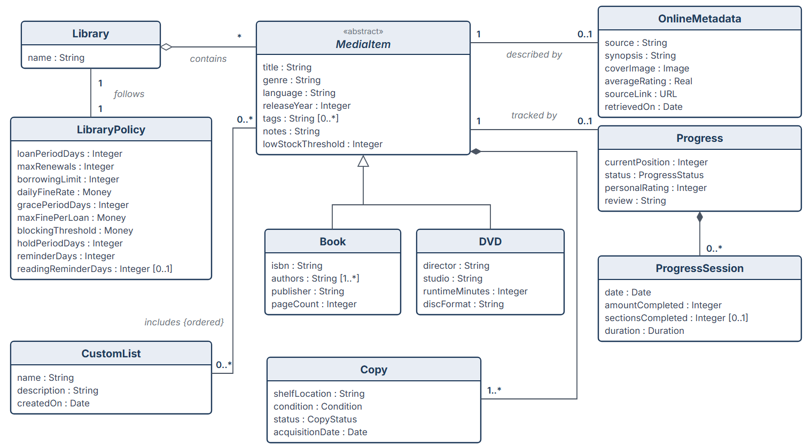
Figure 3.5: Analysis object model – catalog and personal collection
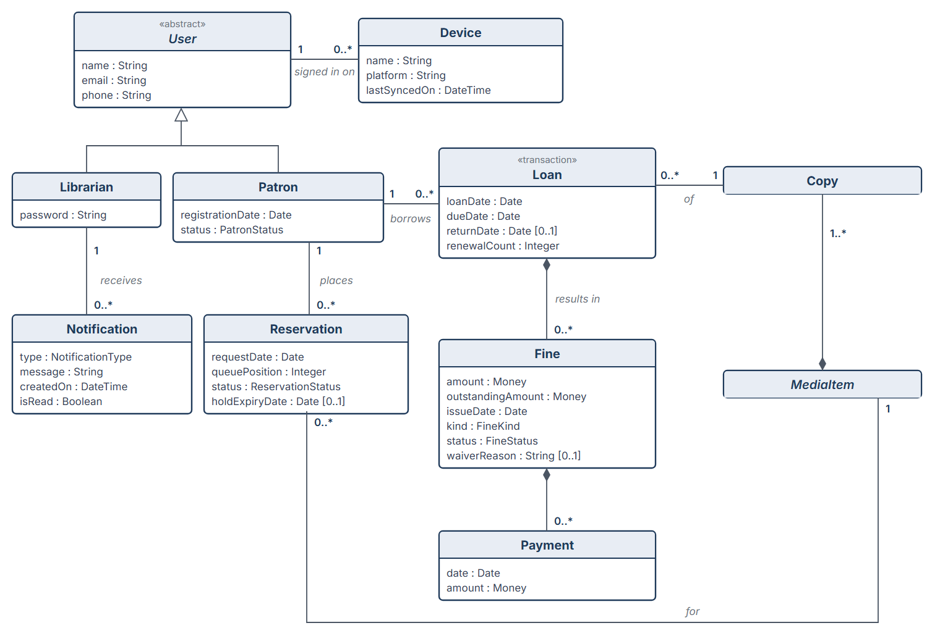
Figure 3.6: Analysis object model – users, devices and circulation (Copy and MediaItem are detailed in Figure 3.5)
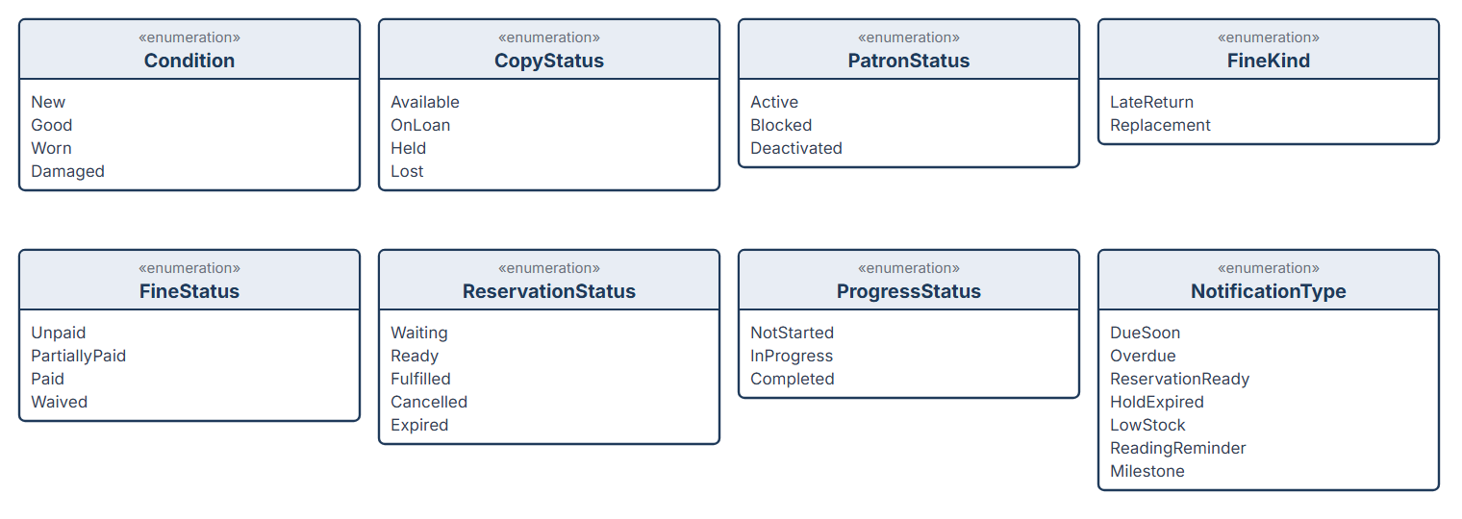
Figure 3.7: Enumerations used in the object model
Classes.
Class | Meaning | Attributes
Library | The personal library as a whole. Contains the media items and the users and follows one library policy. | name
LibraryPolicy | The rules and settings of the library, set by the librarian (FR-65, FR-74). | loanPeriodDays, maxRenewals, borrowingLimit, dailyFineRate, gracePeriodDays, maxFinePerLoan, blockingThreshold, holdPeriodDays, reminderDays, readingReminderDays
User {abstract} | A person who can use the system. | name, email, phone
Librarian | The owner of the library, who registers the account and manages the library. | password (the e-mail address of User is used for log-in)
Patron | A person who borrows copies from the library. | registrationDate, status (PatronStatus)
Device | A computer, tablet or phone on which a user is signed in; it keeps a local copy of the library data. | name, platform, lastSyncedOn
MediaItem {abstract} | A title in the catalog, independent of the physical copies. | title, genre, language, releaseYear, tags, notes, lowStockThreshold
Book | A media item that is a printed book. | isbn, authors, publisher, pageCount
DVD | A media item that is a film or series on disc. | director, studio, runtimeMinutes, discFormat
Copy | One physical exemplar of a media item. Loans always refer to a copy. | shelfLocation, condition (Condition), status (CopyStatus), acquisitionDate
OnlineMetadata | Descriptive data about a media item retrieved from Google Books or OMDb. | source, synopsis, coverImage, averageRating, sourceLink, retrievedOn
Loan «transaction» | The lending of one copy to one patron (the “Transaction” of the problem statement). | loanDate, dueDate, returnDate, renewalCount
Fine | An amount charged to a patron for a late return or a lost copy. | amount, outstandingAmount, issueDate, kind (FineKind), status (FineStatus), waiverReason
Payment | A payment that reduces the outstanding amount of a fine. | date, amount
Reservation | A patron’s place in the queue for a media item. | requestDate, queuePosition, status (ReservationStatus), holdExpiryDate
Notification | A message to the librarian about a due, overdue, ready or expired item, about low stock, or a reading reminder or milestone. | type (NotificationType), message, createdOn, isRead
CustomList | A named, ordered list of media items created by the librarian. | name, description, createdOn
Progress | The librarian’s reading or viewing progress for a media item. | currentPosition, status (ProgressStatus), personalRating, review
ProgressSession | One reading or viewing session. | date, amountCompleted, sectionsCompleted (chapters or scenes), duration

Associations.
Classes | Kind and multiplicity | Meaning
Library – MediaItem | Aggregation, 1 to 0..* | The library contains media items.
Library – LibraryPolicy | Association, 1 to 1 | The library follows exactly one policy.
User ◁ Librarian, Patron | Generalisation | Librarian and Patron are kinds of User (problem statement).
User – Device | Association, 1 to 0..* | A user is signed in on one or more devices.
MediaItem ◁ Book, DVD | Generalisation | Book and DVD are kinds of media item.
MediaItem ◆ Copy | Composition, 1 to 1..* | A copy cannot exist without its media item.
MediaItem – OnlineMetadata | Association, 1 to 0..1 | A media item may be described by online metadata.
MediaItem – Progress | Association, 1 to 0..1 | A media item may have reading/viewing progress.
Progress ◆ ProgressSession | Composition, 1 to 0..* | Sessions belong to one progress record.
CustomList – MediaItem | Association, 0..* to 0..* {ordered} | A list includes media items in an order; an item can be in many lists.
Patron – Loan | Association, 1 to 0..* | A patron borrows copies through loans.
Loan – Copy | Association, 0..* to 1 | Each loan is of exactly one copy; a copy has many loans over time.
Loan ◆ Fine | Composition, 1 to 0..* | A fine results from one loan (late return or replacement).
Fine ◆ Payment | Composition, 1 to 0..* | Payments belong to one fine.
Patron – Reservation | Association, 1 to 0..* | A patron places reservations.
Reservation – MediaItem | Association, 0..* to 1 | A reservation is for a media item (not for a specific copy).
Librarian – Notification | Association, 1 to 0..* | The librarian receives notifications.

Analysis objects. Following [1], the dynamic model uses three kinds of analysis objects: entity objects (the classes above), boundary objects that represent the interface between the actors and the system, and control objects that carry out the use cases. These boundary and control objects are conceptual and will be refined in system and object design.
Kind | Objects
Boundary | LoginForm, DashboardView, CatalogView, MediaItemForm, PatronForm, LendCopyForm, ReturnCopyForm, ReservationForm, FineForm, InventoryView, CustomListView, ProgressForm, ReportView, PolicyForm, NotificationPanel, GoogleBooksGateway, OmdbGateway, MailGateway, RegistrationForm, PasswordResetForm, ConflictDialog, DeviceListView, CameraScanner
Control | LoginControl, CatalogControl, MetadataLookupControl, PatronControl, LendCopyControl, ReturnCopyControl, ReservationControl, FineControl, InventoryControl, ListControl, ProgressControl, ReportControl, PolicyControl, BackupControl, LoanMonitor, RegistrationControl, PasswordResetControl, SyncControl, DeviceControl, SuggestionControl, ImportControl
Entity | The classes of Figures 3.5 and 3.6.

Dynamic model
The dynamic model describes the behaviour of the system with sequence diagrams for the most important use cases, an activity diagram for the return process, and state machine diagrams for the classes whose behaviour depends on their state.
Add Media Item with online metadata (UC-3, UC-4). The boundary object MediaItemForm passes the ISBN to the control object MetadataLookupControl, which queries Google Books. If a result arrives within 5 seconds, it is shown for review and the accepted fields are stored with a new Book, OnlineMetadata and Copy; otherwise the librarian enters the data manually.
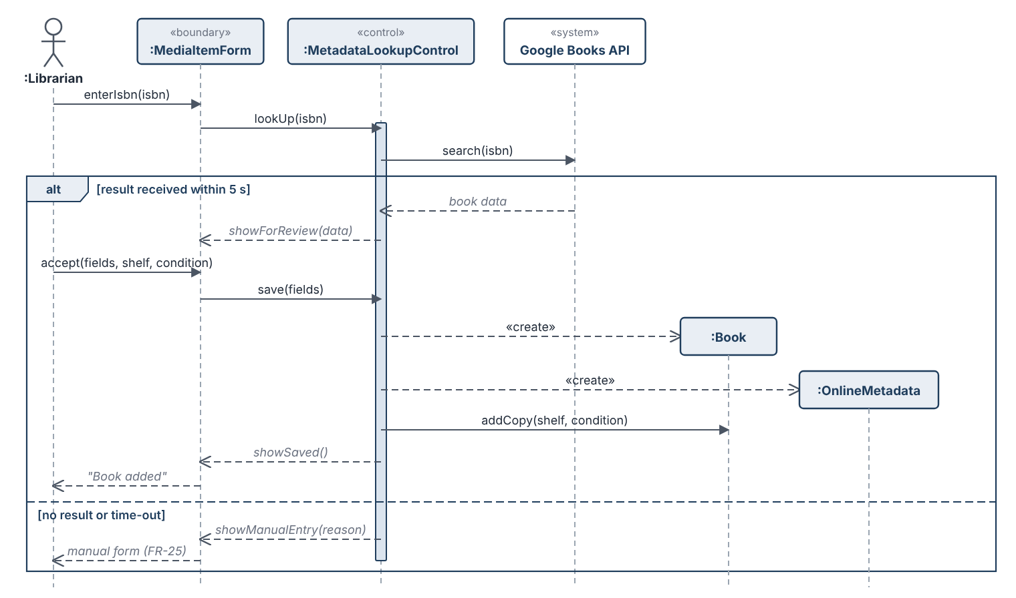
Figure 3.8: Sequence diagram – Add Media Item with online metadata
Lend Copy (UC-7). LendCopyControl checks the eligibility of the patron and the availability of the copy, reads the loan period from the library policy, creates the Loan and changes the status of the copy. If a check fails, no loan is created and the reason is shown.
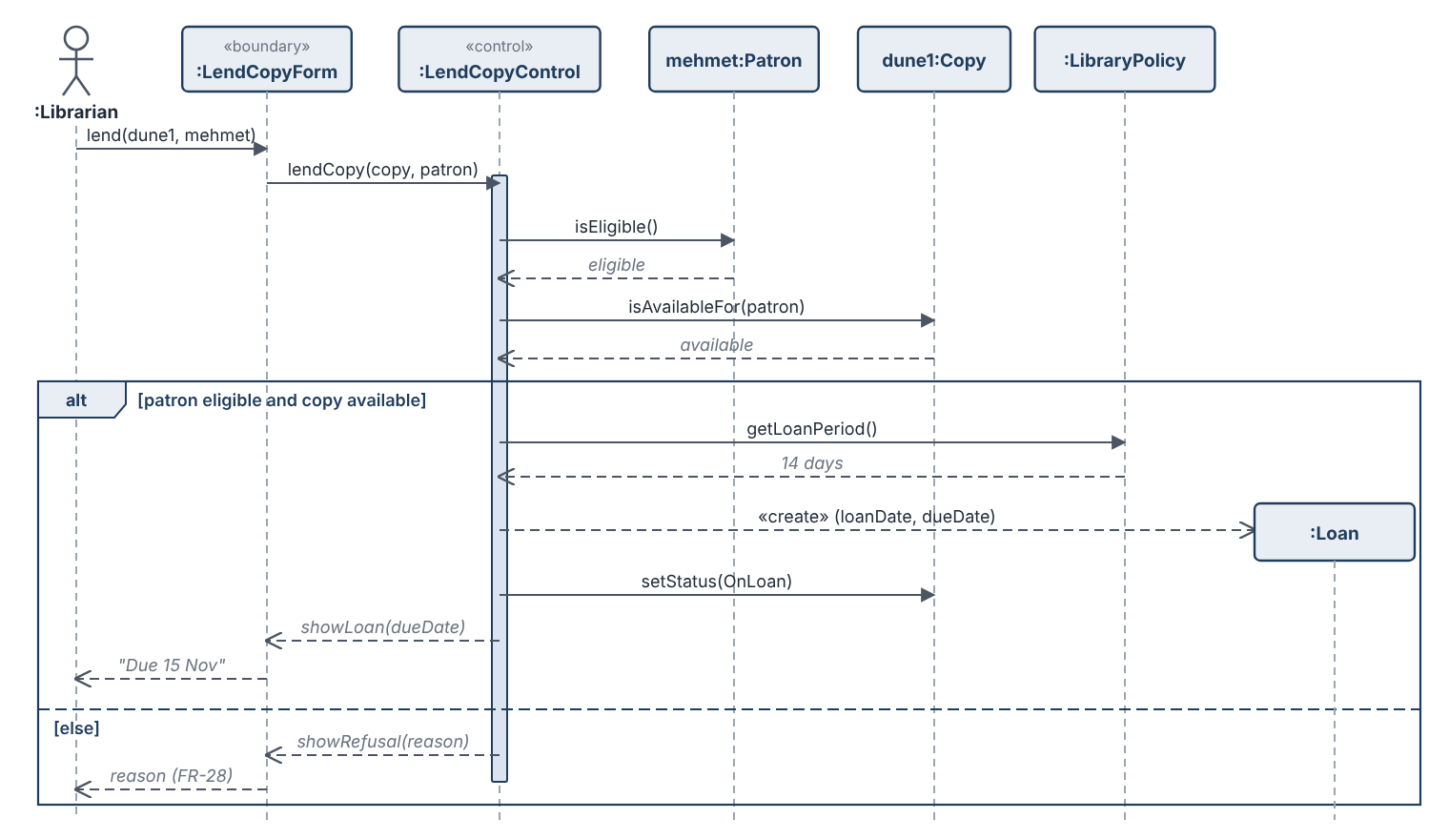
Figure 3.9: Sequence diagram – Lend Copy
Return Copy (UC-8, UC-9). ReturnCopyControl closes the loan and, if the return is late, creates a Fine. If a reservation is waiting, the copy is held for that patron and the LoanMonitor issues a reservation-ready notification; otherwise the copy becomes Available.
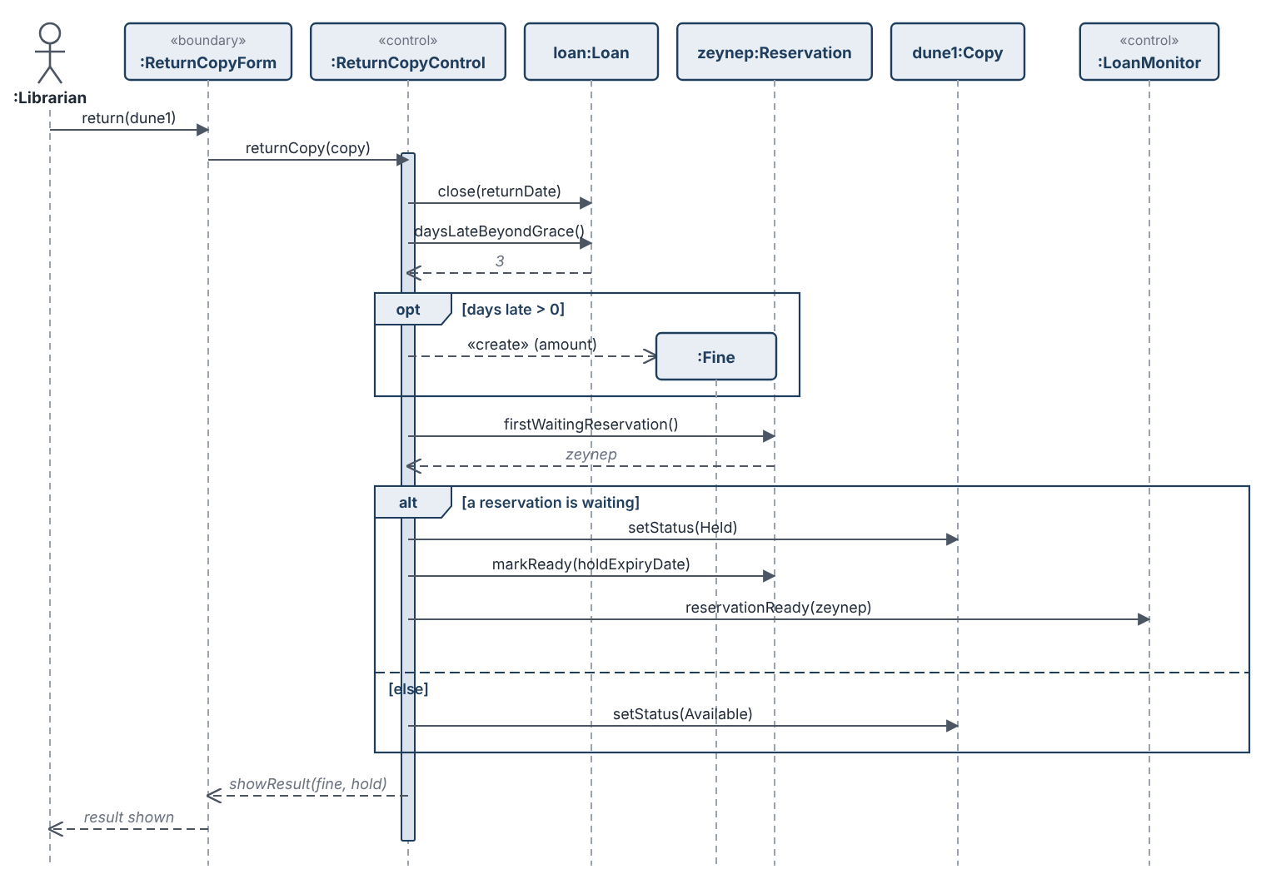
Figure 3.10: Sequence diagram – Return Copy with fine and reservation
Synchronize Library Data (UC-23). ProgressControl records a reading session and passes the change to SyncControl. If the device is online, the change is applied to the library in the cloud database at once; otherwise it is kept in the local queue and the form shows the number of waiting changes. When the connection is restored, SyncControl applies the queued changes in order; if a change conflicts with a change from another device, ConflictDialog shows both versions and the librarian selects the one to keep.
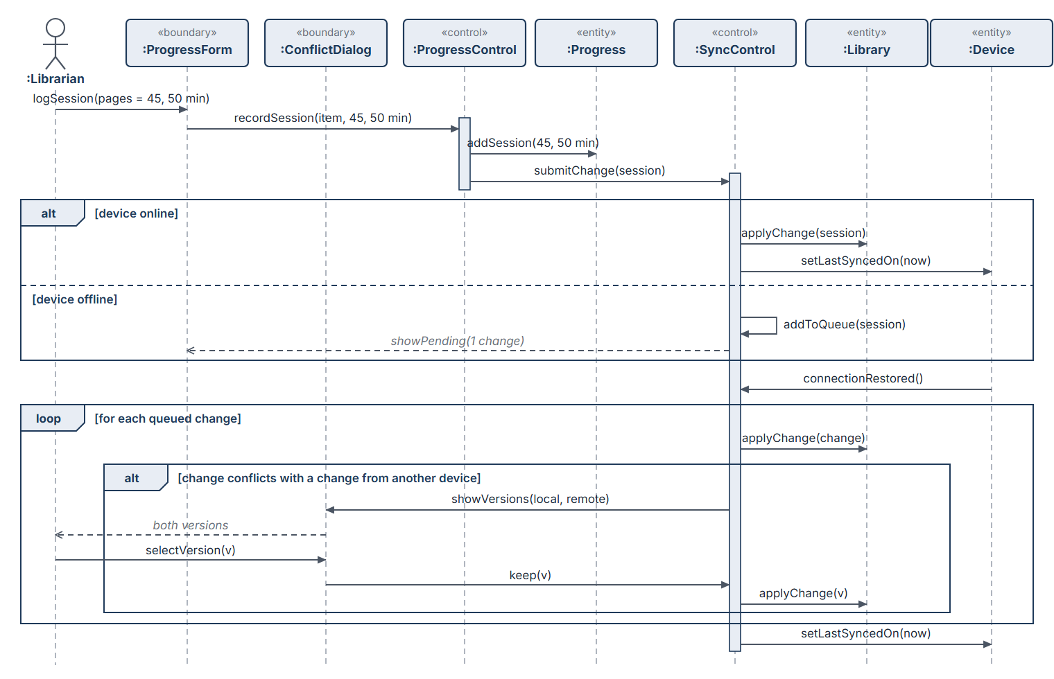
Figure 3.11: Sequence diagram – Synchronize Library Data after offline work
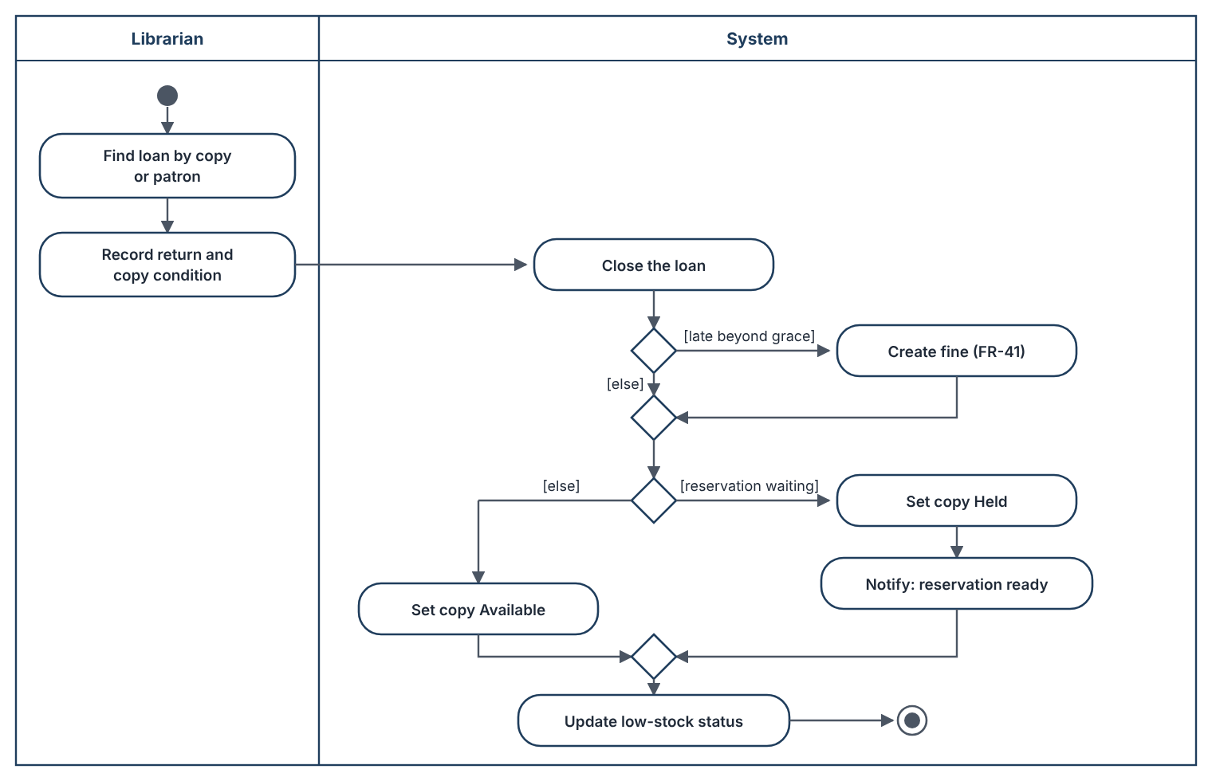
Figure 3.12: Activity diagram – returning a copy
State machines. Figure 3.13 shows the life cycle of a copy. Figure 3.14 shows the states of a reservation and of a fine, and Figure 3.15 the states of a patron and of reading/viewing progress. Transitions are labelled with the event and, where needed, a guard in square brackets.
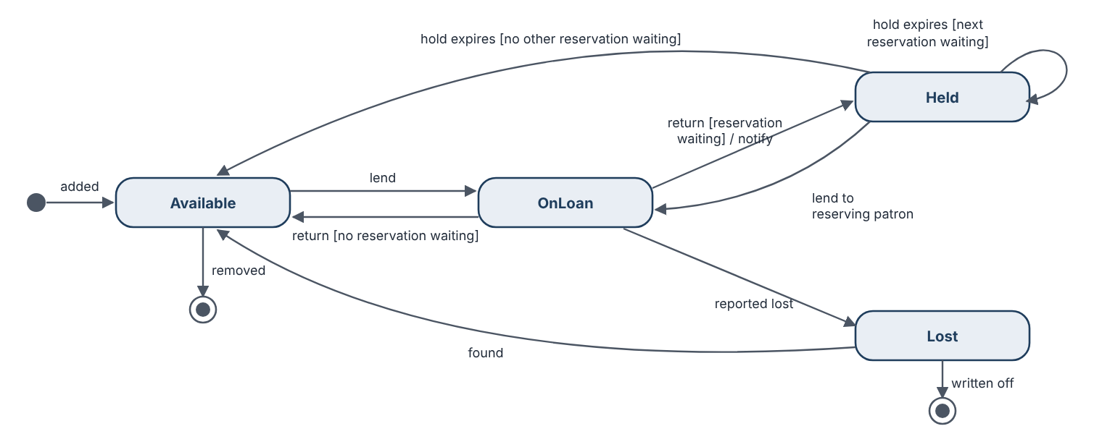
Figure 3.13: State machine diagram – Copy
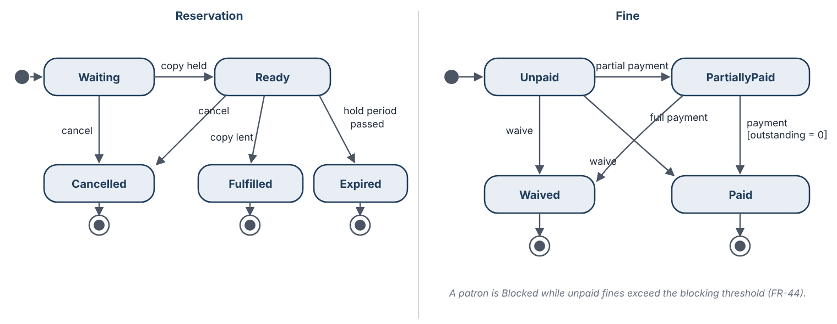
Figure 3.14: State machine diagrams – Reservation and Fine
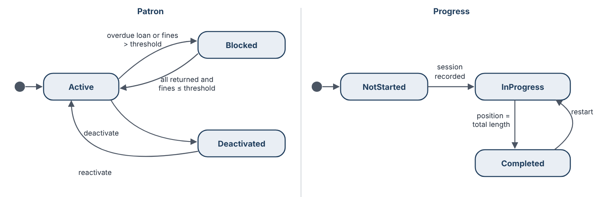
Figure 3.15: State machine diagrams – Patron and Progress

User interfaces and Mock-ups
The mock-ups below show the planned layout of the main screens. They illustrate the requirements and are not final designs. The same screens adapt to the size of the device (NFR-30): on wide screens every screen has the navigation menu on the left (Figures 3.16 – 3.18), and on phones a bottom navigation bar is used (Figure 3.19, NFR-3).
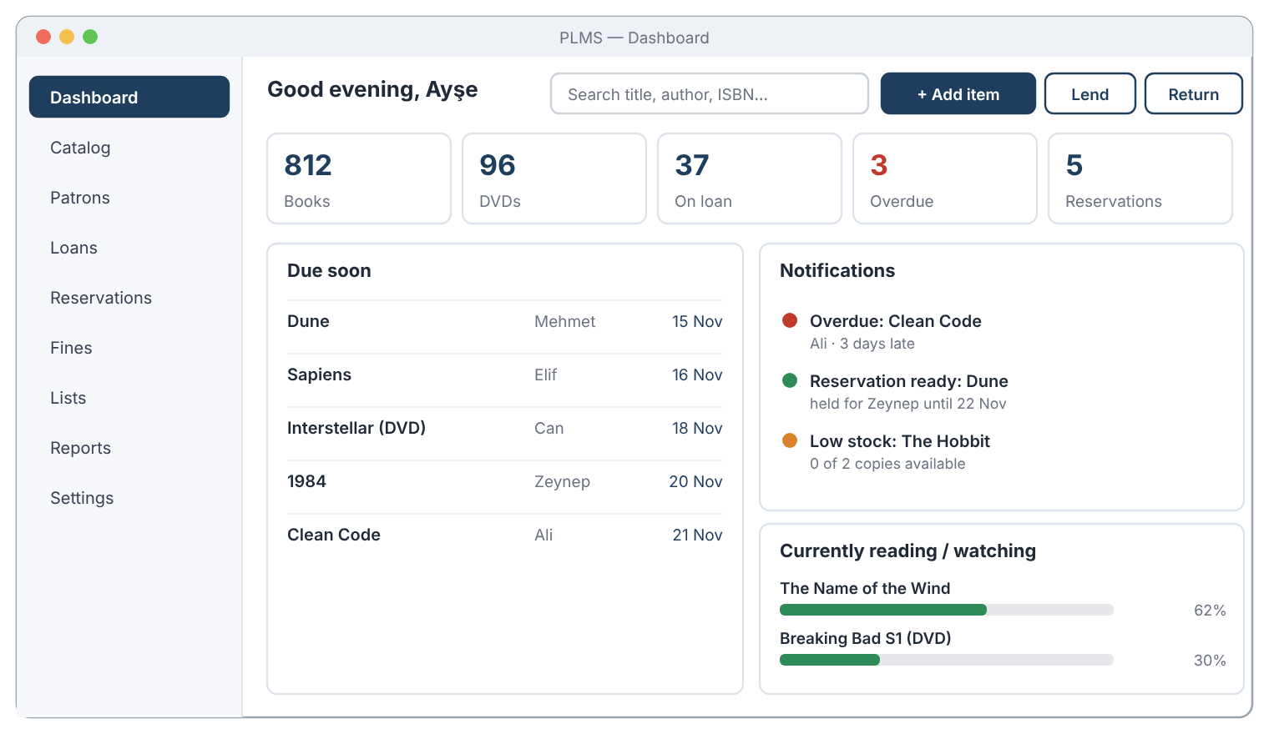
Figure 3.16: Mock-up – Dashboard
- Header: search field (FR-18) and quick actions “Add item”, “Lend” and “Return”.
- Summary: numbers of books, DVDs, copies on loan, overdue loans and reservations.
- Due soon and notifications: loans due within the reminder period and the notification list (FR-50 – FR-53).
- Current progress: items in progress with percentage (FR-61).
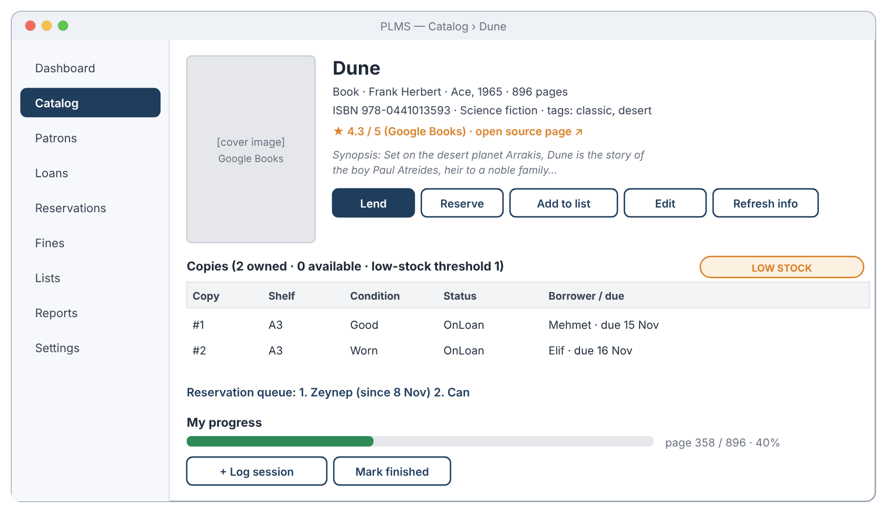
Figure 3.17: Mock-up – Media item details
- Data and online metadata: title, creator, publisher, ISBN, rating, synopsis, cover and source link (FR-20, FR-26).
- Copies: every copy with shelf, condition, status and borrower; low-stock badge (FR-46, FR-47).
- Reservation queue and progress: waiting patrons (FR-36) and reading progress with “Log session” (FR-59 – FR-63).
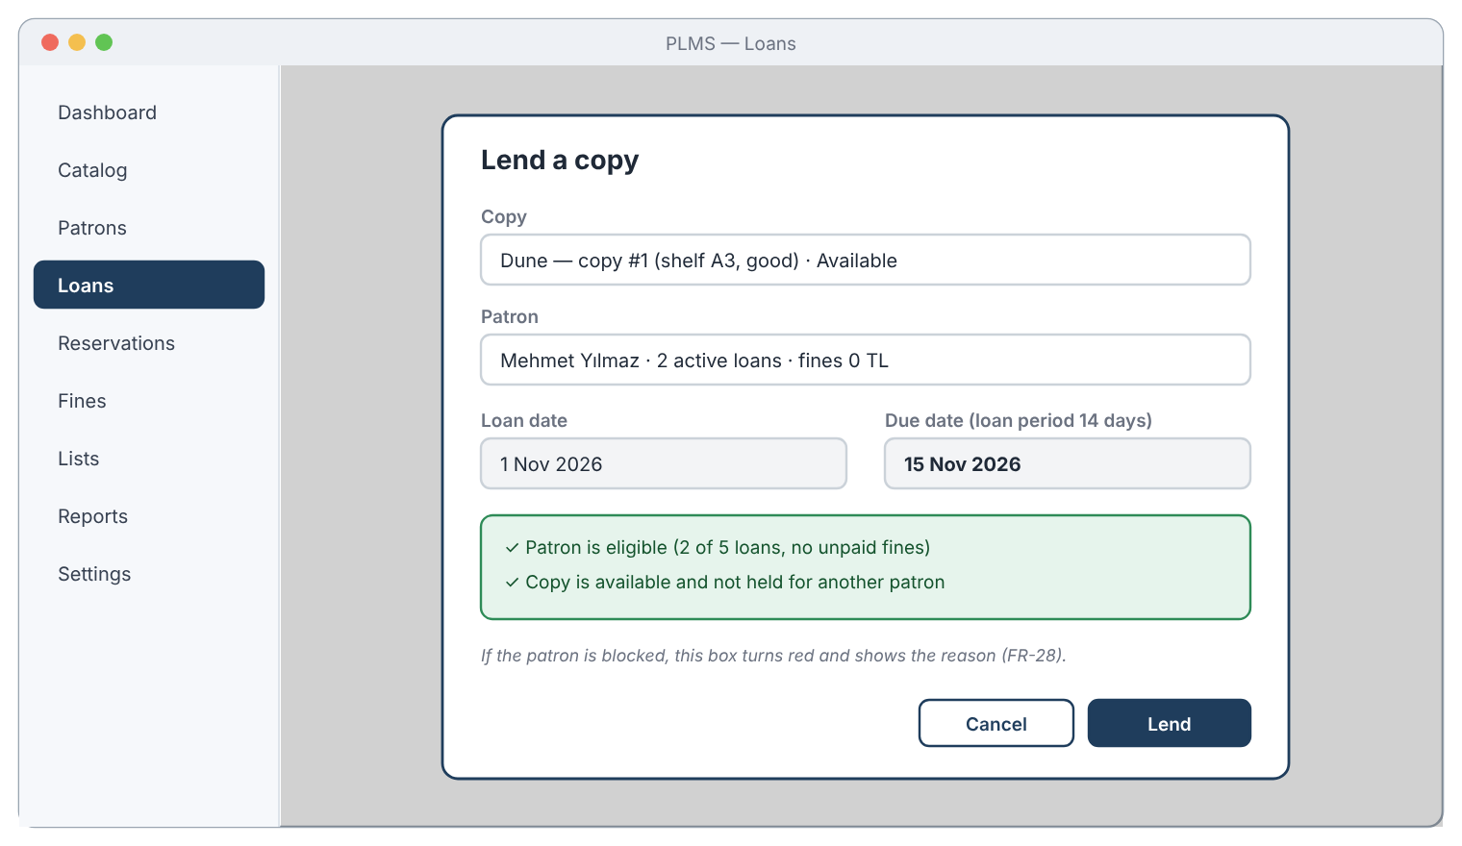
Figure 3.18: Mock-up – Lend a copy
- Lending dialog: copy and patron selection, loan and due date computed from the library policy, and the result of the eligibility checks (FR-27, FR-28).
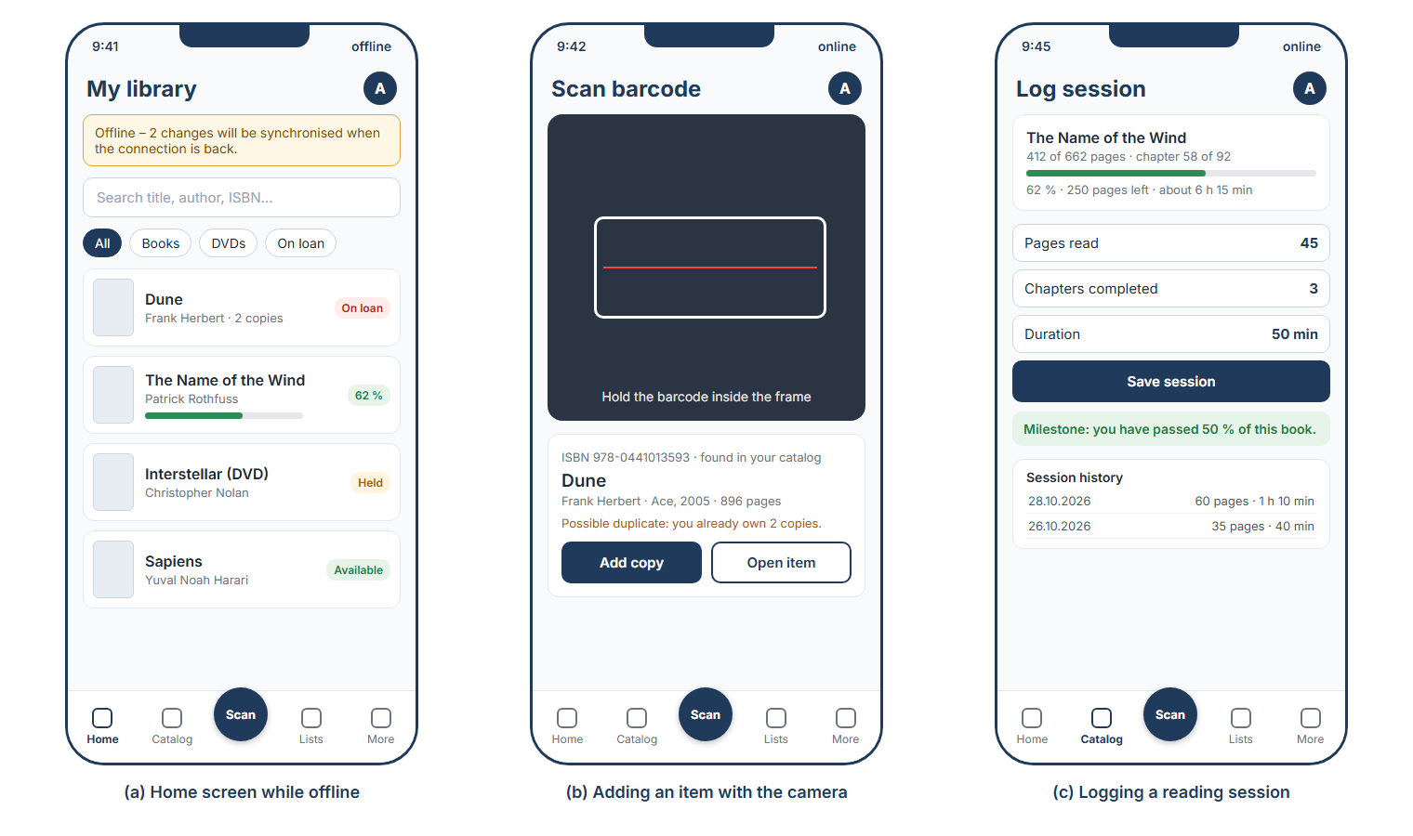
Figure 3.19: Mock-up – Mobile screens: home while offline, adding an item with the camera, logging a reading session
- Home (a): offline banner with the number of waiting changes (FR-79), search, filters and item cards with status and progress (FR-18, FR-19, FR-61).
- Scan (b): barcode scanning with the camera of the phone and duplicate warning (FR-13, FR-14).
- Log session (c): pages, chapters and duration of a session, estimated remaining time, milestone notification and session history (FR-59, FR-61, FR-75, FR-76).

Glossary of Terms
The glossary defines the domain terms used in the requirements, use cases and object model. Class names in the object model correspond to these terms.
Term | Definition
Active (patron) | Status of a patron who may borrow and reserve.
Available | Status of a copy that is on the shelf and may be lent.
Blocked | Status of a patron who has an overdue loan or unpaid fines above the blocking threshold; such a patron cannot borrow.
Blocking threshold | The amount of unpaid fines above which a patron is Blocked.
Book | A media item that is a printed book, identified by its ISBN.
Borrowing limit | The maximum number of active loans a patron may have at the same time.
Clock | The time actor that triggers the periodic check of loans and holds.
Condition | The physical state of a copy: New, Good, Worn or Damaged.
Copy | One physical exemplar of a media item, with its own shelf location, condition and status.
Custom list | A named, ordered list of media items created by the librarian, for example “To read”.
Device | A computer, tablet or phone on which a user is signed in to PLMS; it keeps a local copy of the library data.
Due date | The date by which a lent copy must be returned: loan date plus loan period (plus renewals).
DVD | A media item that is a film or series on an optical disc.
Fine | An amount charged to a patron for a late return (LateReturn) or for a lost copy (Replacement).
Grace period | The number of days after the due date during which no fine is charged.
Held | Status of a returned copy that is kept for the first patron in the reservation queue.
Hold period | The number of days a held copy is kept for a patron before the hold expires.
Librarian | The owner of the personal library and main user of the system; registers the account of the library.
Library policy | The set of rules of the library: loan period, renewals, borrowing limit, fine rules, blocking threshold, hold and reminder periods.
Loan | The lending of one copy to one patron, from the loan date to the return date; called “Transaction” in the problem statement.
Loan period | The number of days a copy may be kept by a patron.
Low-stock threshold | The minimum number of Available copies of a media item; below it a low-stock notification is issued.
Media item | A title in the catalog (a book or a DVD), independent of how many copies exist.
Milestone notification | A motivational notification issued when the progress of a media item passes 25 %, 50 % or 75 % or is completed.
Notification | A message shown to the librarian about a due, overdue, ready or expired item, about low stock, or a reading reminder or milestone.
Offline | The state of a device without an internet connection; changes are kept in the local queue until synchronisation.
OnLoan | Status of a copy that has been lent and not yet returned.
Online metadata | Descriptive information about a media item (synopsis, cover, rating, link) retrieved from Google Books or OMDb.
Overdue | A loan whose due date has passed while the copy has not been returned.
Patron | A person registered by the librarian who may borrow copies.
Patron self-service | Optional feature with which patrons log in and use some functions themselves.
Progress | The reading or viewing state of a media item: current position, status, rating and review.
Progress session | One recorded reading or viewing session with its date and the pages or minutes completed.
Progressive web application (PWA) | A web application that runs in a browser and can be installed on desktop and mobile devices like a native application.
Reading reminder | A notification that reminds the librarian of an item in progress for which no session has been recorded during the reading reminder interval.
Renewal | Extending the due date of an active loan by one loan period.
Reservation | A patron’s place in the first-come, first-served queue for a media item that has no Available copy.
Reservation queue | The ordered list of Waiting reservations of a media item.
Shelf location | The place in the house where a copy is kept, for example “A3”.
Synchronisation | The automatic exchange of changes between the devices of an account and the cloud database.
Visitor | A person without an account, who can register.

Priority
The functional requirements are prioritised with the MoSCoW scheme. Must-have requirements form the minimum product that fulfils the problem statement [2]; they will be implemented first. Should-have requirements are important and are planned for the same release. Could-have requirements will be implemented if time allows. Won't-have items are explicitly excluded from this release (see Section 1.2). Must-have requirements cover the inventory, lending, accounts, notifications, storage and synchronisation; most enrichment functions of the problem statement [2] (online metadata, lists, progress tracking) are Should-have, because the system stays usable without them, but they are planned for the same release.
Module | Must have | Should have | Could have
M1 Accounts and access | FR-1, FR-4, FR-5, FR-6, FR-7, FR-70, FR-72 | FR-2, FR-3, FR-71 | FR-8
M2 Catalog | FR-9, FR-10, FR-11, FR-12, FR-15, FR-16, FR-17, FR-18 | FR-13, FR-14, FR-19, FR-20 | —
M3 Online metadata | — | FR-21, FR-22, FR-23, FR-25, FR-26 | FR-24
M4 Lending and returning | FR-27, FR-28, FR-29, FR-30, FR-31, FR-35 | FR-32, FR-33, FR-34 | —
M5 Reservations | FR-36, FR-37, FR-38, FR-40 | FR-39 | —
M6 Fines | FR-41, FR-42, FR-44 | FR-43 | FR-45
M7 Inventory | FR-46, FR-47 | FR-48 | —
M8 Notifications | FR-49, FR-50, FR-51, FR-52, FR-53 | — | FR-54
M9 Custom lists | — | FR-55, FR-56, FR-57 | FR-58, FR-73
M10 Progress tracking | — | FR-59, FR-60, FR-61, FR-62, FR-63, FR-76 | FR-74, FR-75
M11 Reports, policy and data | FR-65, FR-66 | FR-64, FR-67, FR-68 | FR-69, FR-77
M12 Multi-device access and synchronisation | FR-78, FR-79, FR-80 | FR-81 | FR-82

In total there are 82 functional requirements: 40 Must have, 31 Should have and 11 Could have. The nonfunctional requirements apply to the whole system; NFR-7 and the Electron desktop package of NFR-24 have the priority Should, all others Must.
Won’t have in this release:
- Playing or reading digital media (e-book reader, video streaming)
- Real payment processing (card, online payment)
- Separate native applications for app stores (Swift, Kotlin); mobile devices use the PWA
- RFID gates and other special hardware
- Automatic purchase or price comparison for new copies

Traceability
The traceability tables link the needs in the client’s problem statement [2] to functional requirements and use cases (Table A), every use case to its functional requirements and analysis classes (Table B), and every functional requirement to the use cases and classes that realise it (Table C). Every use case is linked to at least one functional requirement, and every functional requirement to at least one use case.
Table A – Problem statement to requirements and use cases
Need | Problem statement item | Functional / nonfunctional requirements | Use cases
PS-1 | Manage an organised inventory of books and DVDs: CRUD operations, categorisation, tagging, searching and filtering | FR-9 – FR-12, FR-14 – FR-20 | UC-3, UC-5, UC-6
PS-2 | Add items by scanning barcodes or ISBNs for automatic lookup | FR-13, FR-21, FR-22, NFR-21 | UC-3, UC-4
PS-3 | Map local items to internet resources (e.g. Google Books, IMDb): metadata, summaries, reviews, links and corrections | FR-21 – FR-26, NFR-19, NFR-20 | UC-4, UC-6
PS-4 | Reading/viewing lists: create, modify and delete lists, add and remove items, sort and prioritise, lists based on recommendations | FR-55 – FR-58, FR-73 | UC-14
PS-5 | Progress tracking: pages, chapters and remaining time; minutes, scenes and percentage; session history with dates and durations; progress indicators, reminders and motivational notifications | FR-59 – FR-63, FR-74 – FR-76 | UC-15, UC-16
PS-6 | Track the status and condition of items (available, loaned out, damaged, lost) to avoid lost items | FR-12, FR-15, FR-27, FR-29 – FR-31, FR-34, FR-35 | UC-5, UC-7, UC-8
PS-7 | User accounts: registration, login and password management | FR-1 – FR-3, FR-70 – FR-72 | UC-1, UC-21, UC-22
PS-8 | Desktop and mobile platforms with an intuitive, responsive user interface | NFR-1 – NFR-3, NFR-24, NFR-30, NFR-31 | all use cases
PS-9 | Synchronisation of library data and progress across devices; robustness in offline scenarios | FR-66, FR-78 – FR-82, NFR-6 | UC-23, UC-24
PS-10 | Secure storage and transmission of personal information; privacy | NFR-26, NFR-27, NFR-32, NFR-33 | UC-1, UC-23
PS-11 | Relational database for media items, creators, internet links, user profiles, progress logs and lists | FR-66, NFR-15 | UC-19, UC-23
PS-12 | Asynchronous data fetching, API key management and error handling for service interruptions | FR-25, NFR-10, NFR-20 | UC-4
PS-13 | Discrepancies between local item data and external internet data | FR-23, FR-24 | UC-4
PS-14 | Import and export of data for migration and backup | FR-67 – FR-69, FR-77, NFR-7, NFR-22 | UC-19
EL | Additional needs from elicitation and team analysis: patrons, loan rules and renewals, reservations, fines, inventory and low stock, loan notifications, reports and library policy | FR-4 – FR-8, FR-28, FR-32, FR-33, FR-36 – FR-54, FR-64, FR-65 | UC-2, UC-7 – UC-13, UC-16 – UC-18, UC-20

Table B – Use cases to requirements and analysis classes
Use case | Functional requirements | Analysis classes
UC-1 Log In | FR-1, FR-2, FR-3, FR-8, FR-72 | Librarian, Patron, Loan, Reservation, Fine, Device
UC-2 Manage Patron Accounts | FR-4, FR-5, FR-6, FR-7 | Patron, Loan, Fine
UC-3 Add Media Item | FR-9, FR-10, FR-11, FR-12, FR-13, FR-14, FR-25 | MediaItem, Book, DVD, Copy
UC-4 Retrieve Online Metadata | FR-21, FR-22, FR-23, FR-24, FR-25 | OnlineMetadata, Book, DVD, MediaItem
UC-5 Update or Remove Media Item | FR-12, FR-15, FR-16, FR-17, FR-34 | Copy, MediaItem, CustomList, Loan, Reservation
UC-6 Search Catalog | FR-13, FR-18, FR-19, FR-20, FR-26 | Book, MediaItem, Copy, CustomList, Loan, Reservation, OnlineMetadata
UC-7 Lend Copy | FR-27, FR-28, FR-29, FR-35, FR-44, FR-47 | Loan, Copy, Patron, LibraryPolicy, Fine, MediaItem, Notification
UC-8 Return Copy | FR-30, FR-31, FR-34, FR-35, FR-38, FR-45, FR-52 | Loan, Copy, Reservation, Patron, LibraryPolicy, Fine, Notification
UC-9 Assess Fine | FR-41, FR-45 | Fine, Loan, LibraryPolicy, Copy
UC-10 Renew Loan | FR-32, FR-33, FR-35 | Loan, Reservation, LibraryPolicy, Copy, Patron
UC-11 Reserve Media Item | FR-36, FR-37, FR-38, FR-40 | Reservation, MediaItem, Patron, Copy, Loan, LibraryPolicy
UC-12 Manage Fines | FR-42, FR-43, FR-44 | Fine, Payment, Patron, Loan, LibraryPolicy
UC-13 Monitor Inventory | FR-46, FR-47, FR-48 | MediaItem, Copy, Notification, Loan
UC-14 Manage Custom Lists | FR-55, FR-56, FR-57, FR-58, FR-73 | CustomList, MediaItem
UC-15 Track Progress | FR-59, FR-60, FR-61, FR-62, FR-63, FR-75, FR-76 | Progress, ProgressSession, Book, DVD, Notification
UC-16 Monitor Loans and Holds | FR-39, FR-49, FR-50, FR-51, FR-52, FR-53, FR-54, FR-74 | Reservation, Copy, Loan, Notification, LibraryPolicy, Patron, Progress, ProgressSession
UC-17 View Reports | FR-64 | Loan, Fine, MediaItem, Patron, Progress
UC-18 Configure Library Policy | FR-65 | LibraryPolicy
UC-19 Back Up, Import and Export Data | FR-66, FR-67, FR-68, FR-69, FR-77 | Library, MediaItem, Copy, Patron, Loan
UC-20 View My Account | FR-8 | Patron, Loan, Reservation, Fine
UC-21 Register Account | FR-70 | Librarian, Library, LibraryPolicy
UC-22 Reset Password | FR-71 | User
UC-23 Synchronize Library Data | FR-66, FR-78, FR-79, FR-80, FR-81 | Library, Device, Progress, ProgressSession
UC-24 Manage Devices | FR-72, FR-82 | Device, User, Librarian

Table C – Functional requirements to use cases, classes and origin
Origin: PS-n = item of the problem statement (Table A); EL = need identified during elicitation and analysis.
FR | Module | Priority | Use cases | Analysis classes | Origin
FR-1 | M1 | Must | UC-1 | Librarian | PS-7
FR-2 | M1 | Should | UC-1 | Librarian | PS-7
FR-3 | M1 | Should | UC-1 | Librarian | PS-7
FR-4 | M1 | Must | UC-2 | Patron | EL
FR-5 | M1 | Must | UC-2 | Patron, Loan | EL
FR-6 | M1 | Must | UC-2 | Patron | EL
FR-7 | M1 | Must | UC-2 | Patron, Loan, Fine | EL
FR-8 | M1 | Could | UC-1, UC-20 | Patron, Loan, Reservation, Fine | EL
FR-9 | M2 | Must | UC-3 | MediaItem, Book, DVD | PS-1
FR-10 | M2 | Must | UC-3 | Book | PS-1
FR-11 | M2 | Must | UC-3 | DVD | PS-1
FR-12 | M2 | Must | UC-3, UC-5 | Copy, MediaItem | PS-1, PS-6
FR-13 | M2 | Should | UC-3, UC-6 | Book | PS-2
FR-14 | M2 | Should | UC-3 | MediaItem, Copy | PS-1
FR-15 | M2 | Must | UC-5 | MediaItem, Copy | PS-1, PS-6
FR-16 | M2 | Must | UC-5 | MediaItem, Copy, CustomList | PS-1
FR-17 | M2 | Must | UC-5 | MediaItem, Copy, Loan, Reservation | PS-1
FR-18 | M2 | Must | UC-6 | MediaItem | PS-1
FR-19 | M2 | Should | UC-6 | MediaItem, Copy, CustomList | PS-1
FR-20 | M2 | Should | UC-6 | MediaItem, Copy, Loan, Reservation | PS-1
FR-21 | M3 | Should | UC-4 | OnlineMetadata, Book | PS-2, PS-3
FR-22 | M3 | Should | UC-4 | OnlineMetadata, DVD | PS-2, PS-3
FR-23 | M3 | Should | UC-4 | OnlineMetadata, MediaItem | PS-3, PS-13
FR-24 | M3 | Could | UC-4 | OnlineMetadata, MediaItem | PS-3, PS-13
FR-25 | M3 | Should | UC-4, UC-3 | MediaItem | PS-3, PS-12
FR-26 | M3 | Should | UC-6 | OnlineMetadata | PS-3
FR-27 | M4 | Must | UC-7 | Loan, Copy, Patron, LibraryPolicy | PS-6
FR-28 | M4 | Must | UC-7 | Patron, Copy, LibraryPolicy | EL
FR-29 | M4 | Must | UC-7 | Copy, Loan | PS-6
FR-30 | M4 | Must | UC-8 | Loan, Copy | PS-6
FR-31 | M4 | Must | UC-8 | Copy, Reservation | PS-6
FR-32 | M4 | Should | UC-10 | Loan, Reservation, LibraryPolicy | EL
FR-33 | M4 | Should | UC-10 | Loan, Reservation | EL
FR-34 | M4 | Should | UC-5, UC-8 | Copy | PS-6
FR-35 | M4 | Must | UC-7, UC-8, UC-10 | Loan, Copy, Patron | PS-6
FR-36 | M5 | Must | UC-11 | Reservation, MediaItem, Patron | EL
FR-37 | M5 | Must | UC-11 | Reservation, Copy, Loan | EL
FR-38 | M5 | Must | UC-8, UC-11 | Reservation, Copy, LibraryPolicy | EL
FR-39 | M5 | Should | UC-16 | Reservation, Copy | EL
FR-40 | M5 | Must | UC-11 | Reservation | EL
FR-41 | M6 | Must | UC-9 | Fine, Loan, LibraryPolicy | EL
FR-42 | M6 | Must | UC-12 | Fine, Payment | EL
FR-43 | M6 | Should | UC-12 | Fine | EL
FR-44 | M6 | Must | UC-7, UC-12 | Patron, Fine, Loan, LibraryPolicy | EL
FR-45 | M6 | Could | UC-8, UC-9 | Fine, Loan, Copy | EL
FR-46 | M7 | Must | UC-13 | MediaItem, Copy | EL
FR-47 | M7 | Must | UC-7, UC-13 | MediaItem, Copy, Notification | EL
FR-48 | M7 | Should | UC-13 | MediaItem, Copy, Loan | EL
FR-49 | M8 | Must | UC-16 | Loan, Reservation | EL
FR-50 | M8 | Must | UC-16 | Loan, Notification, LibraryPolicy | EL
FR-51 | M8 | Must | UC-16 | Loan, Notification | EL
FR-52 | M8 | Must | UC-8, UC-16 | Reservation, Notification | EL
FR-53 | M8 | Must | UC-16 | Notification | EL
FR-54 | M8 | Could | UC-16 | Notification, Patron | EL
FR-55 | M9 | Should | UC-14 | CustomList | PS-4
FR-56 | M9 | Should | UC-14 | CustomList, MediaItem | PS-4
FR-57 | M9 | Should | UC-14 | CustomList, MediaItem | PS-4
FR-58 | M9 | Could | UC-14 | CustomList | PS-4
FR-59 | M10 | Should | UC-15 | Progress, ProgressSession, Book | PS-5
FR-60 | M10 | Should | UC-15 | Progress, ProgressSession, DVD | PS-5
FR-61 | M10 | Should | UC-15 | Progress | PS-5
FR-62 | M10 | Should | UC-15 | Progress | PS-5
FR-63 | M10 | Should | UC-15 | Progress | PS-5
FR-64 | M11 | Should | UC-17 | Loan, Fine, MediaItem, Patron, Progress | EL
FR-65 | M11 | Must | UC-18 | LibraryPolicy | EL
FR-66 | M11 | Must | UC-19, UC-23 | Library, Device | PS-9, PS-11
FR-67 | M11 | Should | UC-19 | Library | PS-14
FR-68 | M11 | Should | UC-19 | Library | PS-14
FR-69 | M11 | Could | UC-19 | MediaItem, Copy, Patron, Loan | PS-14
FR-70 | M1 | Must | UC-21 | Librarian, Library | PS-7
FR-71 | M1 | Should | UC-22 | User | PS-7
FR-72 | M1 | Must | UC-1, UC-24 | User, Device | PS-7
FR-73 | M9 | Could | UC-14 | CustomList, MediaItem | PS-4
FR-74 | M10 | Could | UC-16 | Progress, ProgressSession, Notification, LibraryPolicy | PS-5
FR-75 | M10 | Could | UC-15 | Progress, Notification | PS-5
FR-76 | M10 | Should | UC-15 | ProgressSession | PS-5
FR-77 | M11 | Could | UC-19 | MediaItem, Copy | PS-14
FR-78 | M12 | Must | UC-23 | Library, Device | PS-9
FR-79 | M12 | Must | UC-23 | Device | PS-9
FR-80 | M12 | Must | UC-23 | Device, Library | PS-9
FR-81 | M12 | Should | UC-23 | Library | PS-9
FR-82 | M12 | Could | UC-24 | Device, User | PS-9

