# Results

In this chapter we present the results to answer the initially formulated research questions and to verify the hypotheses. First, we discuss our findings of how the overall rating is calculated for restaurants on Tripadvisor and Google. The subsequent sections are devoted to the correlation analyses – the primary goal of our thesis – where we utilize different tools, e.g., line and scatter plots; the correlation coefficients, Pearson and Spearman; and time series decomposition.

## Analysis of the overall rating

The notion behind this analysis is that nowadays, popular online review platforms provide an enormous amount of information. We assume that the first thing a person might do to learn about a restaurant on such platforms, is to look at the overall rating, often displayed at the beginning of the website. We believe that a good overall rating can increase the popularity of a restaurant, which in turn can have a positive effect on restaurant revenue. Furthermore, we hypothesize that the reckoning of the overall rating varies from platform to platform, since each platform is built differently.

### Tripadvisor overall rating

Tripadvisor states that the overall bubble rating takes into account the quality, quantity and age of individual tourists’ ratings and reviews. The “bubble” rating ranges from one to five – one meaning “terrible” and five meaning “excellent”. The overall rating can be broken down by distribution of ratings; type of travel, such as business or family; or aspects of the business, such as service or cleanliness. **(Source: https://www.tripadvisorsupport.com/en-GB/hc/traveler/articles/438)**

Since the formula, Tripadvisor use to calculate the overall rating, is not publicly accessible, an alternative solution approach had to be devised. Initially, the plan was to employ multiple linear regression. We therefore scraped additional restaurant review information **(see Section XY)**, we thought, were necessary to build and train a model to predict the overall rating. Before deciding for this approach, we had also considered – contrary to Tripadvisor's statement – whether the overall rating might just be the average of the individual costumer ratings.

Thus, we scraped the review data from 1720 restaurants in canton Zurich. We then computed the average rating for each restaurant and compared it with the overall rating. The below scatterplot in **figure XY** depicts that the computed and rounded average of the individual costumer ratings is equivalent to the overall rating. For all the 1720 restaurants, the data points lie on a straight line. The scatterplot above in **figure XY** showcases the link between the overall rating and the computed overall rating. Notice, that despite all the data points being scattered in a horizontal direction, they remain within the bounds specified by the vertical dashed red lines.

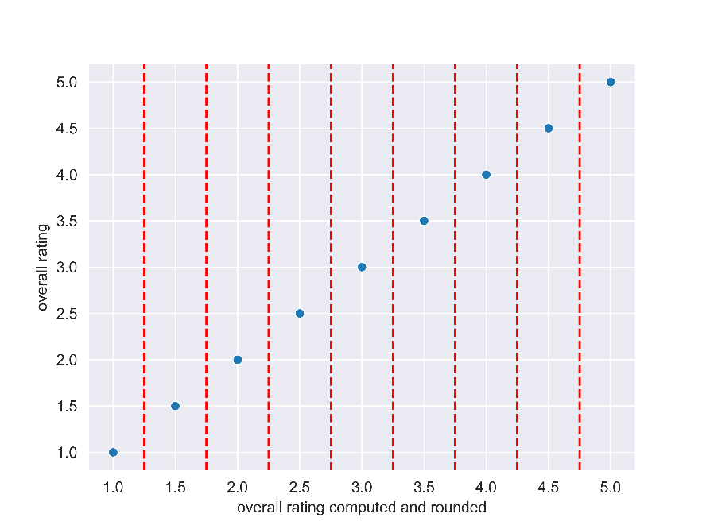  
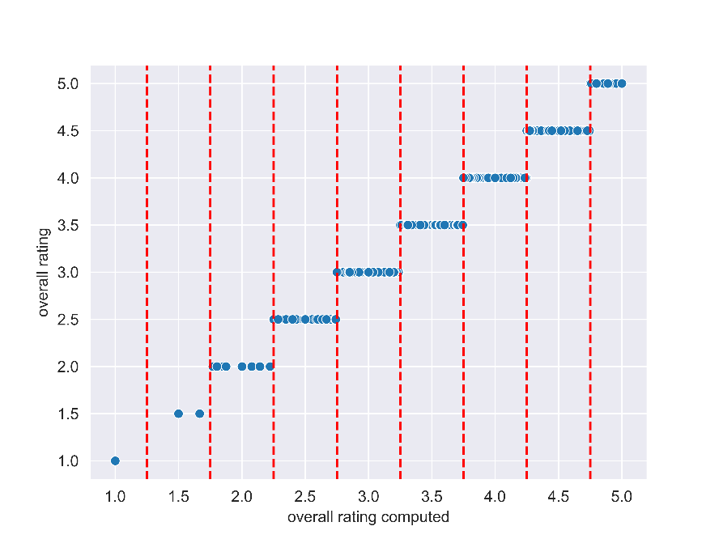

### Google overall rating

The restaurant overall rating on Google is calculated from user ratings and a variety of other factors. **(Source:** [**https://support.google.com/business/answer/4801187?hl=en-GB**](https://support.google.com/business/answer/4801187?hl=en-GB)**)** Nevertheless, we tried the same approach as previously described, with the only difference, we did not use a large dataset, but rather the review data of the 15 restaurants, where we had the revenue data, because the scraping of a large Google review dataset is sophisticated. In addition, we did not have time to investigate this further. The scatterplots in **figure XY** demonstrate that for the 15 restaurants, the computed and rounded average of the individual user ratings is equivalent to the overall rating.

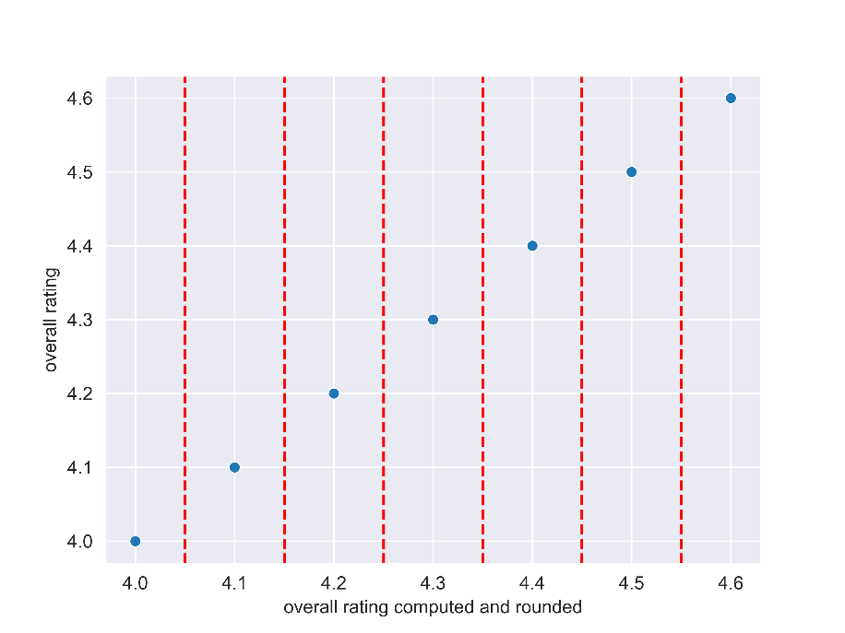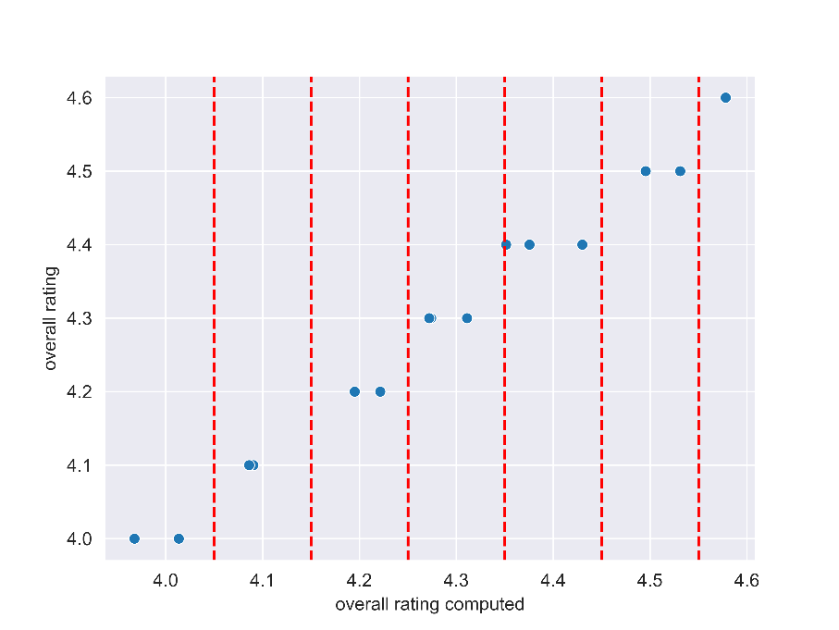

## Correlation between Tripadvisor and Google restaurant rating (Fatih)

### Average restaurant rating Tripadvisor against Google

### Overall restaurant rating development Tripadvisor against Google

## Correlation between Google restaurant rating and Prognolite turnover data (Fatih)

### Average restaurant rating against average turnover

### Overall restaurant rating development against average turnover

## Correlation between Tripadvisor restaurant rating and Prognolite turnover data (Fatih)

### Average restaurant rating against average turnover

### Overall restaurant rating development against average turnover