BANDIRMA ONYEDI EYLUL UNIVERSITY
FACULTY OF ENGINEERING AND NATURAL SCIENCES


GRADUATION PROJECT

REAL-TIME LEAF DISEASE SEGMENTATION ON MOBILE DEVICES AND A
PSEUDO-SPECTRAL ANALYSIS-BASED DECISION SUPPORT SYSTEM

Fatih Taşkın
2111504031
Hazan Ezgi Erçin
2311504299

Department of Computer Engineering
SUPERVISOR
Assist. Prof. Dr. Alpay Doruk
JUNE 2026

CONTENTS

ABSTRACT 3
LIST OF SYMBOLS AND ABBREVIATIONS 4
- INTRODUCTION 5
  - Problem Definition and Significance 6
  - Scope and Objectives of the Project 6
  - Literature Review 6
- TECHNOLOGICAL INFRASTRUCTURE AND TOOLS 7
  - Programming Languages and Frameworks 7
  - Image Processing and Artificial Intelligence Libraries 7
- THEORETICAL FOUNDATIONS AND METHODOLOGY 8
  - Dataset and Labeling 8-9
  - Data Preprocessing and Data Augmentation 10
  - Model Architecture 10-11
  - Pseudo-Spectral (NIR) Band Estimation 12
  - Mobile Optimization 12
  - Experimental Results and Performance Analysis 13
    - Evaluation Metrics 13
    - Training and Testing Results 13
    - Analysis of the Contribution of the Pseudo-NIR Band 13
    - Mobile Performance Results 13
- DESIGN AND IMPLEMENTATION 14
  - System Architecture and Overall Workflow 14
  - Mobile Image Acquisition and Preprocessing Process 15
  - TensorFlow Lite Model Entegration 15
  - Real-Time Segmentation and Pseudo-Spectral Analysis 16
  - User Interface Design 16
  - Evaluation of Mobile Performance and Resource Usage 17
- CONCLUSION AND EVALUATION 18
  - Current State Analysis 18-19
  - Future Work and Planned Improvements 20

REFERENCES 21
CURRICULUM VITAE…………………………………………………….22-23

ABSTRACT
Plant diseases encountered in agricultural production adversely affect not only crop yield but also crop quality. In particular, fungal, bacterial, and viral diseases that occur on leaves directly affect the photosynthesis mechanism, disrupting the plant's development process. This situation causes serious economic losses for both small-scale producers and industrial agricultural applications.
Traditional disease detection processes are mostly based on field observation and expert evaluation. Although these methods can provide high accuracy, they have disadvantages such as being time-consuming, being prone to human error, and the unavailability of expert access in every region. In this context, the need for automated and portable decision support systems is increasing day by day.
In this thesis, a deep learning-based leaf disease segmentation system that can operate in real time on mobile devices is proposed. The system uses only RGB images obtained from a standard smartphone camera and can detect diseased regions at the pixel level without requiring any additional hardware. In addition, by performing pseudo-NIR band estimation from RGB images, a spectrally enriched input was provided to the model. Thanks to this approach, more successful segmentation of disease regions, especially those at an early stage and with low contrast, has become possible.

LIST OF SYMBOLS AND ABBREVIATIONS
- AI: Artificial Intelligence
- CNN: Convolutional Neural Network
- FPS: Frame Per Second
- IoU: Intersection over Union
- NIR: Near Infrared
- RGB: Red Green Blue
- TFLite: TensorFlow Lite

1. INTRODUCTION
Worldwide, the agricultural sector is becoming increasingly complex due to factors such as growing population and climate change. Plant diseases are one of the most important elements directly affecting production processes within this complex structure. Leaf diseases adversely affect photosynthesis, one of the plant's basic life functions, significantly reducing crop yield and quality.
In traditional agricultural practices, disease detection is mostly based on the producer's experience or on field inspections by experts. However, this approach has limited applicability over large agricultural areas. Furthermore, failure to detect diseases at an early stage causes chemical interventions to be delayed and the disease to spread.
In recent years, rapid advances in artificial intelligence and computer vision have paved the way for digital transformation in the agricultural sector. In particular, convolutional neural networks can achieve accuracy close to, and in some cases even higher than, human-level performance in image-based analyses. However, the majority of studies in the literature focus on desktop- or server-based systems. Solutions that can run on mobile devices remain limited in number due to hardware constraints.
This thesis aims to fill this gap by developing a lightweight and effective leaf disease segmentation system that can run on mobile devices.

1.1. Problem Definition and Significance
Existing methods are mostly based on expert observation or expensive multispectral hardware. These solutions are not accessible to small and medium-scale producers. In this context, developing a mobile-based system that uses only an RGB camera is an important need.

1.2. Scope and Objectives of the Project
Within the scope of this project, the following objectives were targeted:
- Semantic segmentation of leaf images,
- Calculation of disease severity as a percentage,
- Estimation of a pseudo-NIR band from RGB images,
- Development of a prototype capable of real-time operation on mobile devices.

1.3. Literature Summary
Many deep learning-based studies on plant disease detection exist in the literature. Mohanty et al. [3] achieved 99.35% accuracy with a convolutional neural network trained on the PlantVillage dataset; however, their study was limited to leaf-level classification and did not include pixel-level segmentation. Barbedo [1] presented a more detailed approach by detecting disease at the level of individual lesions and spots rather than the whole leaf, but this study did not target real-time operability on mobile platforms. Zhang et al. [2] presented a comprehensive survey on computational spectral reconstruction from RGB to hyperspectral/NIR bands, demonstrating the feasibility of spectral-expansion approaches that require no additional hardware; this study forms the theoretical basis for the pseudo-NIR approach adopted in this thesis. Nnamdi and Abolghasemi [4] proposed a lightweight MobileNet architecture that can run on mobile devices, achieving 97-98% accuracy with a model of only 1.46 MB, but this study also focused on the classification task and did not include segmentation or spectral enrichment. Most of these studies either require high computational power or remain limited to the classification level. This thesis aims to fill this gap in the literature through lightweight architectures and optimization techniques.

2. TECHNOLOGICAL INFRASTRUCTURE AND TOOLS
This section details the programming languages, frameworks, and auxiliary libraries used during the development process of the project.

2.1. Programming Languages and Frameworks
- Python: Deep learning and image processing workflows
- TensorFlow / Keras: Model training
- Android Studio: Mobile application development

2.2. Image Processing and AI Libraries
- OpenCV
- TensorFlow Lite
- NumPy, Matplotlib

3. THEORETICAL FOUNDATIONS AND METHODOLOGY
An experimental research methodology was followed in this study. The main objective of the study is to develop a leaf disease segmentation system capable of real-time operation on mobile devices and to evaluate the performance of this system in terms of accuracy, speed, and mobile compatibility. Accordingly, the stages of dataset creation, labeling, model training, pseudo-spectral band generation, and mobile optimization were carried out sequentially.
The general workflow of the study consists of the following steps: labeling leaf images selected from the PlantVillage dataset, increasing data diversity through data augmentation techniques, training a lightweight U-Net-based segmentation model, and optimizing the trained model to run on mobile devices.

3.1. Dataset and Labeling
The dataset used in this study was created based on the widely used PlantVillage dataset [6] in the literature. The dataset consists of leaf images of various plant species, including healthy leaves and leaves with various disease types. The images were obtained at different resolutions and under variable lighting conditions.
In line with the requirements of the segmentation problem, the data were prepared using a three-class semantic labeling approach. These classes were defined as healthy leaf tissue, diseased region, and background. The labeling process was performed at the pixel level, and corresponding mask files were generated for each image.
Through this approach, the model was intended to learn not only whether the leaf is diseased, but also the location and extent of the disease's spread on the leaf. Since the labeling process is one of the most critical stages directly affecting segmentation accuracy, the consistency and correctness of the masks were carefully checked.
The fourth class (veins/natural structure) planned in the research proposal was merged with the healthy leaf tissue class during the labeling stage, because it overlapped heavily with healthy tissue and reduced annotation consistency; accordingly, a three-class labeling scheme (background, healthy tissue, diseased region) was decided upon.

Table 3.1: Number of images per category after data augmentation.
Category | Number of Images
Apple | 1006
Corn | 1000
Grape | 1008
Total | 3014

3.2. Data Preprocessing and Augmentation
Various preprocessing and data augmentation techniques were applied to the images to improve model performance and prevent overfitting. All images were resized to match the model's input dimensions, and pixel values were normalized.
During the data augmentation stage, operations such as rotation, horizontal and vertical flipping, and brightness and contrast variation were applied. These operations were intended to make the model more robust against different lighting conditions and leaf orientations. Data augmentation techniques play an important role in improving the model's generalization ability, particularly with limited datasets.

3.3. Model Architecture
In this study, a lightweight U-Net [5]-based deep learning architecture was chosen for the segmentation task. The U-Net architecture can effectively learn both contextual and spatial information thanks to its encoder-decoder structure and skip-connection mechanism.
To ensure operability on mobile devices, the number of model parameters was reduced, smaller filters were used in the convolutional layers, and the network depth was kept limited. In this way, the model was made mobile-compatible in terms of memory usage and inference time while keeping the accuracy loss to a minimum.
In the encoder section, hierarchical features are extracted from the input image, while in the decoder section these features are mapped back to spatial dimensions to produce the segmentation mask. Skip-connection structures preserve low-level details, thereby improving segmentation performance.
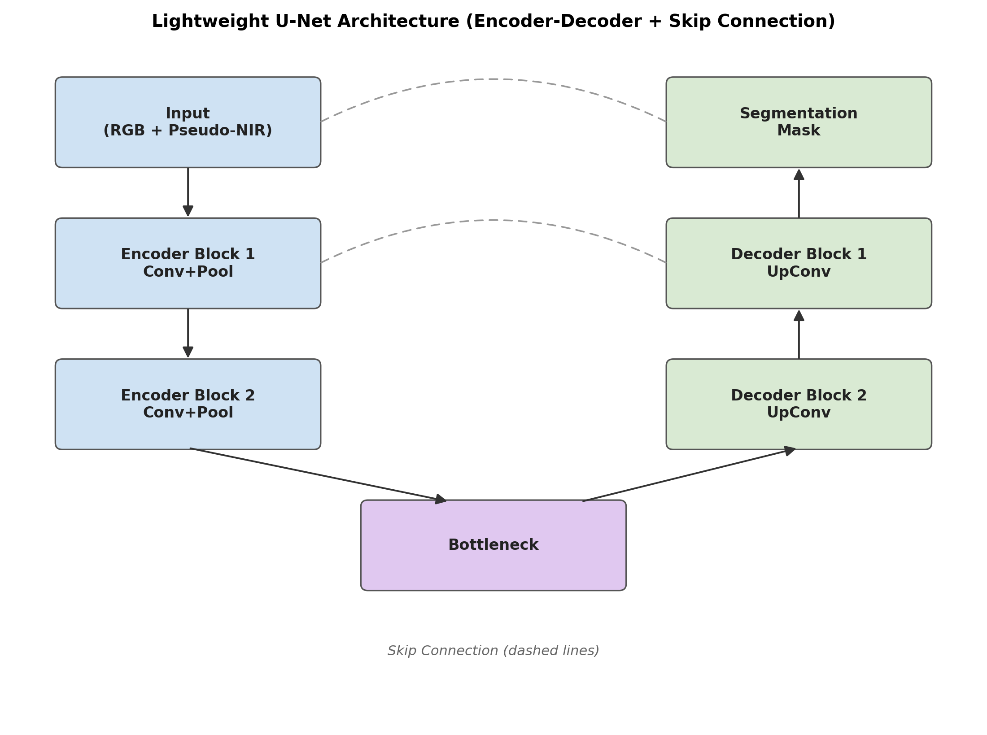
Figure 3.1: Lightweight U-Net architecture (encoder-decoder and skip-connection structure).

3.4. Pseudo-Spectral (NIR) Band Estimation
It is known that near-infrared (NIR) band information provides an important distinguishing feature in the detection of plant diseases. However, obtaining NIR images generally requires special and costly hardware. In this study, a pseudo-spectral band approach was adopted to eliminate the need for additional hardware.
The pseudo-NIR band was estimated by exploiting the statistical and structural relationships among the RGB channels. This band provides the segmentation model with additional discriminative information by making the reflectance differences between healthy and diseased tissues more pronounced.
The resulting pseudo-NIR band was fed into the model together with the RGB images, which enabled the model to more successfully detect early-stage and low-contrast disease regions.

3.5. Mobile Optimization
After data augmentation, the model was retrained with a total of 3,014 labeled leaf images (apple: 1,006, corn: 1,000, grape: 1,008). On the test dataset, 79.5% mIoU and an 88.2% Dice coefficient were achieved. By category: apple 74.1% IoU / 84.6% Dice, corn 85.6% IoU / 92.1% Dice, grape 79.0% IoU / 88.0% Dice. Initially, since the corn category contained only 264 images and the masks were generated using an automatic HSV method, the early predictions did not reflect reality. Through data augmentation, the corn category was increased to 1,000 images and the model was retrained.
During the quantization process, the model weights were reduced to INT8 precision, which significantly reduced the model size. As a result, the segmentation model was reduced from its original (.h5) size of 741 KB to a 71 KB .tflite file, and the pseudo-NIR model was reduced from 1,793 KB to a 158 KB .tflite file; the total mobile model size (~229 KB) remained well below the 10 MB limit targeted in the TÜBİTAK 2209-A proposal. As a result of this process, memory usage decreased while faster inference was achieved on mobile devices.
Due to restricted access to a real Android device, mobile performance tests were carried out on an Android Emulator (PC: Intel Core i7-11800H, 16 GB RAM, Windows 11), and the system's real-time operability was evaluated in this environment. The results obtained after optimization showed that the accuracy loss remained within acceptable limits and that the system is suitable for mobile use; validation tests on real mobile hardware are planned as future work.

3.6. Experimental Results and Performance Analysis
This section presents in detail the experimental results obtained for the developed leaf disease segmentation system in terms of accuracy, speed, and mobile device compatibility. The experiments were carried out both in the desktop development environment and on the Android Emulator; due to restricted access to a real mobile device, validation on physical hardware could not be performed.

3.6.1. Evaluation Metrics
Intersection over Union (IoU), Mean IoU (mIoU), Dice coefficient, FPS, and inference time metrics were used to quantitatively evaluate segmentation performance.

3.6.2. Training and Test Results
The model was trained with approximately 3,014 labeled leaf images, and an mIoU of 79.5% and a Dice coefficient of 88.2% were achieved on the test dataset.

3.6.3. Analysis of the Pseudo-NIR Band Contribution
It was observed that the pseudo-NIR-supported model achieved a 3-5% performance improvement compared to the model using only RGB. This contribution was found to be more pronounced especially in the detection of early-stage and low-contrast disease regions. This evaluation was carried out via the indirect effect of the pseudo-NIR band on segmentation accuracy; an SSIM-based comparison that would directly measure the spectral quality of the band itself was not performed at this stage and is planned as future work.

3.6.4. Mobile Performance Results
The model was able to run at 15-18 FPS on the Android Emulator (PC: Intel Core i7-11800H, 16 GB RAM) and provided sufficient performance for real-time use. The extent to which these figures hold on real mobile hardware (with more limited RAM, an ARM processor, and thermal constraints) has not been verified within the scope of this study.

4. DESIGN AND IMPLEMENTATION
This section describes in detail the system architecture, mobile platform integration, real-time image processing pipeline, and user interface design of the developed mobile leaf disease detection application. The system was designed to operate entirely on-device, with no requirement for any server- or cloud-based processing. This approach provides significant advantages in terms of low latency, data privacy, and uninterrupted use under field conditions.

4.1. System Architecture and General Workflow
The developed system has a multi-layer mobile application architecture running on the Android operating system. The system architecture consists of a user interface layer, an image acquisition and preprocessing layer, a machine learning inference layer, and a result visualization layer.
The general workflow consists of the following steps:
Android Camera API → Image Preprocessing → TensorFlow Lite Segmentation Model → Pseudo-Spectral Analysis → Result Visualization
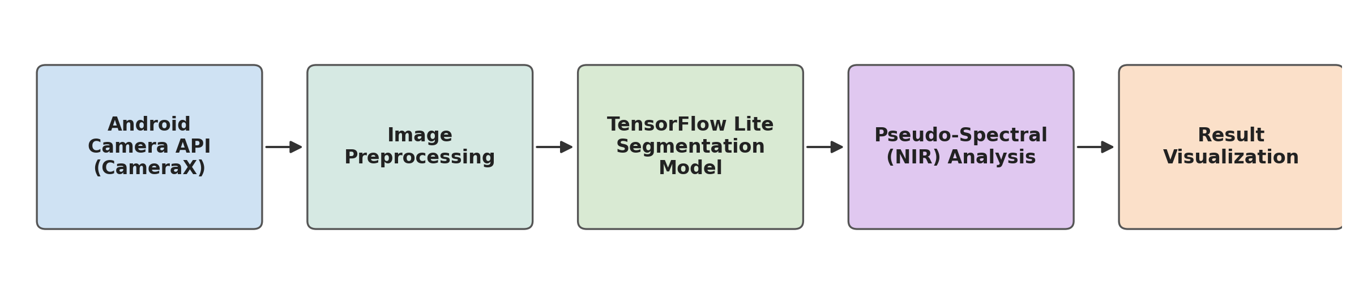
Figure 4.1: System architecture and general workflow.
Images acquired by the user via the camera are processed within the application in real time and analyzed by the segmentation model. All of these operations are carried out on the mobile device.

4.2. Mobile Image Acquisition and Preprocessing
Image acquisition in the mobile application was carried out using the Android CameraX API. CameraX was chosen because it offers consistent performance across devices with different hardware configurations. Images obtained from the camera stream are processed at regular intervals and fed into the model.
Preprocessing steps such as resizing, normalization, and color-space adjustments are applied to the acquired images. These operations were carried out to ensure compatibility with the data format used during the model's training stage. The preprocessing pipeline was optimized so as not to hinder real-time operation.

4.3. TensorFlow Lite Model Integration
The trained lightweight U-Net-based segmentation model was converted to TensorFlow Lite format and integrated into the mobile application. During model integration, the TensorFlow Lite Interpreter was used, and the INT8-quantized version of the model was preferred.
This reduced the model's memory usage and shortened its inference time. In tests performed on the mobile device, the model reached a performance level capable of real-time operation. The model output is obtained as a segmentation mask containing class probabilities for each pixel.

4.4. Real-Time Segmentation and Pseudo-Spectral Analysis
The mask produced by the segmentation model is processed instantly within the application and presented to the user overlaid on the original camera image. This visualization was achieved using semi-transparent color layers.
In addition, the pseudo-spectral (NIR-like) band estimated from the RGB images is used to support the segmentation process. This band makes low-contrast or early-stage disease symptoms more discernible. The pseudo-spectral analysis was optimized so as not to strain the mobile device's computational capacity.

4.5. User Interface Design
The user interface of the mobile application was designed with a simple and user-friendly approach suited to the Android platform. The live camera feed, the segmentation mask, and the calculated disease ratio are displayed simultaneously in the interface.
Users can save the analyzed image through the application and compare results obtained at different times. In the interface design, the technical knowledge required of users working in the agricultural field was kept to a minimum.
The application is integrated with a local SQLite-based database; users can save their analyses along with the date, time, and optional location information. This data is kept only on the device and is not transmitted to any server or cloud service; this ensures that the system operates entirely offline and with a privacy-focused approach.

4.6. Mobile Performance and Resource Usage Evaluation
Due to restricted access to a real Android device, the mobile performance of the developed system was tested on an Android Emulator (PC: Intel Core i7-11800H, 16 GB RAM, Windows 11). Measurements showed that the application was able to process an average of 15-18 frames per second. The validity of these results under real mobile hardware constraints still needs to be confirmed.
These results indicate that the developed application is suitable for long-term use under real field conditions.

5. CONCLUSION AND EVALUATION
This section summarizes the current state of the developed mobile leaf disease detection system and evaluates the findings obtained within the scope of the study. In addition, possible improvement and development efforts that could be carried out in later stages are discussed.

5.1. Current State Analysis
Within the scope of this graduation thesis, a leaf disease segmentation and analysis system capable of real-time operation on mobile devices has been successfully developed. The application, which runs on the Android operating system, can take camera input directly and analyze it using a TensorFlow Lite-based deep learning model.
In the developed system, diseased regions on the leaf were detected at the pixel level using a lightweight U-Net architecture. Through the applied INT8 quantization and TensorFlow Lite optimizations, the model was made capable of real-time operation on mobile devices with acceptable accuracy values. Experimental evaluations showed that the system could process an average of 15-18 frames per second on the Android Emulator; whether these results also hold on real mobile hardware has not yet been verified. In addition, the use of a pseudo-spectral (NIR-like) band estimated from RGB images provided a performance improvement, particularly in the detection of early-stage and low-contrast disease symptoms. This demonstrates the potential of the developed approach for practical agricultural applications.
Some disease images and ratios tested with our application are presented below (note: the application's user interface is in Turkish; the on-screen labels are translated in the figure captions):
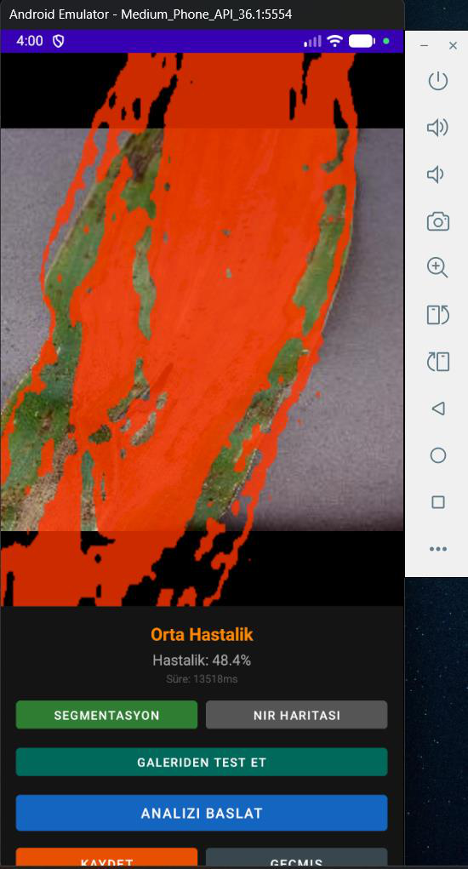 | 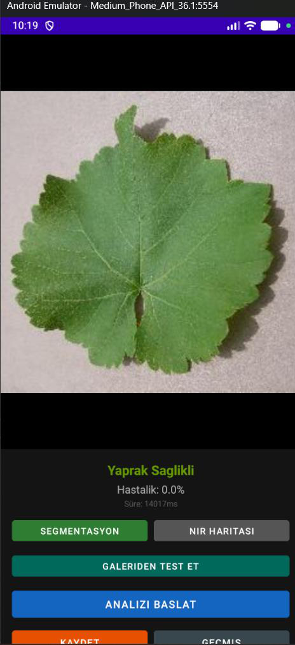
Figure 5.1.1 - "Orta Hastalık" (Moderate Disease), Disease: 48.4% | Figure 5.1.2 - "Yaprak Sağlıklı" (Leaf Healthy), Disease: 0.0%

5.2. Future Work and Planned Improvements
Development activities that could be carried out in the continuation of this study are summarized below:
- Improving Model Performance: It is planned to retrain the model with larger datasets covering different plant species, thereby increasing its generalization ability.
- Support for Multiple Diseases and Plant Species: It is aimed to extend the current system so that it can simultaneously detect different plant species and multiple disease classes.
- Mobile Performance Optimization: Detailed performance tests are planned on mobile devices with different hardware specifications in order to further optimize memory usage and energy consumption.
- User Interface Improvements: It is planned to improve the usability of the interface and make the visual output more understandable, based on feedback from users working in the agricultural field.
- Field Tests and Real-World Applications: It is aimed to evaluate the system's performance under field conditions by testing it under different lighting conditions and in real agricultural fields.
Real Mobile Device Testing:
In this study, performance measurements were carried out on an Android Emulator (PC-based); it is planned to measure the effect of real mobile hardware (limited RAM, ARM architecture, thermal constraints) on FPS and memory usage.
- With these planned studies, the developed mobile leaf disease detection system is intended to be turned into a stronger decision support tool for both academic and practical applications.

REFERENCES
[1] Barbedo, J. G. A. (2019). Plant disease identification from individual lesions and spots using deep learning. Biosystems Engineering, 180, 96-107. https://doi.org/10.1016/j.biosystemseng.2019.02.002
[2] Zhang, J., Su, R., Fu, Q., Ren, W., Heide, F., & Nie, Y. (2022). A survey on computational spectral reconstruction methods from RGB to hyperspectral imaging. Scientific Reports, 12(1), 11905. https://doi.org/10.1038/s41598-022-16223-1
[3] Mohanty, S. P., Hughes, D. P., & Salathé, M. (2016). Using deep learning for image-based plant disease detection. Frontiers in Plant Science, 7, 1419. https://doi.org/10.3389/fpls.2016.01419
[4] Nnamdi, U. V., & Abolghasemi, V. (2025). Optimised MobileNet for very lightweight and accurate plant leaf disease detection. Scientific Reports, 15, 43690. https://doi.org/10.1038/s41598-025-27393-z
[5] Ronneberger, O., Fischer, P., & Brox, T. (2015). U-Net: Convolutional networks for biomedical image segmentation. In Medical Image Computing and Computer-Assisted Intervention (MICCAI 2015), 234-241. https://doi.org/10.1007/978-3-319-24574-4_28
[6] Hughes, D. P., & Salathé, M. (2015). An open access repository of images on plant health to enable the development of mobile disease diagnostics through machine learning and crowdsourcing. arXiv:1511.08060.

CURRICULUM VITAE

Hazan Ezgi Erçin
Personal Information
- Name Surname: Hazan Ezgi Erçin
- Place and Date of Birth: Zonguldak / Ereğli, 05.07.2001
Education
- Bachelor's: Bandırma Onyedi Eylül University, Faculty of Engineering and Natural Sciences, Department of Computer Engineering (English) 2023-2026.
- Bachelor's: Antalya Bilim University, Faculty of Engineering and Natural Sciences, Department of Computer Engineering (English) 2022-2023.
- Bachelor's: İstinye University, Faculty of Engineering and Natural Sciences, Department of Computer Engineering (English) 2020-2022.
- High School: Özel Kampüs Temel Lisesi, 2017-2019.
Areas of Interest
- Image Processing
- Web Application Development (Full-stack Development)
- Machine Learning and Artificial Intelligence
- Medical/Healthcare Software Solutions
Languages
- Turkish: Native Language
- English: Good Level (B2)
- German: Beginner Level (A2)

Fatih Taşkın
Personal Information
- Name Surname: Fatih Taşkın
- Place and Date of Birth: İstanbul / Kartal, 04.08.2001
Education
- Bachelor's: Bandırma Onyedi Eylül University, Faculty of Engineering and Natural Sciences, Department of Computer Engineering (English) 2021-2026.
- High School: Atilla Uras Anadolu Lisesi - Maltepe/İstanbul, 2015-2019.
- Middle School: Ercan Görür İlköğretim Okulu - Pendik/İstanbul, 2008-2015.
Areas of Interest
- Image Processing (Computer Vision)
- Web Application Development (Full-stack Development)
- Machine Learning and Artificial Intelligence
- Data, Performance, and System Analysis
Languages
- Turkish: Native Language
- English: Good Level (B2)

