Fatih ÜNAL 1250885
Faruk ÖNEN 1298074

HOMEWORK REPORT
PART A :

Original Image: Original Image:

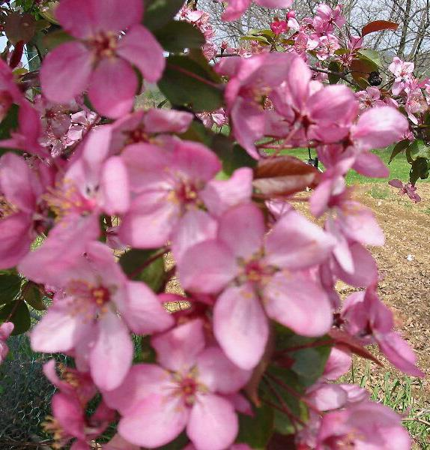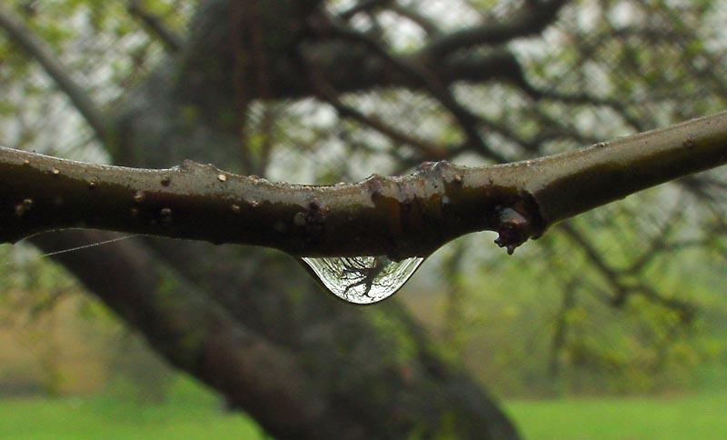

After applying sharpen( ) function: After applying sharpen( ) function:

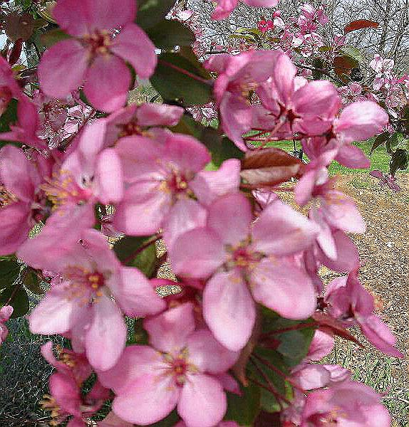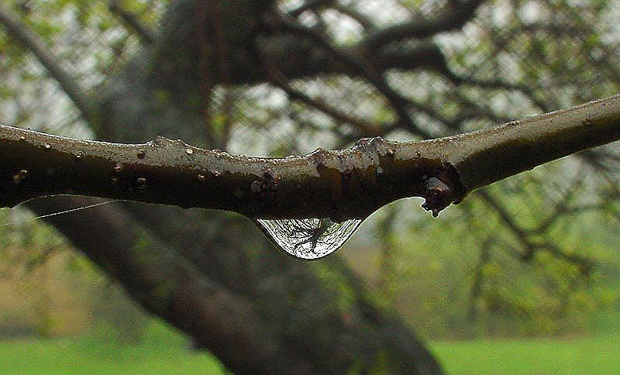

we use the mask:
0 -1 0
-1 5 -1
0 -1 0

and navigate through the picture from left to right meanwhile to the bottom.

Original Image: Original Image:

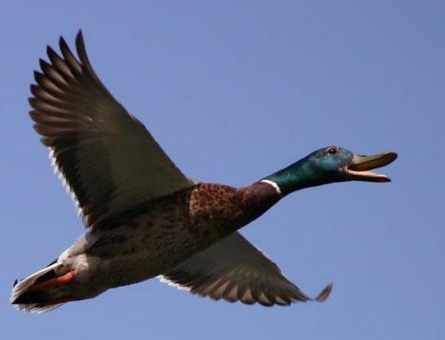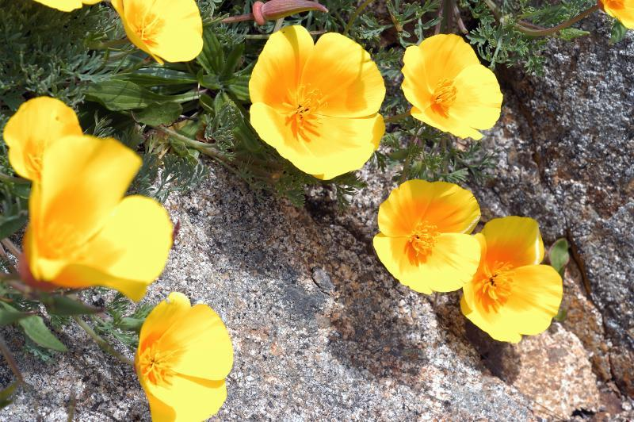

After applying the blur() function: After applying the blur() function:

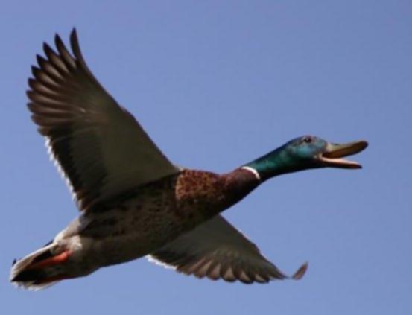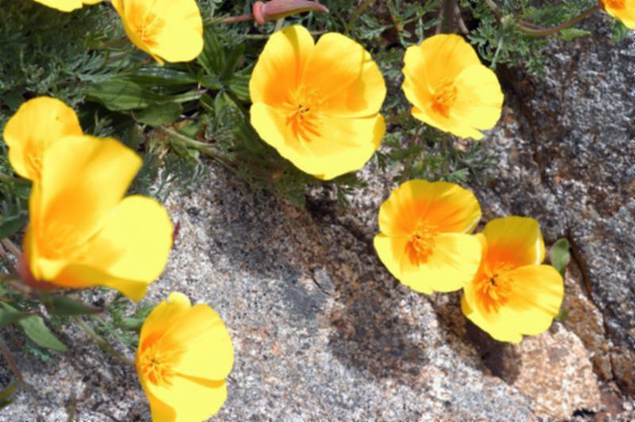

we use the mask:
0 1 0
1 1 1
0 1 0

and navigate through the picture from left to right meanwhile to the bottom.
Original Image: Original Image:

After applying the Log( ) function: After applying the Log( ) function:

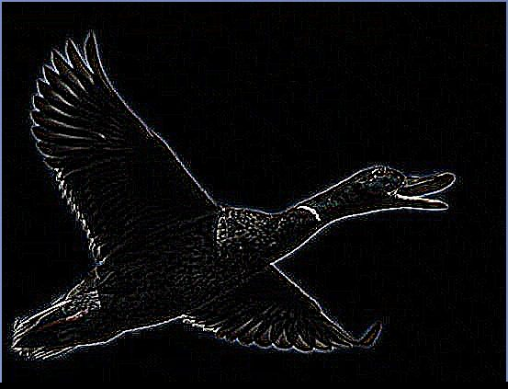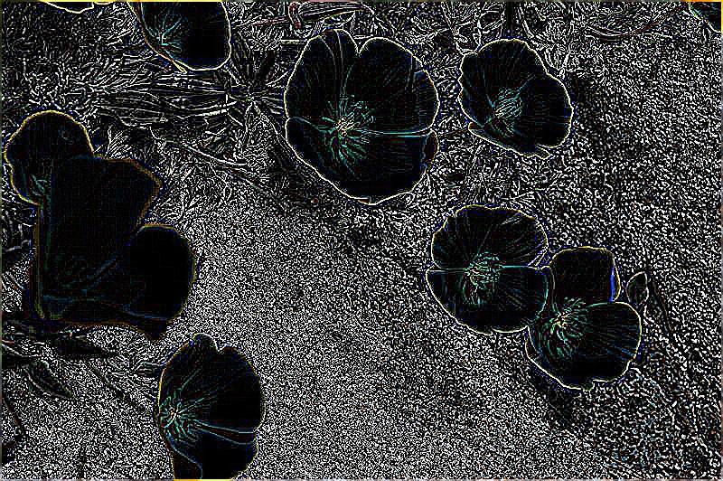

we use the mask:
0 0 -1 0 0
0 -1 -2 -1 0
-1 -2 16 -2 -1
0 -1 -2 -1 0
0 0 -1 0 0

and navigate through the picture from left to right meanwhile to the bottom.

Original Image: Original Image:

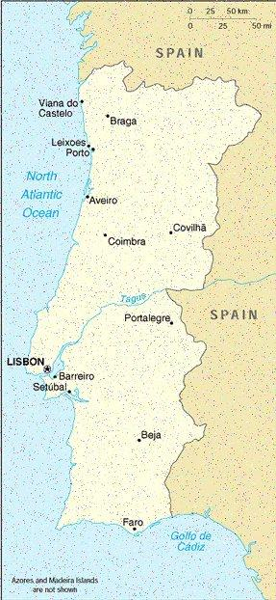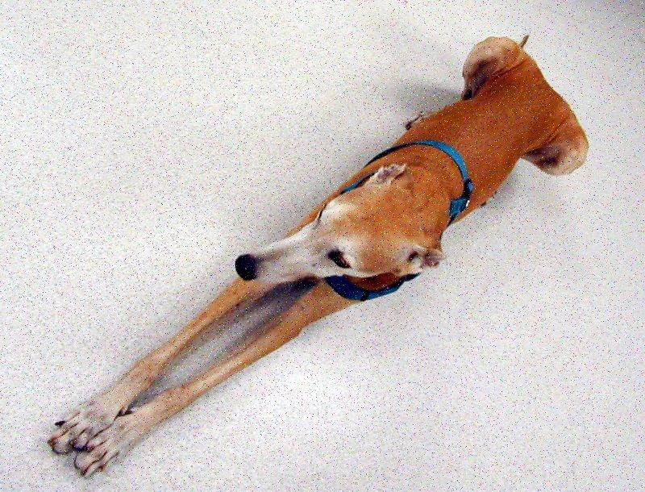

After applying After applying
the median filtering() function: the median filtering() function:

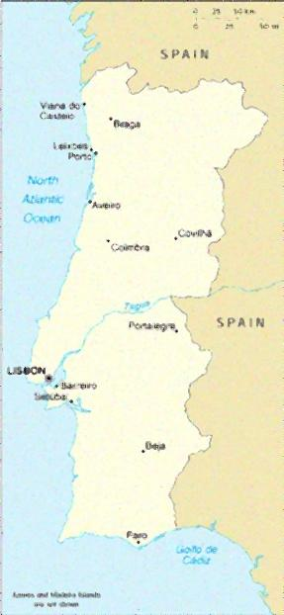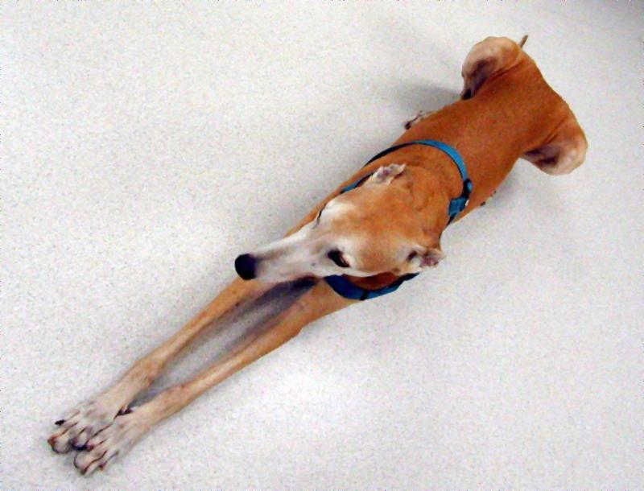

We find the median of each 3x3 matrices pixels and write the new value to the middle pixel.
PART B:

We enhanced the original given image by applying histogram equalization. Result is below.

Original Image:

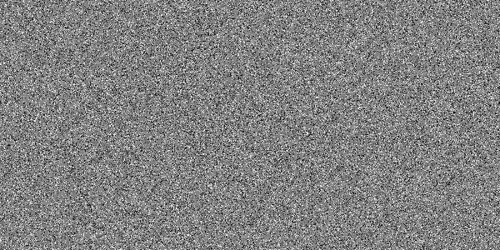

After applying the histogram equalization function:

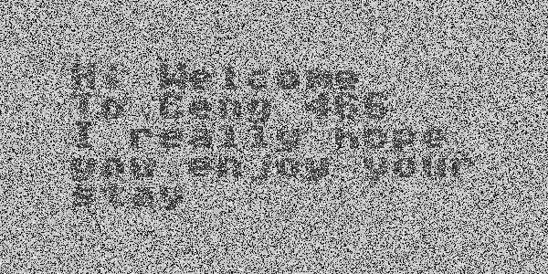

Then we applied the median filtering function several times so as to decrease the noise level in the image. The result is given below.
after applying the median filtering function 1st time:
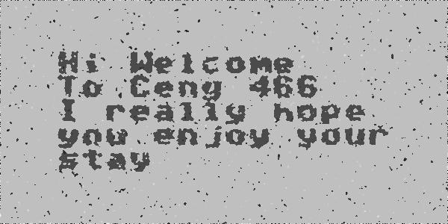
after applying the median filtering function 2nd time:
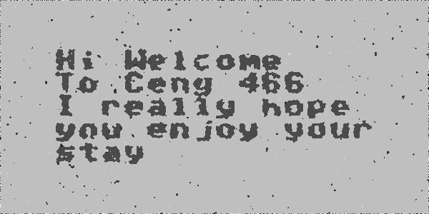
after applying the median filtering function 3rd time:
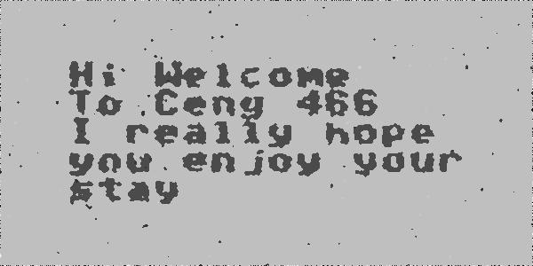
after applying the median filtering function 4th time:
