CENG 466 HW#3 REPORT
by
Mine ARSOY (e1249929) & Fatih ÜNAL (e1250885)

Part-1
For the first part of our program, we have first tried to smooth the image by using the median filtering algorithm. After we have smoothed the image, we split the image into 4 parts by using quad tree method. Then we look at a splitted part for sameness of that part. If that part’s all pixels’ color values are in the same interval then we take those pixels as one homogeneous region. Otherwise, we continue to split until finding homogeneous parts (one pixel is homogeneous by itself).

Before constructing the quad tree representation of the image, we have converted it from RGB to HSV format (because the comparison of hue values is simple and they give absolute color values) .In detail of the comparison, first of all we look at the value (v) and saturation(s) and we determine some specific intervals for colors. And then if necessary, we look the hue (h) values of those pixels. If the v values of the pixels are in the same interval, we look at these pixels’ s values. If their s values are in the interval of [0.2,1] then we compare the h values, as they are in same interval or not, to decide to combine them as a same region’s pixels.

Our interval criteria for looking that they are in the same region or not is:

v[0 ,50 ] => ok
v[50 ,135] && s[0,0.2] => ok
v[50 ,135] && s[0.2,1] && h values are in the same interval* => ok
v[135,255] && s[0,0.2] => ok
v[135,255] && s[0.2,1] && h values are in the same interval* => ok

*intervals for h values are:
h[0 ,25 ] => ok
h[25 ,50 ] => ok
h[50 ,75 ] => ok
h[75 ,165] => ok
h[165,270] => ok
h[270,295] => ok
h[295,335] => ok
h[335,360] => ok

The input images and outputs of these images are as shown below:

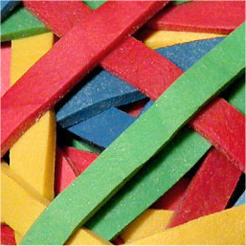
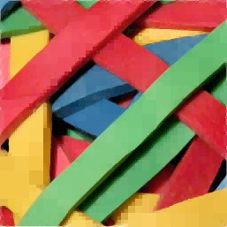
The input image The output image after split & merge

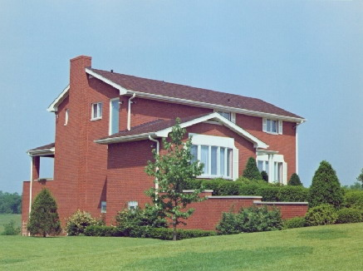
The input image

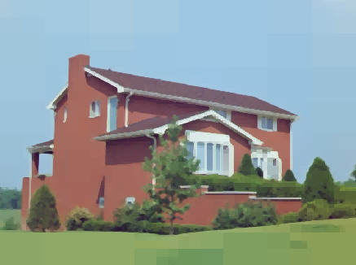
The output image after split & merge

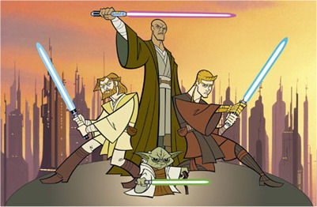
The input image

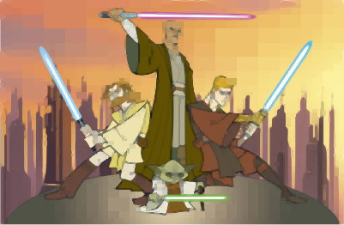
The output image after split & merge

Part-2
For the second part of our program, we have used canny edge detection algorithm in order to extract the boundaries of the images. For canny operation, we choose two threshold values which are low and high threshold (20 as low threshold and 150 as high threshold). The higher threshold is the edge strength that guarantees that a pixel will be marked an edge. Pixel near these pixels that do not fall below the lower threshold will be marked as edges also. Rising this threshold means that fewer edges are likely to be detected, since there will be fewer seeds to grow edges from. Lowering this threshold increases the possibility of relatively isolated edge pixels. The lower threshold is the edge strength that prevents a pixel from being marked an edge regardless of its neighbours. Pixels below this threshold will never be edges, regardless of their neighbours’ value. Increasing this threshold increases the possibility of getting dotted edges. And the Gaussian of scale σ is 1.0 by default. Small sigma select edges with a great deal of detail, while larger sigma limits the detected edges.
Canny edge detection follows interesting method and this method provides that canny edge detection is better way than the other detection methods. Because, in canny, threshold values prevent the natural noise which occurs when an ordinary edge detection method is used. We observe nearly perfect edges of a given input image. Canny edge detection is optimal for step edges corrupted by white noise.
At this homework given images’ edges are so clear so we didn’t see necessity to apply median filtering or other noise reduction methods to make edges clear.
The input images and outputs of these images are as shown below:

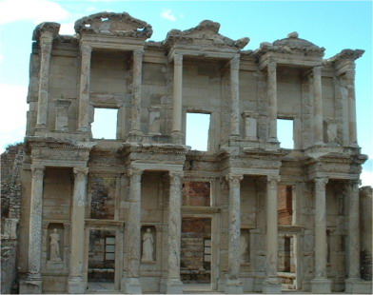
The input Image

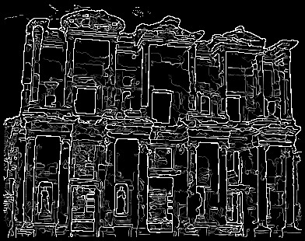
The output image after canny operation

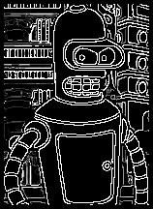

The input image The output image after canny operation

The input image

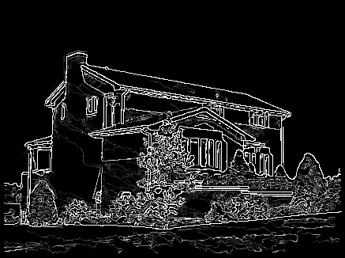
The output image after canny operation

For the second part of the homework we also tried Sobel edge detection method, but canny edge detection gave better result so we decided to use canny edge detection method in our homework. We used the Sobel edge detection method as follows: Firstly we applied the Sobel mask to each color channel of the image (red, green, blue). And then we sum these three-channel results and find their average. If that average is below the threshold value that we defined, we make that pixel black, on the contrary if it is above the threshold value we make that pixel white. We didn’t add Sobel edge detector code in our homework. Here are the masks that we use together (to find both vertical and horizontal edges) and the images that we applied Sobel edge detector:

-1 | 0 | 1
-2 | 0 | 2
-1 | 0 | 1
Sobel mask 1

-1 | -2 | -1
0 | 0 | 0
1 | 2 | 1
Sobel mask 2

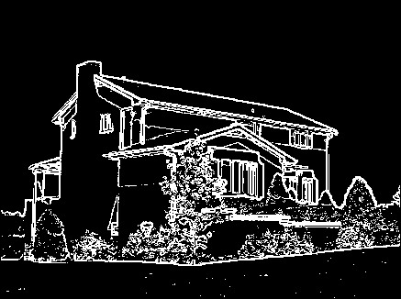
Input image output image (Sobel edge detection method applied)

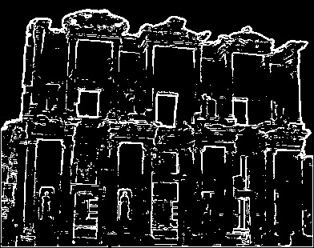
Input image output image (Sobel edge detection method applied)

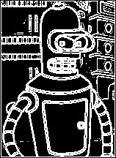

Input image output image (Sobel edge detection method applied)

