For the second part of the homework we also tried Sobel edge detection method, but canny edge detection gave better result so we decided to use canny edge detection method in our homework. We used the Sobel edge detection method as follows: Firstly we applied the Sobel mask to each color channel of the image (red, green, blue). And then we sum these three-channel results and find their average. If that average is below the threshold value that we defined, we make that pixel black, on the contrary if it is above the threshold value we make that pixel white. Here are the masks that we use together (to find both vertical and horizontal edges) and the images that we applied Sobel edge detector:

-1 | 0 | -1
-2 | 0 | -2
-1 | 0 | -1
-1 | -2 |  | -1
0 | 0 |  | 0
-1 | -2 |  | -1

Sobel mask 1 Sobel mask 2

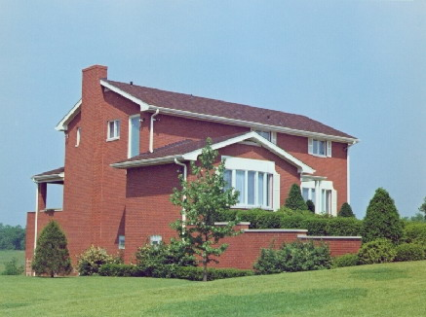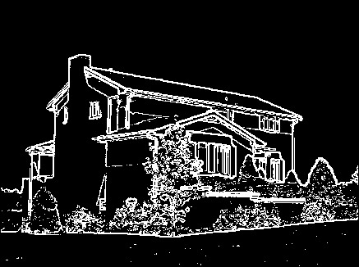
Input image output image (Sobel edge detection method applied)

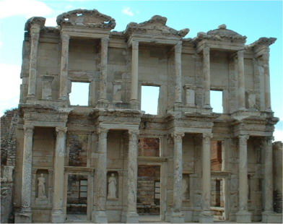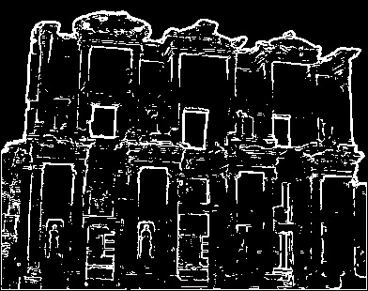
Input image output image (Sobel edge detection method applied)


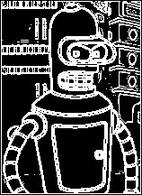

Input image output image (Sobel edge detection method applied)

