CENG 466

HOMEWORK 3

FATİH ÜNAL 1250885
FARUK ÖNEN 1298074

In our homework we implemented Hough transform to detect circles in given images. Hough transform is a powerful method that can be used to find features of any shape in an image. We not only used Hough transform but also made use of many method in order to obtain the desired result. Here are the steps that we follow in our homework:

First of all we read the image with ‘imread’ function and then find the size of the given image m x n (row x column) with the help of function ‘size’. Then we divide the n value to three so we obtain the row column lengths of the image. Because each pixel has three values; for R, G and B.

Secondly, we applied the RGB2GRAY function to convert the given image to gray level. After that, we used the sobel edge detection function in order to obtain the edge-detected version of the image.

Original picture gray-scale edge-detected
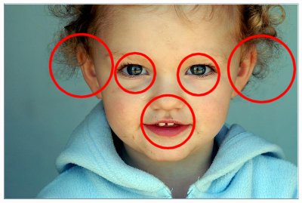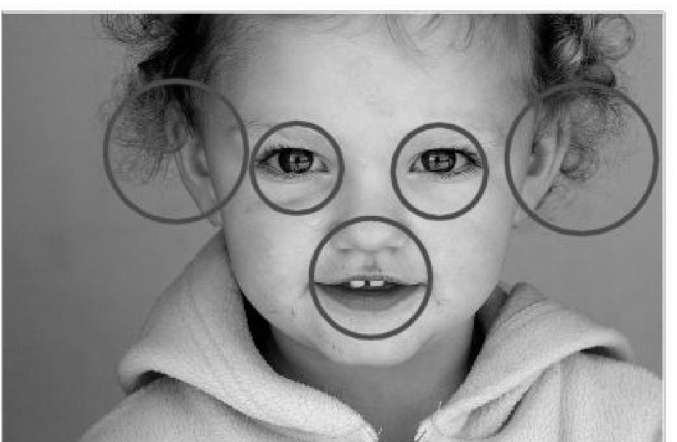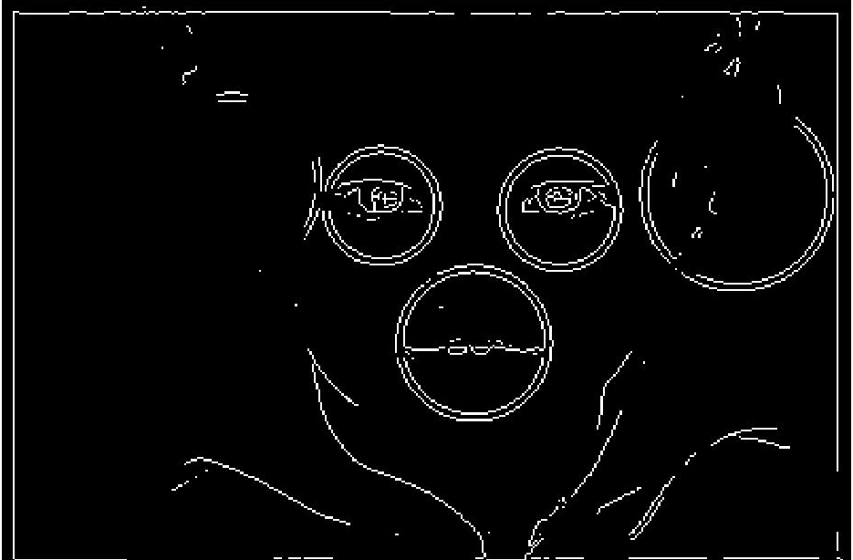

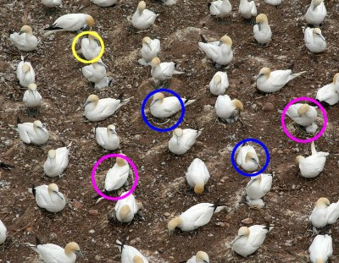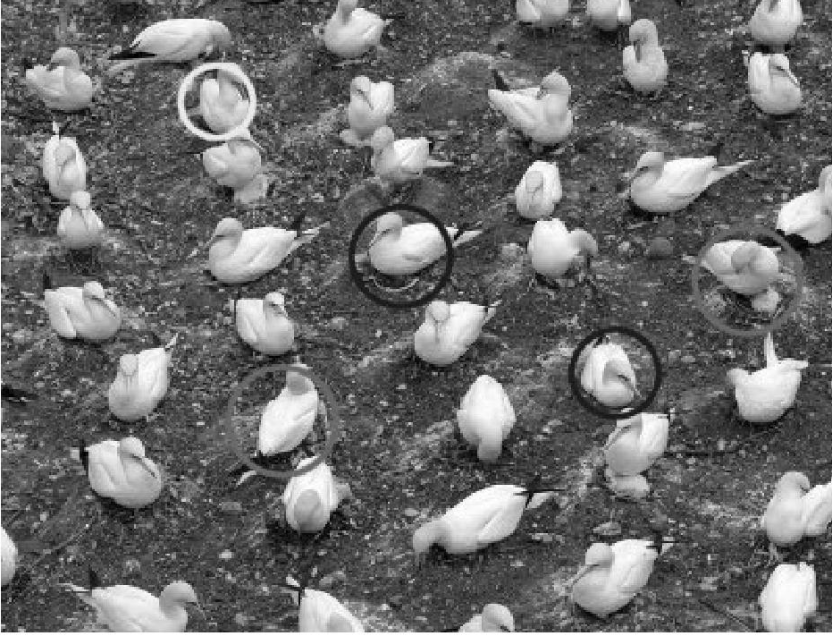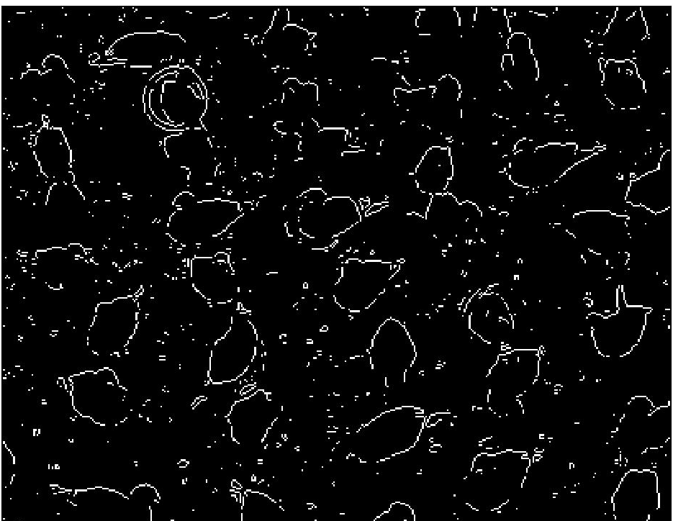

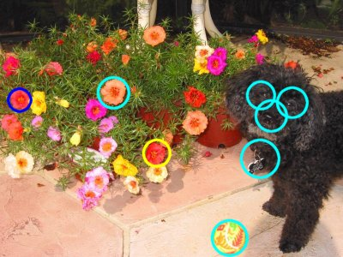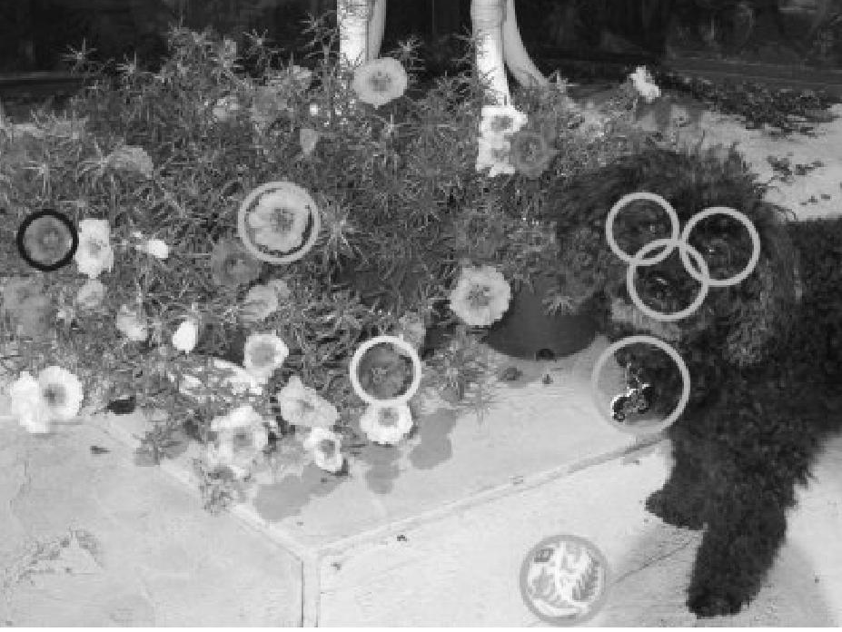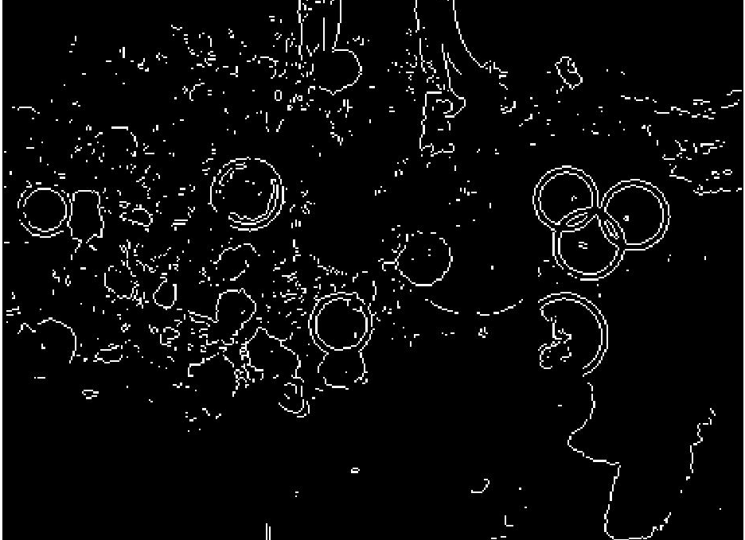

Thirdly, for every m and n value in the image, we detect the circles in the edge-detected image through a series of steps. More clearly (x refers to m and y refers to n, if we think on coordinate axis) we know that any kind of curve can be detected if we are able to express the x and y values as a function of the form. Hough transform verifies this idea too. So as to obtain a circle we must be able to write the equation below from the formula of polar coordinates:

(x – a) ² + (y – b) ² – r² = 0

we can differently explain this equation :

x = a + rcosθ a = x - rcosθ
y = b + rsinθ b = y - rsinθ

if we leave r alone and equalize two equations we obtain an equation depending on x, y, a and b values. Here it is:

b = a * tanθ – x * tanθ + y

According to the formulas above, we divide our parameter space into some number of different accumulator cells, hence we can put the voted values of a, b and r from each data point in x - y data coordinate space (think of x and y as each pixel in the image). We mark values in a - b space with the help of equations of circles in x y coordinate space in order to make the needed points distinct from others. To do this, we used large parameter accumulator arrays. From the figure 1 below we can easily understand the concept of accumulator cells.

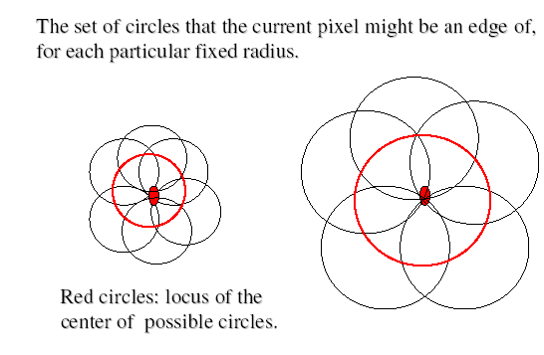
figure 1:

We found the tanθ value for each x and y value in the image. (θ is the gradient angle for the edges available in the image). We accumulate these values in the ‘tanteta’ accumulator cell. We used accumulator cells in order to accumulate (store) different values: a, b, r and tanθ. (acc(x,y,80) array holds a, b and r; and tanteta(x,y) holds tanθ for each pixel). Accumulation of r is explained in the figure 2 below:

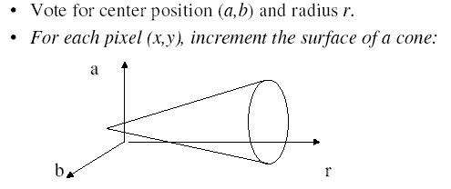
figure 2:

Another function that we used is the zero function. Zeros function is used to fill all values with zero in the accumulator cells arrays. After applying that function we calculate each of the tanθ value with the ‘tantetabul’ user-defined function. This function has 5 different inputs. One of them is gray-level version of the image, second one is the edge-detected version of the image, third and fourth ones are the masks that we used to calculate the derivative of the point with respect to x and y respectively. The last input given to function is the tanteta accumulator cell which is empty (all 0’s) before the calculation. If we divide the derivative matrix of y to the derivative matrix of x, we obtain the tanθ value for the given image at each pixel. The masks applied to the gray-leveled image is below:

First mask ( finds the derivative of given point with respect to x ):

1 | 2 | 1
0 | 0 | 0
-1 | -1 | -1
= Dx

Second mask ( finds the derivative of given point with respect to y ):

1 | 0 | -1
2 | 0 | -2
1 | 0 | -1
= Dy

At the forth step we use accumulator cells in the function ‘tdoldur’. We start using the accumulator cells by initializing all of the cells to the zero value with the help of zeros function. ‘tdoldur’ function gets three parameters. One of them is the accumulator cells (it is a three dimensional matrix which is consist of a, b and r values.) Another one is the tanθ values of each pixel of the image and the last parameter of the function is edge detected version of the image. For each pixel of the edge detected image, we calculate the b value with the help of x y (row and column) and a values. If the calculated b value is between 1 and n (column size) , the location of a and b in the matrix is incremented by one. And the r value is calculated according to x, y, a and b values. These calculations are done according to the circle formula. If the point (x,y) is in the circle (the center of the circle is a and b) which has a radius between 10 and 80, we increment the appropriate array location of r by one, which gives the hint that this point a and b has a circle which has a radius r. We will use these accumulated values in later steps of our program. Why we use defined r sizes is because the given images has a circle range that varies between these values and this defined values gives us the abilities of less program execution duration and less calculation complexity. The output of the ‘tdoldur’ function is the new values of the accumulator array.

In the fifth step we used the threshold value T to separate real circle centers from the false circle centers. If the accumulated cells have values below the threshold value they are not taken into care. (Because there are lots of shapes in an image which can also resemble a circle and edge-detection may also detect a circle not fully but partially, we skip them with the help of threshold value.) We used the ‘cemberleribul’ function which has two parameters; one of them is the user defined threshold value and the other one is the accumulator cell. According to the values which are above the threshold value, we find the number of circles in the image. The threshold value must be changeable from image to image because every image has different characteristic properties. The number of circles is stored in a variable called ‘say’. There are two outputs of the image: one of them is the ‘say’ value that stores the number of circles in the image and the other one is the 3 dimensional ‘cem’ arrays which store the centers of each circle and their radius value respectively.

The last step of our program is finding the new image which only shows the areas inside the circles as in the original image and shows areas outside the circles as black. This function is called ‘uy2’ which has three input parameters respectively: the ‘cem’ array consists of circle center coordinates and radius of each circle, next one is number of circles and the last one is the original image. For each number of the detected circle we control each pixel of the original image whether it is a member of the circle (the point is inside the circle, it satisfies the circle equation) or it is not the member of the circle (the point is outside the circle it does not satisfy the equation). For each circle (we have the x, y circle center coordinates and circle’s radius) we try the pixels of the image. If the point is outside a circle it is defined as black, otherwise if it is inside the circle its pixel values are supplied from the original image. After all, we find our new image that emphasizes the areas inside the circles. In order to obtain the correct result that only shows the emphasized circles, we used different techniques for example we calculated the circle center density for each accumulated points region in our accumulated cell array. By the way we can find whether that accumulated cells refers to a real circle’s center or not. Finally the result is converted to the needed number representation system (uint8) and we show the result image with the function ‘imshow’. We can see the resultant images we obtain below, after applying our Matlab functions.

Circle detected hw3p1.jpg: Circle detected hw3p2.jpg:
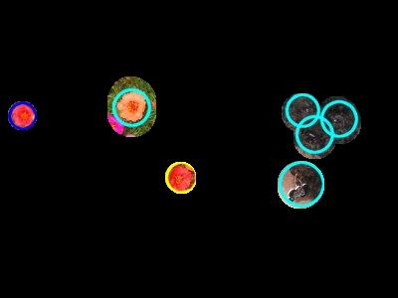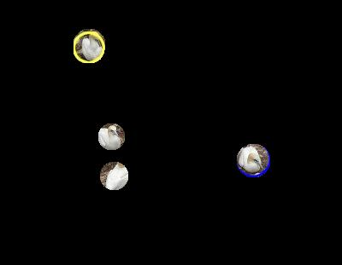

Circle detected hw3p3.jpg: Circle detected hw3p4.jpg:
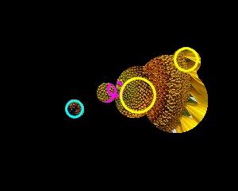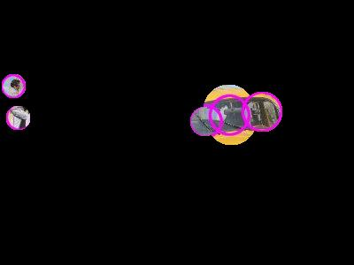

Circle detected hw3p5.jpg: Circle detected hw3p6.jpg:
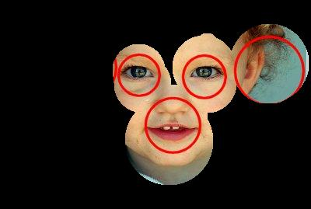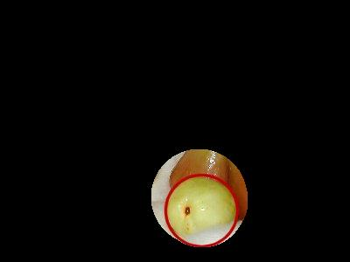

Our major problem in detecting the circles is that circles are sometimes bigger than its original size. It means there is a minor problem with the radius, but too see the artificial circles clearly we decided to use the bigger radii. So pictures have bigger circles now.

Another problem is with the edge detection. We used ‘sobel’ edge detector function in Matlab, but as you can see in the first page some circle edge are not detected. Therefore our circle-extracting algorithm can’t find it neither. Since it is a problem related with edge detection by a function of Matlab, we kept the pictures with not all the edges clearly detected. If we had applied a different edge detection function such as canny or anything else we may obtain more or less edges than we obtain now. These new edge-detected images may either cause more circles to be found or fewer circles to be found. It depends on the quality of edge detection function.

Rarely, some areas without any artificial circles are printed in the picture. Since circle finding algorithm searches in the gray-scale image, it can determine areas with the same color as circles.

