CENG 466 HW#4 REPORT
By
Mine ARSOY (e1249929) & Fatih ÜNAL (e1250885)

PART 1

In this part of homework we used “Watershed Segmentation Algorithm” in order to segment input images by using morphological algorithms.
Our algorithm works like this:

Firstly we read the input image channel by channel (red green and blue channels) for each pixel. Then we convert our RGB color system to HSI color system and stored both of these values in order to use them. We used intensity values in order to make a proper segmentation, because red, green or blue values don’t make sense lonely and when they come together they have meaning.

Segmentation algorithm starts to examine each pixel of the picture. Also we have a label array matrix, which shows the region of each pixel. As our image has intensity values between 0-255, we started to look for 0 values and label them as region 1. For every intensity value, we examine the whole image. Next, we look at intensity value1, but when we look at 1 value, we also look whether value 1 has a neighbor that is labeled before. If it has only one labeled-neighbor, it will take the region number of its neighbor. However if it has more than one labeled-neighbor, it will take the average value of its neighbor’s region values. If it doesn’t have any labeled-neighbor it will take its intensity value as region number. For each intensity value we visit every pixel in the image and give its region number as explained.

When labeling region numbers is finished, we calculate average value of red channels, green channels and blue channels of pixels for every region number, then (there are 256 regions maximum, 256 different intensity values). This calculated average values are the new red, green and blue values of each pixel for each region. Watershed segmentation helps to display similar values identical, which are close to each other. Also edges will be apparent in this segmentation algorithm because edges have very different values with their neighbors.

If we start our segmentation algorithm from the 0 intensity value to 255 intensity value dark colors are dominant in the image, on the contrary if we start from the 255 intensity value and go to 0 intensity value, light colors become apparent. For the output images we firstly but the watershed-segmented output image that gives priority to 0 when starting region segmentation (darker colors), then we put the watershed segmented output image that gives priority to 255 when starting region segmentation (lighter colors). Taking average value between the distance regions of same region number, removes the value difference. This algorithm may be extended, for example for a catchments basin, there can be applied a threshold, also prior knowledge about the image can be used to apply an examination priority rule for the intensity values.

Morphology in segmentation can estimate many features of the geometrical structure in the image such as size, connectivity and shape.

In our code, we implemented watershed algorithm which firstly looks for light colors and passes dark colors. (255 to 0 intensity).0 to 255 implementation makes dark colors dominant, and 255 to 0 implementation makes light colors dominant we use the second one. But in report, we put both output images for light to dark and dark to light implementations. Here are the input images and the watershed segmentation applied output images (for dark colors and for light colors) side:

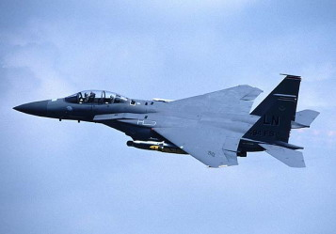

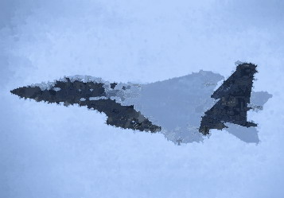

Input image Output image watershed segmented (0 to 255)

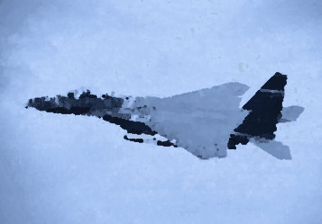

Output image watershed segmented (255 to 0)

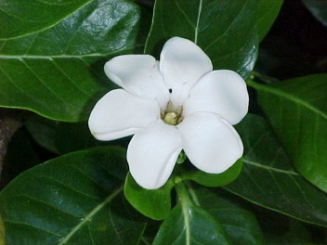
Input image
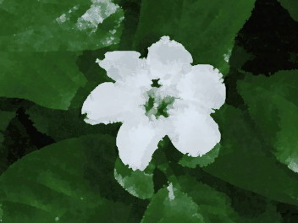

Output image watershed segmented (0 to 255)

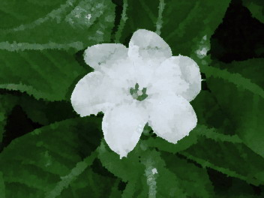
Output image watershed segmented (255 to 0)

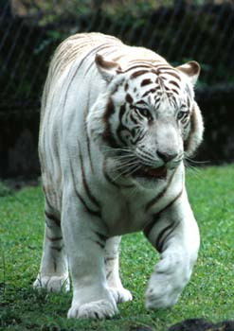
Input image

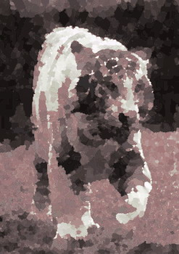
Output image watershed segmented (0 to 255)

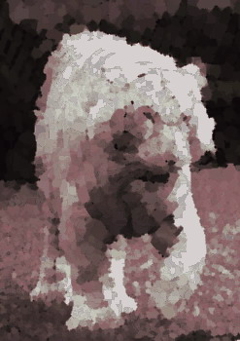
Output image watershed segmented (255 to 0)

PART 2

For the second part of the homework, we have applied dilation and erosion operations in order to detect the edges of the images. First of all, we have done histogram equalization and got equally distributed color levels over the whole color scale. Then we have done dilation operation and expanded the image. This is done by applying a 3*3 mask through image and giving the biggest color value to the seed pixel. Then we have done erosion operation and shrinked the image. Similarly we have applied the 3*3 mask through the image but this time we gave the smallest value to the seed pixel. At the end of these operations, we have subtracted the eroded image from the dilated one and got the edge detected output image. Making dilation and erosion more then once makes the edges in the image clear.

The output images after these operations are as follows:

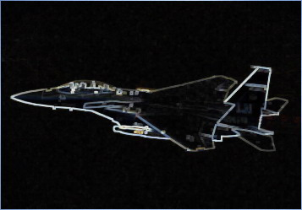
The input image The output image without histogram equalization

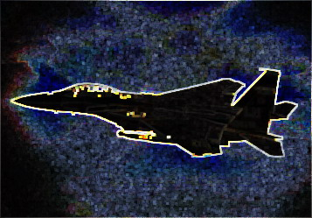
The output image with histogram equalization

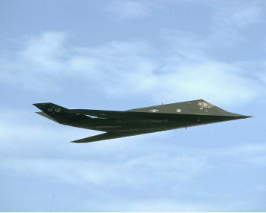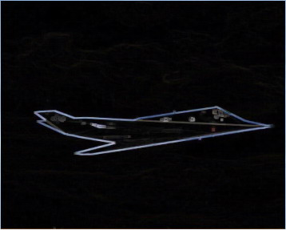
The input image The output image without histogram equalization

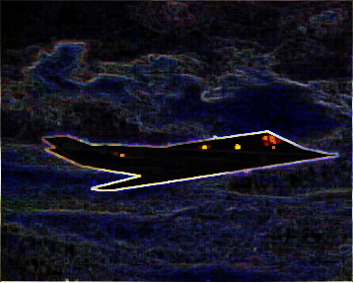
The output image with histogram equalization
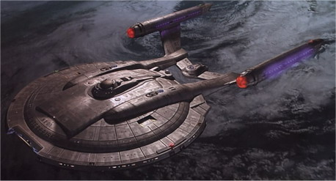
The input image

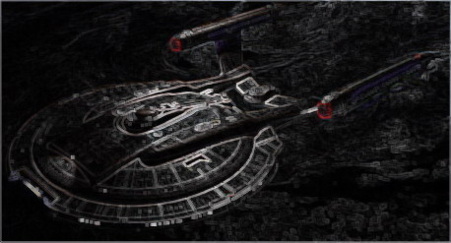
The output image without histogram equalization

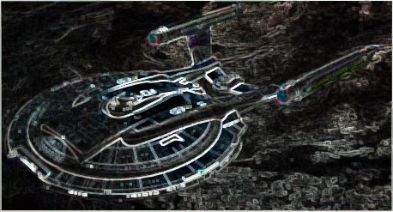
The output image without histogram equalization
In order to see sobel outputs of the input images run this command:
hw4 sobel <input image> <output image>
Here are the output images after sobel operation:

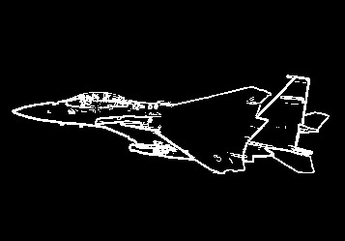
Sobel edge detection output of the input image

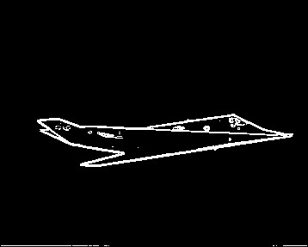
Sobel edge detection output of the input image

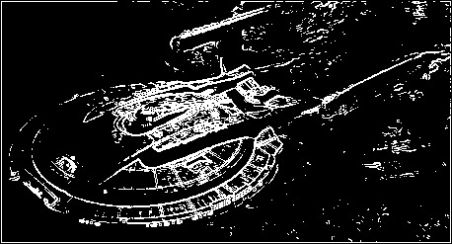
Sobel edge detection output of the input image
As seen from the above images, the sobel is more successful in detecting the edges compared to our operations.

