**ASSIGNMENT #2**

**(E-SPORTS)**

**FA17-BCS-014**

**FA17-BCS-020**

**FA17-BCS-024**

**PROBLEM:**

As we know “Healthy mind requires a healthy body”. As we know that Sports play a very vital role in the development and enhancement of the students mental and physical capabilities but unfortunately in our society ,sports is not given any attention due to a number of reasons ,among which the poor administration of this department and events is one of the primary cause.

So, to promote sports and create a sense of awareness and interest among the students we are planning to solve this issue by coming up with E-SPORTS.

**PROPOSAL:**

The aim and objective of this project is to create an android platform to promote sports in Pakistan and other institutional levels,

This project is known as *E-Sports.*

It will not only help the administration and the individuals to create fixtures but also allow them to participate in various upcoming events

Additionally, the organization can evaluate the participants on basis of their scoreboards and points on score table.

Each user will have an individual account and options as per their roles,i.e. admin and participants.

**ABSTRACT:**

Our university needs an online sports management to promote sports culture in CUIATD, to provide a platform to the young talented sportsmen where they could test and improvise themselves according to results scoreboards and fixtures.

1. **Group Meeting.**

***Status:*** **Done**

1. **Scope and time for the development of modules.**

***Scope:***

The project initially targets our own university and will be usable by all the students and the faculty of CUIATD for taking part, viewing fixtures and results of multiple sports events.

The projects can be generally categorized into three basic modules at the instant, namely:

* **SIGNUP/LOGIN** (creation and authentication of accounts)
* **FIXTURES** (detailed information about standings upcoming events)
* **RESULTS** (a score board depicting results of matches and events)

1. **Modules Division**

|  |  |
| --- | --- |
| **Members** | **Modules** |
| **FA17-BCS-024** (Haroon khan) | **FIXTURES** |
| **FA17-BCS-020** (Rafia khalid) | **SIGNUP/LOGIN** |
| **FA17-BCS-014** (Fatima Anwerzeb) | **RESULTS** |

1. **SIGNUP/ LOGIN:**

The user can create an account via signing up and then access it via login buttons, everyone will be prompted to create a unique account and will have a unique id.

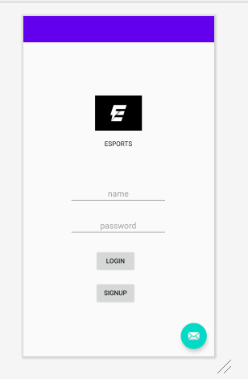

**Reviewed by:**

FA17-BCS-024

FA17-BCS-014

**FA17-BCS-024’s comment:**

Insert hint text not ordinary text fields for the name and password section. I have sent you a logo, insert that as well.

**FA17-BCS-014’s comment:**

Rest is good just center align the text in buttons and text fields, you can do it from code and add **android:textAlignment="center"**

1. **FIXTURES:**

In this section the user can see fixtures and standing (time and venue) of upcoming events and matches and participate in whatsoever he or she desires to be a part of.

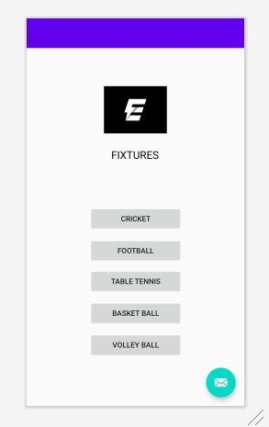

**Reviewed by:**

FA17-BCS-020

FA17-BCS-014

**FA17-BCS-020’s comment:**

Don’t use text fields with buttons at the end ,make simple buttons with respective sports.

**FA17-BCS-014’s comment:**

**android:textAlignment="center"** also follow it by **android:gravity="center"** otherwise it will give errors.

1. **RESULTS**

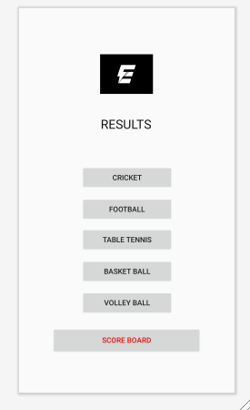Here the user can see the results of any particular game of any sports as well as a scoreboard will be showing the leading team and individuals a pe r their scores and points.

**Reviewed by:**

FA17-BCS-020

FA17-BCS-024

**FA17-BCS-020’s comment:**

Do not re organize the buttons, go for the same pattern as mine to give it a cleaner look.

**FA17-BCS-020’s comment:**

Add a scoreboard button too as we discussed to display overall leading teams and players.