**ASSIGNMENT #2**

**(E-SPORTS)**

**FA17-BCS-014**

**FA17-BCS-020**

**FA17-BCS-024**

1. **Group meeting.**

Status: **Done**

1. **Scope and time for the development of modules.**

**Scope:**

The project initially targets our own university and will be usable by all the students and the faculty of CUIATD for taking part, viewing fixtures and results of multiple sports events.

The projects can be generally categorized into three basic modules at the instant, namely:

1. **SIGNUP/LOGIN** (creation and authentication of accounts)
2. **FIXTURES** (detailed information about standings upcoming events )
3. **RESULTS** (a score board depicting results of matches and events)
4. **Modules division**

|  |  |
| --- | --- |
| **Member** | **Module** |
| FA17-BCS-024 **(Haroon khan)** | FIXTURES |
| FA17-BCS-020 **(Rafia khalid)** | SIGNUP/LOGIN |
| FA17-BCS-014 **(Fatima Anwer Zeb)** | RESULTS |

1. **SIGNUP/ LOGIN**

The user can create an account via signing up and then access it via login buttons, each individual will be prompted to create a unique account and will have a unique id.

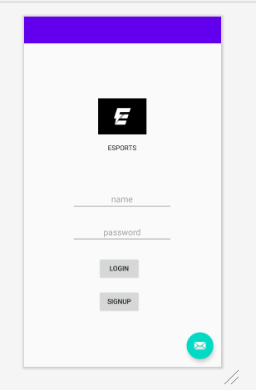

**Reviews:**

**(FA17-BCS-024)**

Insert hint text not ordinary text fields for the name and password section. I have sent you a logo, insert that as well.

**(FA17-BCS-014)**

Rest is good just center align the text in buttons and text fields ,you can do it from code and add **android:textAlignment="center"**

1. **FIXTURES**

In this section the user can see fixtures and standing (time and venue) of upcoming events and matches, and participate in whatsoever he or she desires to be a part of.

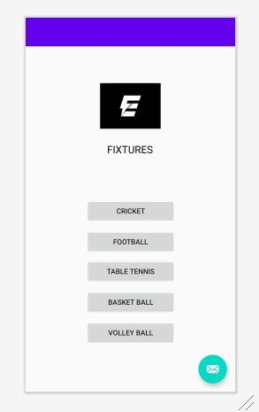

**Reviews:**

**(FA17-BCS-020)**

Don’t use text fields with buttons at the end, make simple buttons with respective sports.

**(FA17-BCS-014)**

**android:textAlignment="center"** also follow it by **android:gravity="center"**

Otherwise it will give errors.

1. **RESULTS**

Here the user can see the results of any particular game of any sports as well as a scoreboard will be showing the leading team and individuals as per their scores and points.

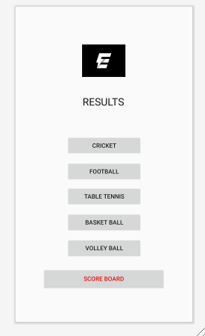

**Reviews:**

**(FA17-BCS-024)**

Don’t re organize the buttons, go for the same pattern as mine to give it a cleaner look.

**(FA17-BCS-020)**

Add a scoreboard button too as we discussed to display overall leading teams and players.