**C# INHERITANCE – ASSIGNMENT TEST**

# Section A: (MCQs)

1. Colon
2. Class-to-class
3. Access parent class members
4. Protected
5. Dog

# Section B: Short Questions

1. Define inheritance in C#. Why is it used?

Inheritance ek system hai jisme child class apne parent class ki properties aur functions use kar sakti hai. Yeh code reuse karne mein help karta hai.

2. Differentiate between base class and derived class.

Base class parent hai, derived class child hai jo features inherit karti hai.

3. Difference between base and this keyword?

'base' parent members ko refer karta hai, 'this' current class instance ko refer karta hai.

4. Method overriding vs overloading?

Overriding: base method ko derived class mein redefine karna. Overloading: same name, different parameters.

5. Role of virtual and override?

'virtual' overriding allow karta hai, 'override' new implementation provide karta hai.

# Section C: Coding Exercise and Solutions

Q1: Person -> Student

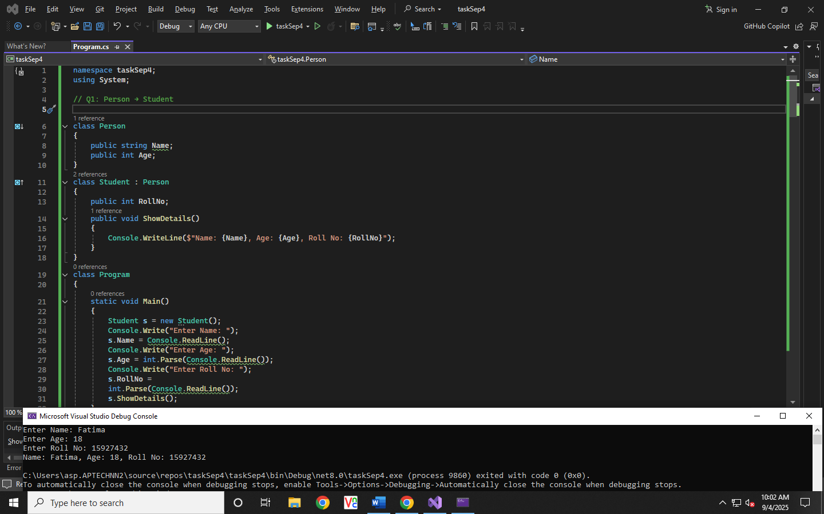

Output Screen Shot:

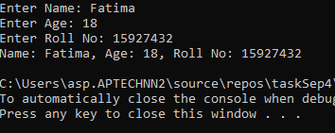

Q2: Shape - > Rectangle

Output Screen Shot:

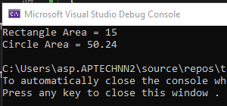

Q3: Multilevel Inheritance (Vehicle → Car → Electric Car)

Output Screen Shot:

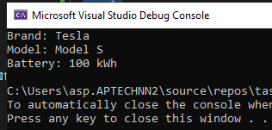

Q4: Hierarchical Inheritance (Employee → Manager, Developer)

Output Screen Shot:

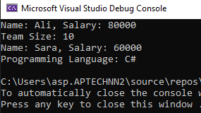

Q5: Bank Account → Savings Account

Output Screen Shot:

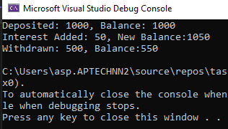

**ASSIGNMENT Done By : Fatima Nahid**