

**GlamGait Shopping Website**

**Spring 2024 – CMPS350**

**Project Report Phase 1**

**Name: Fatima Almohannadi QU ID: 202002315**

**Name: Kholoud Alshafai QU ID: 202001597**

**Name: Reham Alameen QU ID: 201901682**

**Section: L51**

# **Github Link:** <https://github.com/fatima-fa2002315/webProject.git>

**Application Design**

**Use case Testing**

# **Use Case 1: Login**

* It allows users to login to use the app using their username and password.

Login should be verified using the user’s data in users.json.

* User cannot login if the password or username does not match

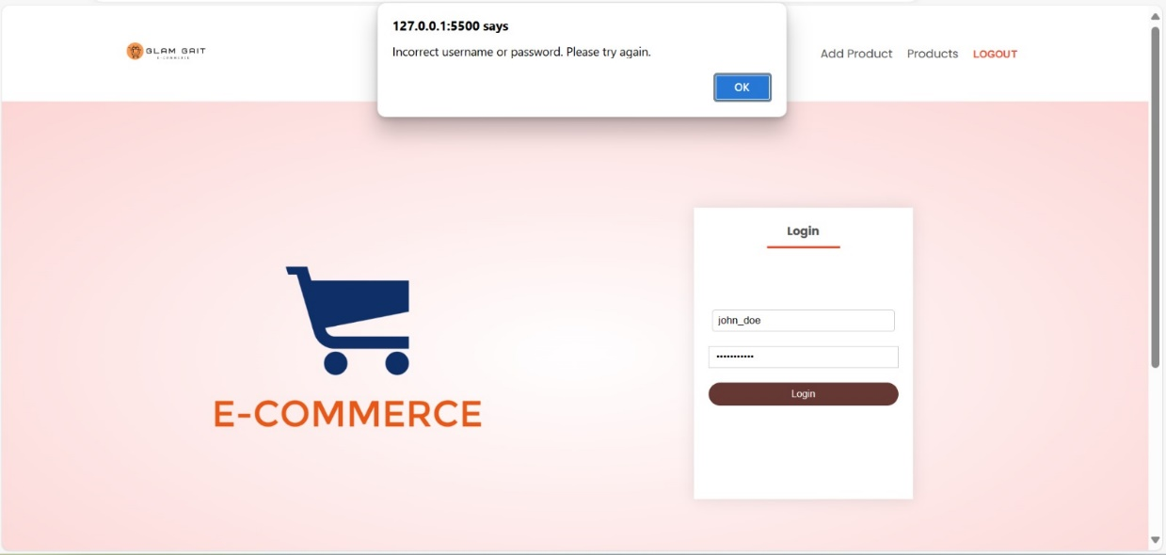



* A sample list of users will be provided on users.json. To keep the app simple, there is no need for the users to register to create an account to use the app.

* Once a user is logged in, they will be directed to the main page.

# **Use Case 2: Search available items**

* In the main page, user should be able to search available items. Once the search button is clicked, it will show only the suitable ones.
* To keep the application simple, you can create and use a json file for items.

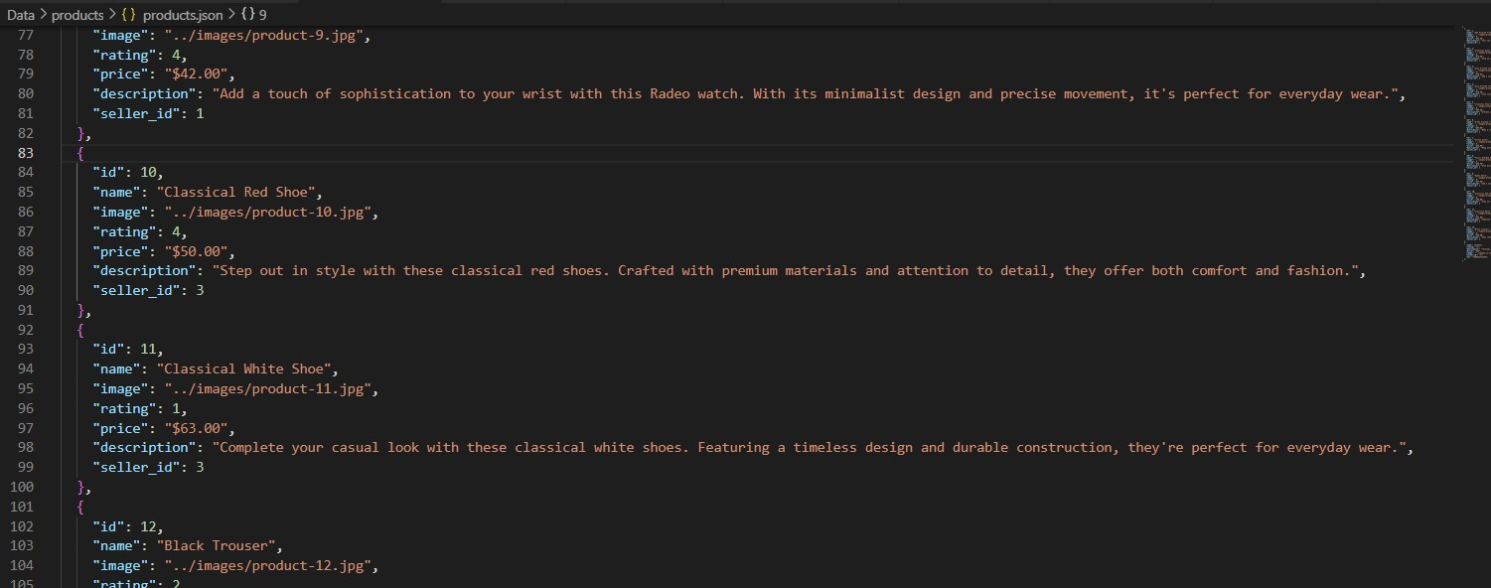

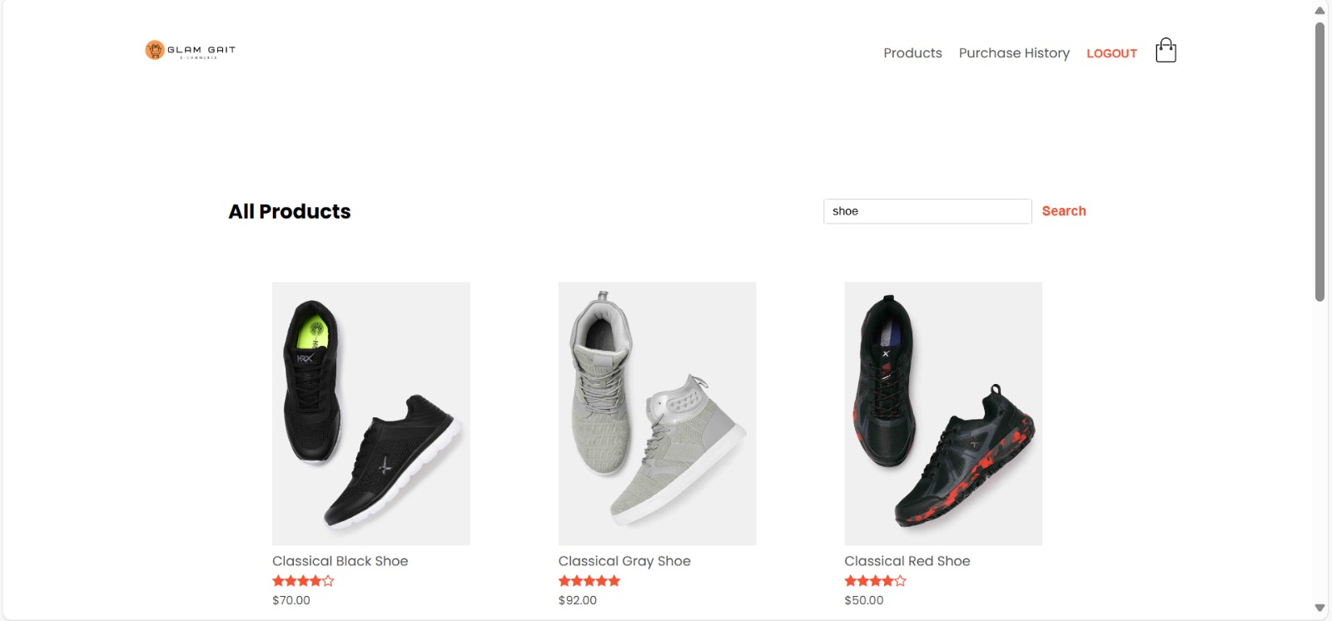

# **Use Case 3: Purchase an item**

* A user can purchase an item. When the purchase button is clicked, it should direct the user to a new page to checkout.

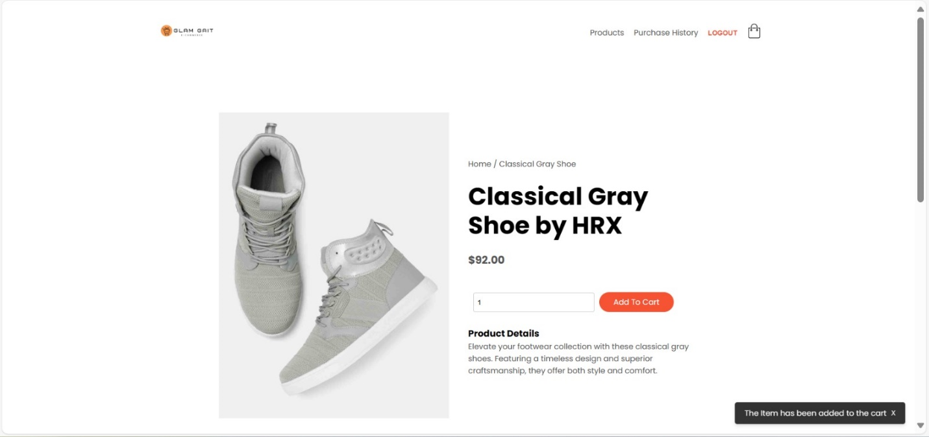

* purchase/sale histories are updated if purchase is successful.

* purchase an item without enough money.

# **Use Case 4: View the purchase history**

• Customers should be able to see the list of purchased items.

# **Use Case 5: View available items on sale and sale history**

* A seller should be able to see the list of items s/he is currently selling and the items that have already been sold.

* S/he should be able to click the item and see its details. In the sale history section, how many items are sold, who bought it (username)

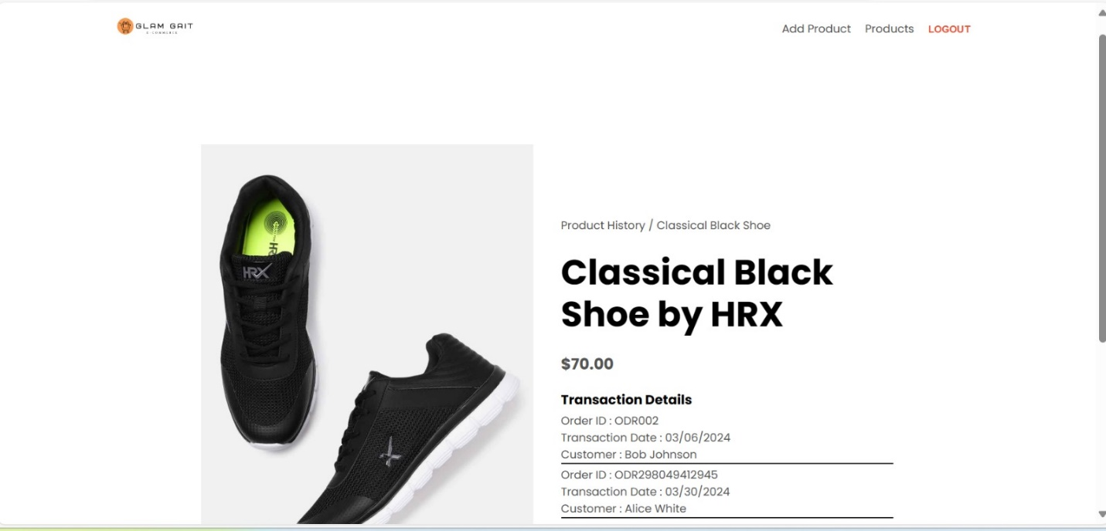

# **Case 6: Upload an item to be sold**

* A seller can upload new items to be sold. The seller should define its price and its picture and other details.

* The item should start appearing in the search.

