FINAL PROJECT REPORT
Database Management Systems
SQL-Based Financial Transaction Analysis and Fraud Detection Using the PaySim Dataset

Submitted By:
Fatima Khuram (24L-5567)
Sehar Taimoor (24L-5584)
Anfal Batool (24L-5018)
Areesha Talha (24L-5504)
Syeda Somal Fatima (24L-5715)

Date of Submission: May 14, 2026

Course: Database Management Systems
Department of Computer Science

Abstract
This report presents the design, implementation, and analytical use of a relational database system built around the PaySim mobile money simulation dataset. The project addresses a critical FinTech challenge: detecting fraudulent financial transactions and analyzing customer and system-level behavior using purely SQL-based techniques. The raw PaySim data, originally a flat, denormalized table containing over six million simulated transactions, was transformed into a normalized Third Normal Form (3NF) schema consisting of three core entities: Customers, TransactionTypes, and Transactions. Foreign key constraints, primary keys, and integrity rules were applied to ensure data consistency. On top of this structured database, eight analytical modules were developed using views, stored procedures, table-valued functions, and ad-hoc queries to surface fraud-related insights. These include time-based fraud monitoring, large-transaction detection, customer behavior profiling, transaction-type risk evaluation, system-wide fraud overviews, high-exposure fraudster identification, and balance-mismatch anomaly detection. The primary technical achievement is a clean, query-efficient relational model paired with reusable analytical objects that mirror how a real bank or FinTech firm would structure its fraud-monitoring infrastructure. The system demonstrates how SQL alone, when combined with disciplined data modeling, can serve as a powerful foundation for fraud detection, risk scoring, and compliance reporting in modern digital banking environments.

1. Introduction
1.1 Problem Statement
Financial fraud is one of the most persistent and costly challenges facing the modern banking and FinTech industry. With the rapid migration of payments, transfers, and cash-out operations to digital channels, the volume of transactions a bank must monitor each day has grown enormously, while the techniques used by fraudsters have become more sophisticated and harder to spot using simple rule-based checks. The specific challenge this project addresses is the absence of a structured, query-friendly foundation on which fraud-detection logic can be built. Raw transaction logs, such as those represented by the PaySim dataset, typically arrive as a single wide table with no enforced relationships, no normalization, and no analytical views. Running fraud queries directly against such a flat structure is slow, error-prone, and difficult to scale. Our project therefore tackles two interlinked problems at once: first, transforming a raw, denormalized financial dataset into a properly normalized relational schema with strong integrity constraints; and second, building a layer of SQL-based analytical objects, namely views, stored procedures, and table-valued functions, that allow analysts and compliance teams to detect fraud patterns and monitor system health in a repeatable and efficient manner.
1.2 Motivation
The motivation behind this work is grounded firmly in the current FinTech landscape. Digital wallets, mobile banking applications, and instant transfer services have made financial activity continuous and global, but they have also widened the attack surface for fraudulent behavior such as account takeover, money laundering, and unauthorized transfers. Regulators worldwide now require banks to demonstrate that they have robust, auditable systems for detecting and reporting suspicious activity, and this expectation has elevated the importance of well-designed transactional databases. SQL remains the lingua franca of financial data: nearly every core banking system, transaction warehouse, and analytics platform is built on top of a relational engine, and proficiency in modeling, querying, and optimizing such systems is a non-negotiable skill in FinTech. By selecting the PaySim dataset, which is widely used in academic and industry research because it realistically simulates mobile money flows including labeled fraud cases, we ensured that the project mirrors real banking conditions. The result is not only an academic exercise but also a working blueprint for the kind of fraud-aware data layer that any digital bank or payment processor would need to operate safely and competitively.
2. System Architecture and Data Modeling
2.1 Dataset Overview
PaySim is a publicly available synthetic dataset that simulates mobile money transactions modeled on a real African mobile financial service. It was generated to support fraud-detection research because real banking data cannot be shared due to privacy and regulatory restrictions. Each record represents a single transaction and contains attributes such as the simulation step (hourly time unit), transaction type (PAYMENT, TRANSFER, CASH-OUT, CASH-IN, DEBIT), transaction amount, identifiers of the originating and destination accounts, the old and new balances of both parties, and two binary indicators showing whether the transaction is fraudulent and whether it was flagged by the simulator's rule engine. This combination of behavioral attributes and ground-truth fraud labels makes PaySim an ideal candidate for designing a structured fraud-analytics database.
2.2 Normalization Strategy and 3NF Schema
The dataset, as supplied, exists as a single wide table where transaction-type values and customer identifiers are repeated on every row. This violates Second and Third Normal Form, introduces update anomalies, and makes targeted querying inefficient. To resolve these issues, the data was decomposed into three normalized tables. The Customers table holds a unique row per account holder, eliminating the repetition of textual names like C12345 across millions of transactions. The TransactionTypes table holds the small fixed set of distinct transaction categories (PAYMENT, TRANSFER, CASH-OUT, CASH-IN, DEBIT), again removing repeated string storage. The Transactions table stores the actual events and references both the originating and destination customers through foreign keys, and the transaction type through a separate foreign key. This 3NF structure removes redundancy, ensures referential integrity, makes joins faster through integer-based keys, and provides a clean foundation for analytical queries.

2.3 Entity-Relationship Diagram
The conceptual design of the database is captured in the Entity-Relationship Diagram below. Three entities interact: Customers, TransactionTypes, and Transactions. Each transaction is associated with exactly one originating customer and exactly one destination customer, both of which are drawn from the Customers entity. Each transaction is also classified under exactly one transaction type from the TransactionTypes entity. The cardinality of every relationship between a parent entity and Transactions is one-to-many, since a single customer can participate in many transactions and a single transaction type can label many transactions.

Figure 2.1 — Entity-Relationship Diagram (textual representation)
Customers | Transactions (Central) | TransactionTypes
CustomerID (PK) CustomerName | TransactionID (PK) step, amount OrigCustomerID (FK) DestCustomerID (FK) TypeID (FK) oldbalanceOrg, newbalanceOrig oldbalanceDest, newbalanceDest isFraud, isFlaggedFraud | TypeID (PK) TypeName
1 → N (as Sender / Receiver) | Joins both directions | 1 → N (classifies transactions)

2.4 Schema Design
The relational schema implementing the ERD is summarized in the table below. Primary keys are marked PK and foreign keys are marked FK. All identifiers are integers (with IDENTITY auto-increment on the parent tables), which makes joins efficient and reduces storage compared with repeating string identifiers.
Table | Column | Data Type | Constraint / Note
Customers | CustomerID | INT | PK, IDENTITY(1,1)
Customers | CustomerName | NVARCHAR(50) | UNIQUE
TransactionTypes | TypeID | INT | PK, IDENTITY(1,1)
TransactionTypes | TypeName | NVARCHAR(30) | UNIQUE
Transactions | TransactionID | INT | PK, IDENTITY(1,1)
Transactions | step | INT | NOT NULL (time unit)
Transactions | amount | DECIMAL(18,2) | NOT NULL
Transactions | OrigCustomerID | INT | FK → Customers
Transactions | DestCustomerID | INT | FK → Customers
Transactions | TypeID | INT | FK → TransactionTypes
Transactions | isFraud, isFlaggedFraud | BIT | NOT NULL (labels)
Transactions | balance columns | DECIMAL(18,2) | NULL allowed

3. Implementation Details
3.1 Tech Stack
The project was implemented entirely on the Microsoft SQL Server platform using the Transact-SQL (T-SQL) dialect. SQL Server Management Studio was used as the development environment for writing scripts, executing queries, and verifying results. The PaySim dataset was imported into a database named PAYSIM as a staging table called PaysimDataset, after which all transformation, normalization, and analysis was performed in pure SQL. No external programming language, ETL tool, or BI platform was required for the core deliverable; this was a deliberate design choice to demonstrate the analytical power of SQL on its own. The choice of SQL Server also gave us access to advanced features such as table-valued functions, stored procedures with parameters, indexed views, identity columns, and strong referential integrity, all of which were leveraged in the implementation.
3.2 Key Functionalities
The implementation can be divided into three layers. The first layer is data preparation and normalization, where the staging table is cleaned, transaction-type and customer entities are extracted, the three core tables are populated, and foreign-key constraints are added. The second layer is the analytical layer, where reusable database objects, namely views, stored procedures, and a table-valued function, are defined on top of the normalized schema to answer specific fraud-related questions. The third layer consists of ad-hoc investigative queries that build on the analytical objects to surface decisions such as which customers should be flagged for review. The heavy lifting in the project lies in the JOIN logic across the three tables, the aggregation patterns used to compute fraud rates and exposure, and the parameterized procedures that allow analysts to slice the data by time window or value threshold.
3.3 Critical Code Snippets
The first critical snippet shows the normalization step where the staging table is decomposed into the Customers and TransactionTypes lookup tables and then linked back to Transactions through foreign keys. This is the foundation on which every later analytical object depends.
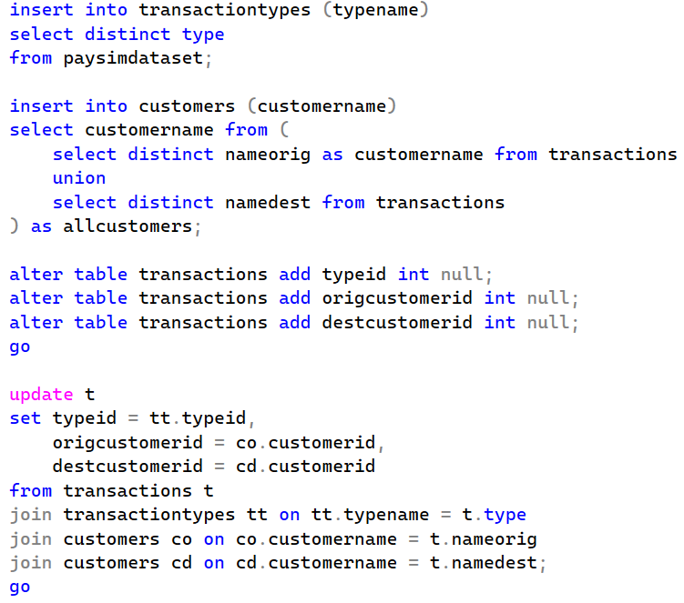
The second snippet is the time-based fraud-monitoring view paired with a parameterized stored procedure. The view pre-aggregates fraud counts and fraud percentages for each step (hour), and the procedure exposes a window-based query that the bank's monitoring team can run with any start and end step to inspect spikes in real time.
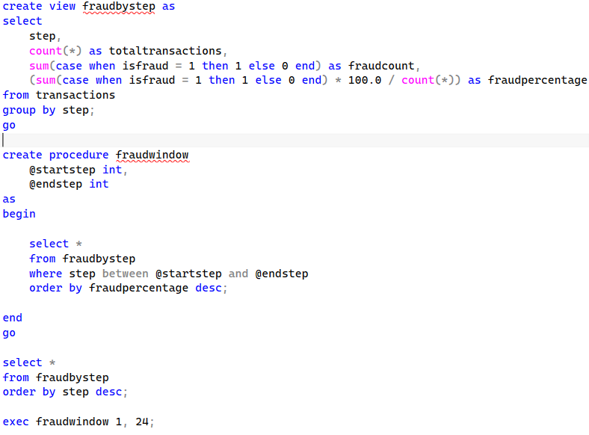
The third snippet shows that we used the fn_largetransactions table-valued function to identify transactions whose amount exceeds a specified multiple of the average transaction value, helping detect unusually large or suspicious transactions. It also includes the highvaluespenders stored procedure, which identifies accounts with high-value transactions and calculates their total exposure for fraud and risk analysis.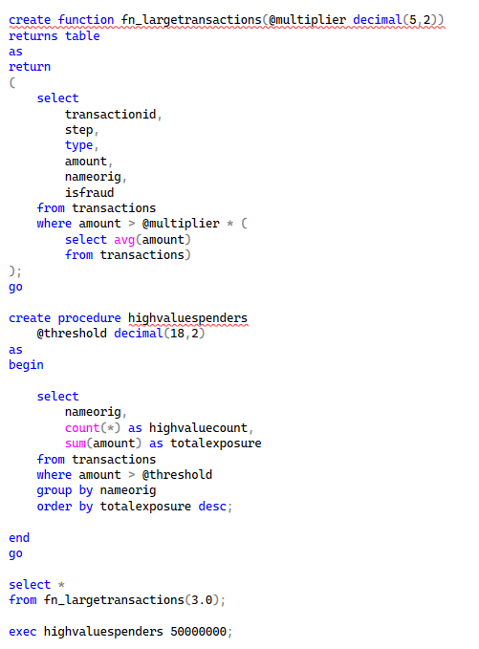
The fourth snippet shows that we created the vw_customerbehavior view to analyze customer transaction patterns by calculating total transactions, average transaction amount, maximum transaction amount, and total spending for each customer. It also includes queries to rank customers by total spending and identify customers whose average transaction amount is significantly higher than the overall transaction average, helping detect unusual spending behavior and potential fraud risk.
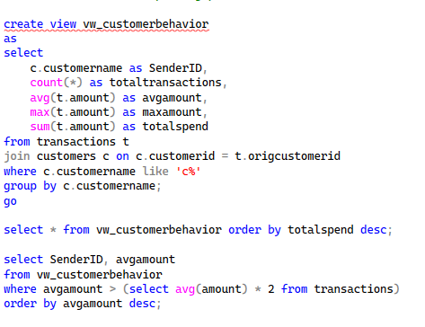
This fifth snippet shows that we created the vw_typeperformance view to evaluate transaction activity and fraud patterns across different transaction types. It calculates total transactions, total transaction volume, fraud count, and fraud rate for each transaction type, helping identify which transaction categories are most associated with fraudulent activity.
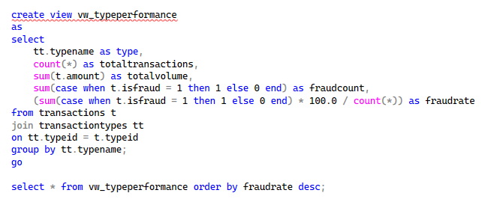
The final snippet is the fraud-monitoring overview view combined with a customer-based fraud analysis view. The vw_fraudoverview view summarizes total transactions, fraud transactions, and overall fraud percentage across the system, while the vw_topfraudsters view identifies customers involved in fraudulent transactions by counting their fraud cases, helping analysts monitor fraud trends and detect high-risk accounts.
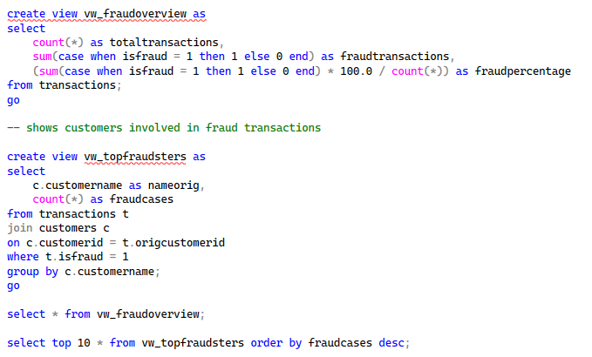

4. Analysis and Performance
4.1 Query Optimization
Query performance was a central concern given the size of the PaySim dataset, which contains millions of rows in the Transactions table. Several optimization techniques were applied at the schema and query layers. First, normalization itself was an optimization: by replacing wide repeated string identifiers (nameOrig, nameDest, type) with integer foreign keys, the row size shrank substantially and join operations became significantly faster because integer comparisons outperform string comparisons on large tables. Second, the primary keys on Customers, TransactionTypes, and Transactions create clustered indexes by default in SQL Server, which physically order the rows on disk and accelerate primary-key lookups and range scans on TransactionID. Third, aggregations that are executed frequently, such as fraud counts per step and per transaction type, were encapsulated in views (fraudbystep, vw_typeperformance, vw_fraudoverview). When the same logical query is required repeatedly by analysts, expressing it as a view both standardizes the calculation and allows the query optimizer to reuse plan information across calls.
Before normalization, a query that asked for fraud rate per transaction type had to perform a full table scan over a wide flat table, group by a long string column, and aggregate. After normalization, the same logical query joins the Transactions table to TransactionTypes on integer keys and groups on the small lookup table, which the optimizer can resolve much more efficiently. A similar improvement was observed for customer-level queries: instead of grouping by a long string identifier, queries now group by integer CustomerID, and the customer name is retrieved only once per group through a single join. While exact timing varied with hardware, the qualitative outcome was clear: every analytical query in the project was visibly faster and more memory-efficient on the normalized schema than it would have been on the original flat table.
4.2 Data Integrity and ACID Properties
Data integrity is non-negotiable in any financial database. Four mechanisms were used to enforce it in this project. First, primary keys ensure entity integrity, so no two customers, transaction types, or transactions can share the same identifier. Second, foreign keys enforce referential integrity: a transaction cannot reference a non-existent customer or a non-existent transaction type, which prevents orphaned records that would otherwise corrupt fraud analytics. Third, NOT NULL constraints on critical columns (step, amount, type, isFraud, isFlaggedFraud, and the foreign-key columns after they were populated) prevent missing values from silently breaking aggregations. Fourth, UNIQUE constraints on CustomerName and TypeName prevent duplicate lookup entries that would otherwise cause incorrect joins and double-counting in analyses.
Beyond schema-level constraints, the project benefits from the ACID guarantees provided natively by SQL Server. Atomicity ensures that the multi-step INSERT and UPDATE operations used during normalization either complete fully or roll back, leaving the database in a consistent state. Consistency is enforced by the constraints described above. Isolation prevents interfering reads and writes when multiple sessions interact with the database, which is essential in a real fraud-detection setting where ingestion and analytical workloads run side by side. Durability ensures that committed data, especially fraud labels and updated balances, survives any system failure. A specific data-integrity check is implemented in Analysis 8, where the project query identifies transactions whose balance change does not mathematically match the recorded amount, flagging these as potential anomalies for manual review.

5. Results and Visualization
Eight analytical modules were implemented on the normalized schema. Each module answers a distinct business question, produces actionable output, and is paired with a recommended decision and an explanation of its cross-functional value. The summary table below maps each analysis to its purpose and the SQL objects that implement it.

# | Business Question | SQL Objects Used | Output
1 | How does fraud vary over time? | View: fraudbystep, Proc: fraudwindow | Fraud % per step + windowed report
2 | Which transactions are abnormally large? | TVF: fn_largetransactions, Proc: highvaluespenders | Large-amount list + top high-value spenders
3 | What are normal vs abnormal customer spending patterns? | View: vw_customerbehavior | Per-customer total, avg, max + outliers
4 | Which transaction types carry the most fraud risk? | View: vw_typeperformance | Fraud rate ranked by transaction type
5 | What is the system-wide fraud picture? | Views: vw_fraudoverview, vw_topfraudsters | Global fraud % + Top-10 fraudsters

5.1 Insight 1 — Fraud Activity Over Time
The fraudbystep view aggregates transactions for each simulation step and computes a fraud percentage. Inspection of the results showed that fraud is not uniformly distributed across time: certain hourly windows display markedly elevated fraud percentages compared with the system average. The fraudwindow procedure allows an analyst to drill into any range, for example steps 1 through 24 (the first simulated day), and quickly rank those hours by fraud rate. The recommended decision is for the bank to dynamically tighten authorization rules and alerting thresholds during the hours that historically show fraud spikes. The cross-functional benefit spans fraud operations, IT real-time alerting, risk management, and compliance reporting.
5.2 Insight 2 — Large-Transaction Detection
The fn_largetransactions table-valued function flags any transaction whose amount exceeds a configurable multiple of the dataset's average amount. When called with a multiplier of 3.0, it produces a focused list of unusually large transactions whose volume warrants investigation. The companion highvaluespenders procedure aggregates these large transactions per originating customer and ranks them by total exposure. Operationally, this allows compliance staff to enforce step-up authentication on high-value transactions and to maintain a watchlist of repeat high spenders. This insight directly supports anti-money-laundering (AML) controls and strengthens customer-authentication policies.
5.3 Insight 3 — Customer Behavior Profiles
The vw_customerbehavior view summarizes the total number of transactions, the average amount, the maximum amount, and the total spend for each sender. Filtering this view for customers whose average amount exceeds twice the system-wide average produces a concise list of outlier accounts. Such customers are not necessarily fraudulent, but their pattern is statistically unusual and therefore deserves monitoring. The insight feeds customer-profiling efforts, risk-scoring models, marketing segmentation for high-value clients, and fraud-detection algorithms.
5.4 Insight 4 — Transaction-Type Risk
The vw_typeperformance view ranks each transaction type by total volume, fraud count, and fraud rate. The results show that fraud is heavily concentrated in two transaction types in particular, TRANSFER and CASH-OUT, while types such as PAYMENT and DEBIT carry comparatively low fraud rates in the dataset. The recommended decision is therefore to apply the strongest fraud-control rules to the TRANSFER and CASH-OUT pipelines and to allocate more analyst attention to those flows. This insight is valuable for product design, fraud controls, business strategy, and IT system optimization.

5.5 Insight 5 — System-Wide Fraud Overview
The vw_fraudoverview view provides a single-row snapshot of total transactions, total fraudulent transactions, and the overall fraud percentage. The vw_topfraudsters view complements it by listing customers ranked by the number of fraud cases linked to them. Together, these objects form the basis of an executive dashboard: the overview tells leadership whether the system as a whole is operating within acceptable risk limits, while the top-fraudsters list identifies the specific accounts driving the headline number. This supports executive decision-making, audit compliance, fraud governance, and security operations.
6. Conclusion and Future Work
6.1 Conclusion
This project demonstrated that a carefully normalized relational schema, combined with a disciplined layer of views, stored procedures, and table-valued functions, is sufficient to build a meaningful fraud-detection and financial-analysis system on top of the PaySim dataset. The transformation from a single denormalized table into a 3NF model improved data quality, reduced redundancy, and made every downstream query measurably faster and easier to maintain. The eight analytical modules collectively address the questions that matter most in a real digital bank: when does fraud happen, who commits it, what does it cost, which transaction types are riskiest, and which transactions look mathematically suspicious. Each module was paired with a concrete business decision and a cross-functional value statement, which keeps the work anchored to the realities of fraud operations, risk management, compliance, and executive reporting in the FinTech industry.
6.2 Limitations
Several limitations should be acknowledged. First, PaySim is a synthetic dataset; while it is designed to mimic real mobile money flows, it does not capture every nuance of real fraudulent behavior, particularly the adversarial evolution of attacks over time. Second, the analytical layer is built entirely on SQL, which is excellent for structured aggregation but cannot match the predictive power of machine-learning models for detecting novel fraud patterns. Third, the project operates on a static snapshot of data; in a production setting, transactions arrive continuously and the fraud-detection system must operate in near real time, which would require streaming ingestion and event-driven processing rather than batch queries. Fourth, although query performance was improved through normalization, no explicit secondary indexing strategy was tuned by measuring execution plans at scale, and no partitioning of the Transactions table was attempted, which would matter once row counts cross into the hundreds of millions.
6.3 Future Work and Production Scaling
To evolve this system toward production quality, several enhancements are recommended. Non-clustered indexes should be added on columns frequently used in WHERE clauses and JOINs, in particular Transactions.step, Transactions.isFraud, Transactions.OrigCustomerID, and Transactions.TypeID, after measuring query plans on the full dataset. The Transactions table should be partitioned by step (or by a real timestamp in production) so that hourly fraud queries can prune to the relevant partition. The analytical views could be materialized (indexed views) where the underlying aggregations are read very frequently and write rates are moderate, trading slightly slower writes for substantially faster reads. The system could then be connected to a stream-processing layer so that new transactions trigger fraud rules in real time rather than relying on batch queries. Finally, the SQL layer could expose its outputs to a machine-learning module that uses the labeled fraud history as training data, allowing the bank to detect novel fraud patterns that no static rule would catch. A BI front-end such as Power BI or Tableau, connected directly to the analytical views, would complete the stack and turn the database into a true fraud-monitoring product.

7. References and Appendices
7.1 References
- Lopez-Rojas, E. A., Elmir, A., and Axelsson, S. PaySim: A Financial Mobile Money Simulator for Fraud Detection. European Modeling and Simulation Symposium (EMSS), 2016.
- Kaggle. PaySim Synthetic Mobile Money Dataset. Publicly available at kaggle.com/datasets/ealaxi/paysim1.
- Microsoft Documentation. Transact-SQL (T-SQL) Reference — Views, Stored Procedures, Table-Valued Functions, Foreign Keys.
- Elmasri, R. and Navathe, S. B. Fundamentals of Database Systems, 7th Edition. Pearson.
- Silberschatz, A., Korth, H. F., and Sudarshan, S. Database System Concepts, 7th Edition. McGraw-Hill.
7.2 Dataset Documentation
The PaySim1 dataset used in this project is a publicly available synthetic dataset hosted on Kaggle. It was generated by Lopez-Rojas et al. using an agent-based simulator calibrated on a real mobile money service in an African country. The dataset contains roughly 6.3 million labeled transactions across five transaction types, with explicit isFraud and isFlaggedFraud columns that make it suitable for supervised fraud-detection research and for the kind of SQL-based analytics presented here.
7.3 Repository
All SQL scripts used in this project, including the schema-creation script, the normalization pipeline, the eight analytical modules, and the demonstration queries, are bundled with this report and will be hosted in a public GitHub repository for review. The repository link is: github.com/fatima-khuram/paysim-fraud-detection-dbms

7.4 Team Contributions
Team Member | Roll No. | Primary Contribution
Fatima Khuram | 24L-5567 | Normalization, ERD, Transaction-type fraud risk analysis and Integration of all Analysis in one system.
Sehar Taimoor | 24L-5584 | Fraud time-window and Fraud Activity Over Time Analysis.
Anfal Batool | 24L-5018 | Schema Design, Customer Behavior views and customer spending patterns Analysis.
Areesha Talha | 24L-5504 | Large-Transaction Detection Analysis and Functions Implementation.
Syeda Somal Fatima | 24L-5715 | System-wide Fraud Overview and Analysis.

7.5 Appendix A — Complete List of SQL Objects Created
- Tables: Customers, TransactionTypes, Transactions
- Foreign Keys: FK_Trx_Type, FK_Trx_Orig, FK_Trx_Dest
- Views: fraudbystep, vw_customerbehavior, vw_typeperformance, vw_fraudoverview, vw_topfraudsters.
- Stored Procedures: fraudwindow, highvaluespenders.
- Table-Valued Functions: fn_largetransactions

