Task-1 Accept two numbers and calculate addition, multiplication, division, subtraction.

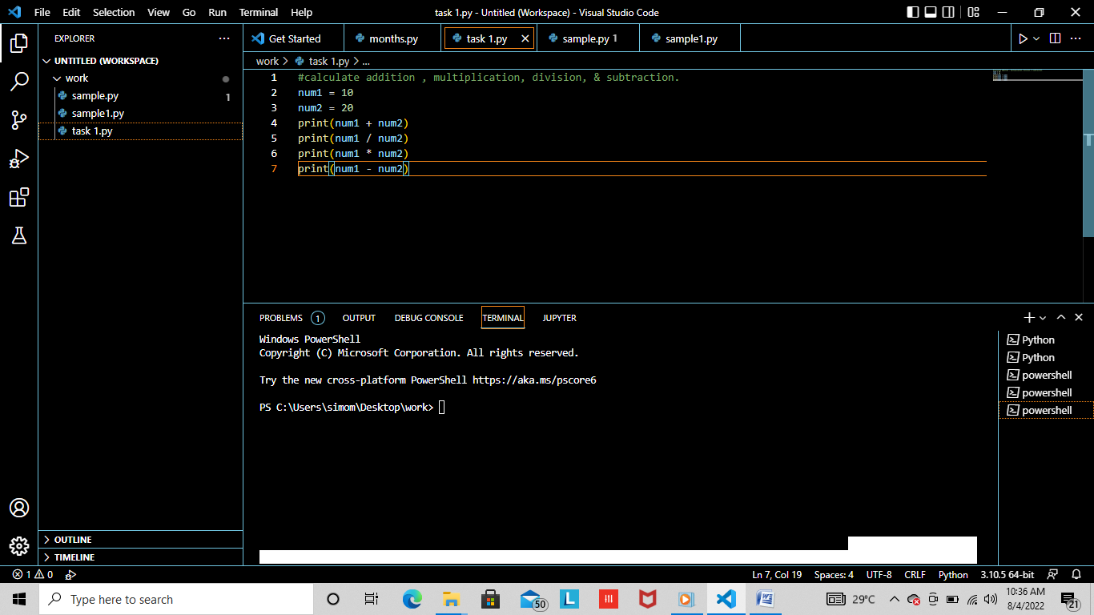

Task-2 Accept years from user and convert it into year.

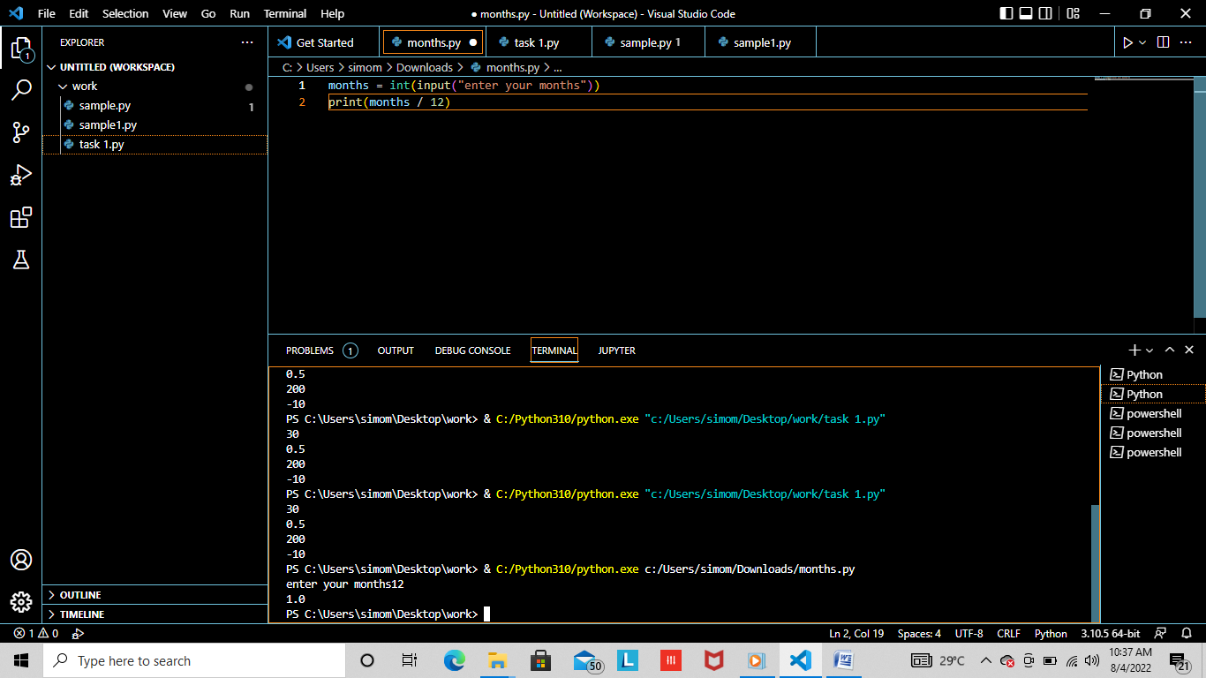

Task-3 Accept years from user and convert it into numbers of months and days.

