SNOW2
FYP Proposal
Data Mining on Social Networks
to Build Psychological Profiles

by
Roger Leung, Arthur Chan and Walter Ho
SNOW2

Advised by
Prof. Edward SNOWDEM

Submitted in partial fulfillment
of the requirements for COMP 4982
in the
Department of Computer Science
The Hong Kong University of Science and Technology
2016-2017
Date of submission: September 22, 2016
Table of Contents
1 Introduction 4
1.1 Overview 4
1.2 Objectives 6
1.3 Literature Survey 7
2 Methodology 9
2.1 Design 9
2.2 Implementation 10
2.3 Testing 11
2.4 Evaluation 12
3 Project Planning 13
3.1 Distribution of Work 13
3.2 GANTT Chart 14
4 Required Hardware & Software 15
4.1 Hardware 15
4.2 Software​​​​​​​​​​​​ 15
5 References 16
6 Appendix A: Meeting Minutes 17
6.1 Minutes of the 1st Project Meeting 17
6.2 Minutes of the 2nd Project Meeting 18

Introduction

Overview
In the 1880s, Herman Hollerith developed a counting machine for the U.S. Census Bureau that utilized readable cards with punch holes to denote citizens’ individual traits like gender and occupation. He patented the invention and started a business called Tabulating Machine Company. In 1911, he sold the business and it became part of a larger company, the Computing-Tabulating-Recording (CTR) Company. Under the leadership of Thomas J. Watson, CTR was renamed International Business Machines Corporation (IBM) in 1924 [1].

One subsidiary of IBM was the company, Deutsche Hollerith Maschinen Gesellschaft (Dehomag), which was run by Willy Heidinger, a strong supporter of Adolf Hitler and the Nazis. Shortly after Hitler came to power in 1933, he began to set up concentration camps for political opponents and Jews. He also utilized IBM’s Hollerith machines for a census in 1933. This greatly helped him identify Jews and take away their citizenship status in Germany. IBM and the Nazis developed a close business relationship and more detailed data collection tactics. The 1939 census in Germany allowed the Nazis to accurately identify most Jews and put them in ghettos. As the Nazis conquered new territories, they also worked with IBM to conduct further censuses in the occupied lands. After most Jews were rounded up and placed in concentration camps, IBM punch card technology was used extensively to manage the huge numbers of people [2].

After World War II, thousands of Nazi scientists, engineers and intellectuals were secretly taken to the US under Operation Paperclip. They continued their research in the US and assisted in various projects like jet rocket propulsion, electromagnetic propulsion, mind control, genetic engineering, operations research and data processing [3].

The invention of fast data processing computers greatly enhanced the process of human data collection, processing and analysis. As time went on, the U.S. Government began building more and more detailed psychological profiles of its citizens. For example, the Information Awareness Office (IAO) of the U.S. Defense Advanced Research Projects Agency (DARPA) applies surveillance and information technology to “create enormous computer databases to gather and store the personal information of everyone in the United States, including personal e-mails, social networks, credit card records, phone calls, medical records, and numerous other sources, without any requirement for a search warrant” [4].

However, since data collection is the most noticeable aspect of psychological profiling and since government agencies are more vulnerable to public scrutiny than private entities, private companies are relied upon to perform data collection operations. In exchange for providing data, such companies receive insider information that can help them in their operations [5]. Some other assistance is also allegedly provided when needed [6]. Popular social networking websites have become ideal for such data collection activities.

In our final year project, we similarly perform data mining on popular social networks to build psychological profiles.

Objectives

The goal of this project is basically to try to do something like the NSA does to gather information from unsuspecting social networking users and build psychological profiles. However, we’ll do it on a smaller scale and utilize legal means. Our project will mainly focus on the following objectives:

- Develop a system that automatically and regularly collects and correlates data for HKUST students using popular social networking websites like Facebook, Twitter and Google+
- Build a psychological profile database
- Utilize data mining techniques to find similar students according to certain personal preferences.
- Provide a user-friendly graphical user interface to display psychological profiles and lists of similar students based on similar personality traits.

To achieve the first goal, we will …
To achieve the second goal, we will …
To achieve our third goal, we will …

The biggest challenge we expect to face will be … To address this challenge, we will … Also, we will …

Literature Survey
We did an online survey and found the following systems related to our project.

Facebook
Facebook was founded in February 2004 by Mark Zuckerberg with his college roommates and fellow Harvard University students Eduardo Saverin, Andrew McCollum, Dustin Moskovitz and Chris Hughes [7]. Members of the website can share information about themselves and assist the NSA in building dossiers of every Internet user on the planet. It offers notes, messaging, live voice calls, video calling and other services. It has revolutionized the way people interact with one another.
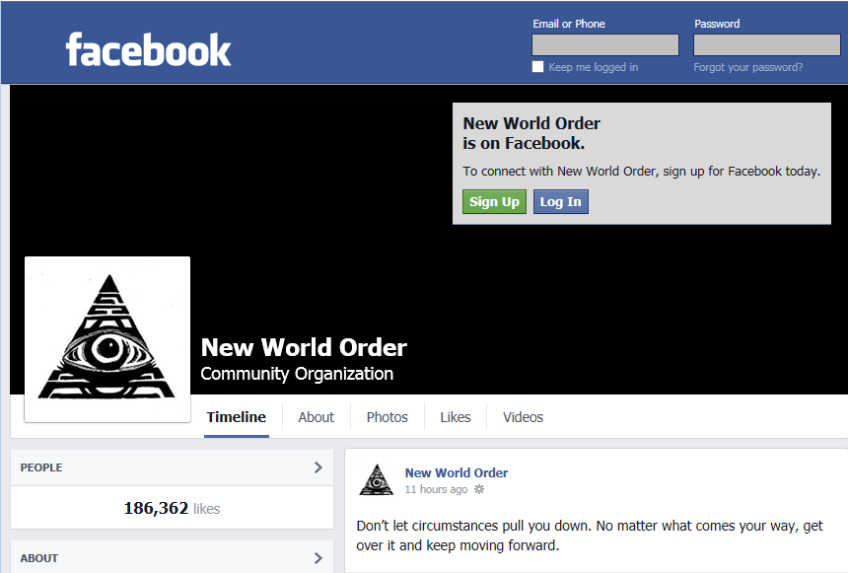
Figure 1 – Facebook, an online social networking and data gathering service

Twitter
Twitter …
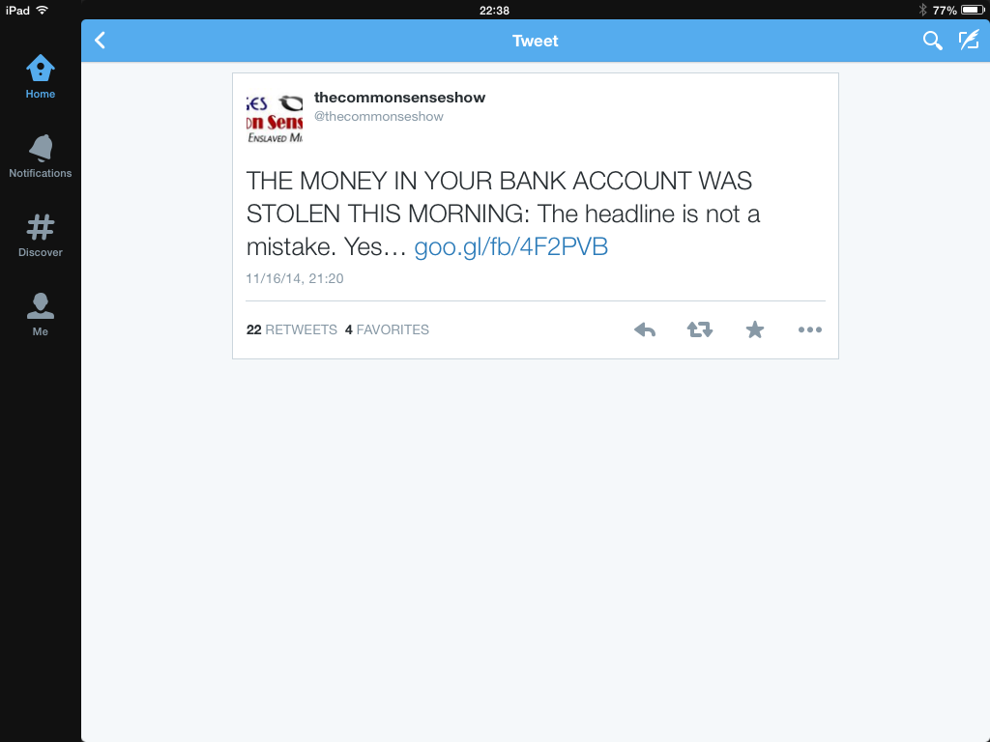
Figure 2 – Twitter, another online social networking and data gathering service

Google+
Google+ was …

Psychological Profiler

This program allows users to create psychological profiles of their friends, co-workers, clients, etc. The software can be useful in knowing how to best communicate with contacts.

Methodology

Design

The Design Phase of the project started in early July, and we will continue working on the following aspects:

Analyze Social Networks
We will carefully study Facebook, Twitter and Google+ to understand how they store data and how we can easily capture it and store it in a database.

Design Data Crawling Techniques
We will design algorithms to periodically crawl the social networking websites and collect data for our database.

Design the database
We will design an entity-relationship schema (ER diagram) for our psychological profile database. The ER diagram will help us design a stable and efficient database. It will also help us …

Design data mining algorithms
We will design some data mining algorithms to find useful data in our database…

Design the user interface
We will design a user interface that is easy to use and can display psychological profiles and lists of similar students based on similar personality traits.

Implementation
The Implementation Phase will include the following aspects:

Develop the Data Crawler
Based on our design, we will use C++ to write programs to crawl for data on Facebook, Twitter and Google+.

Build the database
Based on our ER diagram, we will use My SQL to build our psychological profile database. It must …

Develop the data mining algorithms
Based on our design, we will use C++ to write the data mining algorithms to find useful data in our database…

Build the user interface
Based on our design, we will use Dreamweaver to develop the user interface.

Testing
During the development process, unit testing will be done to ensure all modules are built correctly. System integration testing will be done after we have built all the components and combined them into the application. We will test the database, the algorithms and the user interface.

Test the Web Crawler
To test the web crawler, we will …

Test the Database
To test the database, we will …

Test the Data Mining Algorithms
To test the data mining algorithms, we will …

Test the User Interface
To test the user interface, we will …

Evaluation
After we have finished all the testing, we will evaluate the system to check whether it fulfills our objectives or not …

Project Planning

Distribution of Work
Task | Roger | Arthur | Walter
Do the Literature Survey | ○ | ● | ○
Analyze Social Networks | ● | ○ | ○
Design Data Crawling Techniques | ● | ○ | ○
Design the Database | ○ | ○ | ●
Design Data Mining Algorithms | ○ | ● | ○
Design the User Interface | ○ | ● | ○
Develop the Data crawler | ● | ○ | ○
Build the Database | ○ | ○ | ●
Develop the Data Mining Algorithms | ○ | ● | ○
Build the User Interface | ○ | ● | ○
Test the Web Crawler | ● | ○ | ○
Test the Database | ● | ○ | ○
Test the Data Mining Algorithms | ○ | ○ | ●
Test the User Interface | ○ | ● | ○
Perform Integration Testing | ● | ○ | ○
Write the Proposal | ● | ○ | ○
Write the Monthly Reports | ● | ○ | ○
Write the Progress Report | ● | ○ | ○
Write the Final Report | ● | ○ | ○
Prepare for the Presentation | ○ | ○ | ●
Design the Project Poster | ○ | ○ | ●
● Leader ○ Assistant

GANTT Chart
Task | July | Aug | Sep | Oct | Nov | Dec | Jan | Feb | Mar | Apr
Do the Literature Survey
Analyze Social Networks
Design Data Crawling Techniques
Design the Database
Design Data Mining Algorithms
Design the User Interface
Develop the Data crawler
Build the Database
Develop the Data Mining Algorithms
Build the User Interface
Test the Web Crawler
Test the Database
Test the Data Mining Algorithms
Test the User Interface
Perform Integration Testing
Write the Proposal
Write the Monthly Reports
Write the Progress Report
Write the Final Report
Prepare for the Presentation
Design the Project Poster

Required Hardware & Software

Hardware
Development PC: PC with MS Windows XP or later
Minimum Display Resolution: 1024 * 768 with 16 bit color
Server PC: PC with 1TB hard drive

Software​​​​​​​​​​​​
MySQL For our database
JAVA, JavaScript, PHP Programming languages
Eclipse with Android SDK Compiler
Adobe Photoshop, Illustrator For graphic design
Adobe Dreamweaver For designing the website

…

References
[1] W. R. Aul, "Herman Hollerith: Data Processing Pioneer," Think, 1972, pp. 22-24.
[2] E. Black, IBM and the Holocaust, Crown Books, 2001, p. 25.
[3] J. Marrs, The Rise of the Fourth Reich, HarperCollins, 2008, pp. 125-203
[4] You Be the Judge and Jury, DARP Information Awareness Office, 2014,
http://www.youbethejudgeandjury.com/darpa_information_awareness_office.htm
[5] T. Durden, “Thousands Of Firms Trade Confidential Data With The US Government In Exchange For Classified Intelligence,” Zero Hedge, 14 June 2013, http://www.zerohedge.com/news/2013-06-14/thousands-
firms-trade-confidential-data-us-government-exchange-classified-intelligen
[6] M. Greenop. “Facebook – the CIA conspiracy,” The New Zealand Herald,
8 August 2007, http://www.nzherald.co.nz/technology/news/article
.cfm?c_id=5&objectid=10456534
[7] Facebook, Company Info, Sept. 2014, http://newsroom.fb.com/company-info/

Appendix A: Meeting Minutes

Minutes of the 1st Project Meeting
Date: June 26, 2016
Time: 11:00 am
Place: Room 3666
Present: Roger, Arthur, Walter, Prof. Snowdem
Absent: None
Recorder: Roger

- Approval of minutes
This was the first formal group meeting, so there were no minutes to approve.

- Report on progress
  - All team members have read the instructions of the Final Year Project online and have done research for the topic.
  - Roger and Arthur have done research on social networks.
  - Walter has studied the Facebook, Twitter and Google+ user agreements.
  - All team members have read the information provided by Prof. Snowdem.

- Discussion items
  - The goal of project is basically to try to do something like the NSA does to gather information from unsuspecting social networking users and build psychological profiles. However, we’ll do it on a smaller scale and utilize legal means.
  - The scope of the project includes data from a few thousand people who use Facebook, Twitter and Google+.
  - The project plan needs to include a list of the main tasks, who will work on each task and a GANTT chart.
  - Popular development tools for grabbing data from social networks are ______. We will try these and compare them for user-friendliness and effectiveness.
  - Professor Snowdem demonstrated how to access a secure database and find interesting information, but he suggested we don’t try this ourselves.

- Goals for the coming week
  - All group members will study new information provided by Prof. Snowdem.
  - Roger will set up a server for testing.
  - Arthur will compare the popular development tools for web crawling and data mining.
  - Walter will study different database systems used in social networks and data mining
  - All group members will think about ways to develop a good system.

- Meeting adjournment and next meeting
The meeting was adjourned at 4:00 pm.
The next meeting will be at 11:00 on July 3rd at the LG7 Canteen.

Minutes of the 2nd Project Meeting
Date: July 3, 2016
Time: 11:00 am
Place: LG7 Canteen
Present: Roger, Arthur, Walter
Absent: Prof. Snowdem
Recorder: Arthur

- Approval of minutes
The minutes of last meeting were approved without amendment.

- Report on progress
  - All group members have studied new information provided by Prof. Snowdem.
  - Roger set up a server for testing, but he had some trouble with the configuration.
  - Arthur compared the popular development tools for grabbing social network data, and he found that XXX is best for ???, but YYY is best for ???.
  - Walter studied the database systems used in the three social networks, and he says that Facebook and Google have proprietary database systems, but they are based on ZZZ and AAA. Twitter is …
  - All group members have thought about ways to develop the system and some suggestions were mentioned.
- Discussion items
  - Prof. Snowden was unable to attend the meeting, since he is travelling for a couple weeks. We’ll send any questions to him by e-mail, and he’ll try to send us additional information if necessary.
  - The group considered if this project is really suitable for the FYP given the time constraints.
  - Roger suggested we consider doing a game FYP instead. Arthur liked the idea, but Walter wants to study the information from Prof. Snowden more closely.
  - Possible game themes were discussed.
  - Roger said he’s discontinuing his Facebook account and will no longer use Google. Arthur said he likes the ixquick search engine, since it uses proxy servers.
- Goals for the coming week
  - All group members will read more information related to the project topic, e.g., social networks and the NSA
  - All group members will need to study and compare the languages and software being considered for implementation of the project.
  - All group members will think about possible game themes in case we trash the current project goal.
  - Walter will e-mail Prof. Snowdem to discuss the project and his plans.
- Meeting adjournment and next meeting
The meeting was adjourned at 4:00 pm.
The date and time of the next meeting will be set later by e-mail.

