TEST CHARTER 01:
TEST ENVIRONMENT AND URL: https://adactinhotelapp.com/index.php
Start time : 10:36 pm
Duration: 36 minutes
Tester(s) Name : Fatima Zehra
Testing Notes:
- Multiple wrong username attempts
- Multiple wrong passwords attempts
- Registration form
- Verification of email
- Forgot password feature
- Tested buttons like reset, login etc.
- Website design
- Reset password multiple times
- Copy pasted password to see if it can copied and pasted anywhere else

Data files:
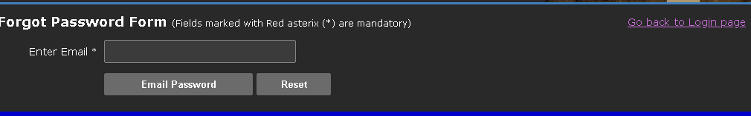
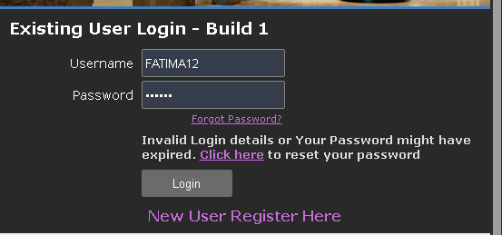
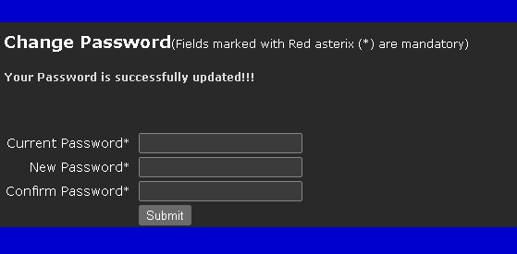
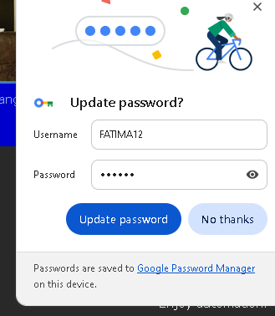

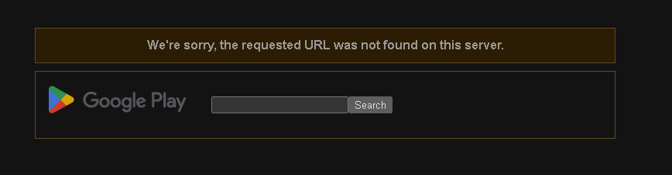
Bugs/defects :
- Gets logged in after multiple wrong password attempts .
- Show password button is missing can’t see what we typed .
- No captcha to check if human or robot anyone can automate multiple attempts .
- Weak security didn’t save password and username it still auto fills everything .
- Reset button is useless it doesn’t work .
- It doesn’t Block account after multiple failed attempts.
- Password gets changes every single time multiple times in day 50 times anyone can open our id and change pass if they want .
- Unnecessary info “click here to change password” while there already is forgot password button present . Anyone can change our password using there own new email.
- In forgot feature unnecessary email’s password is required which is inappropriate also it does work without entering password field again their reset button doesn’t work .
- There in web page link for app is mention when user clicks it . it says no url found in playstore .

