Count Vowels in a String

Write a function that counts how many vowels (a, e, i, o, u) are in a given string (case-insensitive).

Example:

Input: "JavaScript"

Output: 3

Check Even or Odd Numbers in an Array

Write a function that takes an array of numbers and prints "even" if the number is even, or "odd" if the number is odd.

Example:

Input: [1, 4, 7, 10]

Output:

odd

even

odd

even

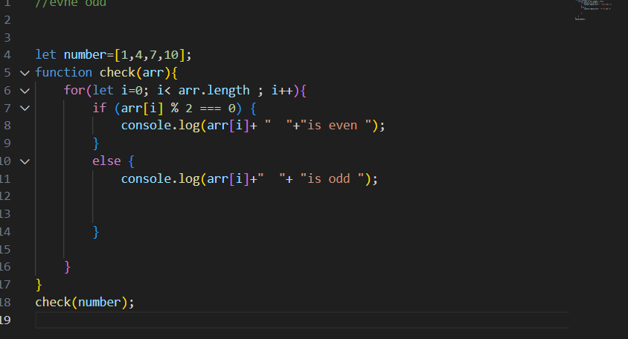

Find Longest Word in a String

Write a function that takes a sentence and returns the longest word in it.

Example:

Input: "I love JavaScript programming"

Output: "JavaScript"

FizzBuzz Problem

Print numbers from 1 to 50. For multiples of 3, print "Fizz", for multiples of 5, print "Buzz", and for multiples of both, print "FizzBuzz".

Find the Second Largest Number in an Array

Write a function to find the second largest number in a given numeric array.

Example:

Input: [10, 5, 20, 8, 12]

Output: 12

Flatten a Nested Array

Write a function that flattens an array with nested arrays into a single-level array.

Example:

Input: [1, [2, [3, 4], 5], 6]

Output: [1, 2, 3, 4, 5, 6]