Yarmouk University


Information Technology and Computer Science
Information Systems (IS)

InternEra

Project Team:
Khadijah Althafir, 2022902038
Sadeen Abu Hana, 2022902061
Dania kasem, 2022802025
Fatima Tawalbleh, 2022902088

Supervisor
Dr. Ahmad Ali Saifan

<2025-2026 Second Semester>

Acknowledgement
We would like to express our sincere gratitude to Allah for granting us the knowledge, strength, and perseverance to successfully complete this project.
We would like to extend our deepest appreciation to our supervisor, Dr. Ahmad Ali Saifan, for his continuous support, valuable guidance, and insightful feedback throughout the development of this project. His expertise and encouragement played a significant role in shaping our work and overcoming challenges.
We are also thankful to Yarmouk University, the Faculty of Information Technology and Computer Science, and all the professors and staff who contributed to our academic journey and provided us with the knowledge and skills necessary to accomplish this project.
We would also like to express our sincere appreciation to Dr. Muwaffaq Ayaad from the Entrepreneurship and Innovation Center for his support and for helping us connect our project with the local market.
Special thanks to our parents, friends, and colleagues for their endless support, motivation, and encouragement during this journey.
Finally, we acknowledge with gratitude everyone who supported us in any way and contributed, directly or indirectly, to the successful completion of this project.

Table of contents
Table of contents
- Introduction 6
- Project overview 6
- Project objectives 7
- Literature Review 7
- Requirements Phase 9
  - Requirements Specification 9
    - Functional Requirements 9
Non Functional Requirements 9
- Analysis Phase 10
  - Use Case Diagram 11
  - Use Case Specification : 11
    - Apply for Internship 11
    - Search for Internship 12
    - Upload a CV 13
    - Complete and Edit Profile 13
    - Save Internship in Dashboard 14
    - Manage Application 15
    - Generate Report 15
    - Accept/Reject Application 16
    - View Student CV 17
    - Post Internship 17
    - Communicate with Student 18
  - Activity Diagrams for all Specification Tables 20
    - Activity Diagram for “Apply for Internship” 20
    - Activity Diagram for “Search for internship” 21
    - Activity Diagram for “Upload a CV” 22
    - Activity Diagram for “Complete and Edit Profile” 23
    - Activity Diagram for “Save Internship in Dashboard” 24
    - Activity Diagram for “Manage Application” 25
    - Activity Diagram for “Generate Reports” 26
    - Activity Diagram for “Accept/Reject Application” 27
    - Activity Diagram for “View Student CV” 28
    - Activity Diagram for “Post Internship” 29
    - Activity Diagram for “Communicate with Student” 30

- Design Phase : 31
  - Context diagram 31
  - ERD Diagram 31
  - Database Logical Diagram 32
- Implementation Phase 32
  - Language used 32
  - Tools used 33
  - Templates 33
  - Screen shoots for the system 33
d.1 Student Screens 33
d.2 Admin Screens 39
d.3 Company Screens 43
  - Scenarios 48
e.1 Pseudocode 48
e.2 Flowchart 49
  - Sample reports 52

- References 54

Table of figures
Table of figure
Figure 1: LinkedIn 7
Figure 2: Indeed 8
Figure 3: InternShala 8
Figure 4: Use Case Diagram 11
6.3 Activity Diagram:
Figure 5: Apply for Internship 20
Figure 6: Search for Internship 21
Figure 7: Upload a CV 22
Figure 8: Complete and Edit Profile 23
Figure 9: Save Internship in Dashboard 24
Figure 10: Manage Application 25
Figure 11: Generate Report 26
Figure 12: Accept / Reject Application 27
Figure 13: View Student CV 28
Figure 14: Post Internship 29
Figure 15: Communicate with student 30
Figure 16: Context Diagram 31
Figure 17: ER Diagram 31
Figure 18: DB Schema Diagram 32
Figure 19: Homepage 33
Figure 20: Welcome Popup 34
Figure 21: Student Login Page 34
Figure 22: Student Registration Page 35
Figure 23: Company Registration Page 35
Figure 24: Student Dashboard Page 36
Figure 25: Applications Page 36
Figure 26: Saved Internships Page 37
Figure 27: Message Page 37
Figure 28: Profile Page 38
Figure 29: Profile Page Cont. 38
Figure 30: CV Upload Page 39
Figure 31+32: Admin Dashboard Page 39
Figure 33: AI Internships Verification Page 40
Figure 34: Manage student Page 41
Figure 35: View Company Page 41
Figure 36: View Internship Page 42
Figure 37: View Applications Page 42
Figure 38: Company Sign In Page 43
Figure 39: Company Dashboard 43
Figure 40: My Internships Page 44
Figure 41: Applicants Overview Page 44
Figure 42: Company Profile Page 45
Figure 43: Messaging Interface 45
Figure 44: Post Internship Form- Step 1 46
Figure 45: Internship Review Page - Step 2 46
Figure 46: Internship Published Confirmation- Step 3 47
Figure 47: Manage Internship Listings Page 47
Figure 48: Flow Chart (Pseudocode for Marching score) 50
Figure 49: Flow Chart (Pseudocode for recommendations Internships) 51
Figure 50+51:Report And Statistics Pages 52
Figure 52+53:Reports PDF Details 53

- Introduction
Students often struggle to find internships that match their field of study because internship opportunities are often scattered across different platforms and websites. This makes it difficult and time-consuming for students to discover opportunities that are relevant to their academic background and career goals. As a result, many students miss valuable chances to gain practical experience during their studies. This project aims to develop a web-based platform that connects students with companies offering internship opportunities in a centralized system. The platform will allow students to easily search for internships, apply for positions, and track their applications, while enabling companies to post internship offers and manage student applicants efficiently.

- Project Overview
The system is a web-based platform that helps students easily find internship opportunities through intelligent features such as internship recommendation and CV analysis, which improve the matching process between students and companies. Students can create accounts, enter their personal and academic information, and upload their CVs, which are then analyzed using Natural Language Processing (NLP) ad Ai to identify their skills and suggest suitable internships. Based on this process, students receive personalized recommendations and can apply directly through the platform, as well as track the status of their applications. In case of rejection, the system provides feedback explaining the reason to help students improve their future chances. On the other hand, companies can create profiles, post internship opportunities, define required skills and qualifications, and review student applications, allowing the system to efficiently connect both parties in a smart and user-friendly environment.
The target audience of this system mainly includes university students in Information Technology (IT) and related fields such as Computer Science, Software Engineering, and Information Systems. The platform is primarily designed for third- and fourth-year students who are actively seeking internships before graduation, but it is also accessible to first- and second-year students who want to explore opportunities and develop their skills early.

In addition, the system targets companies and organizations in the technology sector, including startups, software development firms, and large IT companies that are looking to recruit interns with relevant skills. The platform can also support academic institutions and career guidance units by helping students transition from academic learning to practical experience. By focusing on IT students and tech companies, the system ensures a more accurate and effective internship matching process.
3-Project Objectives
- To create a centralized platform that connects students with companies offering internship opportunities.
- To simplify the process of searching and applying for internships.
- To allow companies to post internship opportunities and manage applicants efficiently.
- To help students discover internships that match their skills, major, and interests.
- To improve the matching process between students and companies using intelligent features.
- To provide an organized system for tracking internship applications and status updates.
- To support students in gaining practical experience relevant to their academic studies and career goals.

4- Literature review
Figure 4.1: LinkedIn: https://www.linkedin.com/?trk=public_jobs_nav-header-logo
One of the most popular platforms , which allows users to build professional profiles, search for internships, and connect with recruiters. It offers a wide range of opportunities and networking features; however, it is not specifically designed for students, and its recommendations are often too general and not tailored to individual academic needs.
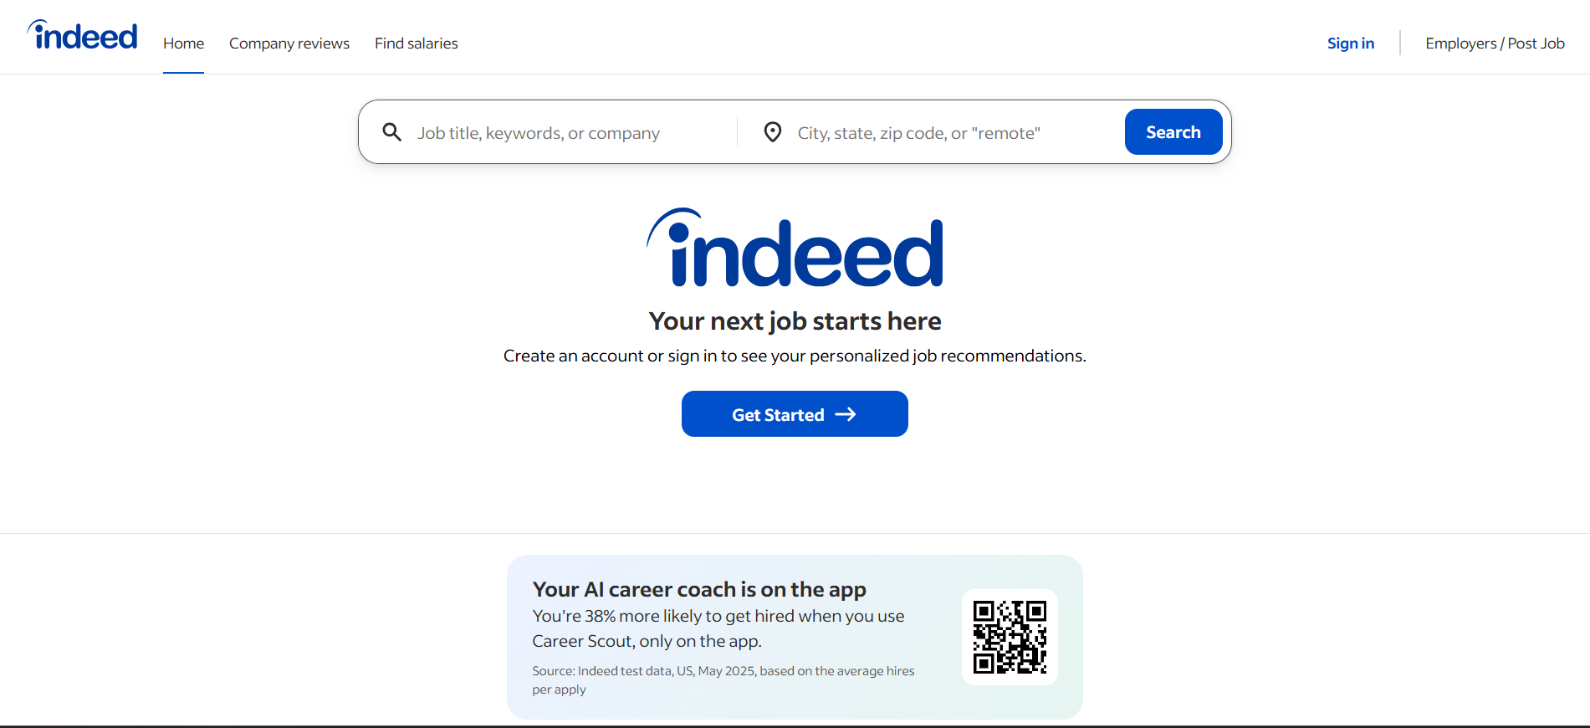
Figure 4.2: Indeed: https://www.indeed.com/
Another widely used platform , which aggregates job and internship listings from various sources. While it provides a large number of opportunities and an easy-to-use search interface, it lacks intelligent features such as skill-based matching or analysis of student profiles, making it less effective for personalized internship discovery.

Figure 4.3: InternShala: https://internshala.com/
is a platform specifically designed for internships, especially for students. It allows users to search and apply for internships based on categories and preferences. Although it is more focused on students, it still depends mainly on manual searching and filtering, with limited use of advanced technologies for personalized recommendations.
The proposed system (our website) integrates Artificial Intelligence (AI), specifically Natural Language Processing (NLP), to analyze student CVs and extract relevant skills. Based on this analysis, it performs intelligent matching between students and internship opportunities, providing personalized recommendations. It also offers feedback on rejected applications to help students improve. This makes the system more advanced, accurate, and student-centered compared to traditional platforms.

5-Requirement Phase
5.1 Requirements Specification:
5.1.2 Functional Requirements
1. Student Requirements
The student shall be able to:
    - Complete and edit their profile
    - Upload a CV
    - Search for internships by field of study, company name, location, internship type and duration
    - Apply for internships
    - Track application (without interact with the system)
    - Save internships in student’s dashboard
    - View recommended internships based on their CV
2. Company Requirements
The company shall be able to:
- Post internship opportunities
- Manage internship (Edit, delete and Update)
- View student CV
- Accept or reject applicants
- Communicate with students through the platform
3. Admin Requirements
The admin shall be able to:
- Manage student and company accounts (approve or reject, monitor, postings, filter based on skills and major)
- The admin can generate reports.

5.1.3 Non Functional Requirements
1. Usability
The system is designed to be user-friendly and easy to learn. A new user should be able to understand how to use the system within 5–10 minutes without prior experience.
- Users can complete main tasks, such as searching for an internship, in 3–5 simple steps
- At least 90% of users should be able to complete tasks without assistance
- The overall user satisfaction should achieve an average rating of 4 out of 5 or higher
2. Performance
The system ensures fast and efficient performance to provide a smooth user experience.
- Search results should be displayed in less than 2 seconds
- The system should support 100–500 concurrent users without performance degradation
- Internship listings and results should fully load within 3 seconds or less
3. Security
The system maintains a high level of security to protect user data and prevent unauthorized access.
- All user passwords must be securely encrypted using hashing techniques
- User accounts should be locked after 5 consecutive failed login attempts
- Sensitive system functions must only be accessible to authorized users
- The system should ensure zero data breaches at all times
4. Reliability
The system is expected to operate consistently and handle errors effectively.
- The system should maintain at least 99% uptime
- No data loss should occur during system operation
- Error messages should be displayed to users within 2 seconds
5. Scalability
The system should be capable of handling growth in users and data over time.
- It should support more than 1000 users as the system expands
- The system should handle over 10,000 internship postings efficiently
- Response time should remain within 3 seconds even under high load conditions
6-Maintainability
The system should be easy to maintain, update, and improve over time.
- Bugs and issues should be identified and fixed within 24–48 hours
- At least 80% of the codebase should be modular and well-structured
- New features and updates should be implemented within 2–3 days

6-Analysis Phase
6.1 Use Case Diagram:
The use case diagram illustrates the main interactions between three actors: Student, Company, and Admin. It outlines each actor’s functions: the Student can complete and edit their profile, upload a CV, search for internships, save them to a dashboard, apply, and track applications. The Company can post and manage internships, view student CVs, and communicate with applicants. The Admin is responsible for managing applicants, generating reports, and accepting or rejecting applications. The diagram also shows relationships such as include and extend, providing a clear overview of the system’s functional requirements.
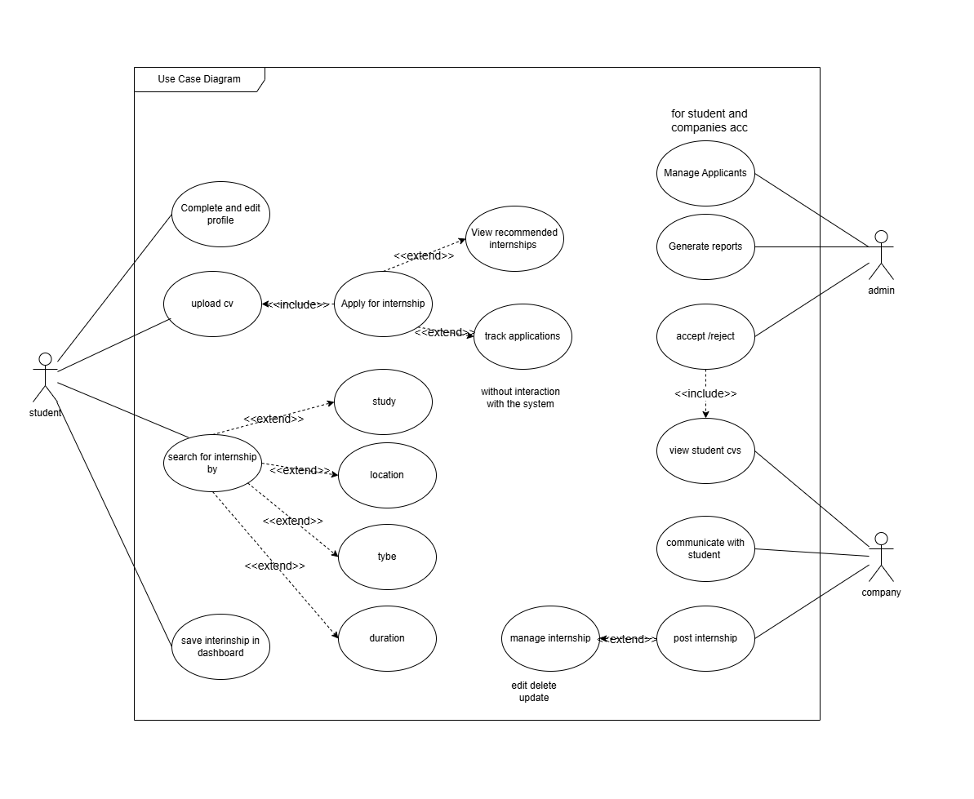
Figure 4: Use Case Diagram.

6.2 Use Case Specifications:
Table 6.2.1: Apply for Internship
Name | Apply for Internship
Description | This use case allows the student to apply for an available internship by submitting the required information and attaching a CV. The system validates the application data and stores it for review by the company.
Used by use Case | Upload CV
Flow of events | 1.The student searches for an internship.
 | 2. The system displays available internships.
 | 3.The student selects an internship
 | 4.The system displays internship details.
 | 5. The student clicks “Apply”.
 | 6. The system checks if a CV is uploaded.
 | 7. The student uploads CV (if not uploaded).
 | 8. The system attaches the CV.
 | 9. The student confirms the application.
 | 10. The system saves the application
Alternative / Exception Flows | 3. If the internship is unavailable, the system displays an unavailable internship message.  6. If no CV is uploaded, the system asks the student to upload a CV.  10. If it does not succeed, display an error message.
Preconditions | - The student has an account.  - The student is authenticated in the system.  - The internship is available.
Postconditions | - The application is saved in the system.  -The CV is attached to the application.  - A confirmation message is displayed.  - The company can view the application.
Input | - Student ID  - Internship ID  - CV file  -Application confirmation data
Output | -Confirmation message  -Application record  -Application status
Non_Functional Requirement | - The system should respond quickly.  - The application data must be stored securely.  - The interface should be user-friendly.

Table 6.2.2: Search for Internship
Name | Search for Internship
Description | This use case allows the student to search for available internships by entering specific criteria such as location, type, and duration. The system processes the search request and displays matching internship opportunities.
Used by use Case | None
Flow of events | 1.The student enters search criteria )study, location, type, duration(
 | 2. The system processes the search request.
 | 3. The system retrieves matching internships
 | 4.The system displays search results
 | 5.The student selects an internship
 | 6 . The system displays internship details.
2. The system validates the selected search type; if valid, it processes the request and displays matching results, otherwise it shows an error message and prompts the student to enter valid input.
3. If no internships match the search criteria, the system displays a "no results found" message.
Alternative / Exception Flows | - The student must have an account.  - The student is authenticated in the system
Pre-conditions | - A list of internships is displayed.  - The student can view internship details.
Post-conditions | Search criteria (study, location, type, duration)
Input | - List of internships  - Internship details
Output | - The system should return results quickly.  - The search results should be accurate.  - The interface should be user-friendly.

Table 6.2.3: Upload CV
Name | Upload CV
Description | This use case allows the student to upload a CV to the system so it can be used when applying for internships.
Used by use Case | Apply for internship
Flow of events | 1.The student opens the CV upload page
 | 2. The system displays the CV upload form.
 | 3.The student selects a CV file.
 | 4. The system validates the selected file
 | 5.The student clicks “Upload”.
 | 6.The system uploads and stores the CV
 | 7. The system displays a confirmation message.
3. If no file is selected, the system prompts the student to select a file.
6. If the upload fails, the system displays an error message and asks the student to try again.
Alternative /Exceptions flow | - The student has an account  - The student is authenticated in the system
Preconditions | - The CV is uploaded successfully  - The CV is stored in the system.  - The student can use the CV when applying for internships
Postconditions | CV file
Input | - Confirmation message  - Stored CV
Output | - The system should upload files quickly.  - The CV must be stored securely .  - The interface should be user-friendly.

Table 6.2.4 : Complete and Edit Profile
Name | Complete and Edit Profile
Description | This use case allows the student to complete or update personal, academic, and contact information in the system profile.
Used by use Case | None
Flow of events | 1. The student opens the profile page.
 | 2. The system displays the current profile information.
 | 3. The student enters or updates profile information.
 | 4. The system validates the entered data.
 | 5. The student clicks “Save”.
 | 6. The system updates the profile information.
 | 7. The system displays a confirmation message.
4. If any entered data is invalid, the system displays an error message and asks the student to enter valid data.
6. If the system fails to update the profile, an error message is displayed and the student is asked to try again.

Alternative /Exceptions flow | - The student has an account  - The student is authenticated in the system
Preconditions | - The profile information is saved successfully.  - The student profile is updated in the system
Postconditions | -Personal information  - Academic information  - Contact information
Input | -Updated profile information  -Confirmation message
Output | - The system should save profile changes quickly.  - Profile data must be stored securely.  - The interface should be user-friendly.

Table 6.2.5: Save Internship in Dashboard
Name | Save Internship in Dashboard
Description | This use case allows the student to save preferred internships into a personal dashboard for quick access, comparison, and future application.
Used by use Case | None
Flow of events | 1. The student views a list of internships or an internship detail page
 | 2. The system displays internship information.
 | 3. The student clicks “Save”.
 | 4. The system checks if the internship is already saved
 | 5.The system adds the internship to the student’s dashboard”.
 | 6. The system updates the dashboard instantly.
 | 7. The system displays a confirmation message. e.g., icon change or message
 | 4. If the internship is already saved, the system notifies the student and prevents duplication.
Alternative /Exceptions flow | - The student has an account  - The student is authenticated in the system.  -The internship is visible in the system.
Preconditions | - The internship is saved in the student’s dashboard  - The student can access it later
Postconditions | Internship ID
Input | - Saved internship list (dashboard)  - Confirmation message or visual indicator.
Output | - The save action should be immediate (real-time feedback).  - The dashboard should update without delay.  - The system should prevent duplicate entries

Table 6.2.6: Manage Application.
Name | Manage application.
Description | This use case allows the admin to review, organize, and manage student applications submitted for available internships.
Used by use Case | Accept / Reject  View Student CV
Flow of events | 1. The admin opens the applicants management page
 | 2. The system displays the list of submitted applications
 | 3. The admin selects an application.
 | 4. The system displays the application details.
 | 5.The admin reviews the applicant information and attached CV
 | 6. The system provides management options such as view, filter, and update application status.
 | 7. The admin performs the required action on the application
 | 8. The system saves the updates and refreshes the applicants list.
 | 9.The system displays a confirmation message.
2.If there are no submitted applications, the system displays a message indicating that no applications are available
4.If the selected application details cannot be retrieved, the system displays an error message.
8.If the system fails to save the changes, an error message is displayed and the admin is asked to try again.
Alternative / Exception Flows | - The admin has a valid account  - The admin is authenticated in the system.  - At least one internship application exists in the system.
Preconditions | - The selected application is reviewed or updated successfully  - The applicants list is updated in the system.
Postconditions | - Application ID  - Admin action or update.
Input | - Application details  - Updated applicants list  -Confirmation message
Output | - The system should load applications quickly.  - Application data must be stored securely  - The interface should allow easy navigation and filtering.

Table 6.2.7: Generate Report
Name | Generate Report.
Description | This use case allows the admin to generate analytical reports about internships, applications, and system activity to support decision-making.
Used by use Case | None
Flow of events | 1. The admin accesses the reporting section
 | 2. The system displays available report options (e.g., applications, internships, statistics.
 | 3. The admin selects the report type.
 | 4. The system requests report parameters (e.g., date range, category)
 | 5. The admin enters report criteria.
 | 6.The system processes and generates the report .
 | 7. The system displays the report results
 | 8.The admin downloads or exports the report (optional)
5.If required report parameters are missing or invalid, the system prompts the admin to enter valid data
6. If no data matches the selected criteria, the system displays a “No Data Available “message.
Alternative /Exceptions flow | - The admin has a valid account.  - The admin is authenticated in the system.
Preconditions | - The report is generated successfully.  - The admin can view or download the report.
Postconditions | - Report type  -Date range  -Filters / criteria
Input | Generated report (table / chart / file)
Output | - The system should generate reports within an acceptable time.  - The report data must be accurate and up-to-date.  The system should support exporting reports in standard formats (e.g., PDF)..

Table 6.2.8: Accept / Reject Application
Name | Accept / Reject Application.
Description | This use case allows the admin to review a student’s application and update its status by accepting or rejecting it.
Used by use Case | Manage Applicants
Flow of events | 1. The admin opens the applications management page.
 | 2. The system displays the list of submitted applications.
 | 3. The admin selects a specific application.
 | 4. The system displays the application details.
 | 5. The admin reviews the application information and chooses to accept or reject it.
 | 6. The system updates the application status.
 | 7. The system displays a confirmation message.
2. If no applications are available, the system displays a message indicating that there are no submitted applications.
4. If the selected application details cannot be retrieved, the system displays an error message.
5. If the application has already been accepted or rejected, the system informs the admin that no further action can be taken.
6. If the system fails to update the application status, an error message is displayed and the admin is asked to try again
Alternative /Exceptions flow | - The admin has a valid account.  - The admin is authenticated in the system.  -At least one student application exists in the system.
Preconditions | - The application status is updated successfully.  - The student application is marked as accepted or rejected in the system.
Postconditions | - Application ID.  -Decision status (Accept / Reject).
Input | -Updated application status.  -Confirmation message.
Output | - The system should update the application status quickly.  - Application data must be stored securely.  -The interface should clearly display the current application status

Table 6.2.9: View Student CV
Name | View Student CV
Description | This use case allows the company to view the CV of students who applied for its internships in order to evaluate applicant.
Used by use Case | Accept / Reject Application
Flow of events | 1. The company opens the list of received applications.
 | 2. The system displays all applications submitted to the company.
 | 3. The company selects a specific application.
 | 4. The system displays application details
 | 5. The company clicks “View CV”.
 | 6. The system retrieves the student’s CV.
 | 7. The system displays the CV.
2. If no applications exist, the system displays a message indicating that there are no applications.
6. If the student has not uploaded a CV, the system displays a message indicating that the CV is not available.
Alternative /Exceptions flow | - The company has a valid account.  - The company is authenticated in the system.  -At least one application exists.
Preconditions | The company successfully views the student CV
Postconditions | Application ID
Input | -Student CV  -Error or availability message
Output | - The system should retrieve CVs quickly.  - The CV must be stored securely .  - The CV should be clearly displayed.
Table 6.2.10: Post Internship
Name | Post Internship
Used by use Case | Manage Internship.
Flow of events | 1.The company selects “Post Internship”.
 | 2.The system displays the internship form.
 | 3. The company enters internship details (title, description, location, type, duration).
 | 4. The system validates the entered data.
 | 5. The company submits the internship.
 | 6. The system saves the internship.
 | 7. The system displays confirmation message.
4. If required fields are missing or invalid, the system displays a validation message and asks the company to correct the data.
6. If the system fails to save the internship, an error message is displayed and the company is asked to try again.
Alternative /  Exception Flows | - The company must have an account.  - The company is authenticated in the system.  - The company account is approved.
Preconditions | - The internship is successfully stored in the system.  - The internship becomes available for students to view.
Postconditions | Internship details (title, description, location, type, duration)
Input | - Confirmation message  - Internship record
Output | - The system should respond quickly.  - The data must be stored securely.  - The interface should be user-friendly.
Table 6.2.11: Communicate with Student.
Name | Communicate with Student.
Description | This use case allows the company to communicate with a student regarding an internship application, such as requesting more information, scheduling an interview, or providing updates
Used by use Case | None
Flow of events | 1. The company opens the list of received applications.
 | 2. The system displays the submitted applications.
 | 3. The company selects a specific student application.
 | 4. The system displays the application details and communication option.
 | 5.The company writes a message to the student
 | 6. The system validates the message content.
 | 7.The company sends the message.
 | 8. The system delivers the message to the student and stores it in the communication record.
 | 9.The system displays a confirmation message.
2. If no applications are available, the system displays a message indicating that there are no student applications.
6. If the message is empty or invalid, the system prompts the company to enter a valid message
8. If the system fails to send the message, an error message is displayed and the company is asked to try again
Alternative /Exceptions flow | - The company has a valid account.  - The company is authenticated in the system.  -At least one student application exists .
Preconditions | - The message is sent successfully to the student.  - The communication record is stored in the system.
Postconditions | - Application ID.  -Message content.
Input | -Sent message.  -Confirmation message.
Output | - The system should send messages quickly.  - Application data must be stored securely.  - The interface should be clear and easy to use.

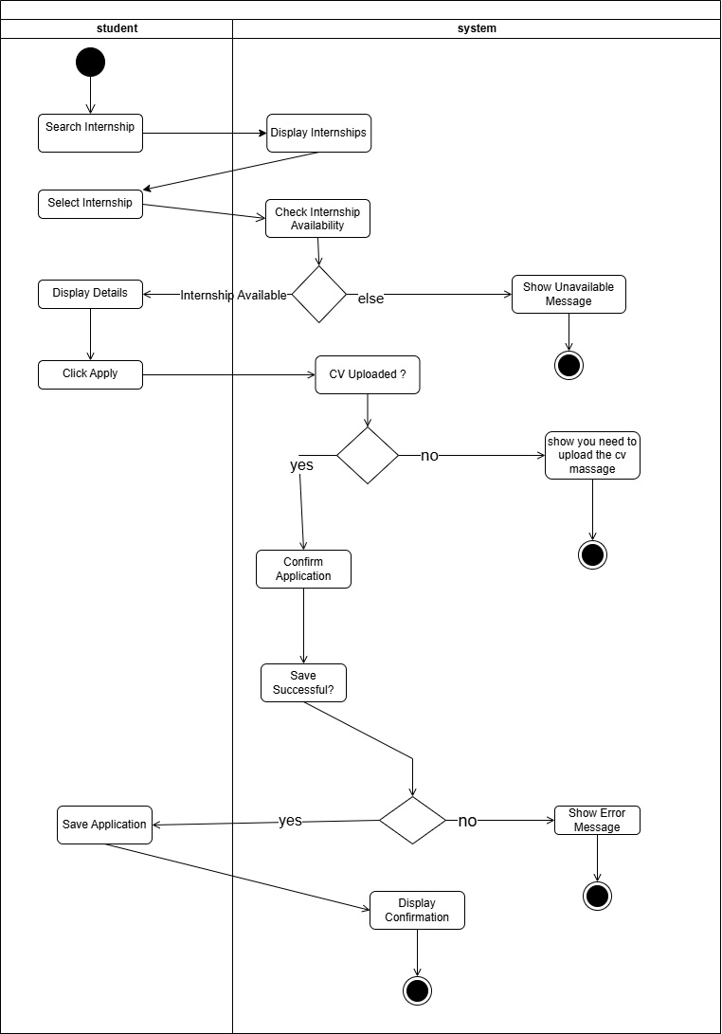
6.3 Activity Diagrams for all Specification Tables

Figure 5: Apply for Internship (Describe specification Table 6.2.1)
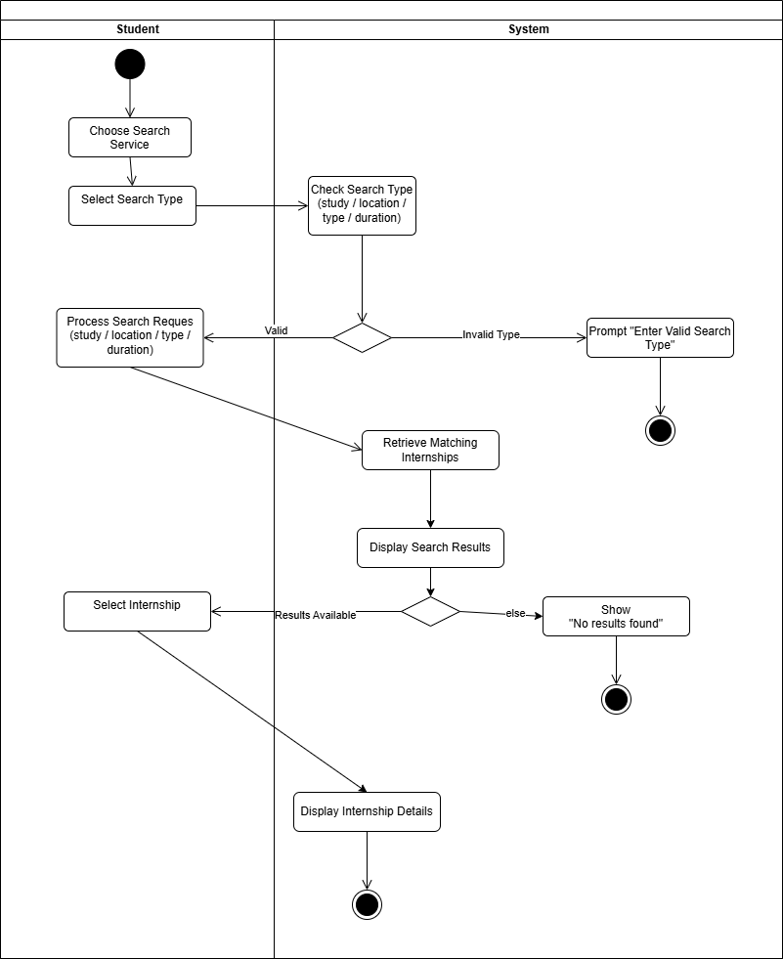
Figure 6: Search for Internship (Describe specification Table 6.2.2)
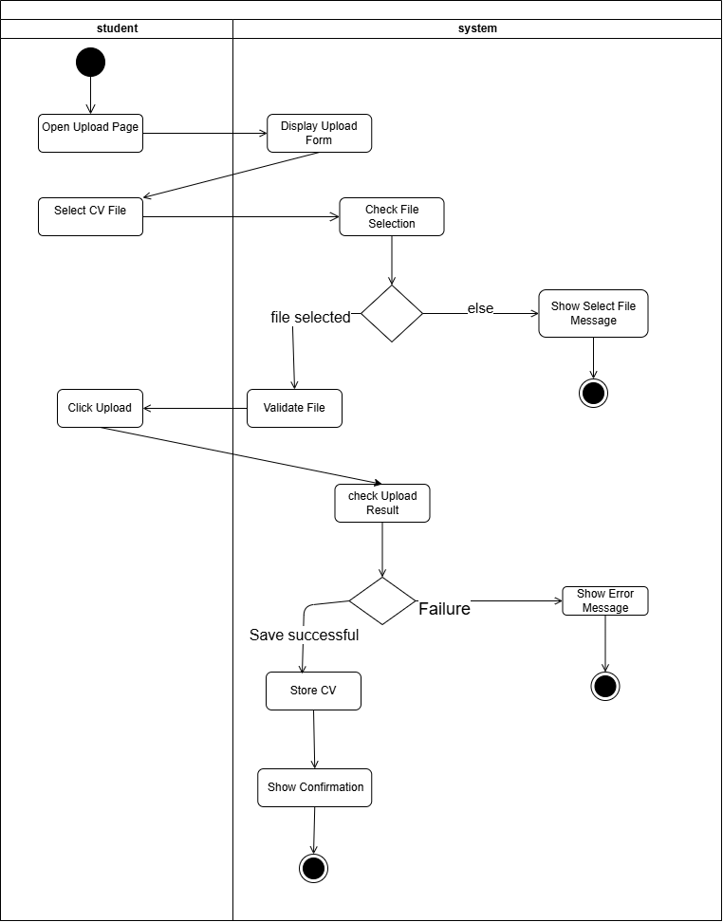

Figure 7: Upload a CV (Describe specification Table 6.2.3)

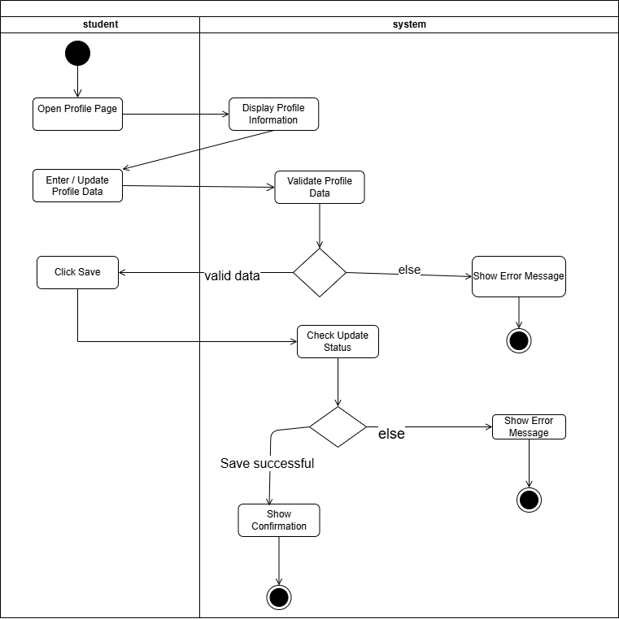

Figure 8: Complete and Edit Profil (Describe specification Table 6.2.4)
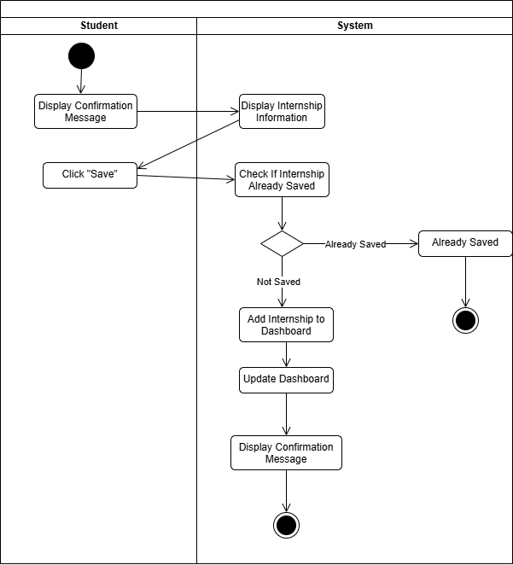

Figure 9: Save Internship in Dashboard (Describe specification Table 6.2.5)

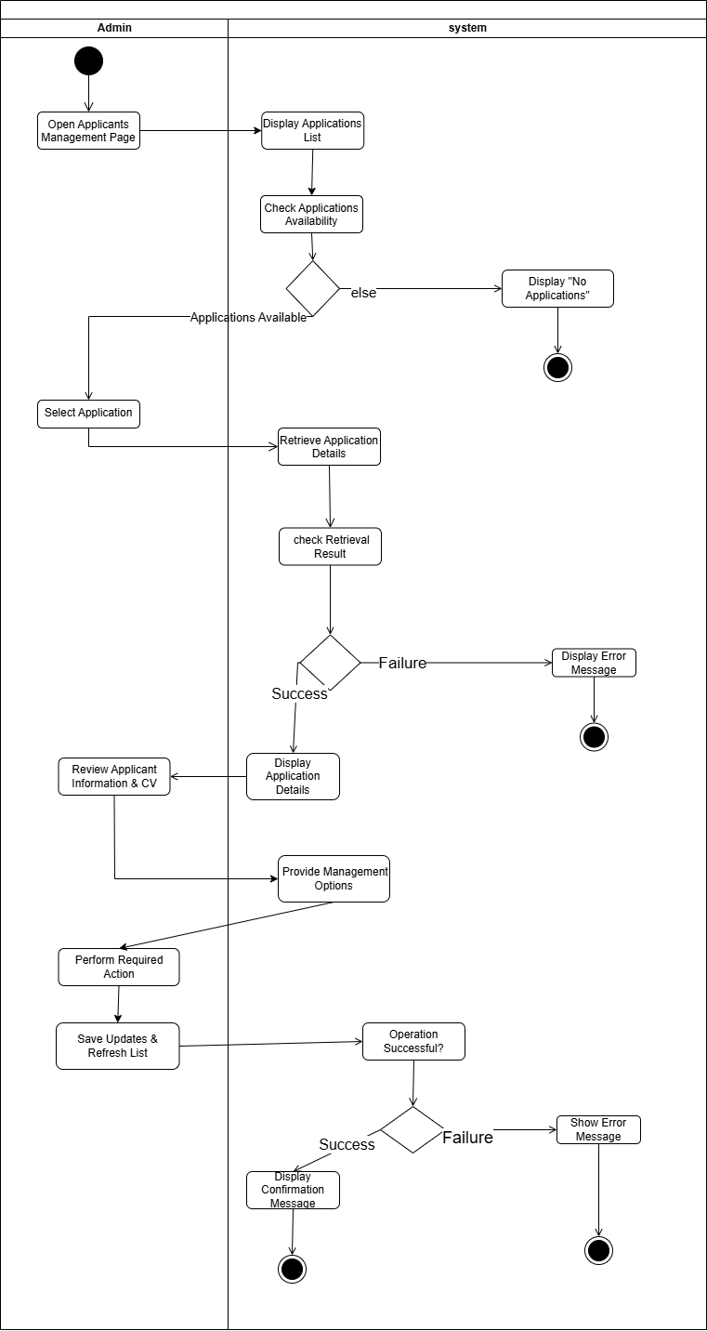

Figure 10: Manage Application (Describe specification Table 6.2.6)

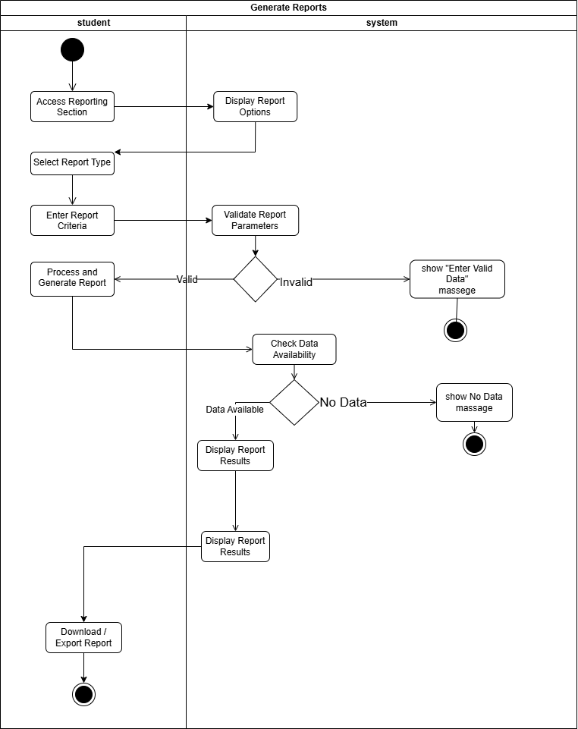
Figure 11: Generate Report (Describe specification Table 6.2.7)

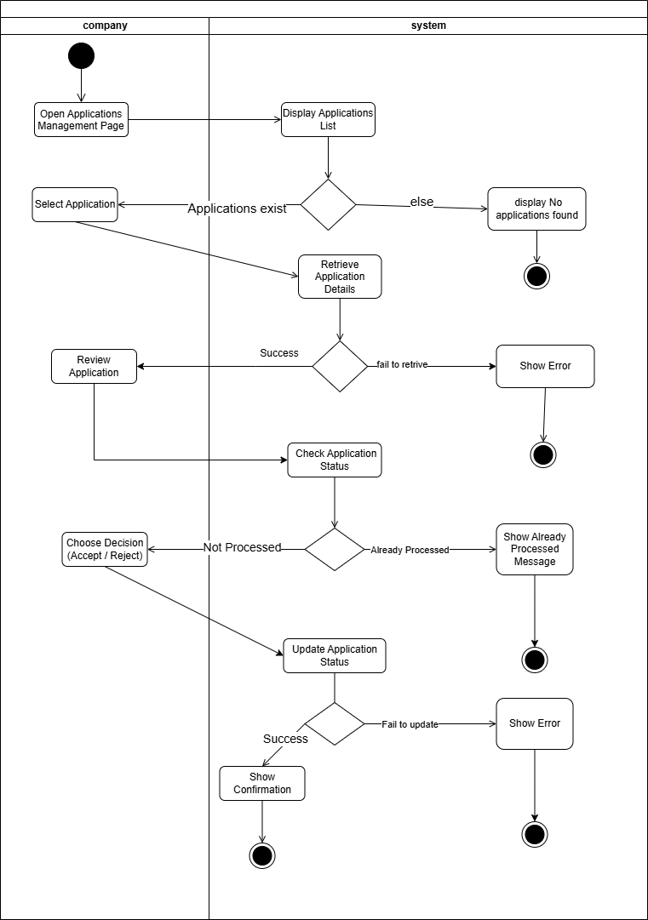

Figure 12: Accept / Reject Application (Describe specification Table 6.2.8)
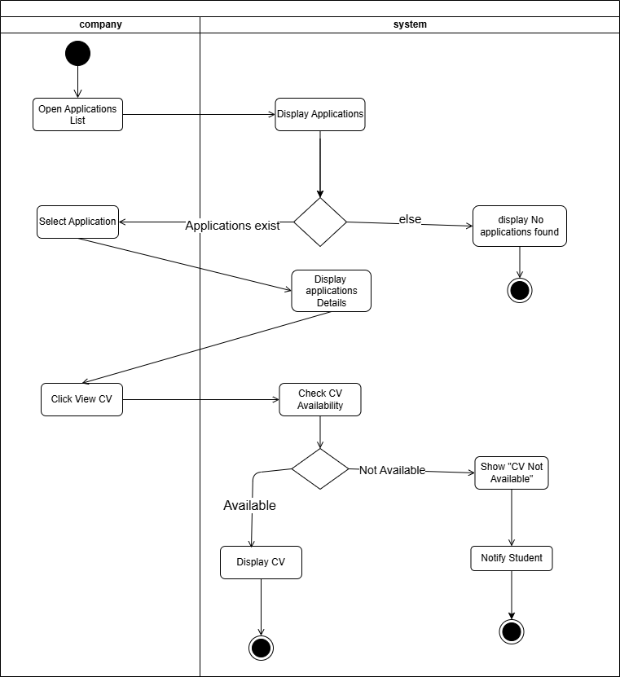

Figure 13: View Student CV (Describe specification Table 6.2.9)

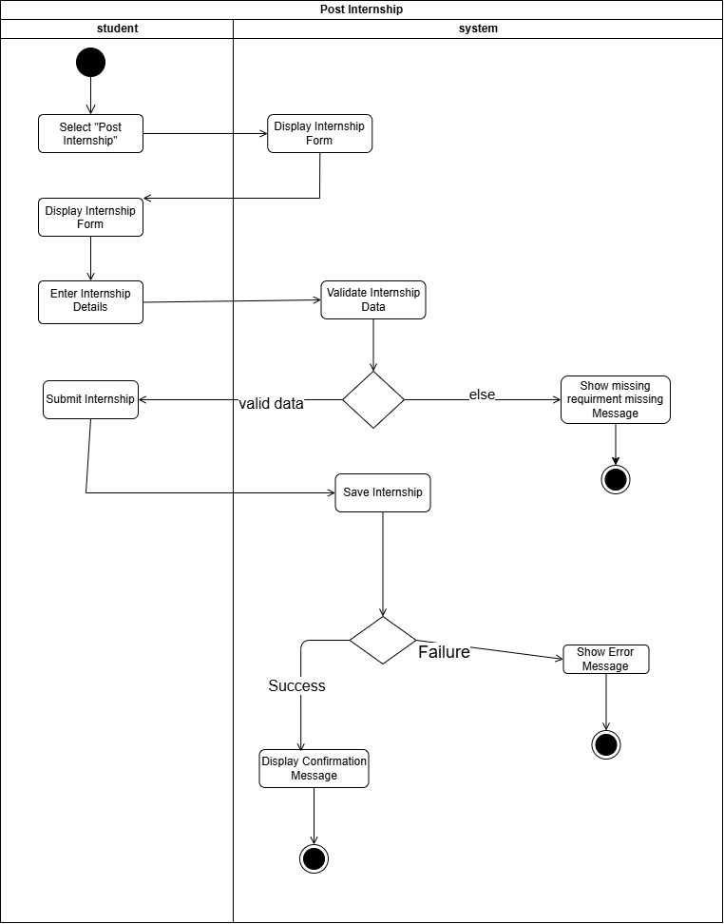

Figure 14: Post Internship (Describe specification Table 6.2.10)
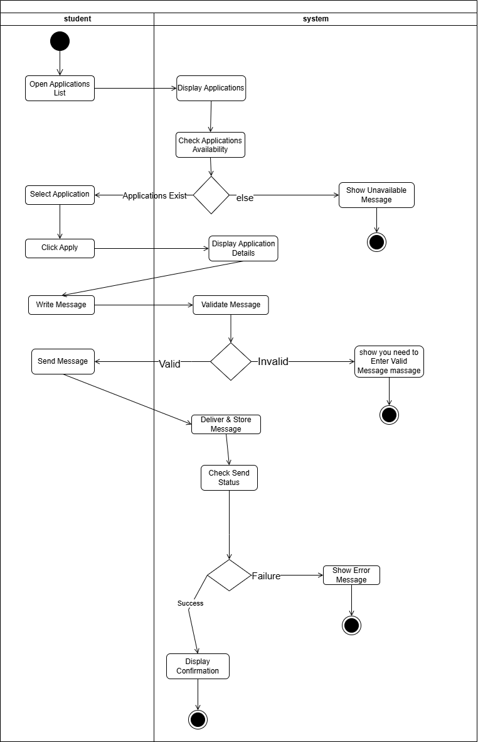

Figure 15: Communicate with Student (Describe specification Table 6.2.11)

7-Design Phase

  - Context diagram
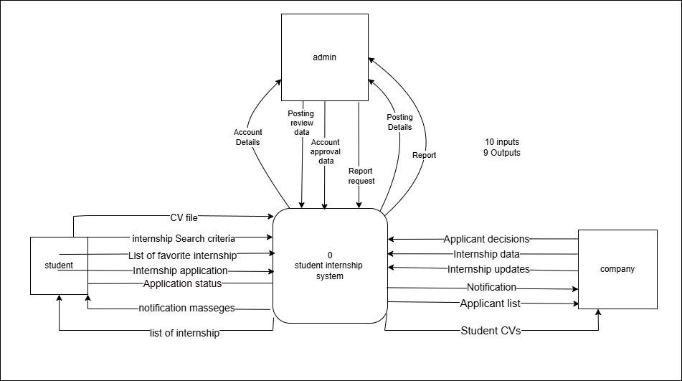
Figure 16 : Context Diagram
The context diagram shows how students, companies, and admins interact with the internship system. Students search and apply for internships, companies manage internship postings and applicants, and admins handle approvals, reviews, and reports.
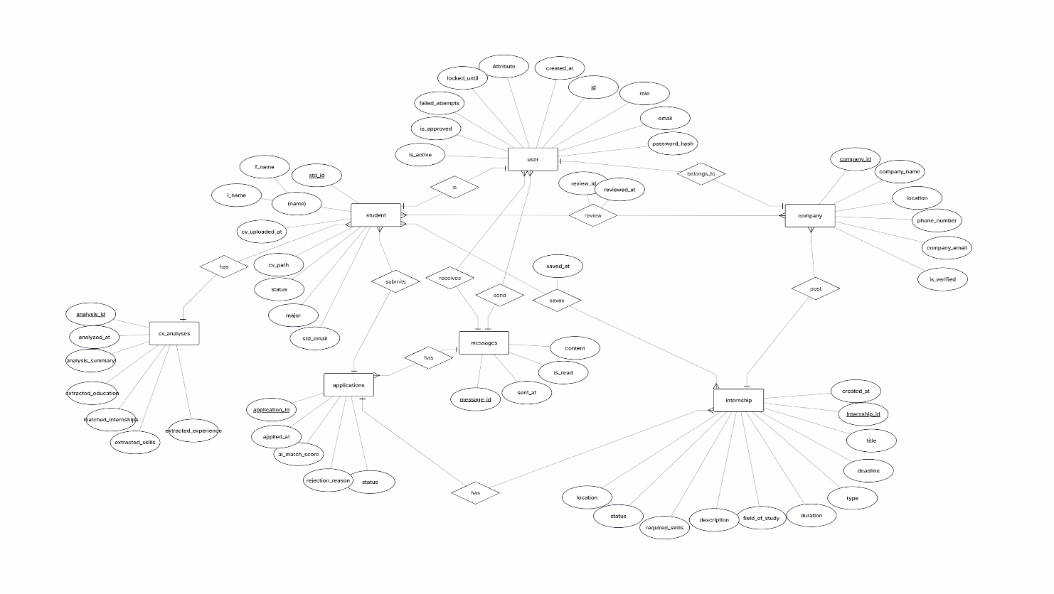
7.2 ER diagram
Figure 17 : ER diagram
The ER diagram shows an AI-powered internship system that connects students, companies, and internships. Students can upload CVs, apply for internships, save opportunities, and communicate with companies. Companies can post internships and review applicants, while the system uses AI to analyze CVs and generate matching scores.
7.3 Database logical diagram
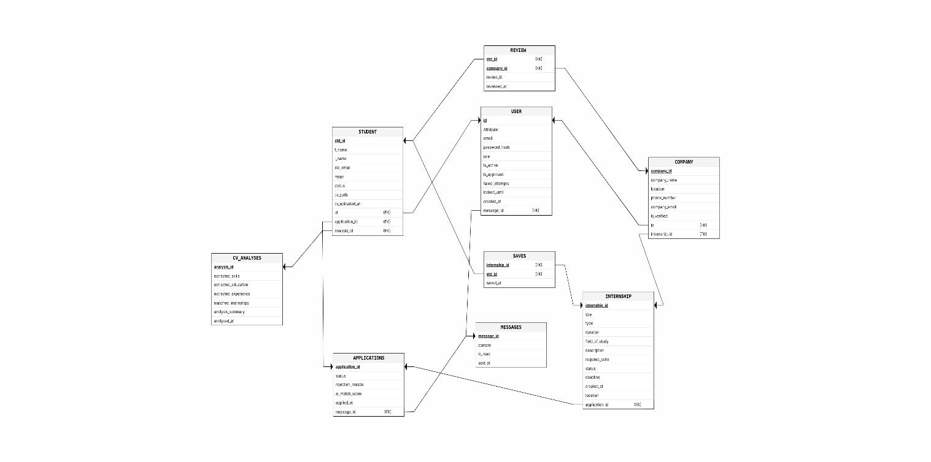

Figure 18 : DB Schema Diagram

The relational schema represents the database structure of the internship system. It includes tables for users, students, companies, internships, applications, messages, reviews, saved internships, and CV analysis, all connected through primary and foreign keys.

8- Implementation Phase

a. Language Used
- Python → backend programming language
- JavaScript → frontend programming language
- HTML → webpage structure
- CSS → webpage styling
- SQL → database query language
Frameworks and Libraries:
- React → frontend library for building user interfaces
- FastAPI → backend framework for building APIs
b. Tools Used
- VS Code → code editor used for development
- pgAdmin → database management tool
- Claude → AI assistant used for development support
- Gemini → AI assistant used for development and analysis
- Antigravity → AI/code assistance tool
- OpenRouter → AI API platform used for CV analysis and internship matching through LLM models
- ChatGPT → AI assistant used for debugging, documentation, development support, and project planning
- GitHub → version control and team collaboration platform
- Postman → API testing tool

- Templates
No external templates were used. All interfaces and components were designed and developed manually by the team.

- Screenshots
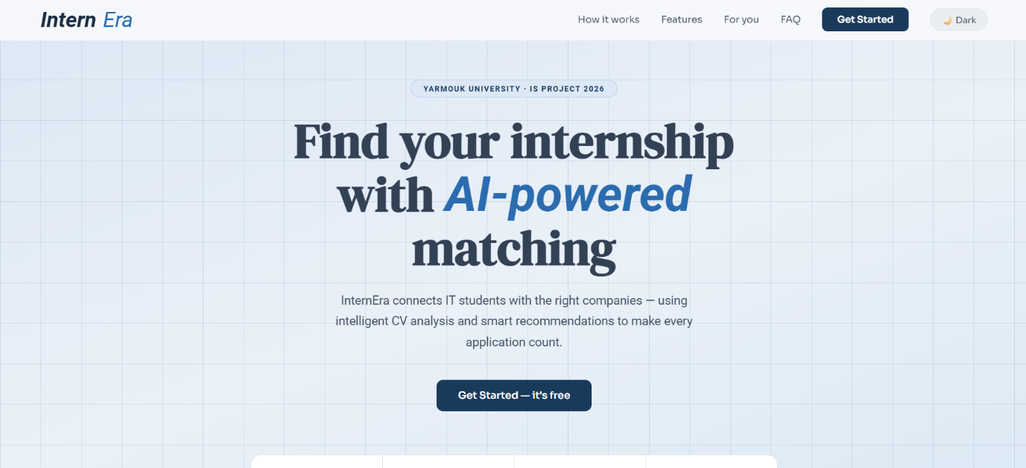

Homepage (Figure 19)
The homepage presents InternEra’s main goal, which is helping IT students find suitable internships through AI-powered CV analysis and smart recommendations.
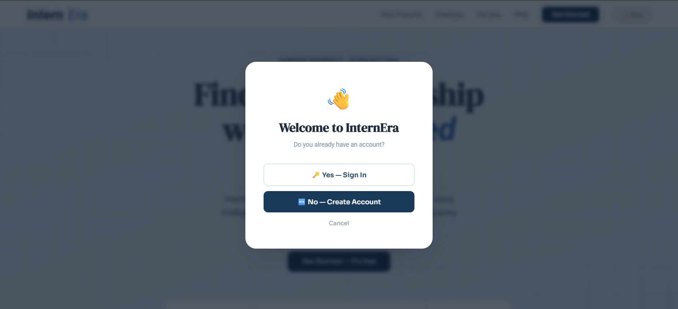
Welcome Popup (Figure 20)
This popup gives users the option to either sign in to an existing account or create a new account before accessing the platform.
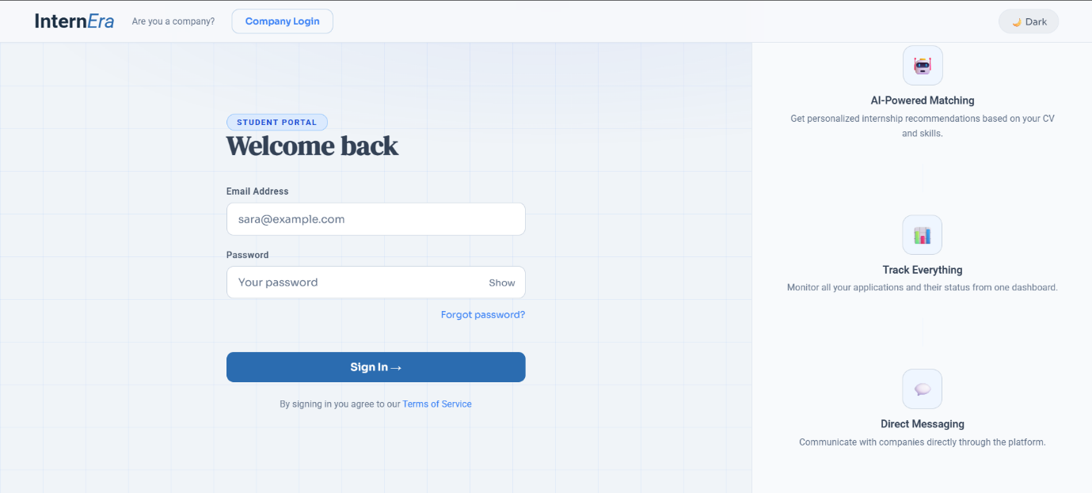
Student Login Page (Figure 21)
The student login page allows users to securely access their accounts and use platform features such as AI internship matching, application tracking, and direct messaging.
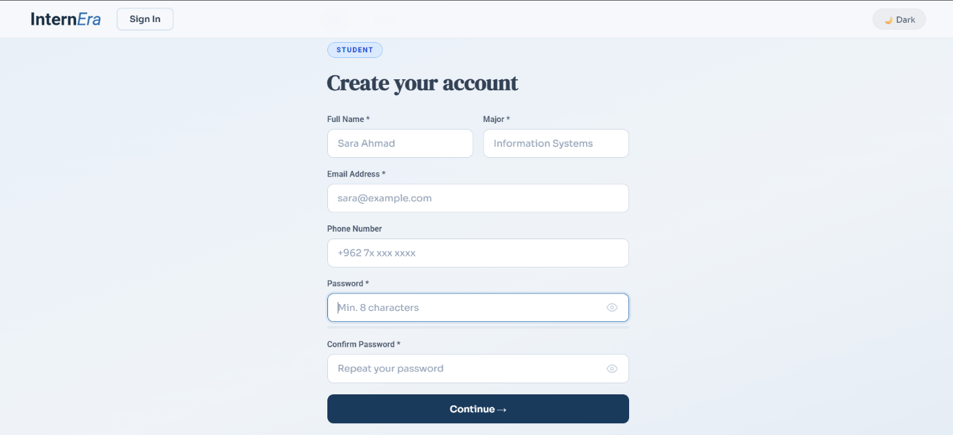
Student Registration Page (Figure 22)
This page allows students to create a new account by entering their personal information, academic major, and login credentials securely.
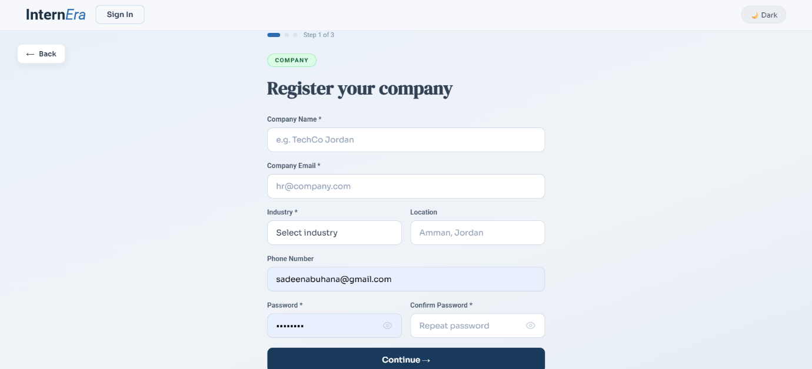
Company Registration Page(Figure 23)
This page allows companies to register on the platform by entering their company information, contact details, and account credentials to start offering internship opportunities.
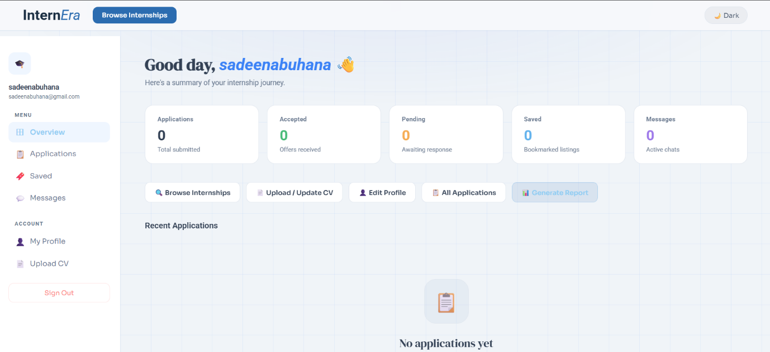
Student Dashboard Page (Figure 24)
The dashboard provides students with an overview of their internship journey, including applications, saved internships, messages, and quick access to important features such as CV upload and profile management.
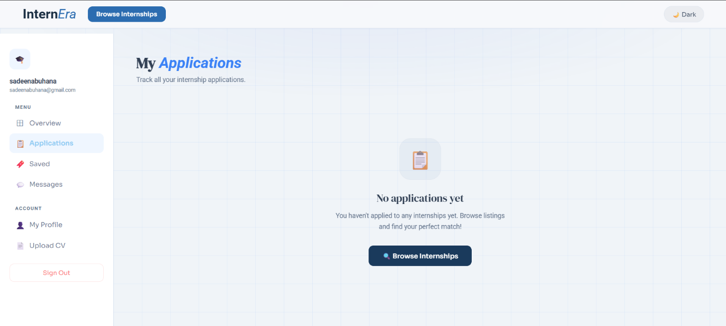
Applications Page (Figure 25)
This page allows students to track and manage all internship applications, helping them monitor their application status and progress easily.
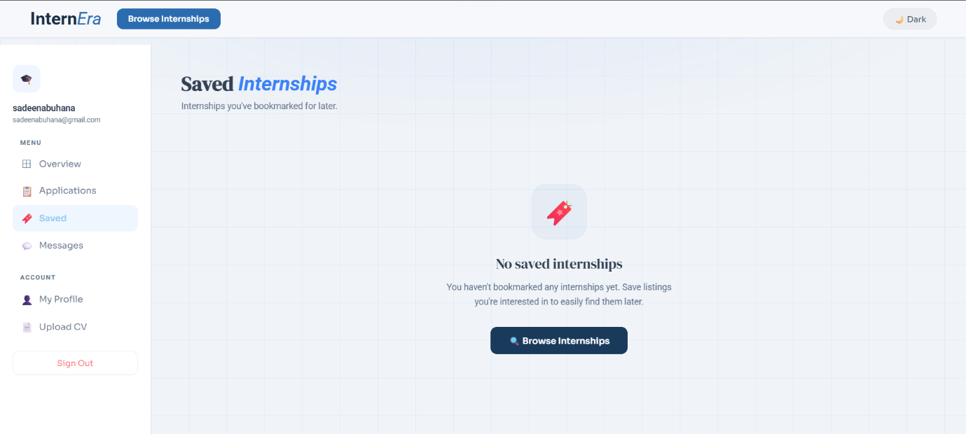
Saved Internships Page (Figure 26)
This page allows students to view and manage internships they have saved for later, making it easier to revisit interesting opportunities.
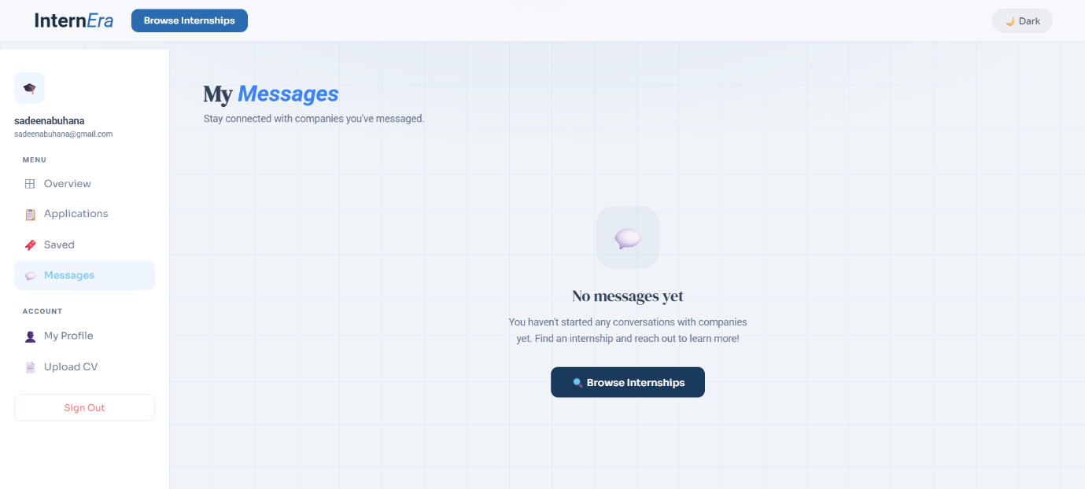
Messages Page (Figure 27)
This page allows students to communicate directly with companies, helping them stay connected and discuss internship opportunities easily.
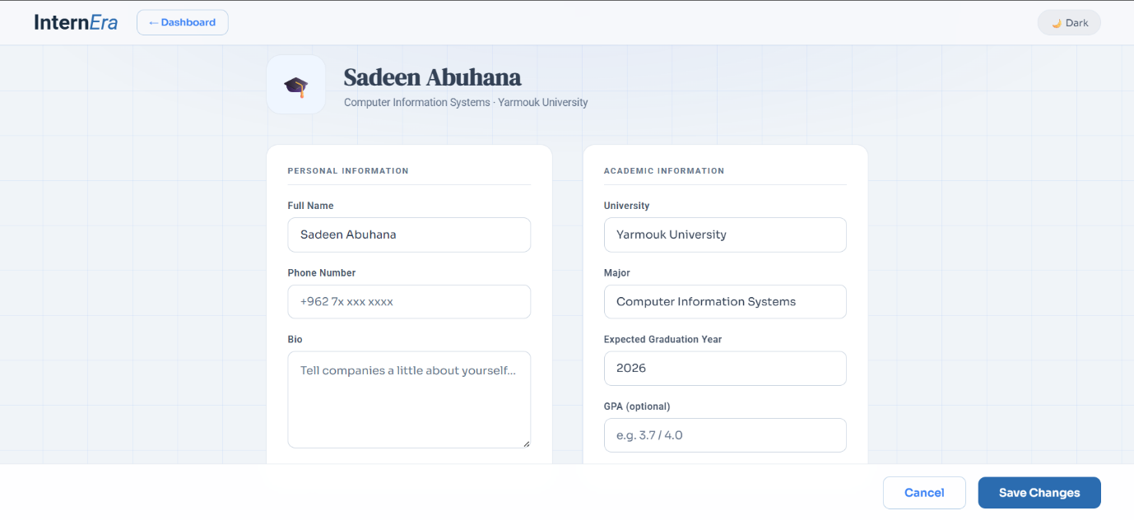
Profile Page (Figure 28)
This page allows students to manage and update their personal and academic information, helping companies better understand their background and qualifications.
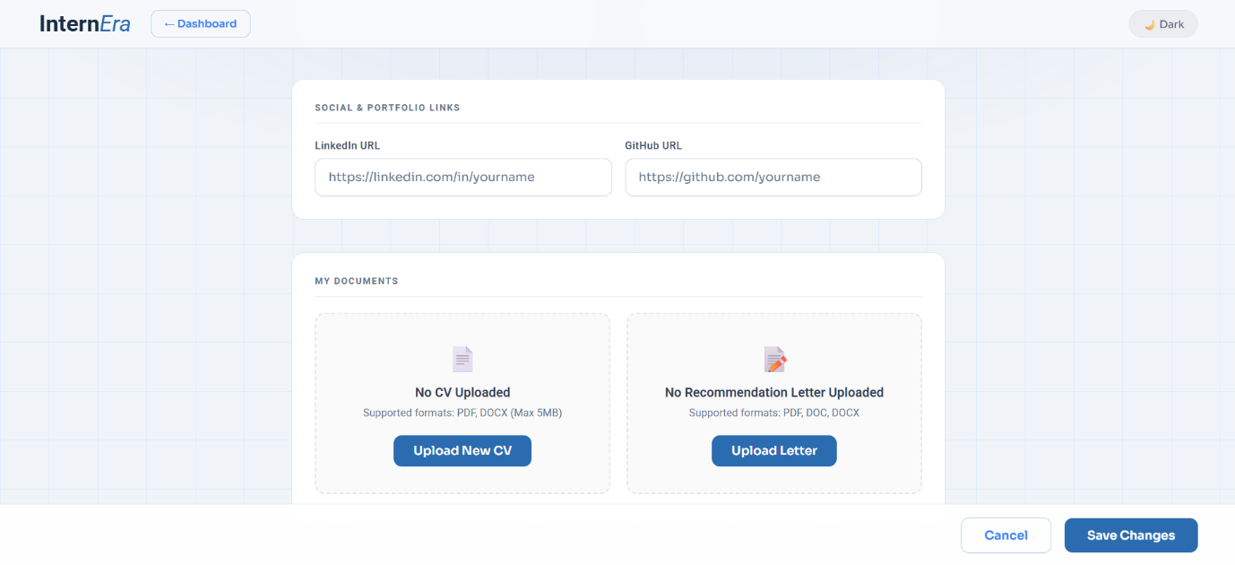
(Figure 29)
Profile page allows students to add professional links and upload important documents such as their CV and recommendation letters to strengthen their internship applications.
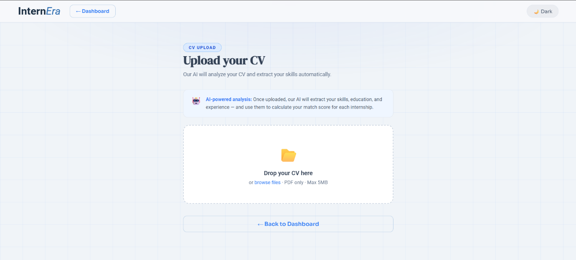
CV Upload Page (Figure 30)
This page allows students to upload their CVs so the AI system can analyze their skills, education, and experience to provide suitable internship recommendations.
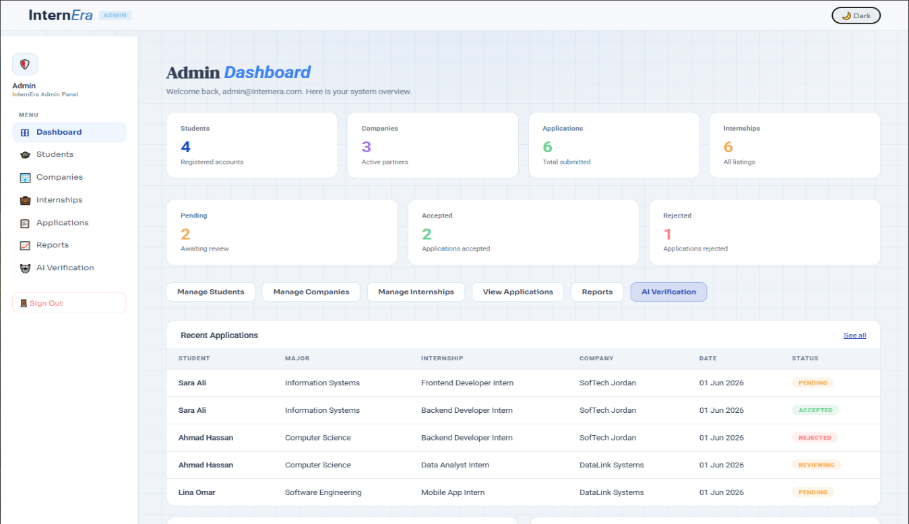
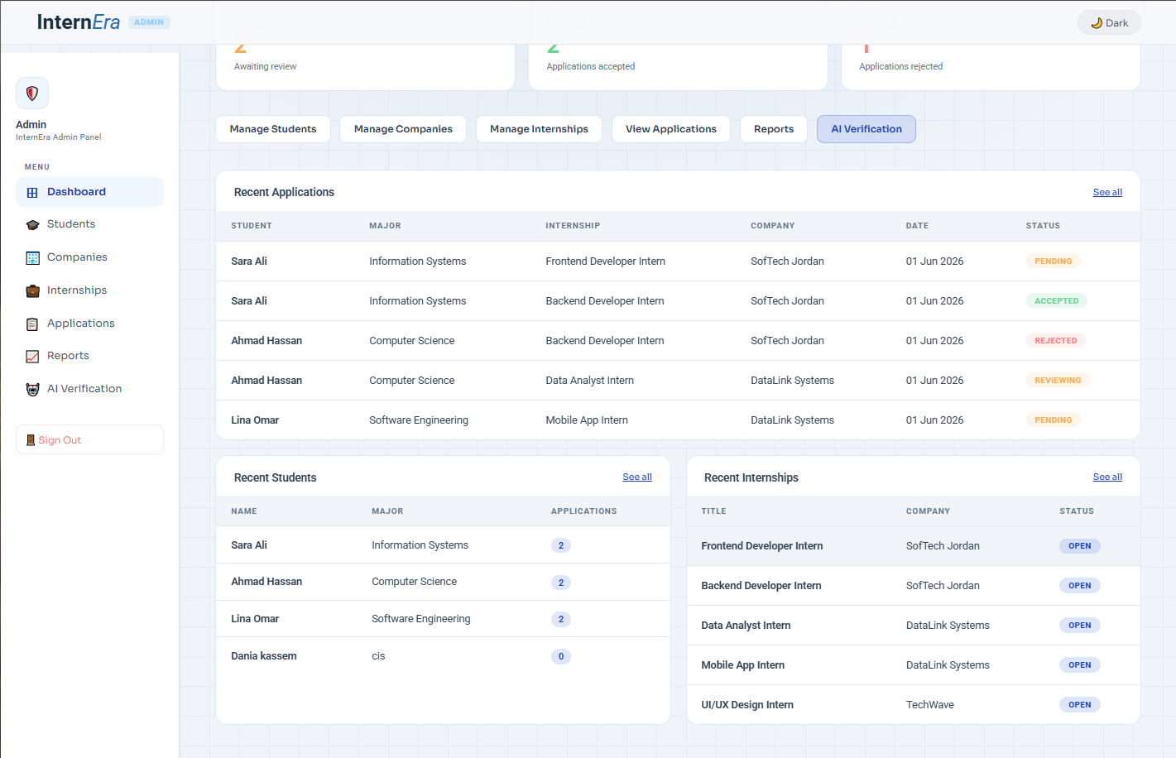
Admin Dashboard Page (Figure 31+32)
The Admin Dashboard displays key system statistics, quick management options, and recent activity such as applications, students, and internships.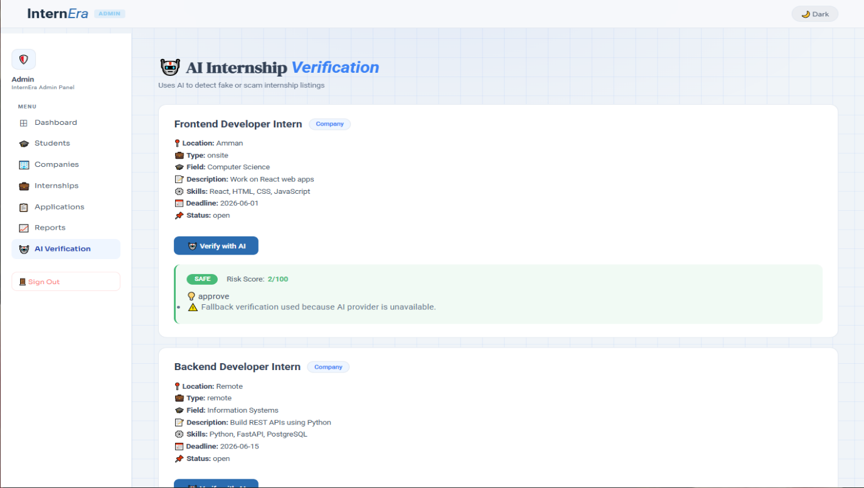
AI Internship Verification Page (Figure 33)
This page allows the admin to use AI technology to analyze and verify internship postings, helping detect fake or suspicious internship opportunities before they are approved on the platform.
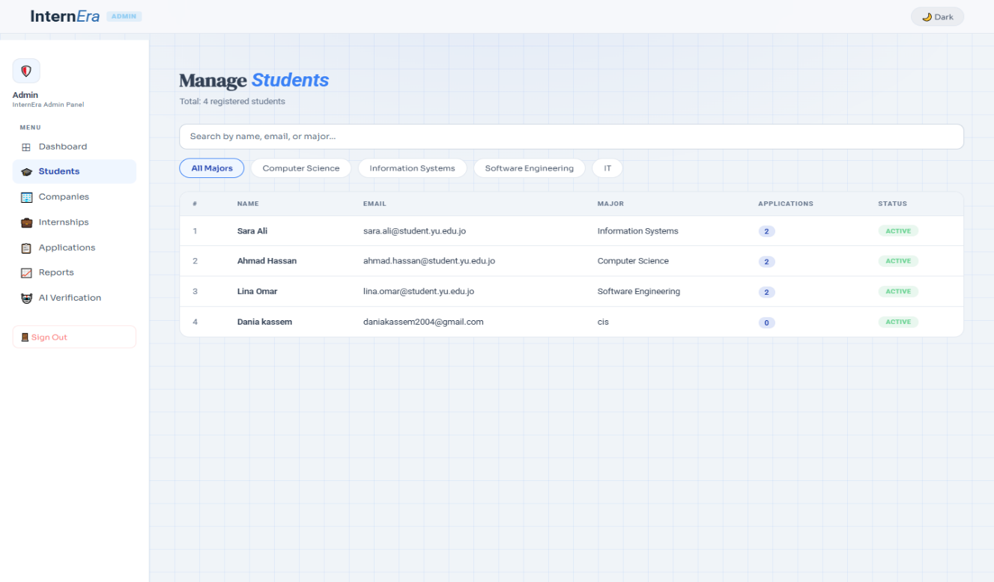
Manage Students Page (Figure 34)
The Manage Students page allows the admin to view, search, and filter registered students while displaying their details, applications count, and account status.
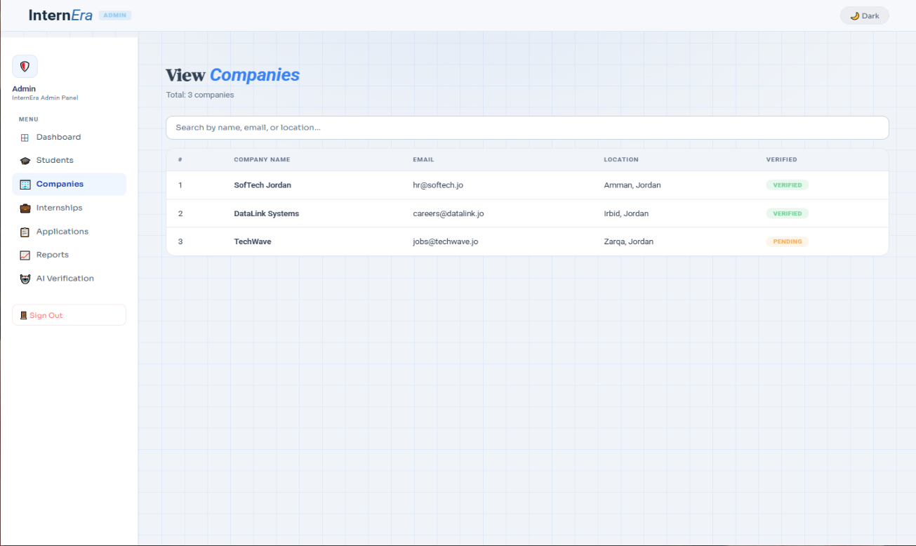
View Companies Page (Figure 35)
This screen shows the View Companies page in the Admin dashboard. The admin can view all registered companies, search by company name, email, or location, and check each company’s verification status, such as verified or pending.
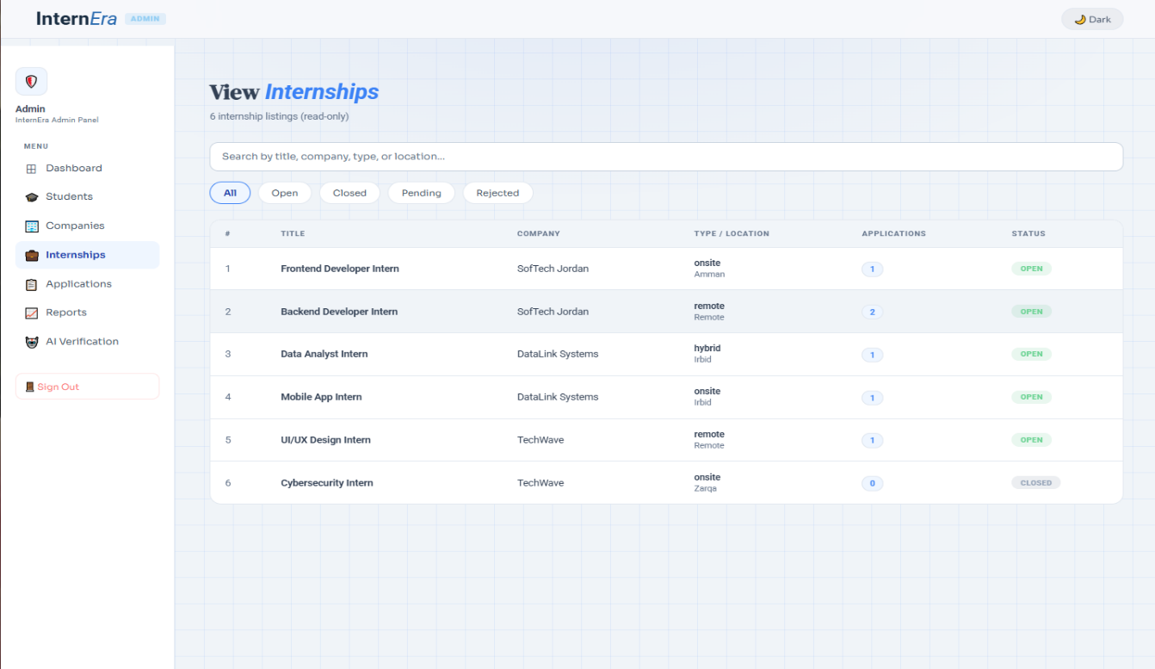
View Internships Page (Figure 36)
The View Internships page allows the admin to view, search, and filter internship listings while checking their details, applications count, and current status.
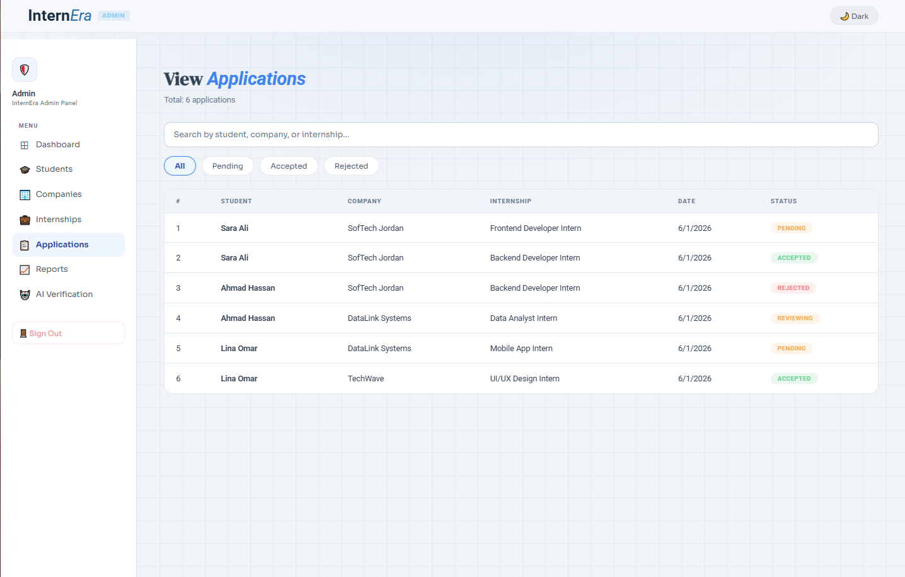
View Applications Page (Figure 37)
The View Applications page allows the admin to view, search, and filter student internship applications while checking applicant details, dates, and current status.

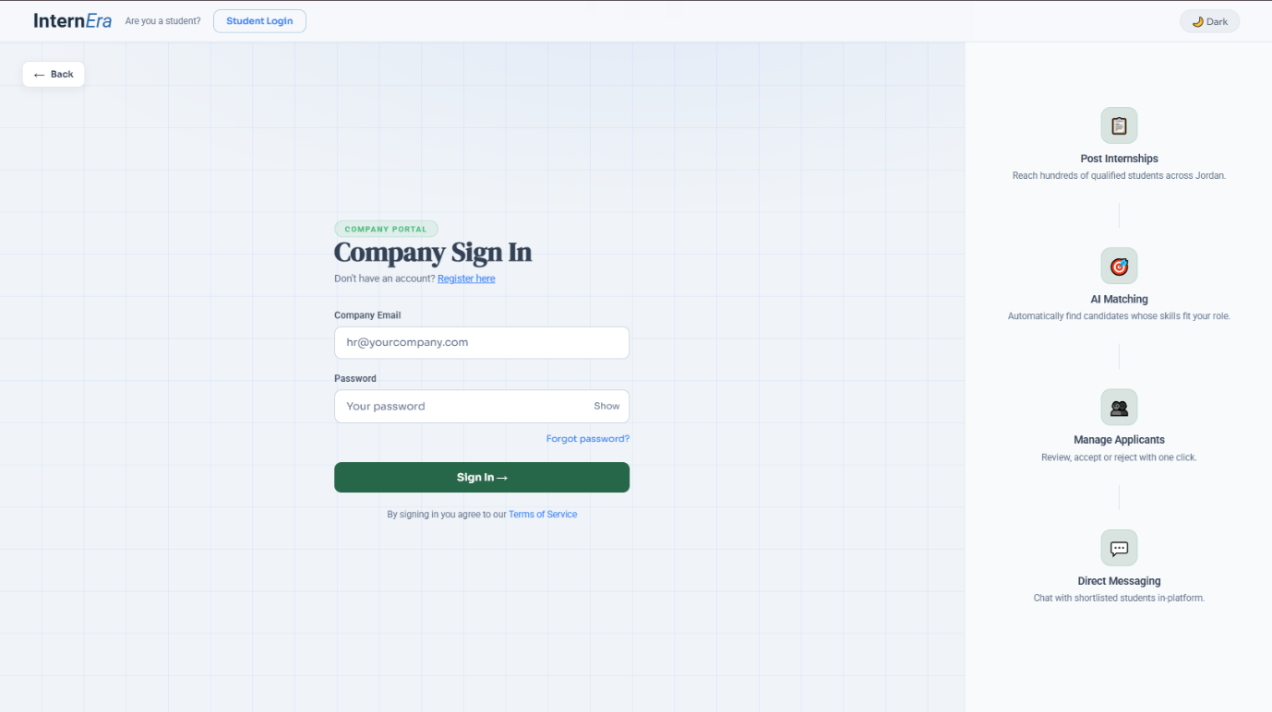
Company Sign In Page (Figure 38)
This page allows companies to securely access the InternEra platform using their email and password. It highlights the main platform features such as AI matching, applicant management, and direct messaging, giving companies a quick overview of the system’s capabilities before logging in.
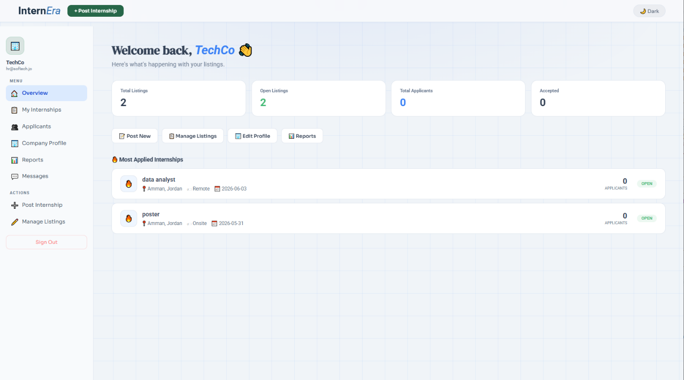
-Company Dashboard (Figure 39)
The dashboard provides companies with a complete overview of their internship activities. It displays important statistics such as total listings, open internships, accepted applicants, and total applications, while also offering quick access buttons for posting internships, managing listings, editing profiles, and viewing reports.
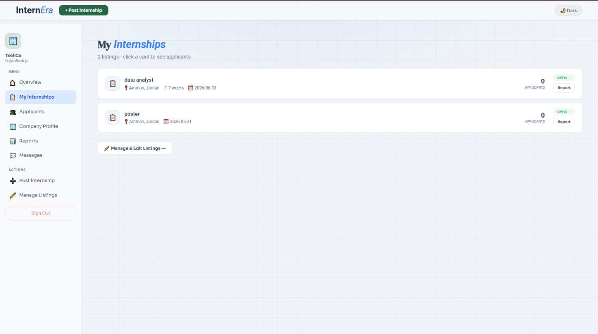
-My Internships Page (Figure 40)
This page displays all internship opportunities posted by the company in a clean and organized layout. Each listing includes details such as location, posting date, status, and number of applicants, allowing companies to easily monitor and manage their active internships.
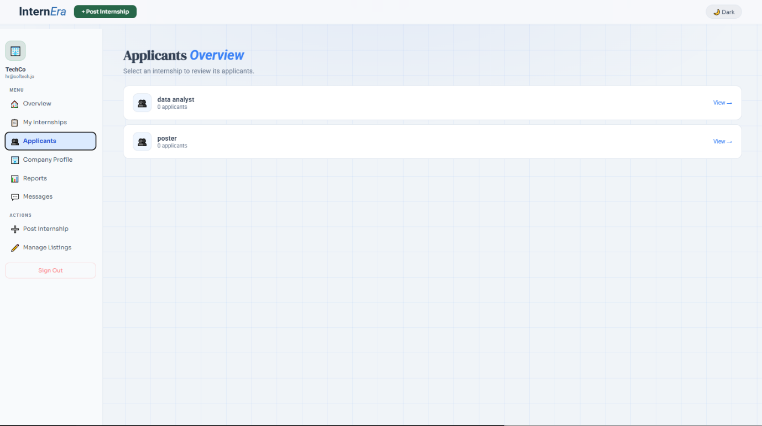
-Applicants Overview Page (Figure 41)
The applicants overview page allows companies to review internship listings and check the number of students who applied to each opportunity. Companies can quickly navigate to applicant details and manage the recruitment process efficiently.
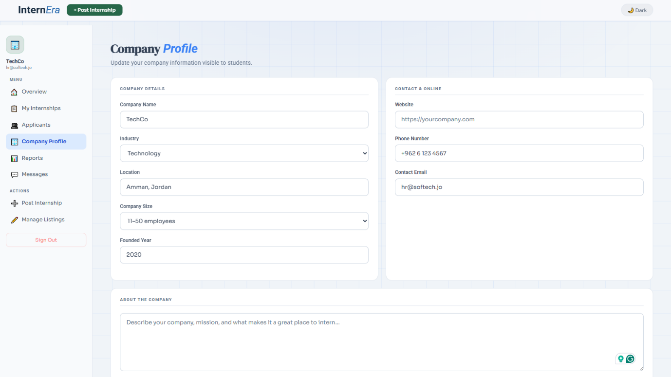
-Company Profile Page (Figure 42)
This page enables companies to manage and update their public profile information. It includes editable fields such as company name, industry, location, website, phone number, company size, and a company description that helps students learn more about the organization.
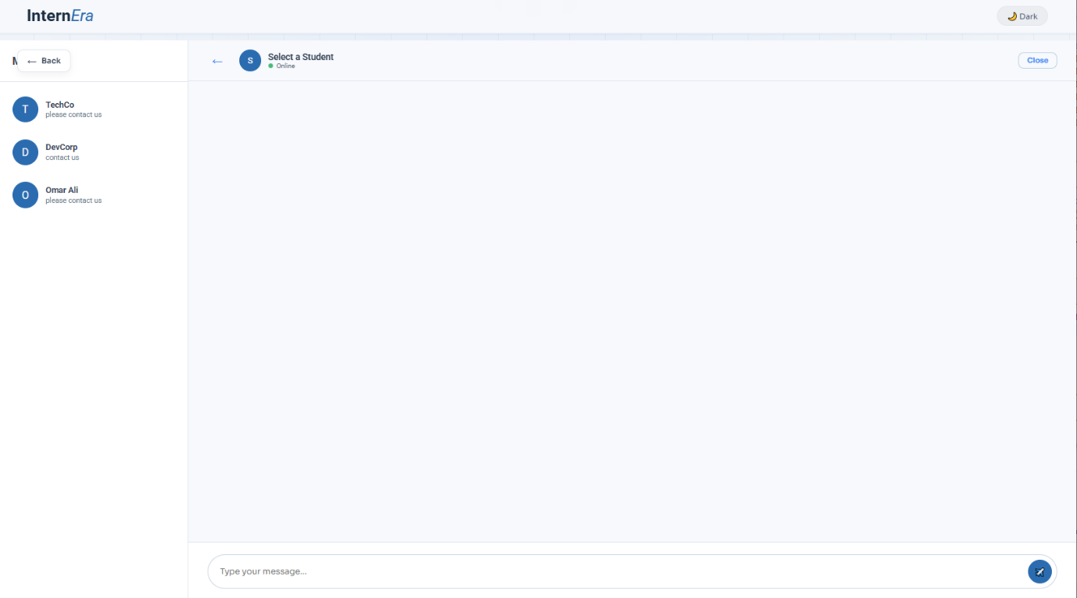
-Messaging Interface (Figure 43)
The messaging system allows direct communication between companies and students through a built-in chat interface. Companies can contact applicants, answer questions, and discuss internship details in real time within the platform.
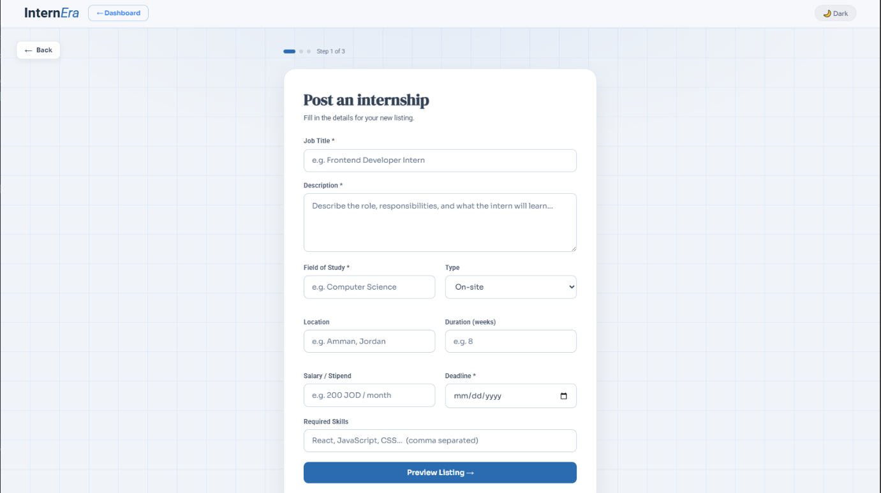
-Post Internship Form – Step 1 (Figure 44)
This page allows companies to create a new internship listing by entering detailed information including job title, description, field of study, internship type, location, duration, salary, deadline, and required skills.
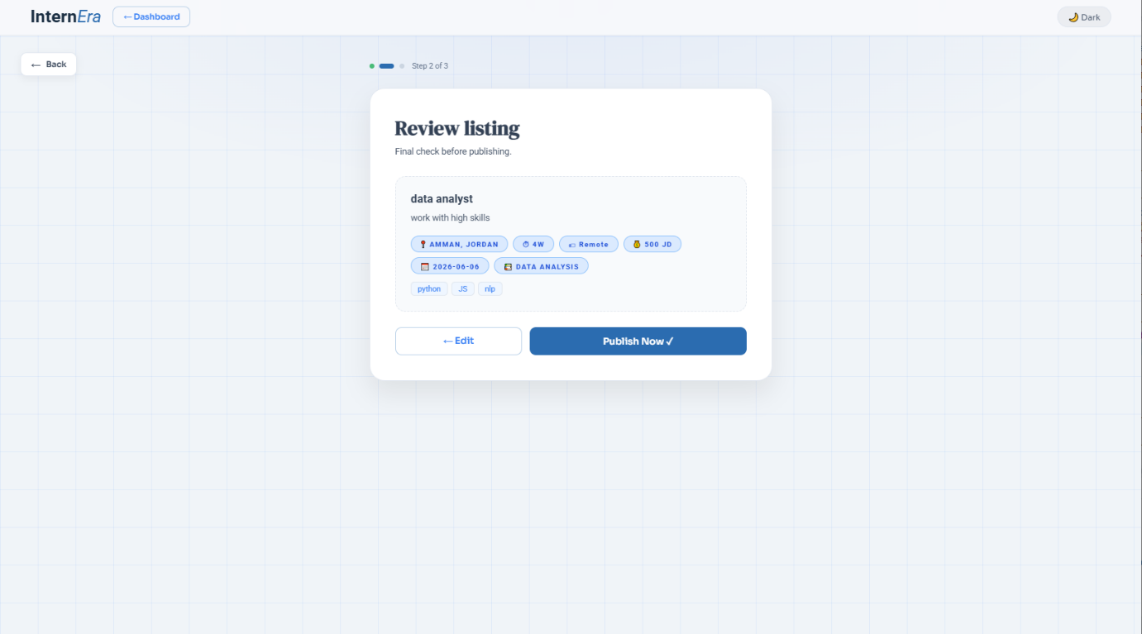
-Internship Review Page – Step 2 (Figure 45)
Before publishing, companies can review all entered internship details in a preview layout. This step ensures that all information is accurate and complete before the listing becomes visible to students.
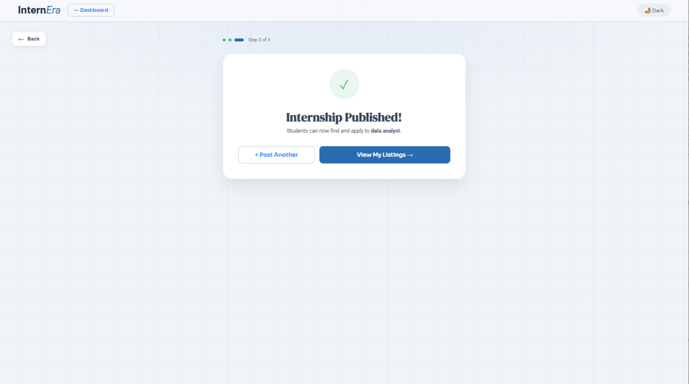
-Internship Published Confirmation – Step 3 (Figure 46)
This confirmation page appears after successfully publishing an internship opportunity. It informs the company that the internship is now available for students to view and apply for, while also providing options to post another internship or manage listings.
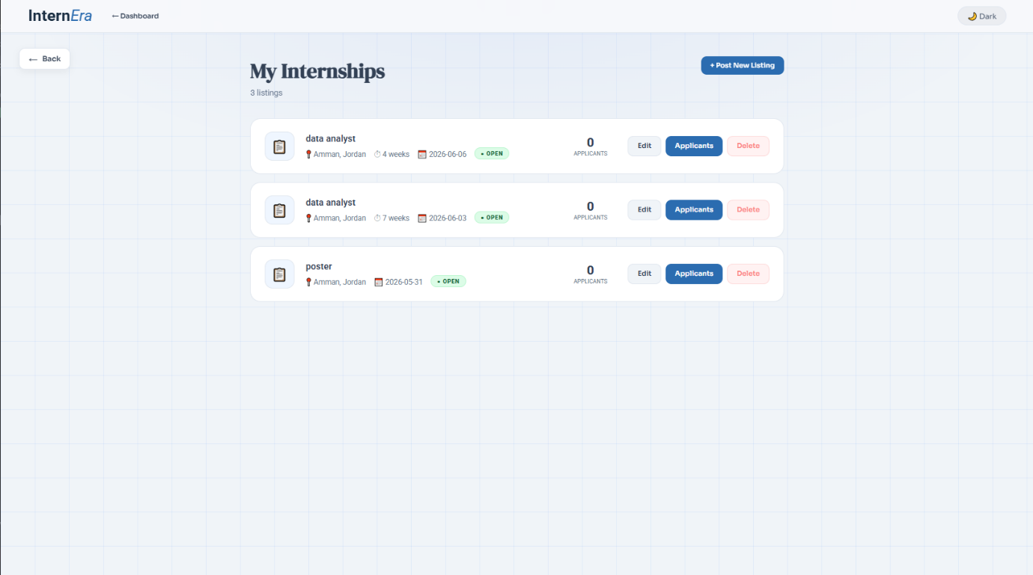
-Manage Internship Listings Page (Figure 47)
This page allows companies to fully manage their posted internships. Companies can edit internship details, review applicants, monitor application counts, and delete listings when necessary through an organized management interface.

e. Scenarios
- Pseudocode :
  - Pseudocode about Matching score :
START

INPUT CV text
INPUT Internship text

SEND CV and Internship to LLM

LLM extracts:
required_skills
cv_skills
matched_skills
missing_skills
notes

IF required_skills count = 0 THEN
numeric_score = 0
ELSE
numeric_score = (matched_skills count / required_skills count) * 100
ENDIF

match_score = numeric_score + "%"

IF numeric_score < 50 THEN
decision = "Rejected"
ELSE IF numeric_score < 75 THEN
decision = "Considered"
ELSE
decision = "Strong Match"
ENDIF

RETURN:
match_score
match_decision
required_skills
cv_skills
matched_skills
missing_skills
notes

END
Description :
“This algorithm uses a rule-based CV matching approach powered by a Large Language Model (LLM) to evaluate how well a candidate’s CV matches an internship opportunity. The LLM analyzes both the CV and internship description to extract relevant skills, identify matched and missing skills, and generate evaluation notes. A match score is then calculated based on the percentage of required skills found in the CV. Based on the final score, the candidate is classified as Rejected, Considered, or Strong Match, making the internship recommendation process automated and efficient.”
  - Pseudocode about Recommendations Internship

Algorithm Generate_Recommendations(CV_Text, All_Internships)

Input:
CV_Text → user's CV as text
All_Internships → list of internship opportunities

Output:
Recommended internships sorted by match score

Begin

Create empty list Recommendations

For each Internship in All_Internships do

Convert internship data into Internship_Text containing:
Title
Description
Requirements

Match_Result ← Match_CV_To_Internship(CV_Text, Internship_Text)

Score_String ← Match_Result.Match_Score
Score_Number ← Remove '%' and convert Score_String to integer

If Score_Number >= 50 then

Add to Recommendations:
Internship_ID
Title
Match_Score
Matched_Skills
Missing_Skills
Decision

End If

End For

Sort Recommendations in descending order by Match_Score

Return Recommendations

End
Description :
“A content-based recommendation algorithm is used to match the user's CV against available internship opportunities. Each internship is analyzed by comparing its title, description, and requirements with the CV text. A match score is generated, and only internships with a score of 50% or higher are selected. The selected internships are then sorted from highest to lowest score to provide the most relevant recommendations first.”
- FlowChart :
2.1 FlowChart for Matching Score :
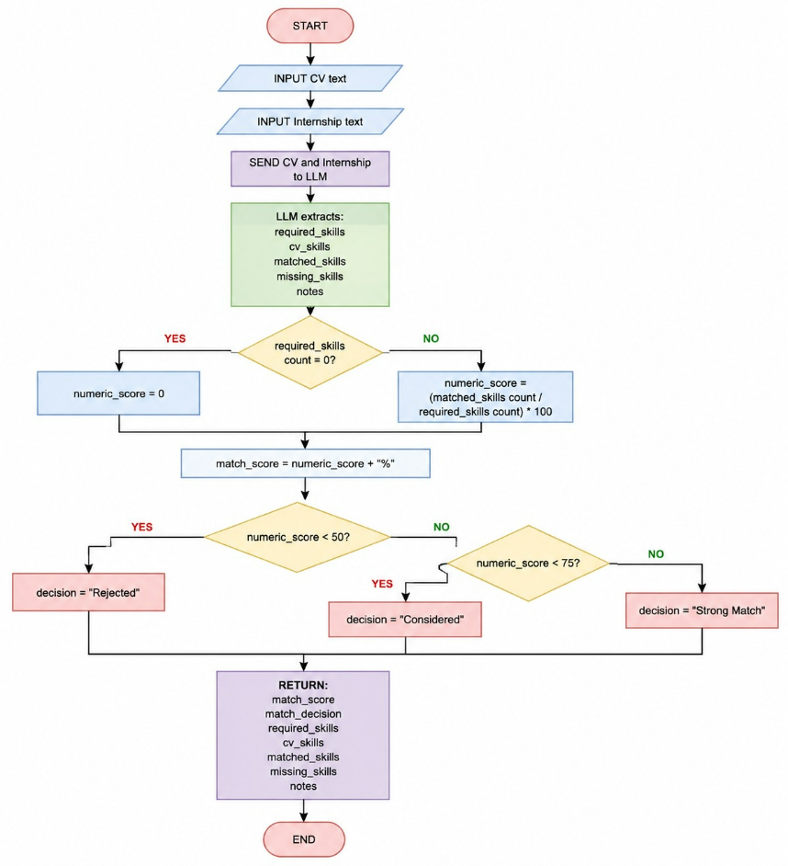

Figure 48 : Flow Chart (Pseudocode for Marching score)
This flowchart explains the AI internship matching process used in the system. The process starts by taking the student CV text and internship description as inputs, then sending them to an LLM (Large Language Model) for analysis. The AI extracts required skills, CV skills, matched skills, missing skills, and notes. Based on the number of matched skills, the system calculates a matching score percentage and classifies the applicant as “Rejected,” “Considered,” or “Strong Match.” Finally, the system returns the match score, decision, extracted skills, missing skills, and additional notes.
2.2 FlowChart for recommendations Internships :

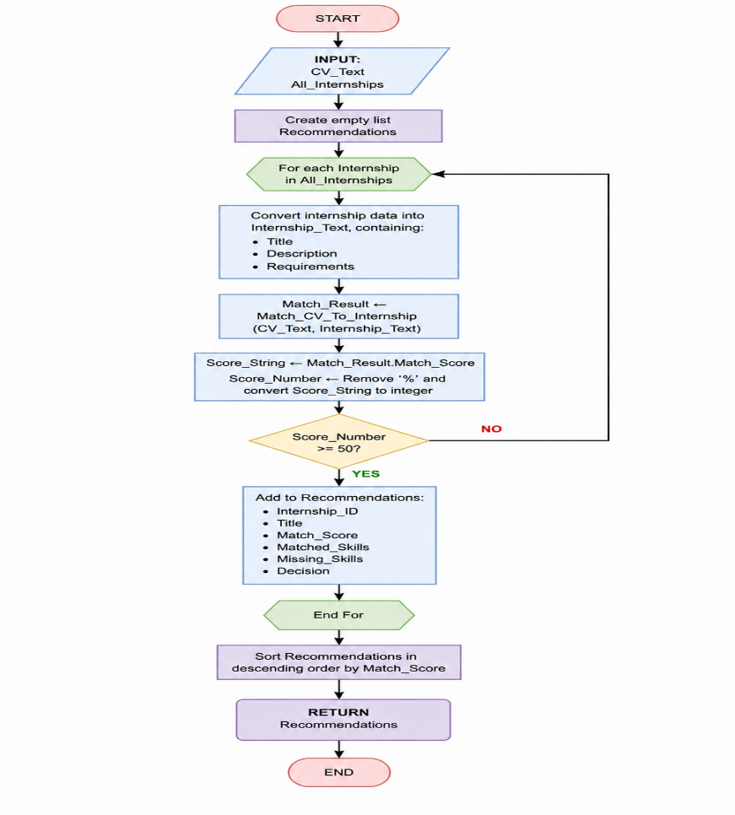

Figure 49 : Flow Chart (Pseudocode for recommendations Internships):
This flowchart explains the AI internship recommendation process. The system takes the student’s CV and available internships as inputs, then analyzes each internship using AI to calculate a match score based on skills and requirements. Internships with a score of 50% or higher are added to the recommendation list, which is finally sorted from highest to lowest match score and returned to the student.
f. Sample Reports
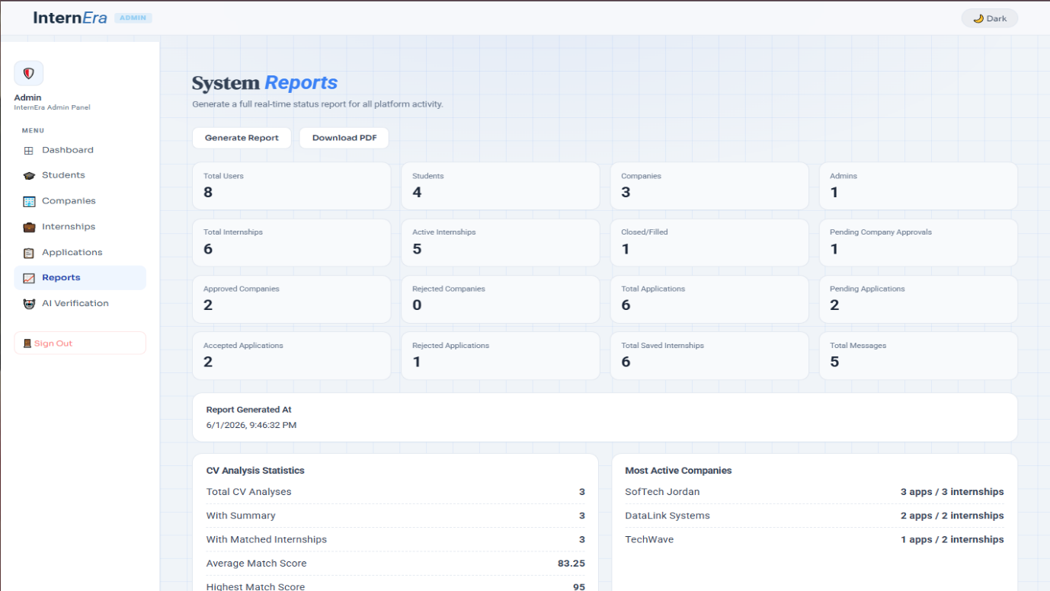
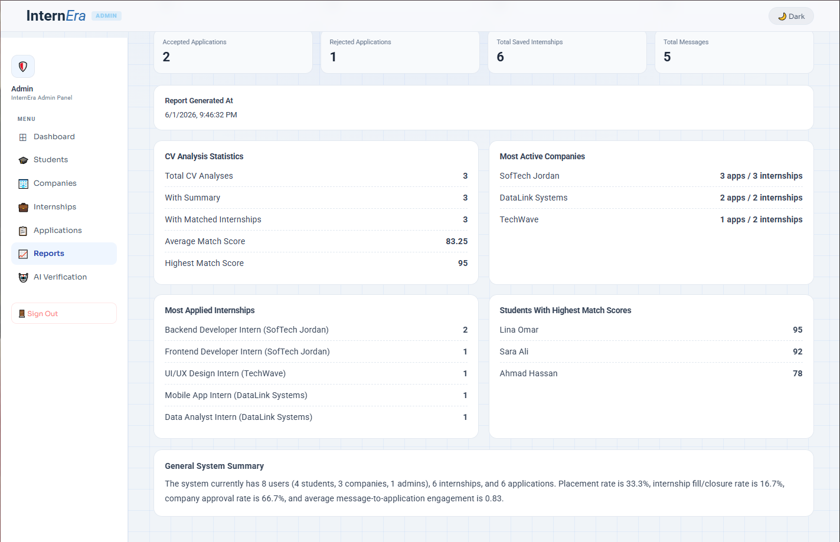
Reports & Statistics Page (Figures 50+51)
The System Reports page allows the admin to generate a PDF report showing platform statistics, CV analysis results, top companies, popular internships, highest match scores, and overall system performance.
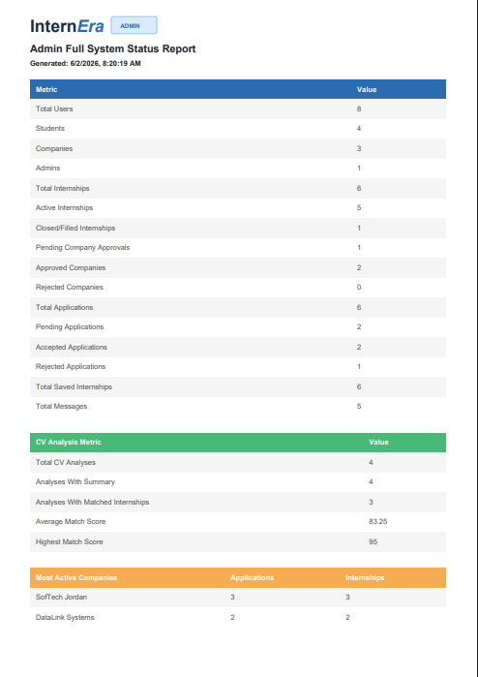
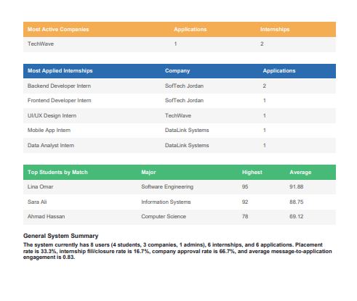
Reports PDF Details (Figures 52+53)
This PDF shows the Admin Full System Status Report for InternEra, including platform statistics, CV analysis results, most active companies, most applied internships, top students by match score, and an overall system performance summary.

References :
  - Modern Systems Analysis and Design. Joseph S. Valacich and Joey F. George. 9th edition, Pearson Education, Inc. 2021 Main Textbook
  - Linkedin
  - Indeed
  - Intershala
  - Claude

ٍ

