Lab 07 Task Report
Node.js Modules, File Handling, REST API Development & Postman Testing
Name: Fatima Akbar Registration No: 242717
Objective: To use Node.js modules, read and write JSON files, develop REST APIs using Express, and test them in Postman.

Task 1: Calculator Module
I created calculator.js with four functions and imported it into app.js. The divide function checks whether the second number is zero to avoid an invalid calculation.

calculator.js
// Task 1: Each function performs one calculation.
function add(a, b) { return a + b; }
function subtract(a, b) { return a - b; }
function multiply(a, b) { return a * b; }
function divide(a, b) {
if (b === 0) { throw new Error("Cannot divide by zero"); }
return a / b;
}
// Allow app.js to use these functions.
module.exports = { add, subtract, multiply, divide };

app.js
// Task 1: Import our own calculator module.
const calculator = require("./calculator");
console.log("Addition:", calculator.add(10, 5));
console.log("Subtraction:", calculator.subtract(10, 5));
console.log("Multiplication:", calculator.multiply(10, 5));
console.log("Division:", calculator.divide(10, 5));
try {
console.log(calculator.divide(10, 0));
} catch (error) {
console.log("Error:", error.message);
}
Expected output: Addition 15, Subtraction 5, Multiplication 50, Division 2, followed by a division-by-zero error message. Run: node app.js.

Task 2: Employee JSON File
I used the built-in fs module to read employees.json, display existing employees, add Hassan if not already present, and save the updated list. The starting file contains at least five employees.

employees.js
// Task 2: Read JSON, show employees, add one, and save.
const fs = require("fs"); // Built-in file system module
const employees = JSON.parse(fs.readFileSync("employees.json", "utf8"));
console.log("Employees before adding:", employees);
// Find the next unused ID; avoid adding the same example again.
if (!employees.some(employee => employee.name === "Hassan")) {
const newId = Math.max(0, ...employees.map(employee => employee.id)) + 1;
employees.push({ id: newId, name: "Hassan", department: "Marketing" });
fs.writeFileSync("employees.json", JSON.stringify(employees, null, 2));
console.log("One employee added and saved.");
} else {
console.log("Hassan already exists; no duplicate added.");
}
console.log("Employees after:", employees);
Run: node employees.js. JSON.parse changes JSON text into a JavaScript array, while JSON.stringify converts the updated array back into text for the file.

Task 3: Student Department Filter
In students-server.js, the GET /students/department/:department route filters the student array using the department given in the URL. It ignores uppercase/lowercase differences.
app.get("/students/department/:department", (req, res) => {
const result = students.filter(s =>
s.department.toLowerCase() === req.params.department.toLowerCase());
res.json(result);
});
Test URLs: GET /students/department/BSCS and GET /students/department/BSIT. Run with node students-server.js (stop the book server first because both use port 3000).

Task 4: Input Validation
The student API rejects POST or PUT requests if a name or department is missing or blank. It sends 400 Bad Request, rather than creating an incomplete record.
function validStudent(body) {
return body && typeof body.name === "string" && body.name.trim() !== "" &&
typeof body.department === "string" && body.department.trim() !== "";
}
Suggested tests: Send POST /students with an empty name; send PUT /students/1 with a missing department. Both should return 400. Screenshots of these student tests have not been provided.

Main Assignment: Book Management REST API
I developed books-server.js with Express. The books are initially read from books.json, and changes are written back using saveBooks(), so they remain after restarting the server.
Method | Route | Purpose | Successful status
GET | /books | Show all books | 200
GET | /books/:id | Find one book | 200 or 404
POST | /books | Add a book | 201
PUT | /books/:id | Update a book | 200 or 404
DELETE | /books/:id | Delete a book | 200 or 404

Key concepts
express.json() reads JSON data from Postman. req.body contains the submitted book details. req.params.id gets the book ID from the URL. res.status(...).json(...) sends a status code and a JSON response.
Input validation requires non-empty title and author fields and a numeric price greater than or equal to zero. Invalid input returns status 400.

How I ran the project
npm.cmd install
node books-server.js
Then I used Postman at http://localhost:3000/books. These are the captured responses from my own Postman tests.

Postman Results and Screenshots

1. GET /books — Read all books
Status 200 OK. The response listed three books (IDs 1, 2, and 3).
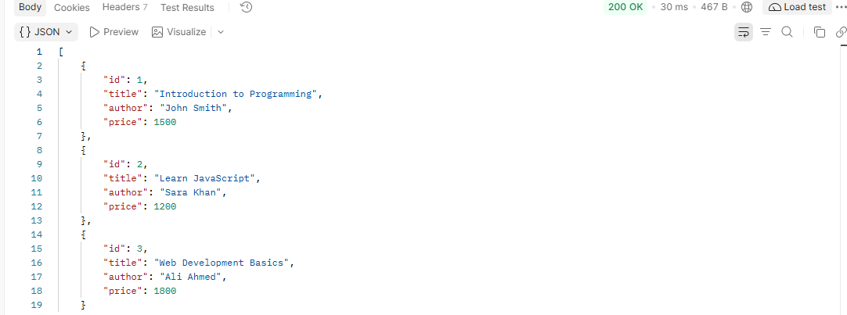
Postman response screenshot supplied during testing.

2. POST /books — Create a book
Status 201 Created. A new Python Programming book was created with ID 4.
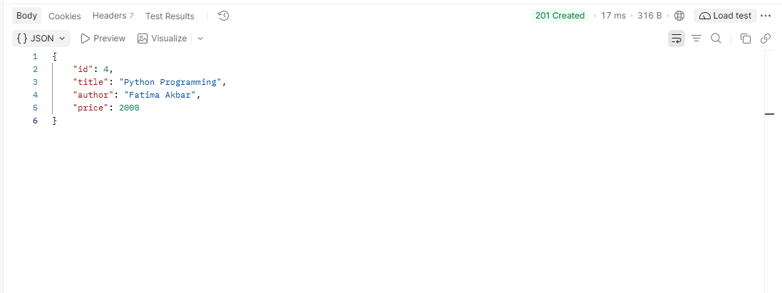
Postman response screenshot supplied during testing.

3. PUT /books/4 — Update a book
The response showed the updated title Advanced Python Programming and price 2500. The status code is not visible in the supplied screenshot.
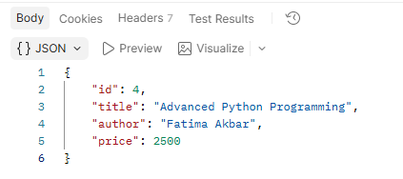
Postman response screenshot supplied during testing.

4. DELETE /books/4 — Delete a book
The response said Book deleted and returned the deleted book details. The status code is not visible in the supplied screenshot.
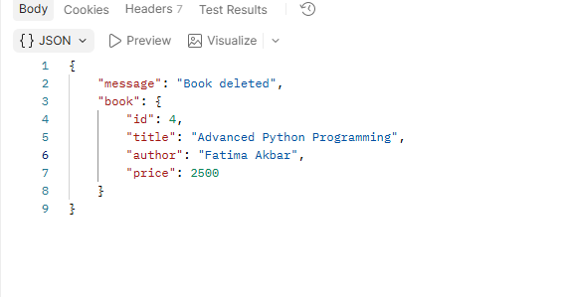
Postman response screenshot supplied during testing.

5. POST /books — Invalid input
Status 400 Bad Request because the book title was empty.
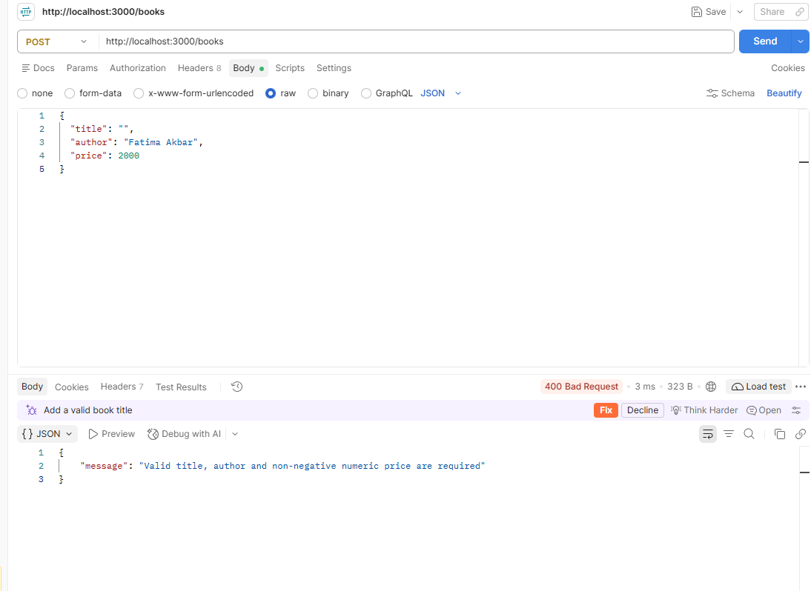
Postman response screenshot supplied during testing.

6. GET /books/4 — Missing record
Status 404 Not Found with the message Book not found after deletion.
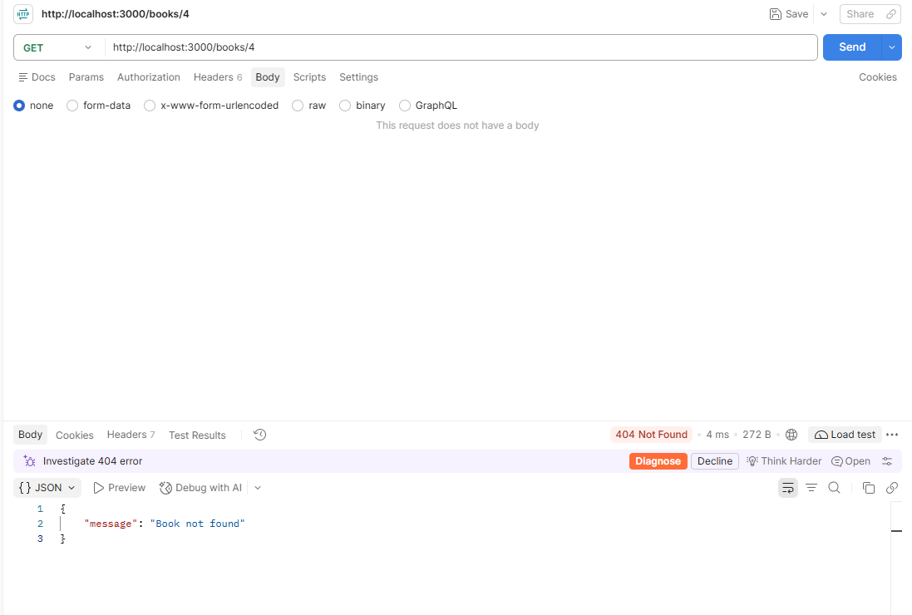
Postman response screenshot supplied during testing.

Result and Conclusion
The Book Management API was tested for reading, creating, updating, and deleting books. The supplied screenshots also demonstrate validation (400) and a missing-record response (404). The report includes the in-lab code, with student API test screenshots still to be captured separately if required by the teacher.

Short Viva Preparation
Question | Simple answer
What is Node.js? | It runs JavaScript outside a web browser.
What is Express? | A Node.js framework for making web servers and API routes.
What is a module? | A reusable JavaScript file imported using require().
What is fs? | The File System module for reading and writing files.
What is CRUD? | Create, Read, Update, Delete.
What is Postman? | A tool for sending requests to test APIs.
What is req.body? | JSON data sent by the client.
What is req.params.id? | The record ID written in the URL.
200 / 201 / 400 / 404? | OK / Created / Bad Request / Not Found.
How is data saved? | saveBooks() uses fs.writeFileSync to update books.json.

Appendix: Book Server Source Code
// Main assignment: Book Management REST API.
const express = require("express");
const fs = require("fs");
const app = express();
app.use(express.json()); // Read JSON data sent from Postman.
let books = JSON.parse(fs.readFileSync("books.json", "utf8"));
// Save after changes so data survives a restart (extra credit).
function saveBooks() {
fs.writeFileSync("books.json", JSON.stringify(books, null, 2));
}
// True only when all required fields are correct.
function validBook(body) {
return body && typeof body.title === "string" && body.title.trim() !== "" &&
typeof body.author === "string" && body.author.trim() !== "" &&
typeof body.price === "number" && Number.isFinite(body.price) && body.price >= 0;
}
// GET all books.
app.get("/books", (req, res) => {
res.status(200).json(books);
});
// GET a single book by its ID.
app.get("/books/:id", (req, res) => {
const book = books.find(b => b.id === Number(req.params.id));
if (!book) return res.status(404).json({ message: "Book not found" });
res.status(200).json(book);
});
// POST: Add one book.
app.post("/books", (req, res) => {
if (!validBook(req.body)) return res.status(400).json({ message: "Valid title, author and non-negative numeric price are required" });
const id = Math.max(0, ...books.map(b => b.id)) + 1;
const book = { id, title: req.body.title.trim(), author: req.body.author.trim(), price: req.body.price };
books.push(book);
saveBooks();
res.status(201).json(book);
});
// PUT: Replace the editable fields of an existing book.
app.put("/books/:id", (req, res) => {
const book = books.find(b => b.id === Number(req.params.id));
if (!book) return res.status(404).json({ message: "Book not found" });
if (!validBook(req.body)) return res.status(400).json({ message: "Valid title, author and non-negative numeric price are required" });
book.title = req.body.title.trim();
book.author = req.body.author.trim();
book.price = req.body.price;
saveBooks();
res.status(200).json(book);
});
// DELETE: Remove a book.
app.delete("/books/:id", (req, res) => {
const index = books.findIndex(b => b.id === Number(req.params.id));
if (index === -1) return res.status(404).json({ message: "Book not found" });
const deleted = books.splice(index, 1)[0];
saveBooks();
res.status(200).json({ message: "Book deleted", book: deleted });
});
app.listen(3000, () => console.log("Book API running at http://localhost:3000"));

