Lab 08 Report
  - Dependency Injection in NestJS and DTOs with ValidationPipe
Name: Fatima Akbar Roll No.: 242717
Date: 20 October 2026
A complete NestJS application was implemented in the initially empty lab08 repository. It includes Students, Courses and Fees modules, constructor injection, configurable storage, fee policies, DTO validation and automated tests. Screenshots in this report show real command/API output rendered for readability; they are not Postman desktop screenshots.

Task 1 — Courses and dependency injection
CoursesModule registers a Symbol COURSE_STORE through useFactory. APP_CONFIG is a string token, CreditService is a class provider, and the abstract Logger class is aliased to AppLogger with useExisting. Storage can be switched between an isolated seeded memory store and a JSON file store. CoursesService implements list, statistics, lookup, create, update and delete, logging each creation and deletion.

Task 2 — Pluggable fees
FEE_RATE is supplied with useValue (5000). FEE_POLICY uses a factory to choose standard or merit pricing. The FEE_CALCULATOR alias resolves the same FeesService instance. The same request for Sara Ahmed at 12 credits returns 60000 under standard pricing and 30000 under merit pricing; the service source is unchanged between runs.

Task 3 — DTO validation
The global ValidationPipe transforms DTOs and rejects unknown properties. Course code and strings are cleaned, tags are lowercased, and field constraints return custom details. Numeric course JSON strings are rejected, while numeric fee/query strings are explicitly converted. PUT requires all mandatory non-code fields; PATCH accepts partial fields. RESULTS.md contains actual request and response bodies with decorator explanations.

Task 4 — Automated checks and Postman collection
The project includes service, fee-policy and DTO unit tests, plus HTTP end-to-end tests using an overridden memory store. The exported Lab 08 Tasks collection has 21 requests, including negative checks, status/body assertions, a saved newCode variable and cleanup. It was executed twice consecutively with Newman, the Postman command-line runner. Import it into Postman to capture a desktop Collection Runner screenshot if your instructor requires that specific UI.

Short answers
(a) Why can an interface not be an injection token? TypeScript interfaces are erased during compilation and have no runtime identity. Nest needs a runtime value such as a string, Symbol or class to look up a provider.
(b) What does singleton mean? A default-scope provider has one shared instance in the application context. Consumers resolving the same provider receive that instance rather than constructing a new service for every request.
(c) How can OtherModule use CoursesService? Add CoursesService to the exports array of CoursesModule. Import CoursesModule in OtherModule and inject CoursesService through the consumer's constructor.

How to run
npm ci
STORAGE=memory LOG_TO_FILE=true FEE_POLICY=standard npm run start:dev
FEE_POLICY=merit STORAGE=memory npm run start:dev
npm test
npm run test:e2e
npm run test:postman
npm run build
Run server commands separately, stopping one server before starting the next. Run the collection against a fresh memory server. Dependencies, build output and runtime logs are excluded from Git. The complete source project accompanies this report.

Unit tests
Captured evidence from the current workspace. Command summaries are excerpts where indicated.
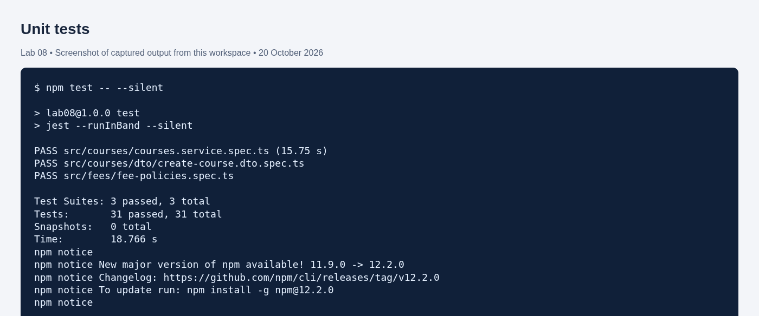

HTTP end-to-end tests
Captured evidence from the current workspace. Command summaries are excerpts where indicated.
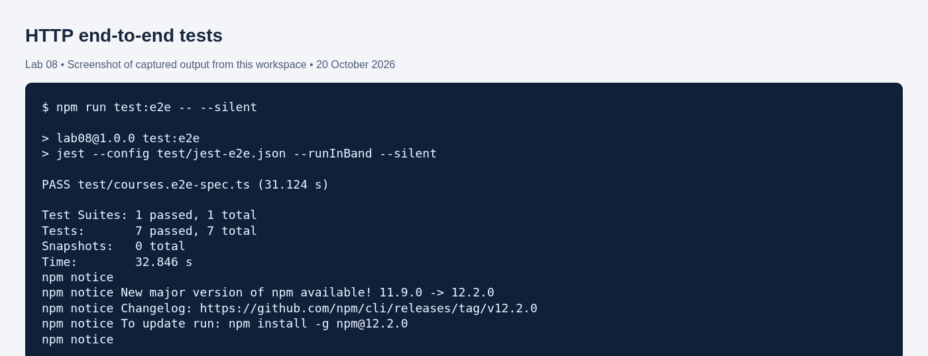

Postman Newman collection — first run
Captured evidence from the current workspace. Command summaries are excerpts where indicated.
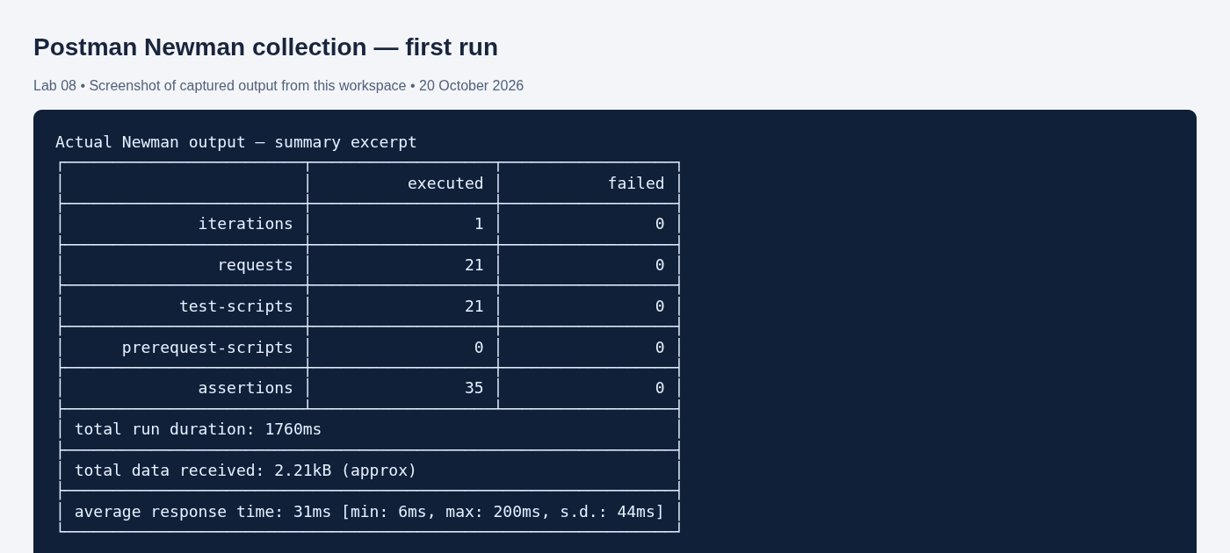

Postman Newman collection — second run
Captured evidence from the current workspace. Command summaries are excerpts where indicated.
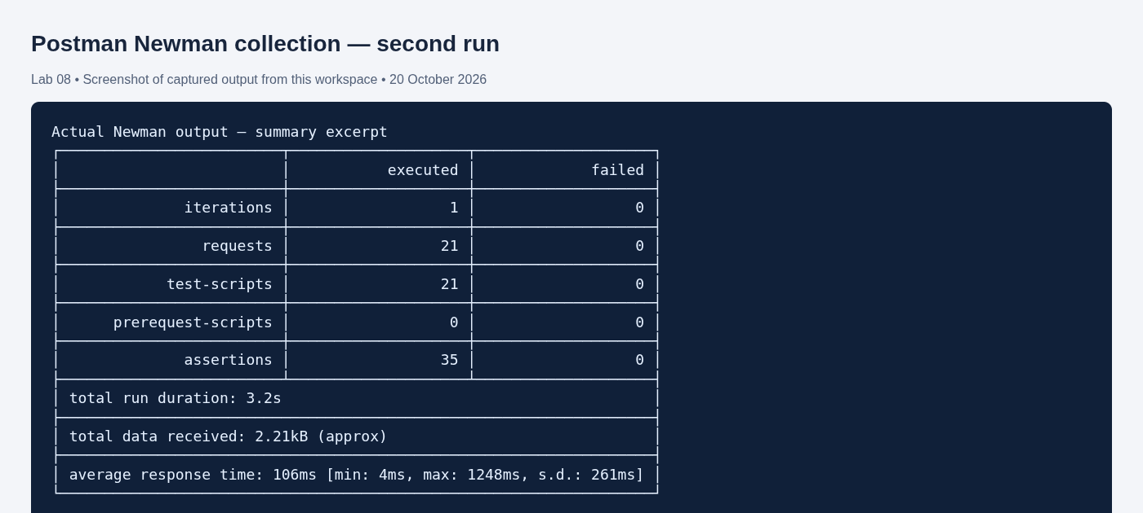

Standard fee policy
Captured evidence from the current workspace. Command summaries are excerpts where indicated.
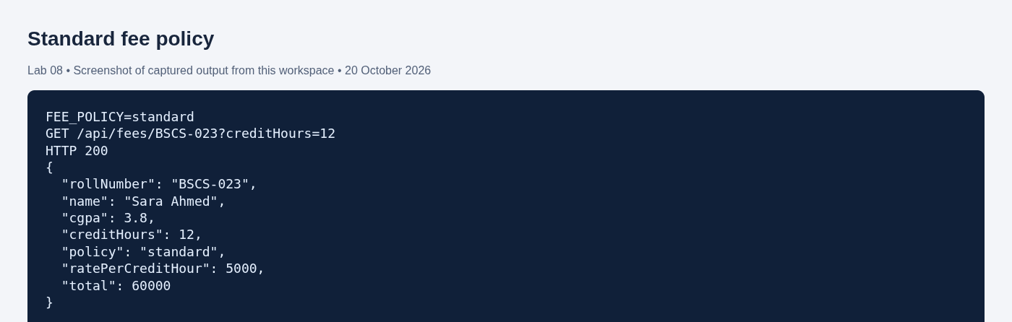

Merit fee policy
Captured evidence from the current workspace. Command summaries are excerpts where indicated.
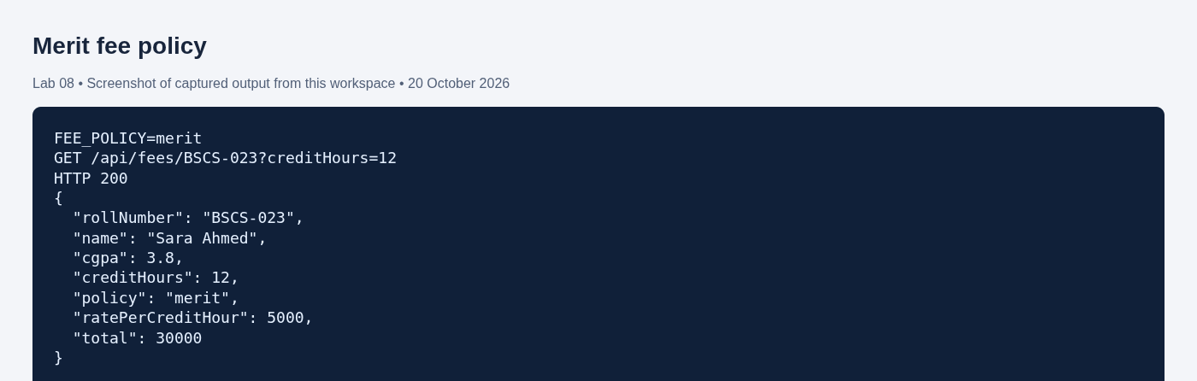

File logging: logs/app.log
Captured evidence from the current workspace. Command summaries are excerpts where indicated.
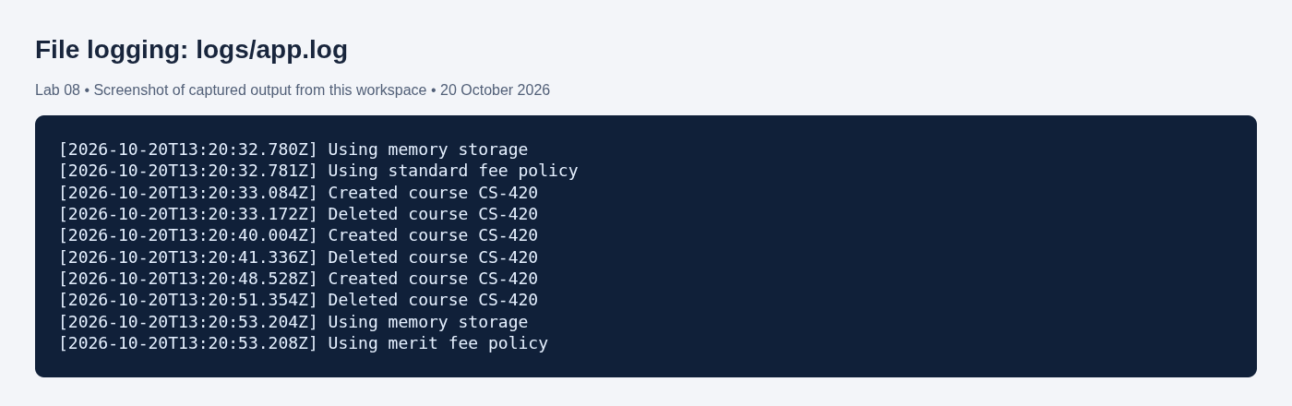

Validation: invalid course response
Captured evidence from the current workspace. Command summaries are excerpts where indicated.
