The idea of my website is to raise awareness about health. This website has a fluid design. I have used <section> so that I could add styles to the heading of the webpage, <div> so that the links would show up in a special way to catch the user’s attention, <p> so that I could add the information in paragraphs, <span> to color part of the text rather than using css, <ul> to show a list.

**Validation**

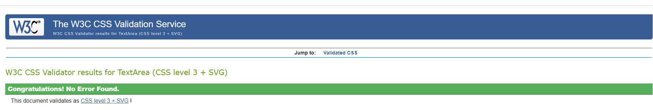

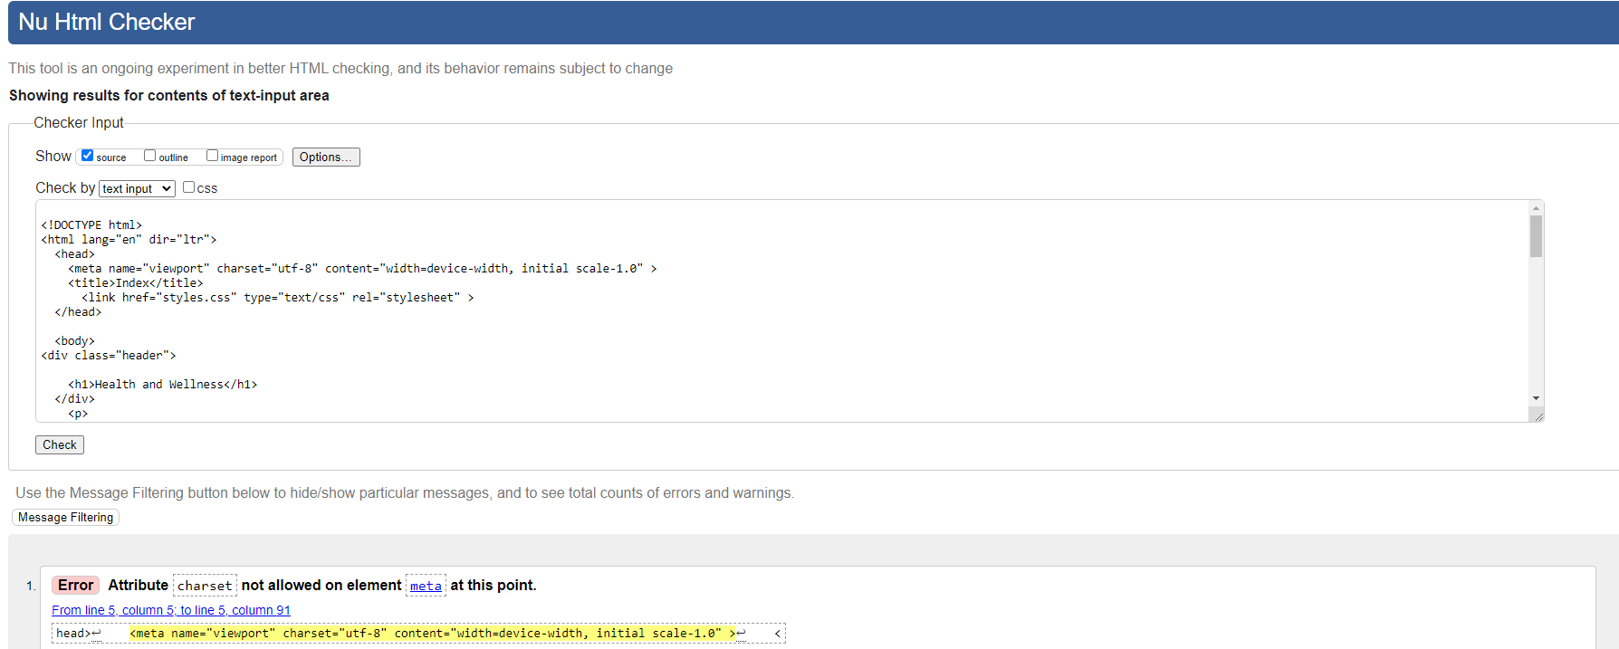

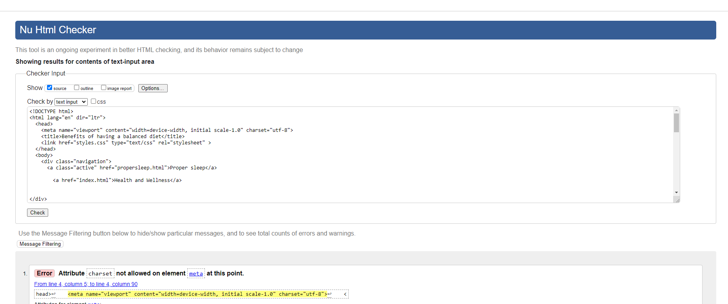

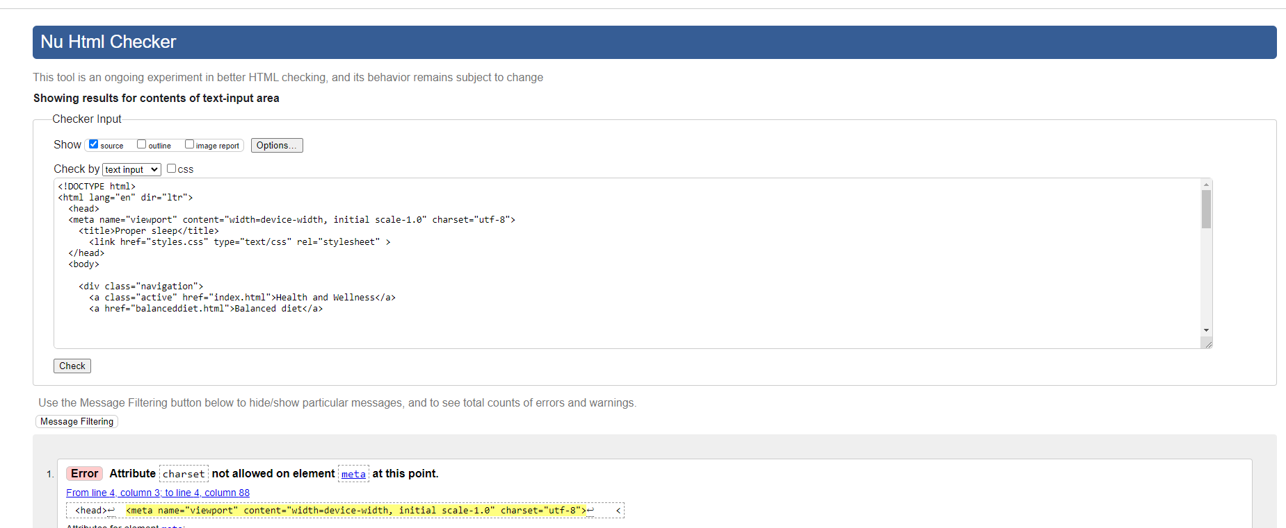

Images from: https://pixabay.com/images/search/cars/