**Air University Islamabad**

**Department of Creative Technologies BSSE_Fall2024_B**

**CS111 – Programming Fundamentals**

**Semester Project**

**Course Instructor: Mr. Zain Abubaker**

**Group Members:**

**Fatima Atta 242184**

**Obaidullah Qureshi**

**Contents**

PROJECT TITLE: 3

SCOPE OF PROGRAM: 3

FUNCTIONAL REQUIREMENTS 3

**PROJECT TITLE:**

Stopwatch Program

This project involves the development of a stopwatch program that can perform basic time-tracking operations such as starting, stopping, recording lap times, and resetting. The program is written in C++ and focuses on providing accurate time measurements and a user-friendly menu interface.

**SCOPE OF PROGRAM:**

The scope of this program includes the following functionalities:

1. Ability to start and stop the stopwatch.
2. Recording multiple lap times with up to 100 laps supported.
3. Displaying the total elapsed time.
4. Summing and displaying all recorded lap times.
5. Presenting lap times in HH:MM:SS format for better readability.
6. Resetting the stopwatch to its initial state.
7. User interaction through a simple menu-based interface.

This program is designed for users who require a simple yet efficient stopwatch solution. It is suitable for personal time tracking, sports timing, or educational purposes to demonstrate time-based programming concepts.

# **FUNCTIONAL REQUIREMENTS**

The program requires the following:

Input:

* User inputs to navigate the menu and select options.
* Numeric input for menu choices.

Processing:

* Capturing current time using time_t for start and stop operations.
* Calculating elapsed time and storing lap times in an array.
* Summing up lap times for total duration.

Output:

* Displaying formatted time in HH:MM:SS format.
* Showing lap times and total elapsed time on the console.
* Informative prompts and error messages for invalid inputs.

Limitations:

* The program supports up to 100 laps.
* It relies on console input and output for interaction.

## **USE CASE DIAGRAM**

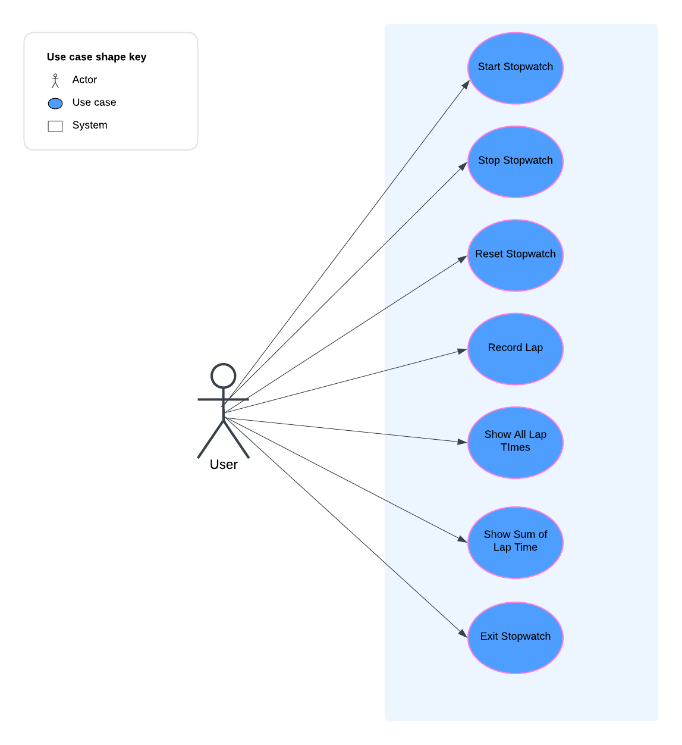

### **OUTPUT:**

Menu Display:

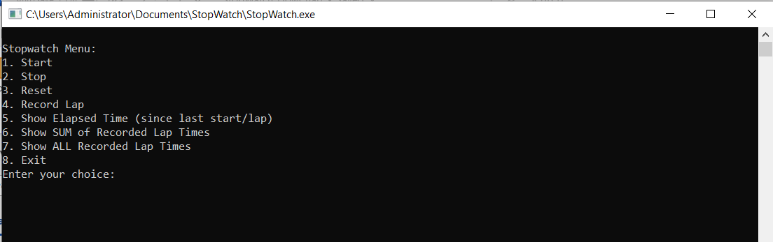

Start:

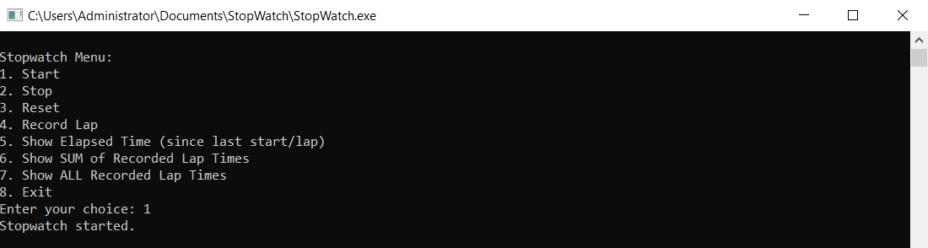

Record Elapsed Time:

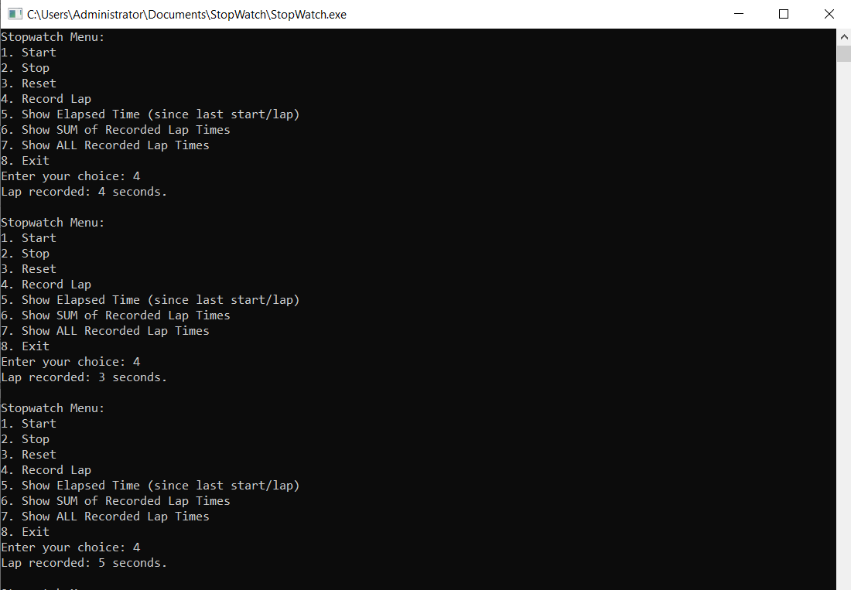

Stop:

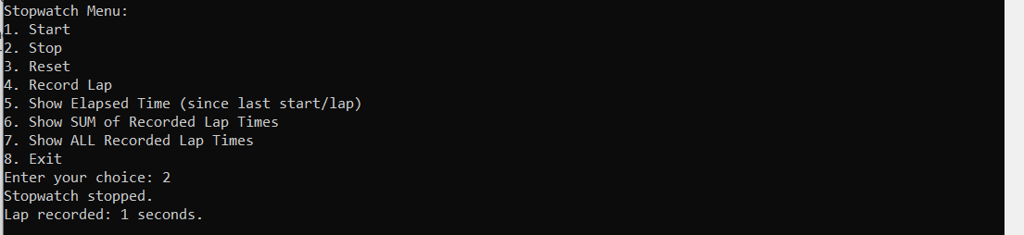

Show All Recorded Lap Times:

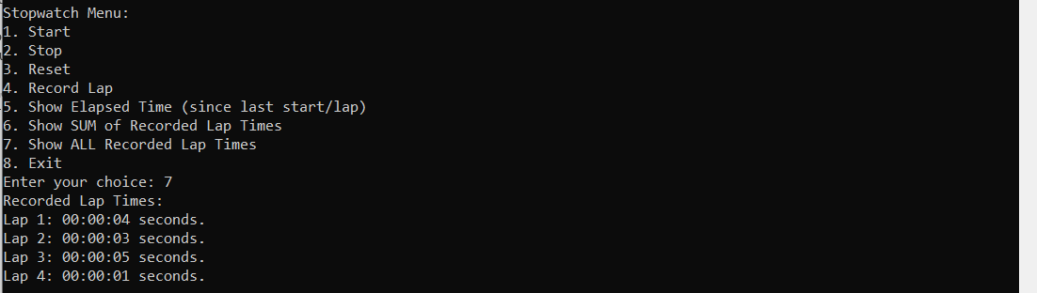

Show Sum of Recorded Lap Times:

Stopwatch Reset:

