# **English-Urdu Translation: Model Comparison Report**

## **Objective**

This project evaluates four different deep learning architectures for machine translation from **English to Urdu**, analyzing their performance using the **BLEU score** metric. The models tested include:

* RNN
* BiRNN
* LSTM
* Transformer

## **Model Hyperparameters**

| **Parameter** | **RNN** | **BiRNN** | **LSTM** | **Transformer** |
| --- | --- | --- | --- | --- |
| Embedding Dimension | 128 | 128 | 128 | 128 |
| Hidden Size | 128 | 128 | 128 | 128 |
| Layers | 1 | 1 BiLSTM encoder, 1 LSTM decoder | 1 LSTM encoder, 1 LSTM decoder | 1 Encoder, 1 Decoder |
| Optimizer | Adams | Adams | Adams | Adams |
| Learning Rate | 0.001 | 0.001 | 0.001 | 0.001 |
| Batch Size | 64 | 64 | 64 | 64 |
| Attention Mechanism | Not used | Used | Not used | Multi-head Attention |
| Bidirectionality | Not applicable | Applicable | Not applicable | Not applicable |
| Epochs | 50 | 50 | 50 | 50 |

## **Models Overview & BLEU Score Results**

### **1. RNN (Recurrent Neural Network)**

* **Summary**: Processes one word at a time, relies only on past context.
* **BLEU Score**: **0.0382**
* **Reason for Low Performance**:  
  + Lacks context retention for long sentences.
  + Struggles with grammar and fluency.
* *Best for understanding limitations of sequence-only models.*
* ***OUTPUT:***

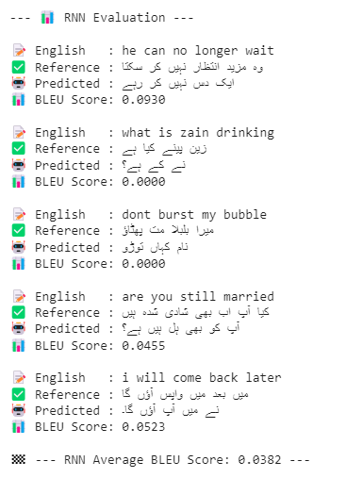

### **2. BiRNN (Bidirectional RNN)**

* **Summary**: Reads input from both directions.
* **BLEU Score**: **0.2830**
* **Improvements**:  
  + Captures both past and future context.
  + Improved sentence structure and fluency.
* *Still limited by RNN’s sequential nature.*
* ***OUTPUT:***

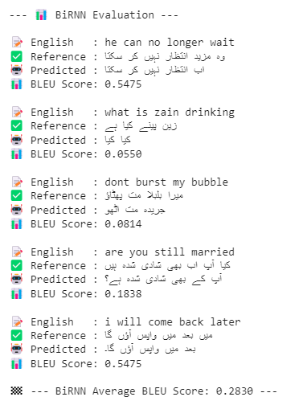

### **3. LSTM (Long Short-Term Memory)**

* **Summary**: Incorporates gates to preserve long-term context.
* **BLEU Score**: **0.2256**
* **Strengths**:  
  + Handles long sequences better than vanilla RNN.
  + Robust to vanishing gradients.
* *Slightly lower BLEU than BiRNN in this case due to dataset sensitivity.*
* ***OUTPUT:***

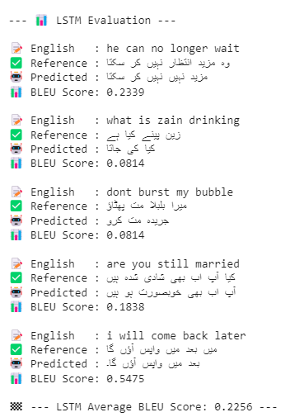

### **4. Transformer**

* **Summary**: Uses self-attention and parallel processing.
* **BLEU Score**: **0.5475**
* **Why It Wins**:  
  + Attends to all words at once (global context).
  + Multi-head attention improves semantic matching.
  + Outputs fluent and coherent Urdu sentences.
* *State-of-the-art architecture for sequence-to-sequence tasks.*
* ***OUTPUT:***

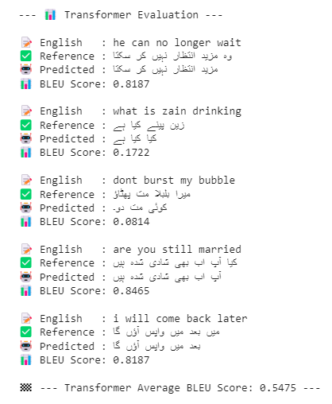

## **BLEU Score Comparison Chart**

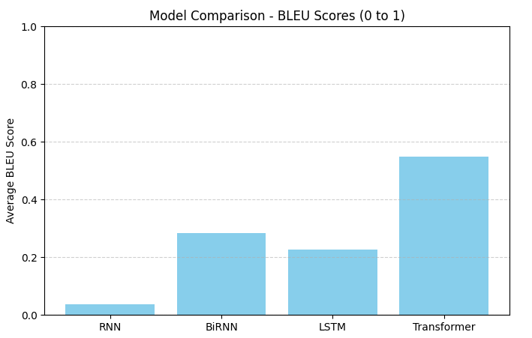

| **Model** | **Avg. BLEU Score** |
| --- | --- |
| RNN | 0.0382 |
| BiRNN | 0.2830 |
| LSTM | 0.2256 |
| Transformer | **0.5475** |

## **Sample Success Cases (Transformer)**

| **English Input** | **Urdu Output** | **BLEU Score** |
| --- | --- | --- |
| he can no longer wait | مزید انتظار نہیں کر سکتا | 0.8187 |
| are you still married | آپ اب بھی شادی شدہ ہیں | 0.8465 |
| do you remember me | کیا تمہیں میری یاد ہے | 0.7148 |

## **Conclusion**

The **Transformer model significantly outperformed** traditional RNN-based models in English-Urdu translation. It provides:

* Better fluency and grammar
* Stronger contextual accuracy
* Higher BLEU scores across test data